GPU - parallelization

STEPS
0. Installazione Linux Mint 21.3 nativo ✓ (page : 1)
1. Compilare ORB-SLAM ( versione non parallela ) ed eseguirlo ✓ (page : 7)
2. Apprendimento di CUDA → work in progress… ⚠ (page : 11)
3. Compilare ORB-SLAM ( versione parallela ). ✓ (page : 85)
4. Studiare la parte di Extract ORB (STEP4 – Analisi e studio di Extract ORB parallelo)
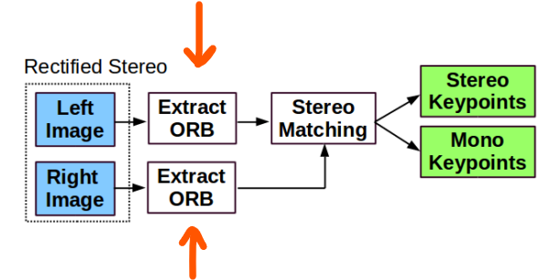
5 Studiare la parte di Stereo Matching (STEP5 – Analisi e studio di Stereo Matching sequenziale)
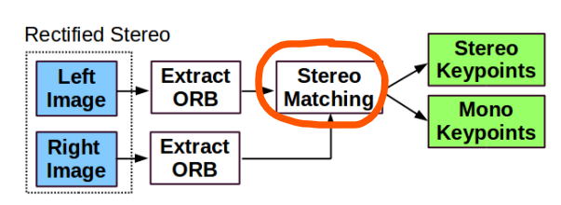

6. Ottimizare la parte di Stereo Matching e cercare di renderla parallela. (page : 94 )

STEP0 – Installation of Linux distribution ✓
0. Elimination tutorial on final step *(extra)
1. Download ISO file from https://linuxmint.com/
- Ricordati di fare il check dell’Integrity e Authenticity. (Using HASH)

2. Download Rufus and choose the ISO file. (https://rufus.ie/it/)

Rufus Interface
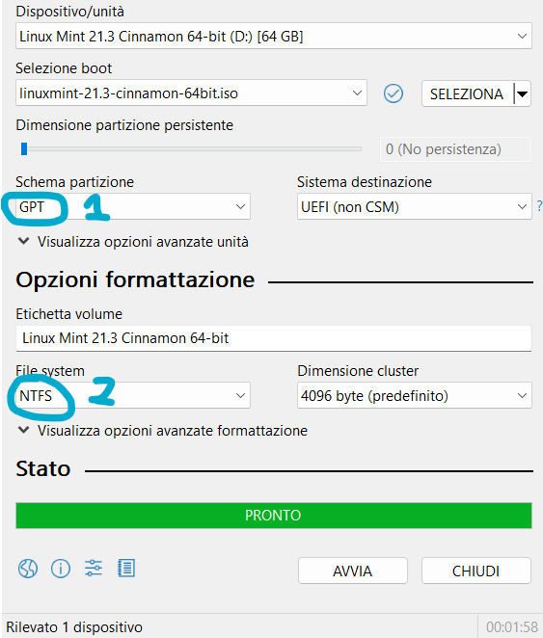
1 → Partizioni possibili : GPT or MBR
GPT: Permette partizioni illimitate, e ha alcuni vantaggi di flessibilità. Dovrebbe funzionare sempre. (Consigliato)
MBR: Permette numero di partizioni limitate, però ha il vantaggio che è LEGACY.
2 → NTFS → Unico File System di ripristino possibile con Rufus. Ricordati che NTFS è il file system di Windows. Linux utilizza exFat,FAT32,...

3. Partiziona il disco

Tasto destro su Windows(C:) e premere “Riduci Volume”
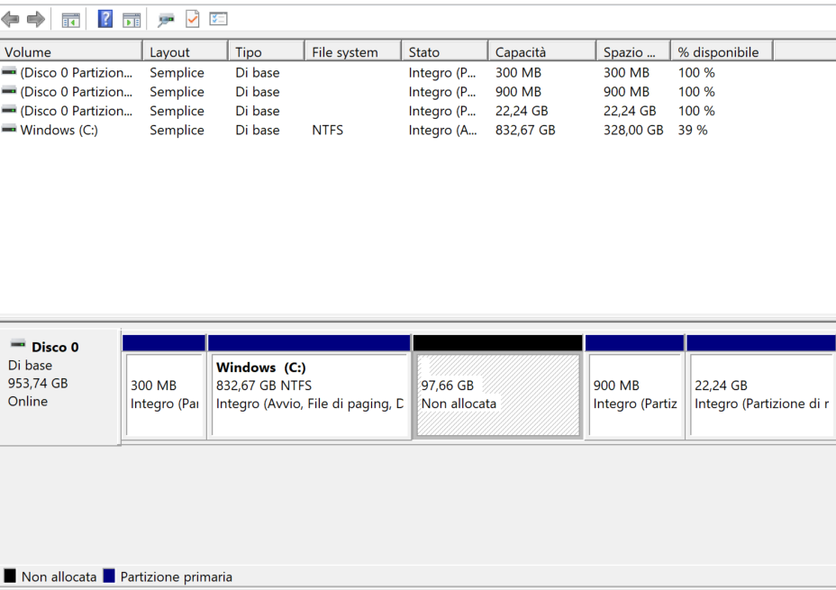
Modificare “Specificare la quantità di spazio da ridurrre,in MB:” ( Ex: 100000Mb )
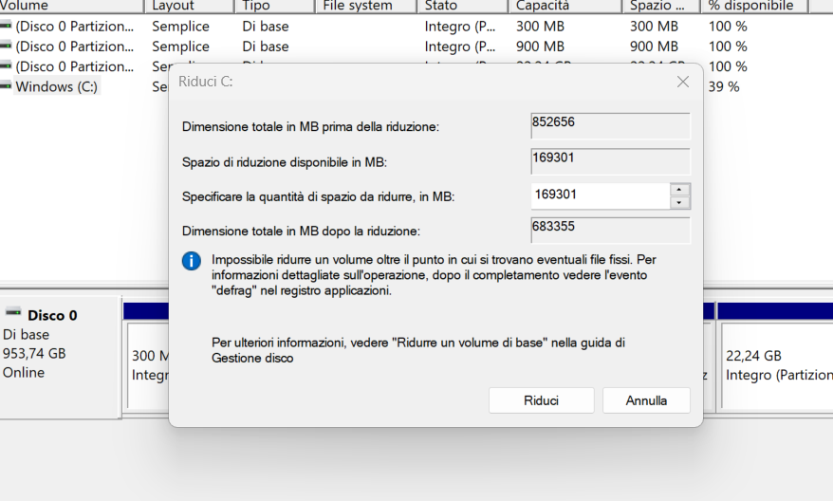
Nuova memoria non allocata
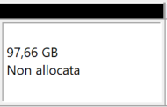

4. Controllare le condizioni del file system di Windows:
□ Aprire come amministratore CMD
1 fsutil dirty set c:
2 # Restart the system

bcdedit # Controlla se [ path \WINDOWS\system32\winload.efi ] è EFI

5. Disattivare avvio rapido! → https://www.youtube.com/watch?v=eIEw4b2QNvM

6. Change BOOT priority on BIOS (Clicca all’avvio F3).
- Aprire barra Windows.
- Cerca “Modifica le opzioni di avvio avanzato”.
- Clicca “Riavvia ora”.
- Clicca “Utilizza un dispositivo”.
- Seleziona la chiavetta con sopra il file .iso
- Quando si apre la scelta tra Linux e Windows, selezionare Linux.
- Installare Linux.
- Torna su Windows
- Cerca “Modifica le opzioni di avvio avanzato”.
- Clicca “Riavvia ora”.
- Clicca “Risoluzione Problemi”/”Opzioni Avanzate”/”Impostazioni Firmware UEFI”
- Fai nel menù dove si cambia l’ordine di avvio
- Selezionare “UEFI Hard Disk Drive BBS properties” (può variare in base al BIOS).
- Salva e riavvia il PC.

7. Restart PC

Extra: Elimination of the S.0
link : https://youtu.be/fmEHLGeG0WQ
Steps:
1. Elimina le partizioni.
2. Apri il “CMD” come amministratore e inserisci i seguenti comandi:
1 diskpart
2 list disk
3 select disk 0 # selezionare il disco dove è installato il S.0
4 list volume # Il volume per linux avrà un file system FAT32 e peserà 100mb circa
5 select volume <n> # selezionare il volume con il file system FAT32
6 assing letter=z # Non usare la lettera C,A,D
7 exit
8 z:
9 dir
10 cd EFI
11 rmdir /S <nome distribuzione linux>

3. Volendo si può rimuovere dal firmware UEFI l’entry. Per farlo scaricare l’applicazione “Hasleo EasyUEFI”

STEP1 – Compilazione ed esecuzione di ORB-SLAM✓
Main repository → https://github.com/UZ-SLAMLab/ORB_SLAM3

Installazione CUDA – Toolkit ✓
1. Controllare la versione dei Driver di CUDA con il comando nvidia-smi
2. Scaricare la versione di CUDA corrispondente alla versione restituita dal comando precedente.
Example: Driver Version: 535.171.04 CUDA Version: 12.2
- Guide : https://docs.nvidia.com/cuda/cuda-installation-guide-linux/index.html
3. Aprire il file .bashrc e inserire il seguente comando:
export PATH=/usr/local/cuda-12.4/bin/:$PATH

Scaricare kitty data set ✓
● https://git.hipert.unimore.it/fmuzzini/cuda-accelerated-orb-slam/-/tree/main#6-orb-slam2-with-kitti-dataset
1. Loggarsi sul sito e scaricare il seguente pacchetto.
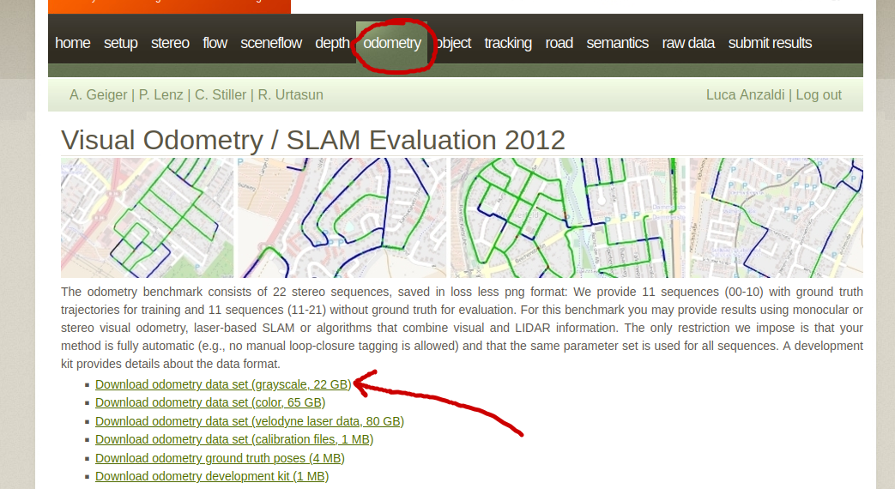2.

Installazione prerequisiti ✓
1. Pangolin → https://github.com/stevenlovegrove/Pangolin. ✓
# Get Pangolin
cd ~/your_fav_code_directory
git clone --recursive https://github.com/stevenlovegrove/Pangolin.git
cd Pangolin

# Install dependencies (as described above, or your preferred method)
./scripts/install_prerequisites.sh recommended

# Configure and build
cmake -B build
cmake --build build

2. Open-CV → Required at least 3.0. Tested with OpenCV 3.2.0 and 4.4.0. ✓
- To install on Linux → sudo apt install libopencv-dev
3. Eigen3 → Required at least 3.1.0. ✓
Download at : https://eigen.tuxfamily.org/index.php?title=Main_Page
- Extract the content in a folder(.zip file)
- You can try your first Eigen programm → g++ <eigen_example.cpp> -I <Eigen_dir> -o <my_program_name>

#include <iostream>
#include <Eigen/Dense>

using Eigen::MatrixXd;

int main()
{
MatrixXd m(2,2);
m(0,0) = 3;
m(1,0) = 2.5;
m(0,1) = -1;
m(1,1) = m(1,0) + m(0,1);
std::cout << m << std::endl;
}

Compilazione ORB-SLAM3✓

--- 1. Clonazione
git clone https://github.com/UZ-SLAMLab/ORB_SLAM3.git ORB_SLAM3
--- 2. Build
cd ORB_SLAM3
chmod +x build.sh
./build.sh
· Se si hanno problemi, andare ad eseguire le sotto-funzioni di ./build.sh per vedere dov’è l’errore.

⚠ Se non funziona modificare C++11 → C++14 ( Presente in /ORB_SLAM3/CmakeLists.txt )
# Check C++11 or C++0x support
include(CheckCXXCompilerFlag)
CHECK_CXX_COMPILER_FLAG("-std=c++11" COMPILER_SUPPORTS_CXX11)
CHECK_CXX_COMPILER_FLAG("-std=c++0x" COMPILER_SUPPORTS_CXX0X)
if(COMPILER_SUPPORTS_CXX11)
set(CMAKE_CXX_FLAGS "${CMAKE_CXX_FLAGS} -std=c++11")
add_definitions(-DCOMPILEDWITHC11)
message(STATUS "Using flag -std=c++11.")

Inoltre commentare il seguente “cout” nel file ORB_SLAM3/src/System.cc ( line 84 )
cv::FileNode node = fsSettings["File.version"];
if(!node.empty() && node.isString() && node.string() == "1.0"){
settings_ = new Settings(strSettingsFile,mSensor);

mStrLoadAtlasFromFile = settings_->atlasLoadFile();
mStrSaveAtlasToFile = settings_->atlasSaveFile();

//cout << (*settings_) << endl;
}

Esecuzione ORB-SLAM3✓
1. Andare nella directory /ORB_SLAM3
2. Eseguire → ./Examples/Stereo/stereo_kitti Vocabulary/ORBvoc.txt Examples/Stereo/KITTIX.yaml ~/Desktop/dataset/sequences/00
□ Le parti in rosa devono essere modificate in base al numero di esempio che vogliamo provare.
□ La parte in verde indica il path contente il kitty data set ( link : sopra )
- KITTI00-02.yaml → sequenze 00,01,02.
- KITTY03.yaml → sequenze 03.
- KITTY04-12.yaml → sequenze 04,05,06,07,08,09,10,11,12.

⚠ Nel caso non funziona debuggare il file :
1. /ORB_SLAM3/Examples/Stereo/stereokitty.cc
2. /ORB_SLAM3/src/System.cc
3. Per compilare vai in /ORB_SLAM3/build ed esegui i seguenti comandi :
# cmake .. -DCMAKE_BUILD_TYPE=Release
# make

STEP2 – Apprendimento di CUDA

● Slide tutorial ( 77 Slide ) : https://cuda-tutorial.github.io/part1_22.pdf
● https://cuda-tutorial.github.io/
● https://cuda-tutorial.readthedocs.io/en/latest/tutorials/tutorial01/

● Youtube tutorial ( 27h , 19 Lections ) : https://www.youtube.com/watch?v=cvo3gnInQ7M&list=PL1ysOEBe5977vlocXuRt6KBCYu_sdu1Ru ( Suggested to watch these lection with multiplier 1.25x )

How to compile ?
nvcc <namefile.cu>

Slide tutorial : <part1_22.pdf>

Exection Model
__global__ → Kernel functions ( called from CPU for GPU )
__device__ → Devices functions (function or variable that is executed or allocated on the device (GPU) only )
__host__ -> Code to be executed on the host (CPU)

Synchronization (Host with Device)
cudaDeviceSynchronize() -> to synchronize CPU and GPU
cudaEventSynchronize() -> to synchronize up to certain event

Execution Hierarchy
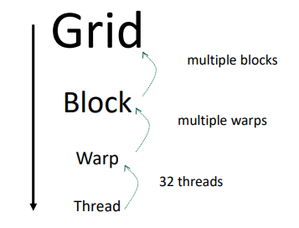
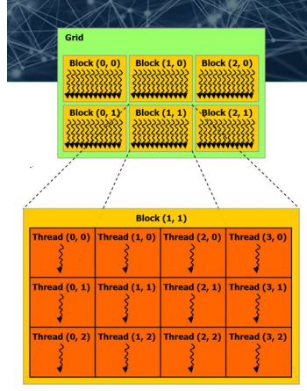

Atomic operations
● atomicAdd(...)
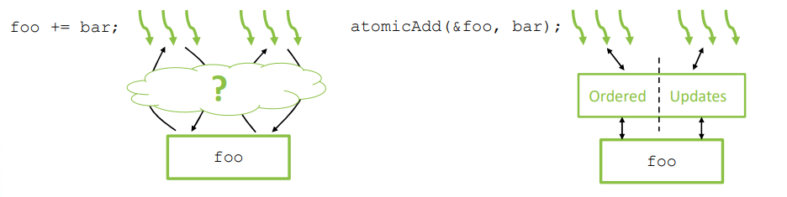

Types of memory
• Registers
• Per-thread, fast, automatically allocated for variables
• Local Memory
• Per-thread, slow, used when registers are unavailable
• Shared Memory
• Per-block, fast, allocated by host or __shared__
• Global Memory
• Per-device(GPU), slow, allocated by host or __device__
• Constant Memory
• Per-device(GPU), fast uniform access, via __constant__
• Texture Memory
• Per-device, slow, with texture reading functionality
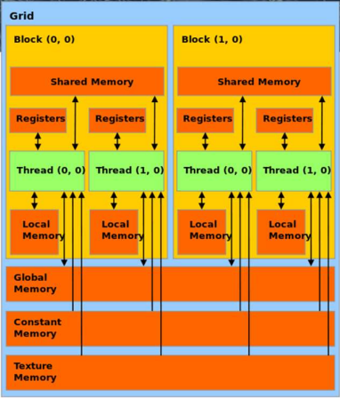

Example on Atomic Redution ( sum )
● Input : [ 1 , 2 , 3 , 4 ]
● Output : 10
Version1 – Atomic Global
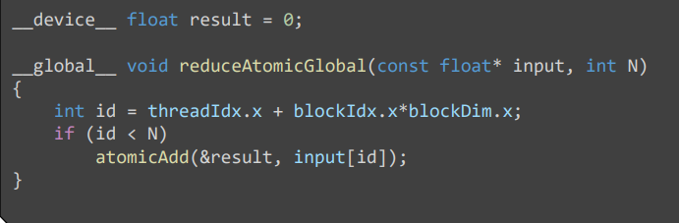
Version2 - Blocks Share Fast Memory
● Ogni blocco gestice una memoria veloce al suo interno, per velocizzare i calcoli. Per accedervi si utilizza __shared__.
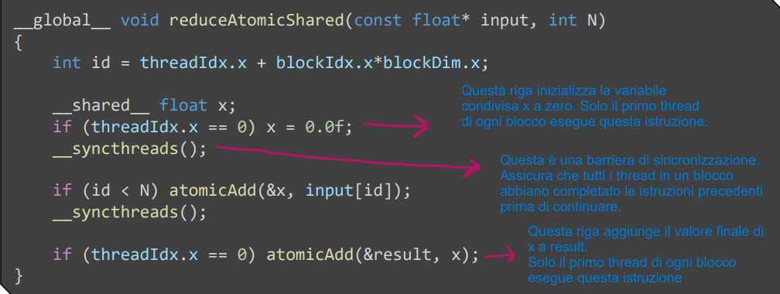
Compute block results in fast, shared memory, update global at end ( &result)
Version3 – Sublinear Runtime
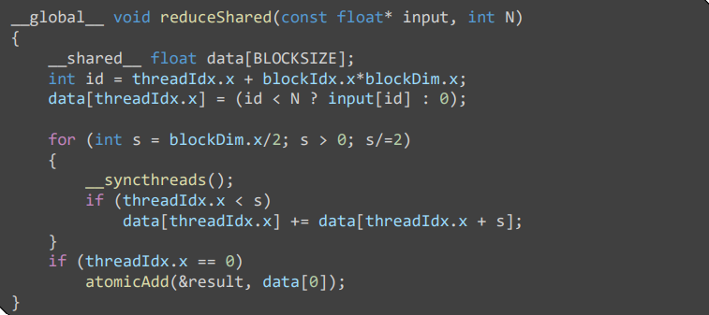
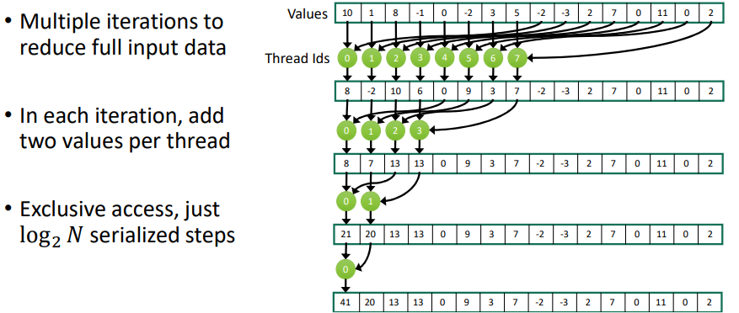
Version4 – Exchangin Registers
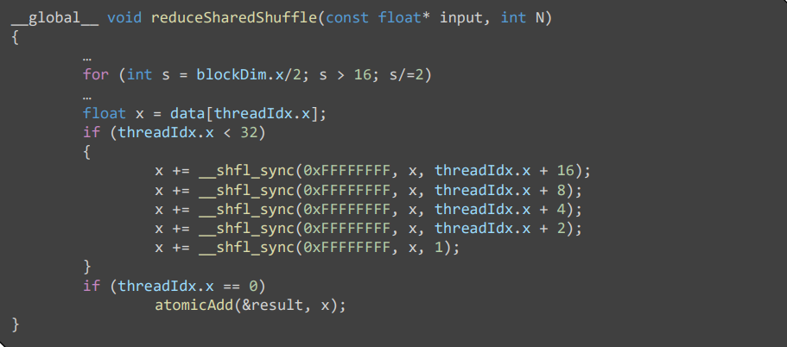

Perfomance comparison
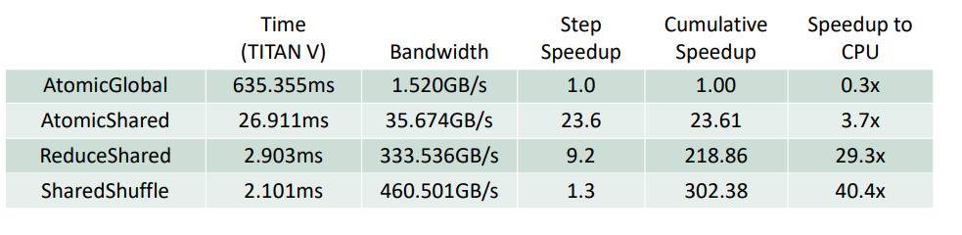

Profiling e Dubugging
● How to print the execution time ?
nvprof ./vector_add_thread

Profiling with Nsight Systems
1. SEQUENTIALLY
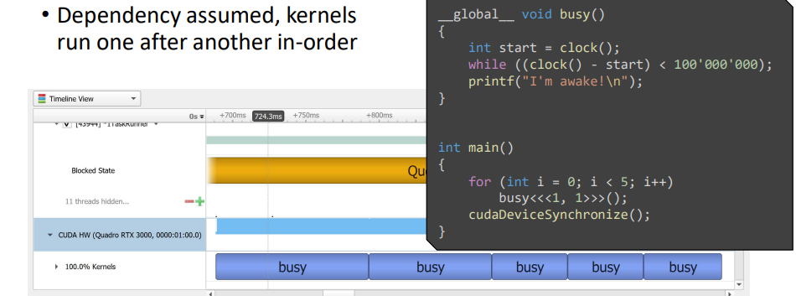
2. STREAMS
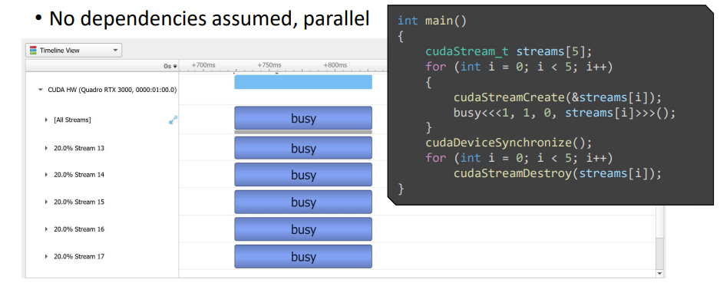

Youtube tutorial : <L1 CUDA Helloworld >
(https://www.youtube.com/watch?v=cvo3gnInQ7M&list=PL1ysOEBe5977vlocXuRt6KBCYu_sdu1Ru)

Introduction
Example1
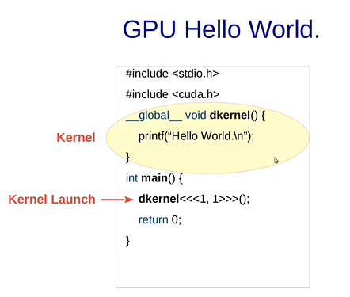
□ Per compilare nvcc hello.cu e poi ./a.out

● Dkernel<<<1,1>>>() →
● Dkernel<<<Block , Thread for block>>>()

● __global__ means it is a Kernel function and it was run by GPU.
→ In questo caso non stamperà nulla perché la CPU non aspetta che la GPU finisce. Il modo per farlo funzionare è aggiungere la funzione cudaDeviceSynchronize();
□ Funzioni CPU (__host__) e GPU(__global__) sono asincrone!

Example2
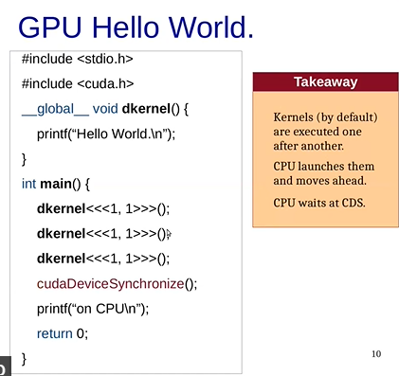
● Ogni chiamata del Kernel viene messa in una lista (FIFO) per poi venire svuotata sequenzialmente.
● Questo succede anche se chiamiamo funzioni diverse di __global__.

Example3
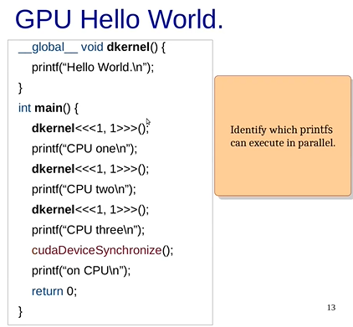
● In questo caso l’input non è deterministico perché le funzioni dkernel verranno mese nella coda.
E non si sa se viene scritto prima “Cpu one\n” o il primo elemento della coda riesce già ad eseguire il codice.

Example4 ( C loop vs possible Cuda parallel loop )
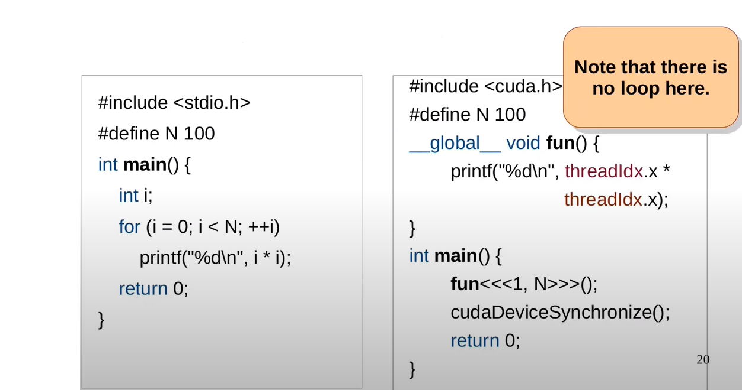
● In questo caso lanciamo, 100 thread all’interno di un blocco.
Ogni thread avrà un id che va da 1 a 100 ( threadIdx.x)

Youtube tutorial : < L2 CUDA program flow and cudamemcopies >
(https://www.youtube.com/watch?v=wgoP4xITs2U)

Example1 → CudaMalloc and CudaMemcpy.
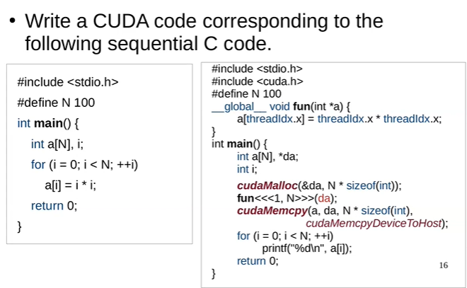
● Osservazione : Non c’è nessuna funzione di sincronizzazione perché cudaMemcpy(...) dato che è un “blocking statements” quindi aspetta che le operazioni precedenti siano finite.
● CudaMalloc → Alloca memoria per la GPU.
● CudaMemcpy → Sposta i dati tra una DRAM e l’altra ( Device = GPU , Host = CPU )
● CudaHostAlloc → Alloca memoria per la GPU. (Memoria usabile anche dal Host)
Example2
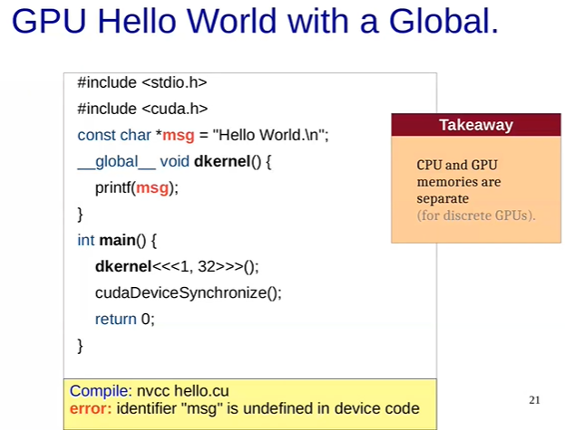
● Le GPU discrete hanno una memoria dedicata.
Quindi non condividono la memoria con la CPU.
↓ ↓ ↓ Solution ↓ ↓ ↓

Solution
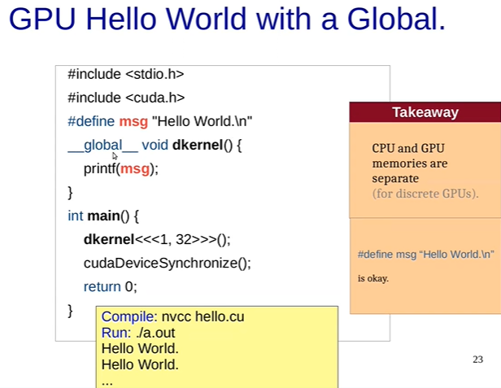

Separate Memories
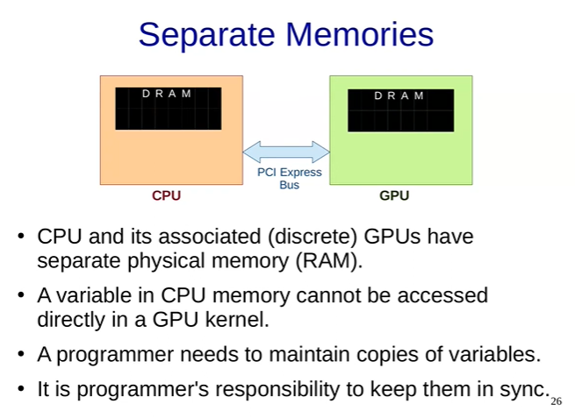

CUDA Program Flow
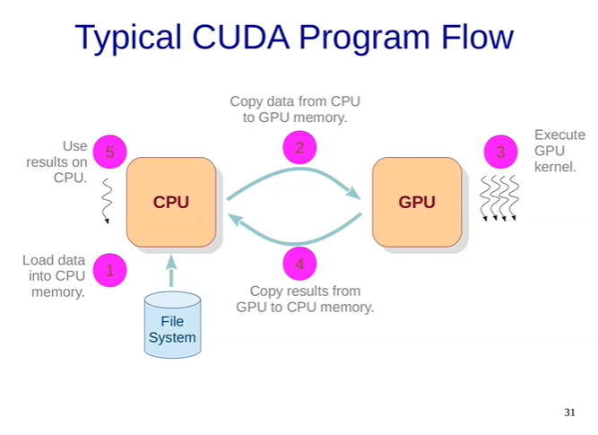
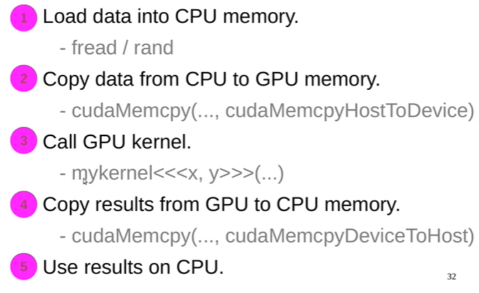

Gpu - Comunication
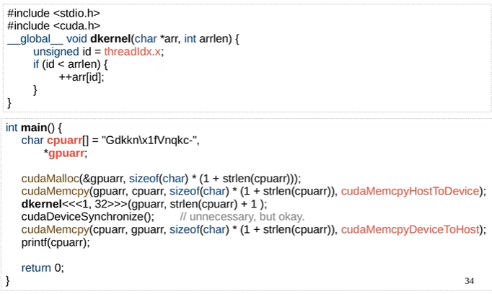
●Output : Hello World! → Questo perché dkernel() incrementa ogni carattere della stringa.
⚠ Don’t switch the ‘\0’ because it could make crash the application.
(1+strlen(cpuarr)) → remove 1+

Homeworks
1. Write a CUDA program to initialize an array of size 32 to all zeros in parallel.
2. Change the array size to 1024
3. Create another kernel that adds i to array[i].
4. Change the array size to 8000.
5. Check if the answer to problem 3 still works.
→ Non funziona sopra 1024 → Poichè BlockDim.x.max = 1024

□ Exercise1
_#include<stdio.h>

__global__ void init_to_zero(int *Arr , int n ){
int id = threadIdx.x;
if(id<n){
Arr[id] = id;
}

}

int main(){

int n = 1024; // n = 1024 , n = 8000
int *GpuArr;
int CpuArr[n];
cudaMalloc(&GpuArr , sizeof(int) * n);
init_to_zero<<<1,n>>>(GpuArr , n);
cudaMemcpy(CpuArr , GpuArr , sizeof(int) * n , cudaMemcpyDeviceToHost );
cudaDeviceSynchronize();

//stampa array finale
for ( int i=0 ; i<n ; i++){
printf("%d\n" , CpuArr[i]);
}

return 0;

}
□ Exercise3 ( include init_to_zero functions)
#include<stdio.h>

// Funzione che aggiunge il valore "index" all'indice "index" dell'array
__global__ void add_to_index(int *Arr , int n){
int id = threadIdx.x;
if(id<n){
Arr[id] = Arr[id] + id;
}
}

// Funzione che inizializza un array a 0
__global__ void init_to_zero(int *Arr , int n ){
int id = threadIdx.x;
if(id<n){
Arr[id] = id;
}
}

int main(){
int n = 2048; // n = 1024 , n = 8000
int *GpuArr;
int CpuArr[n];
cudaMalloc(&GpuArr , sizeof(int) * n);
init_to_zero<<<1,n>>>(GpuArr , n);
add_to_index<<<1,n>>>(GpuArr , n);
cudaMemcpy(CpuArr , GpuArr , sizeof(int) * n , cudaMemcpyDeviceToHost );
cudaDeviceSynchronize();

//stampa array finale
for ( int i=0 ; i<n ; i++){
printf("%d\n" , CpuArr[i]);
}

return 0;
}

Youtube tutorial : < L3 Thread organization and Thread block in CUDA >
https://www.youtube.com/watch?v=3753pgnKLnc

Thread organization
● A kernel is launched as a grid of threads. A grid is a 3d array of thread-blocks ( gridDim.x , gridDim.y , gridDim.z ) with x,y,z. Each block has blockIdx.x , lockIdx.y , lockIdx.z.
● Each thread has threadIdx.x , threadIdx.y , hreadIdx.z.
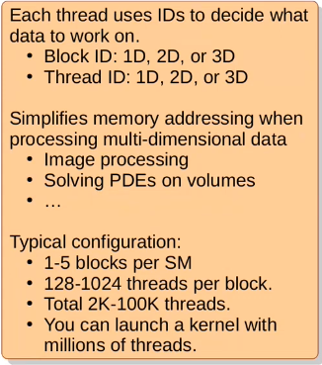
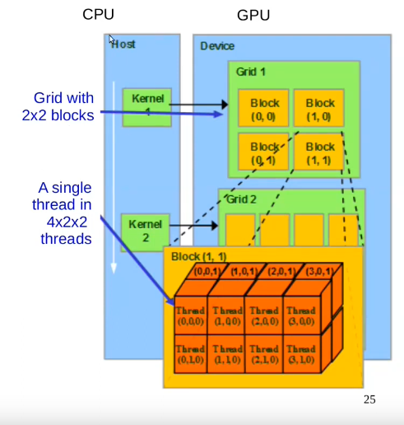

Example1:
#include<stdio.h>

__global__ void dkernel(){

if( threadIdx.x == 0 && blockIdx.x == 0 &&
threadIdx.y == 0 && blockIdx.y == 0 &&
threadIdx.z == 0 && blockIdx.z == 0 ) {
printf("%d %d %d %d %d %d\n" , gridDim.x , gridDim.y , gridDim.z , blockDim.x , blockDim.y , blockDim.z );
}

}

int main(){
dim3 grid(2,3,4); //set size of each grid
dim3 block(5,6,7); // set size of each block
dkernel<<<grid,block>>>();
cudaDeviceSynchronize();
}
● Grafic explanation:

GRID (0) [2 x 3 x 4] Block (0,0,0) [5 x 6 x 7] Thread ( 0,0,0 )
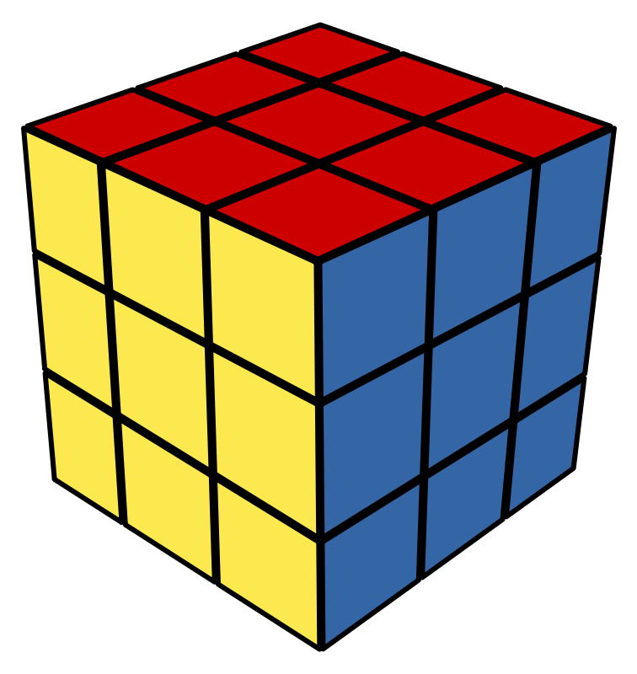

Example2: Init one-dimensional matrix.
#include<stdio.h>
#define N 5
#define M 6

// Init the matrix
__global__ void dkernel (unsigned *matrix) {

//printf("%d , %d\n" , threadIdx.x , threadIdx.y ); //Debugging

unsigned x = threadIdx.y;
unsigned y = threadIdx.x;
unsigned indice = (y * M) + x;

matrix[indice] = indice;

}

int main(){

dim3 block(N,M,1);
unsigned *matrix,*hmatrix;

cudaMalloc(&matrix , N * M * sizeof(unsigned));
hmatrix = (unsigned*) malloc( N * M * sizeof(unsigned int));

dkernel<<<1,block>>>(matrix);

cudaMemcpy(hmatrix , matrix , N*M * sizeof(unsigned int) , cudaMemcpyDeviceToHost);

for(unsigned i = 0 ; i<N ; i++){
for ( unsigned j = 0 ; j<M ; j++){
printf("%2d " , hmatrix[ (i*M) + j]);
}
printf("\n");
}

return 0;

}

Youtube tutorial : < L4 GPU computation Hierarchy and Matrix Squaring Thread Divergence>
https://www.youtube.com/watch?v=Z9K68s9ImJA&list=PL1ysOEBe5977vlocXuRt6KBCYu_sdu1Ru&index=4

GPU Computation Hierarchy
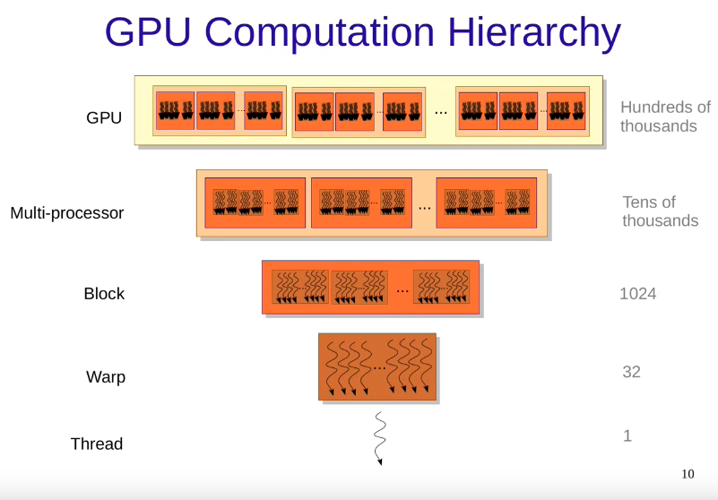
● Notice that every warp has got 32 threads

Warp
A set of consecutive threads ( currently 32 ) that execute in SIMD fashion. SIMD → Single Instruction Multiple Data.
( Very important : Warp-threads are fully synchronized, there is an implicit barrier after each step/instruction ).
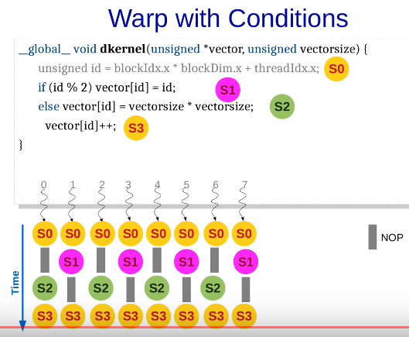
When different warp-threads execute different instructions, threads are said to diverge.
Hardware executes threads satisfying same condition together, ensuring that other threads execute a no-op. This adds sequentially to the execution.
This is problem is called thread-divergence. The best way to resolve this is to try to make every thread flow similiar to other.
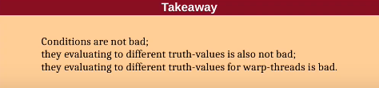
Example:
□ if(vectorsize < N ) S1 ; else S2 ; // they execute in different warp, it is ok!
□ if ( id/32 ) S1 ; else S2 ; // they execute in different warp, it is ok!

Classwork
● Does this code diverge?
__global__ void dkernel( unsigned *vector , unsigned vectorsize ) {
unsigned id = blockIdx.x * blockDIm.x + threadIdx.x;
for ( unsigned ii = 0 ; ii<id ; ++ii ){
vector[id] = ii;
}
}
Solution : yes, it diverge. Because the first thread needs to wait the last thread.
---------------------------→ Start
T0 T1 T2 T3
0 0 0 0
NP 1 1 1
NP NP 2 2
NP NP NP 3
---------------------------→ Finish

● Rewrite the following program fragment to remove thread-divergence.
assert( x == y || x == z );
if( x == y ) x = z;
else x = y;
Solution :
assert ( x == y || x == z );
x = y + z – x;

● How many steps does warp threads take to execute?
__global__ void dkernel( unsigned *vector , unsigned vectorsize ) {
unsigned id = blockIdx.x * blockDIm.x + threadIdx.x;
if ( id <= 0 ){
vector[id] += i;
for ( unsigned i = 1 ; i<=100 ; i++ ){
vector[id] += i;
}
}
else{
vector[id] = 1;
}
}
Solution : 102

Youtube tutorial : < L5 Thread Divergence in CUDA continue>
https://www.youtube.com/watch?v=PuMXrkg09fM

● How many steps does warp threads take to execute?
__global__ void dkernel( unsigned *vector , unsigned vectorsize ) {
unsigned id = blockIdx.x * blockDIm.x + threadIdx.x;
switch(id) {
case 0: vector[id] = 0; break;
case 1: vector[id] = vector[id]; break;
case 2: vector[id] = vector[id-2]; break;
case 3: vector[id] = vector[id+3]; break;
case 4: vector[id] = 4+4+vector[id]; break;
case 5: vector[id] = 5-vector[id]; break;
case 6: vector[id] = vector[6]; break;
case 7: vector[id] = 7+7; break;
case 8: vector[id] = vector[id] + 8; break;
case 9: vector[id] = vector[id] * 9; break;
}
}
Solution : ?

● What is the output?
__global__ void dkernel( unsigned *vector , unsigned vectorsize ) {
if ( threadIdx.x < 16 ) {
printf("Inside If");
Global_Barrier();
}else if ( threadIdx.x >=16 ){
printf("Inside else");
Global_Barrier();
}
}
Solution : “Inside if” x 16 then it crash. ( It is called Deadlock ). Because the first 16 threads are waiting the other that will never execute the first Global_Barrier().

Memory
● Global Memory → Comunicate with the host memory ( CPU ) , long latency access (400-800 cycles ) [ Throughput ⋍ 200GBPS ]
● Texture Memory → Read-only ( 12Kb ) [ Throughput ⋍800GBPS ]
● Costant Memory → Read-only ( 64Kb )

Youtube tutorial : < L6 Types of memories latency and locality >
● https://www.youtube.com/watch?v=oSHJACJAlgA&list=PL1ysOEBe5977vlocXuRt6KBCYu_sdu1Ru&index=6
P.s → Questa lezione non è stata ascoltata completamente, è stato eseguito un estratto dei concetti principali.

Latency hiding ( I/O )
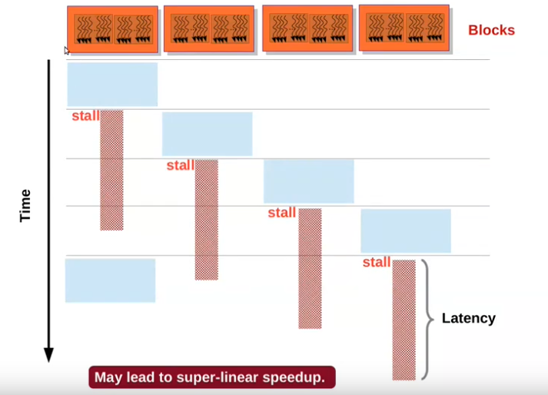

Locality
● All threads in a thread-block access their L1 cache ( usually 64KB )
Spatial
if a[i] is accessed, a[i+k] would also be accessed.
Temporal
if a[i] is accessed now, it would be accessed soon again.

Youtube tutorial : < L7 Memory coalescing and AoS vs SoA>
● https://www.youtube.com/watch?v=6Ulc8EMd_ww&list=PL1ysOEBe5977vlocXuRt6KBCYu_sdu1Ru&index=7&pp=iAQB
P.s → Questa lezione non è stata ascoltata completamente, è stato eseguito un estratto dei concetti principali.

Soa vs Aos
Soa → Structure of Arrays.
Aos → Array of Structurus.
● Example1 : we have to design a struct for a point → int x , int y , int z.
Soa = arrX[] ; arrY[] ; arrZ[] ;
Aos = arrPoints[] ;
● Example2 :
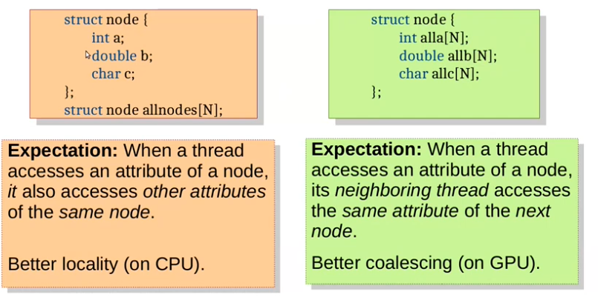

Memory Coalescing ( optimization of load/store instruction )
If warp threads access words from the same block of 32 words, their memory request are clubbed ( raggruppate [IT-Traslation] ) into one.
Without coalescing each load/store instruction would required one memory cicle → A warp would require 32 memory cycles!!! ( in this case GPU would be useful only for compute-heavy kernels, because in the small one load/store would be the majority of the time ).
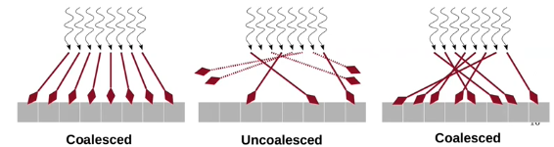

GPU → Is better Coalesced . A chunk should be accessed by consecutive threads. Structure of Arrays ( SoA ) has a better performance.
CPU → Is better Strided. Each thread should accesso consecutive elements of a chunk. Array of Structures (AoS) has a better locality.
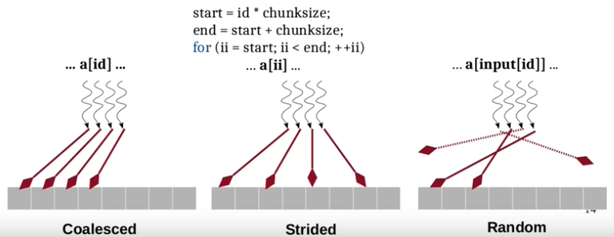

Youtube tutorial : < L8 Shared Memory in CUDA>
● https://youtu.be/6IkIoxuG7Vo?list=PL1ysOEBe5977vlocXuRt6KBCYu_sdu1Ru
P.s → Questa lezione non è stata ascoltata completamente, è stato eseguito un estratto dei concetti principali.

Using of Shared Memory
Example :
__shared__ float a[N];
__shared__ unsigned s;
a[id] = id;
if ( id == 0 ) s = 1 ;

Main features
1. You don’t need to call CudaMalloc()
2. The allocation is static, the size of the array must be declare compiling time.
3. The shared memory is the same for each thread in a block.

Classwork
You are given a 1024x1024 integer matrix M. Each row is assigned to a thread block. Each thread is assigned a matrix element M[i][j]. It changes M[i][j] to M[i][j] + M[i][j+1] ( Exploit shared memory )
→ Solution:
#include<stdio.h>
#define N 100
#define M 100

//Funzione che rende ogni M[i][j] += M[i][j+1]
__global__ void strange_add(unsigned *arr){

__shared__ unsigned sharedRow[M];
int b_id = blockIdx.x;
int t_id = threadIdx.x;
size_t index = M * b_id + t_id;

sharedRow[t_id] = arr[index]; //caricamento elementi riga "cpu" a "shared_memory"
__syncthreads();

if(t_id < M-1){
sharedRow[t_id] += sharedRow[t_id + 1];
}

arr[index] = sharedRow[t_id]; // Copia la riga aggiornata dalla memoria condivisa alla memoria globale

}

// Funzione che inizializza un array a 0
__global__ void init_to_zero(unsigned *arr){

int b_id = blockIdx.x;
int t_id = threadIdx.x;

size_t index = M * b_id + t_id;

if(b_id < N && t_id < M){
arr[index] = 1;
}

}

int main(){

unsigned *cpuMatrix,*gpuMatrix;
cudaMalloc(&gpuMatrix , N * M * sizeof(unsigned));
cpuMatrix = (unsigned*) malloc( N * M * sizeof(unsigned int));

init_to_zero<<<N,M>>>(gpuMatrix);
cudaDeviceSynchronize();
strange_add<<<N,M>>>(gpuMatrix);

cudaMemcpy(cpuMatrix , gpuMatrix , N*M * sizeof(unsigned int) , cudaMemcpyDeviceToHost);

//stampa array cpu
for(unsigned i = 0 ; i<N ; i++){
for ( unsigned j = 0 ; j<M ; j++){
printf("%2u " , cpuMatrix[ (i*M) + j]);
}
printf("\n");
}
cudaDeviceSynchronize();
return 0;
}
● What is the output ?
#include<stdio.h>
#include<cuda.h>

#define BLOCKSIZE 1024
__global__ void dkernel(){
__shared__ unsigned s;

if ( threadIdx.x == 0 ) s = 0; // S0
if ( threadIdx.x == 1 ) s +=1 ; // S1
if ( threadIdx.x == 100 ) s += 2; // S2
if ( threadIdx.x == 0 ) printf(“s=%d\n” ,s); // S3
}
int main() {
dkernel<<<1,BLOCKSIZE>>>();
cudaDeviceSynchronize();
}
It depends, the if could be execute in different order :
1. s +=2 → s=0 → s+=1 → pf(s)
2. s = 0 → s+=2 → s+=1 → pf(s)
3. s = 0 → s+=1 → s+=2 → pf(s)
4. s = 0 → s+=1 → pf(s) → s+=2

This because the flow is like this: (Every instruction in a warp is full-synchronize)
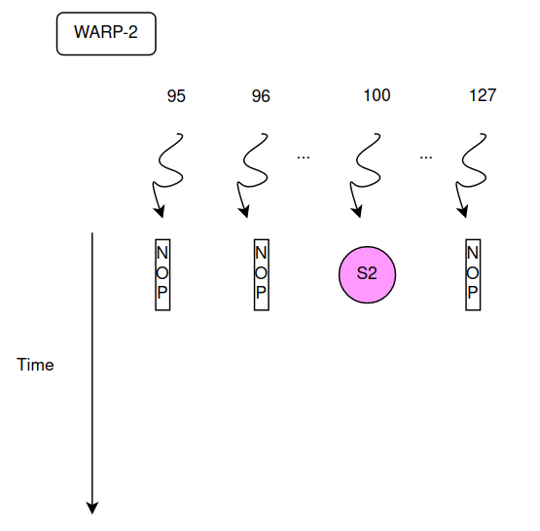
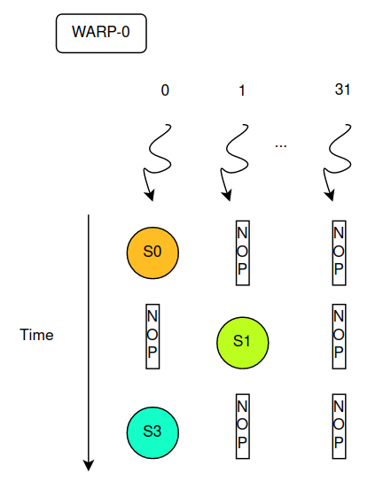
The warp2 instruction can be executed before,after S0,S1,S3 we don’t know, because warp0 and warp2 are not synchronize.

● Possible solution:
#include<stdio.h>
#include<cuda.h>

#define BLOCKSIZE 1024
__global__ void dkernel(){
__shared__ unsigned s;

if ( threadIdx.x == 0 ) s = 0; // S
if ( threadIdx.x == 1 ) s +=1 ; // S1
__syncthreads(); // barrier across threads in a block
if ( threadIdx.x == 100 ) s += 2; // S2
__syncthreads(); // barrier across threads in a block
if ( threadIdx.x == 0 ) printf(“s=%d\n” ,s); // S3
}
int main() {
dkernel<<<1,BLOCKSIZE>>>();
cudaDeviceSynchronize();
}
GRAPHIC EXPLANATION
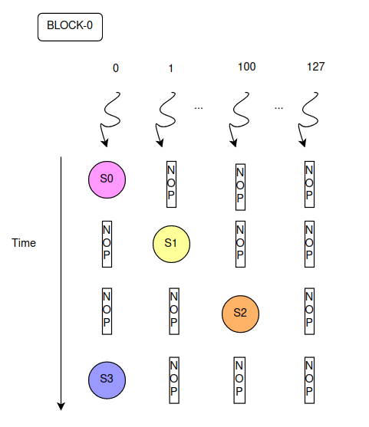
□ Every thread is synchronized because we add __syncthreads() instruction.

□ In this case you can see the block like a warp (warp_dim=block_dim)

Youtube tutorial : < L9 Dynamic Shared Memory Bank Conflicts>
● https://youtu.be/ceNrQAdLUlU?list=PL1ysOEBe5977vlocXuRt6KBCYu_sdu1Ruù

● What is the output ? [L9-Exercise_1]
#include<stdio.h>
#include<cuda.h>

#define BLOCKSIZE 1024
__global__ void dkernel(){
__shared__ unsigned s;

if ( threadIdx.x == 0 ) s = 0; // S0
if ( threadIdx.x == 1 ) s +=1 ; // S1
if ( threadIdx.x == 31 ) s += 2; // S2
if ( threadIdx.x == 0 ) printf(“s=%d\n” ,s); // S3
}
int main() {
dkernel<<<1,BLOCKSIZE>>>();
cudaDeviceSynchronize();
}
Output : 3
In this case the output is deterministic because the sum is executed in the same warps.
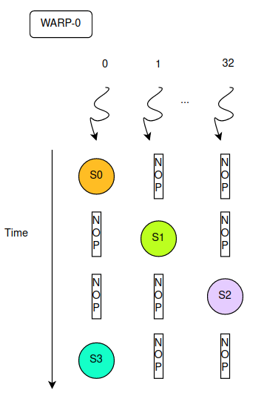
if ( threadIdx.x == 0 ) s = 0; // S0
if ( threadIdx.x == 1 ) s +=1 ; // S1
if ( threadIdx.x == 31 ) s += 2; // S2
if ( threadIdx.x == 0 ) printf(“s=%d\n” ,s); // S3

● What is the output ? [L9-Exercise_2]
# Remember: __shared__ str is shared for each block.
#include<stdio.h>
#include<cuda.h>

#define BLOCKSIZE 10
__global__ void dkernel(){
__shared__ char str[BLOCKSIZE+1];
str[threadIdx.x] = 'A' + (threadIdx.x + blockIdx.x) % BLOCKSIZE;
if(threadIdx.x == 0){
str[BLOCKSIZE] = '\0';
}

__syncthreads() // barrier across threads in a block, need if you have more than 32 thread
if(threadIdx.x == 0 ){
printf("%d: %s", blockIdx.x , str );
}
}

int main() {
dkernel<<<10,BLOCKSIZE>>>();
cudaDeviceSynchronize();
}
Output:
--------------------
8: IJABCDEFGH
7: HIJABCDEFG
2: CDEFGHIJAB
1: BCDEFGHIJA
5: FGHIJABCDE
4: EFGHIJABCD
0: ABCDEFGHIJ
9: JABCDEFGHI
6: GHIJABCDEF
3: DEFGHIJABC
--------------------

Graphic explanation
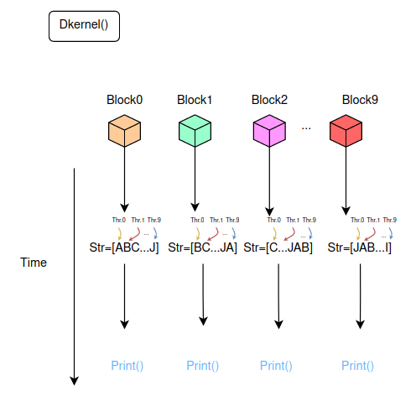

L1 Cache vs Shared Memory
How to configure the memory from the CPU?
- CudaDeviceSetCacheConfig( kernelname, param );
-kernelname → Name of the kernel function.
-param → ( cudaFuncCachePreferNone | L1 | Shared | CudaFuncCachePreferEqual )

● Example:
__global__ void dkernel(){
__shared__ unsigned data[BLOCKSIZE];
data[threadIdx.x] = threadIdx.x;
}

int main() {
cudaFuncSetCacheConfig(dkernel, cudaFuncCachePreferL1);
//cudaFuncSetCacheConfig(dkernel, cudaFuncCachePreferShared);
dkernel<<<1,BLOCKSIZE>>>();
cudaDeviceSynchronize();
return 0;
}

Dinamic shared memory
When the amount of shared memory required is unknown at compile-time, dynamic shared memory can be used.
● Example1: Single Array
#include<stdio.h>
#include<cuda.h>

__global__ void dynshared(){
extern __shared__ int s[];
s[threadIdx.x] = threadIdx.x;
__syncthreads();
if( threadIdx.x % 2) printf("%d\n", s[threadIdx.x]);
}

int main() {
int n;
scanf("%d",&n);
dynshared<<<1,n,n*sizeof(int)>>>();
cudaDeviceSynchronize();
}

● Example2: Multiple Arrays

#include<stdio.h>
#include<cuda.h>

__global__ void dynshared(int sz, int n1){
extern __shared__ int s[];
int *s1 = s;
int *s2 = s + n1;

if(threadIdx.x < n1 ) s1[threadIdx.x] = threadIdx.x;
if(threadIdx.x < (sz - n1)) s2[threadIdx.x] = threadIdx.x * 100;
__syncthreads(); //useless if blockDim.x <= 32 (same warp)
if(threadIdx.x < sz && threadIdx.x % 2 ) printf("%d\n", s1[threadIdx.x]);
}

int main() {
int sz;
printf("Insert n : ");
scanf("%d",&sz);
dynshared<<<1,32, sz*sizeof(int)>>>(sz , sz/2);
cudaDeviceSynchronize();
return 0;
}

↓↓↓Graphic Explanation↓↓↓

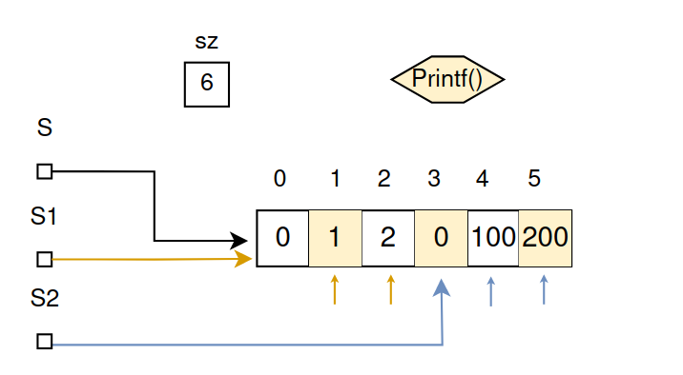

Youtube tutorial : < L10 Bank Conflicts Continue Texture, Constant Memory and Compute Capabilities>
● https://youtu.be/JmE-wgsOtPM?list=PL1ysOEBe5977vlocXuRt6KBCYu_sdu1Ru

Bank Conflicts
- Shared memory is organized into 32 banks.
- Accesses to the same bank are sequential.
- Consecutive words are stored in adjacent banks.
-Useful for coalesced access.
· Exception: Warp accesses to the same word are not sequentialized.

● Example1:
__shared__ int arr[1024]
arr[0] → bank 0
arr[1] → bank 1
…
arr[31] → bank31

● Example2: No conflicts ✓
__global__ void bankNoConfilicts(){
__shared__ unsigned s[1024];
s[1* threadIdx.x] = threadIdx.x;
}
● Example3: Conflicts X
__global__ void bankConflict(){
__shared__ unsigned s[1024];
s[32* threadIdx.x] = threadIdx.x;
}

Graphic explanation
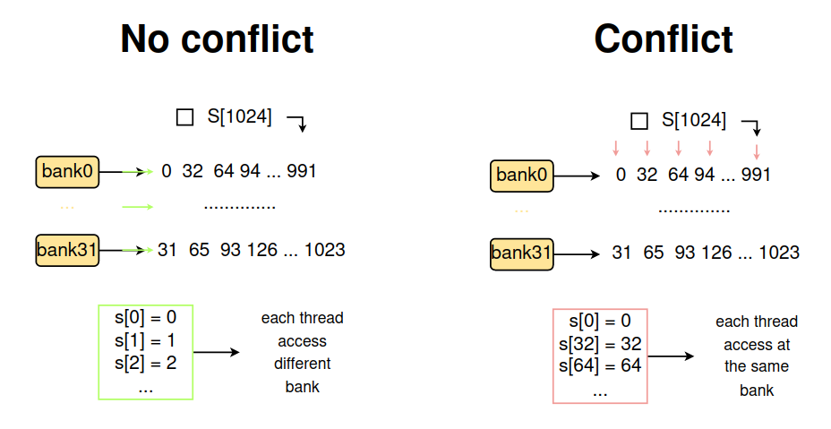
Graphic explanation - General
□ Yellow box → 1 bank
□ Orange box → a particular word in the bank
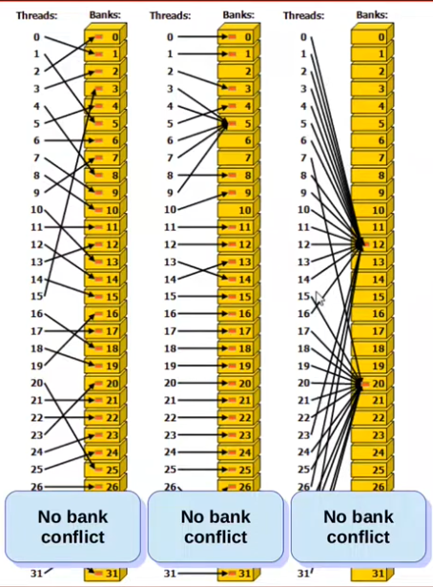
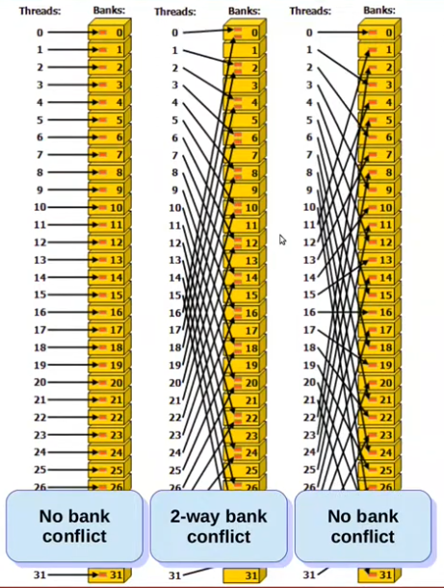

Texture Memory
- Fast read-only memory
- Optimized for 2D spatial access
- Definition: texture<float,2,cudaReadModeElementType> tex;
- Call In main: cudaBindTextureToArray(tex,cuArray);
- Call In kernel: … = tex2D(tex,...)
- Some advantages (+):
1. Caching.
2. Hardware filtering : Texture memory provides hardware-based filtering capabilities, which can be used to perform operations like interpolation and texture mapping
3. Memory coalescing: It improve memory bandwidth.
4. Large address space.

● Example1:
__global__ void transformKernel(float* output , int width , int height , float theta ){
unsigned x = blockIdx.x * blockDim.x + threadIdx.x;
unsigned y = blockIdx.y * blockDim.y + threadIdx.y;

float u = (float) x – (float) width / 2;
float v = (float)y – (float) height / 2;
float tu = ( u * cosf(theta) – v * sinf(theta) / width;
float tv = ( v * cosf(theta) – u * sinf(theta) / height ;

output[y* width + x ] text2D(tex, tu+ 0.5 , tv + 0.5 );
}
Output:


Constant memory
- Read-only memory
- 64Kb per SM
- Definition: __constant__ unsigned meta[1];
- Call in Main: cudaMemcpyToSymbol( meta,&hmeta, 1*sizeof(unsigned) );
- Call in Kernel: data[threadIdx.x] = meta[0];
- Some advantages (+):
1. High bandwith
2. Low latency
3. 64kb of memory
4. Shared among blocks.
● Example1:
#include<cuda.h>
#include<stdio.h>

__constant__ unsigned meta[1];
__global__ void dkernel(unsigned *data){
data[threadIdx.x] = meta[0];
}
__global__ void print(unsigned *data){
printf("%d %d\n" , threadIdx.x , data[threadIdx.x]);
}
int main(){
unsigned hmeta=10;
cudaMemcpyToSymbol(meta,&hmeta,sizeof(unsigned));
unsigned *data;
cudaMalloc(&data , 32 * sizeof(unsigned));
dkernel<<<1,32>>>(data);
cudaDeviceSynchronize();
print<<<1,32>>>(data);
cudaDeviceSynchronize();
return 0;
}

Compute Capability (different version of CUDA)
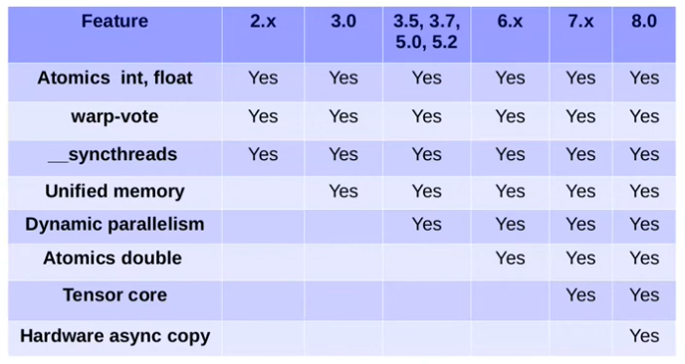

Youtube tutorial : < L11 Data Race and Synchronization>
● https://youtu.be/bo9NBoDOldg?list=PL1ysOEBe5977vlocXuRt6KBCYu_sdu1Ru

Synchronization
__syncthreads() → Syncronization of threads in a single block.

● Example1:
- Write CUDA code for the following functionality:
1. Assume following data type, filled with some values
struct Point {
int x,y;
}
Point arr[N];
2. Each thread should operate on 4 elements of the Array.
3. Find AVG of x values.
4. If a thread sees y value above the average, it replaces all 4 y values with AVG.
Otherwise, it adds y values to a global sum.
5. Host prints the number of elements set to AVG.

Solution ( full code is available on /Cuda_samples )
__global__ void do_some_things(Point *arr , int n , int group_by , int *cont , float *sum){

int id = threadIdx.x;
int start = id*group_by;
float sum_x = 0;
float avg_x;
float sum_y = 0;
bool isAbove = false;

// Calculate avg of 4 elements (group_by = 4)
for(int i=start ; i<start + group_by ; i++){
sum_x += arr[i].x;
sum_y += arr[i].y;
}
avg_x = sum_x/group_by;

// Find if some y is above the avg
for(int i=start ; i<start + group_by && !isAbove ; i++){
if(arr[i].y > avg_x)
isAbove = true;
}

if(isAbove){
// replaces all 4 y values with AVG
for(int i=start ; i<start + group_by; i++){
arr[i].y =avg_x;
}
atomicAdd( cont , 1);
}else{
atomicAdd( sum , sum_y);
}

}

Graphic explanation
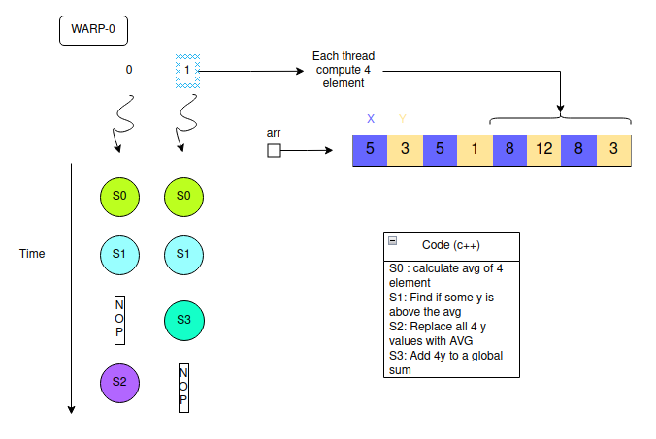

Data Race
A datarace occurs if all of the following hold:
1. Multiple threads.
2. Common memory location.
3. At leats one write.
4. Concurrent execution.
- Ways to remove datarace
1. Execute sequentially.
2. Privatization/Data replication.
3. Separating reads and writes by a barrier.
4. Mutual exclusion.

● Example2: is there a datarace in this code?
// Thread-1
flag = 1;
while(flag);
S1;
// Thread-2
while(!flag);
S2;
flag = 0;
Solution : yes!

● Example3: Given roll numbers and marks of 80 students in GPU programming,assign grades.
- Use input arrays and output array.
- Example:
Input = [ (1,90) , (2,80) , (3,80), (4,90) , (5,0) , (6,80) , (7,80)] { roll ↔ mark }
Output = [ S = 2 , A = 3 , B = 0 , ... , U = 1 ] { name_mark ↔ count }

Name valuation --–- Number valuation
S | 90
A | 80
B | 70
C | 60
D | 50
E | 40
U | 0

Solution : code is available on /Cuda_samples

● Example4: Compute the shortes path
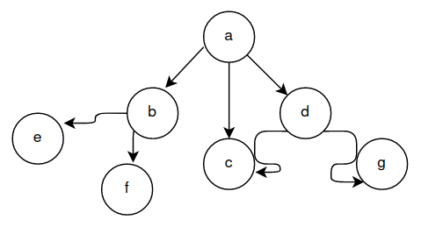
- You are given an in input graph of a City, and you want to compute the shortest path from “a” to every other city.
- Assume that you are given a GPU graph library and the associated routines.

Parzial Solution: we have problem with the statement if (in chapter L14 we will se how to fix)
__global__ void dsssp(Graph g, unsigned *dist){
unsigned id = …
for each n in g.allneighbours(id){ //pseudo-code
unsigned altdist = dist[id] + weigth(id,n);
if(altdist<dist[n]){ //problem of atomicity
dist[n] = altdist;
}
}
}

Youtube tutorial : < L12 Mutual Exclusion>
● https://youtu.be/GlioCYzBR_A?list=PL1ysOEBe5977vlocXuRt6KBCYu_sdu1Ru

Synchronization
- Atomics (chapter L13/L14)
- Barriers (chapter L14/L15)
- Control + data flow
● Example1: Mutual exclusion
flag == false
[THREAD1] [THREAD2]
while (!flag); S2;
S1; flag = true;
● Example2: Mutual exclusion
flag == true or false
[THREAD1] [THREAD2]
while (!flag); while (flag);
S1; S2;
flag = false; flag = true;
Mutual Exclusion: 2 threads
- lock() and unlock() methods
- The methods should be the same for both the threads.
● Example3: Mutual exclusion with lock and unlock
→ Threads ids are 0 and 1:
lock:
me = tid;
other = 1- me;
flag[me] = true; // You lock the thread
while(flag[other]); // May lead to deadlock
unlock:
flag[tid] = false;

Graphic explanation
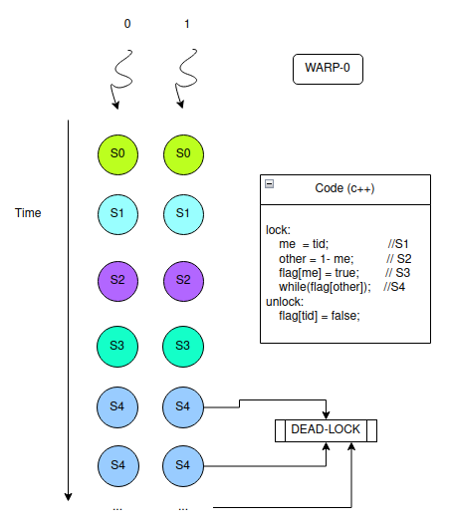
p.s → DeadLock is not 100% sure it depends from data race. If one thread runs before the other, all goes well.

● Example4: Mutual exclusion with lock and unlock
→ Threads ids are 0 and 1:
→ May lead to luck of progress
volatile int victim;
lock:
me = tid;
victim = me;
while (victim == me);
unlock:
victim = me;
Graphic explanation
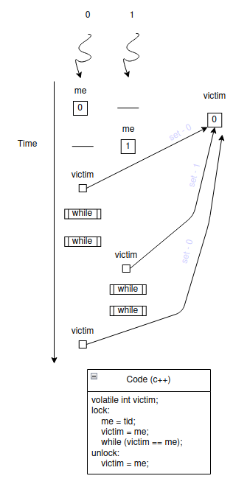

● Example5: Mutual exclusion with lock and unlock
→ Threads ids are 0 and 1:
volatile int victim;
volatile bool flag[2];
lock:
me = tid;
other = 1-me;
flag[me] = true;
victim = me;
while(flag[other] && victim == me);
unlock:
flag[tid] = false;

Youtube tutorial : <L13 Mutual Exclusion continue and atomics in CUDA>
● https://youtu.be/CUWzgaBNRco?list=PL1ysOEBe5977vlocXuRt6KBCYu_sdu1Ru

Bakery algorithm
- Deviced by Lamport, works with N threads.
- Maintains FCFS using ever-increasing numbers.
- Main idea:
1. Choosing a number (Scelta di un numero): Quando un thread desidera entrare in una sezione critica, sceglie un numero che è maggiore di qualsiasi altro numero scelto in precedenza da qualsiasi altro thread. Questo numero è il "biglietto" del thread.
2. Waiting your turn (Aspettare il proprio turno): Dopo aver scelto un numero, il thread controlla se ci sono altri thread con numeri minori che stanno ancora eseguendo le loro sezioni critiche. Se è così, il thread attende.
3. Critical Section (Sezione critica): Quando tutti i thread con numeri minori hanno finito le loro sezioni critiche, il thread può entrare nella sua sezione critica.
4. Leaving the bakery (Uscire dalla panetteria): Dopo aver finito la sua sezione critica, il thread "esce dalla panetteria", permettendo ad altri thread di procedere.

Pseudocode
bool flag[N] // init with false
int label[N] // init with zero
lock:
me = tid;
flag[me] = true;
label[me] = 1 + max(label); // max is not atomic
while( ∀k != me: flag[k] && label[k] < label[me] );
unlock:
flag[tid] = false;
Graphic explanation(2 thread example)
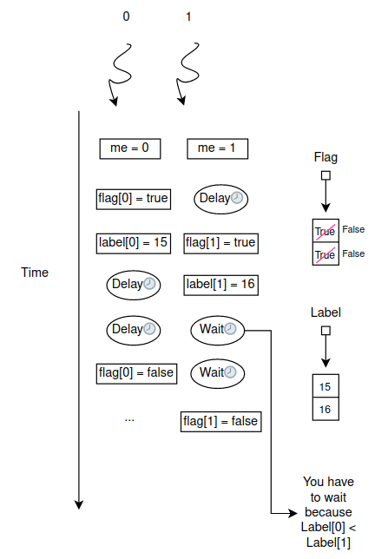

Atomic operations
- Atomics are primitive operations whose effects are visible either none or fully(never partially).
- Need hardware support.
- Several variants: atomicCAS , atomicMin , atomicAdd,...
- Work with global and shared memory.
● Example1: non atomic increment
__global__ void dkernel(int *x){
++x[0];
}
…
dkernel<<<2,1>>>(x);
++x[0]:
- Load x[0] , R1
- increment R1
- Store R1 , x[0]

time
Load x[0], R1
Increment R1

Store R1, x[0]
Load x[0], R2
Increment R2
Store R2, x[0]

The result can be 1 or 2, it’s not deterministic.

● Example2: atomic increment
__global__ void dkernel(int *x){
atomicInc(&x[0] , 1 );
}
…
dkernel<<<2,1>>>(x);
In this case the output is deterministic and it is 2.

Youtube tutorial : <L14 various Atomic functions and Barriers in CUDA>
● https://youtu.be/CUWzgaBNRco?list=PL1ysOEBe5977vlocXuRt6KBCYu_sdu1Ru

● Example1: Compute the shortes path, usa atomic operations
Solution:
__global__ void dsssp(Graph g, unsigned *dist){
unsigned id = …
for each n in g.allneighbours(id){ //pseudo-code
unsigned altdist = dist[id] + weigth(id,n);
atomicMin(&dist[n] , altdist); //atomic operation
}
}

AtomicCas
- Syntax: atomicCas(&var,x,y);
- Uses:
- Locks: critical section processing.
- Single: Only one arbitrary thread executes the block.

● Example2: AtomicCas how it works?
int *address = ...; // Indirizzo di memoria
int compare = ...; // Valore da confrontare
int swap = ...; // Nuovo valore da scambiare
int old = atomicCAS(address, compare, swap);
→ If (address == compare){
temp = address
address = swap
return temp // It will be the value of old
}Else{
return address
}

● Example3: Lock using atomicCas
do{
old = atomicCAS(&lockvar, 0 , 1);
}while(old != 0);
//critical section
lockvar = 0 //unlock
→ Work on CPU
→ Works on GPU accross warp (not in the same warp X)

● Example4: Lock using atomicCas
do{
old = atomicCAS(&lockvar, 0 , 1);
if(old == 0){
//critical section
locvar = 0 // unlock
}
}while(old != 0);
→ Work on CPU
→ Works on GPU

● Example5: Single using atomicCas
if(atomicCAS(&lockvar,0,1 == 0)
//single section

● Example6: What is the output?
#include<stdio.h>
#include<cuda.h>
__global__ void k1(int *gg){
int old = atomicCAS(gg,0,threadIdx.x + 1);
if (old == 0){
printf(“Thread %d succeeded 1.\n” , threadIdx.x);
}
int old = atomicCAS(gg,0,threadIdx.x + 1);
if (old == 0){
printf(“Thread %d succeeded 2.\n” , threadIdx.x);
}
int old = atomicCAS(gg,0,threadIdx.x - 1);
if (old == 0){
printf(“Thread %d succeeded 3.\n” , threadIdx.x);
}
}
int main(){
int *gg;
cudaMalloc(&gg , sizeof(int));
cudaMemset(&gg , 0 , sizeof(int) );
k1<<<2,32>>>(gg);
cudaDeviceSynchronize();
return 0;
}
- On most executions, you would see the output of the first if. (thread-0)
- Could happened that thread1 executes the third if. (thread-1)

Barriers
- A barrier is a programm point where all threads need to reach before any thread can proceed.
- End of kernel is an implicit barrier for all GPU threads. (global barrier).
- Exist an explicit barrier → grid.sync()
- Exist synchronization in a block → __syncthreads()

Youtube tutorial : <L15 Barriers, Reductions and Prefix sum in CUDA>
● https://youtu.be/7uRnbY0-57o

● Example1: Barrier example
__global__ void dkernel(unsigned *vector , unsigned vectorsize){
unsigned id = blockIdx.x * blockDim.x + threadIdx.x; // S1
vector[id] = id; // S2
__syncthreads(); // S3
if(id < vectorsize – 1 && vector[id+1] != id + 1) // S4
printf(“syncthreads does not work.\n”);
}

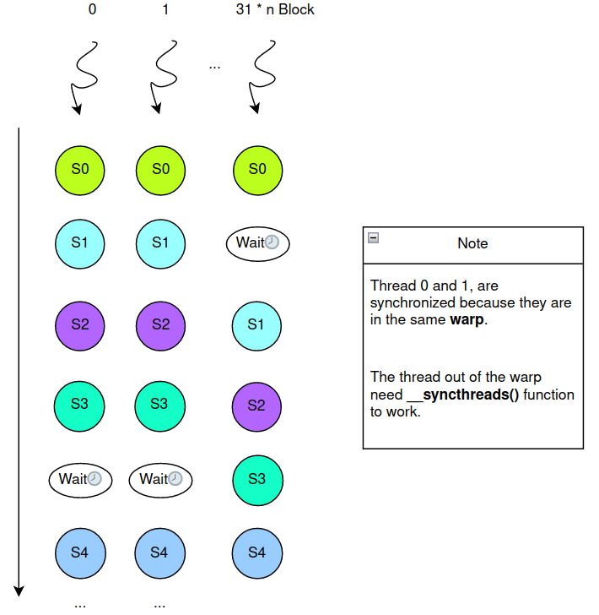

- __syncthreads() is not only about control synchronization, it also has data synchronizationmechanism.
- It performs a memory fence operation.
- A memory fence ensures that the writes from a thread are made visible to other threads.
- __syncthreads() executes a fence for all the block-threads.
- There is a separate __threadfence_block() instruction also, it is __threadfence().

Reductions
- Converting a set of values to few values(typically 1).
- Computation must be reducible.
- Must satisfy associativity property.
- Typical operations: Min,Max,Sum,XOR, …
- Can be often implemented using atomics
- atomicAdd(&sum, a[i]); (adds sequentiality!)
- atomicMin(&min , a[i]); (adds sequentiality!)
- Reductions allow improving parallelism.
- Complexity measures:
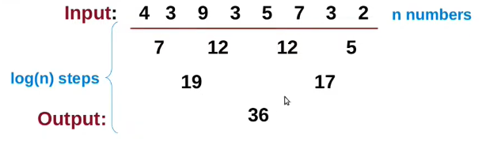

● Example2: Reduction example
for(int off = n/2 ; off ; off/=2 ){
if( threadIdx.x < off) {
a[threadIdx.x] += a[threadIdx.x + off];
}
__syncthreads();
}
Graphic explanation
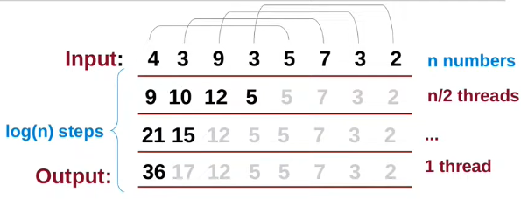
● Example2: Reduction example
for(int off = n/2 ; off ; off/=2 ){
if( threadIdx.x < off) {
a[threadIdx.x] += a[2*off – threadIdx – 1 ] ;
}
__syncthreads();
}
Graphic explanation:

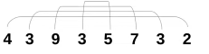

….

● Example3: Prefix sum
for(int off = 1 ; off<n ; off *=2){
if(threadIdx.x >= off){
tmp = a[threadIdx.x – off];
}
__syncthreads();
if (threadIdx.x >= off ){
a[threadIdx.x] += temp;
}
__syncthreads();
}

Graphic explanation:

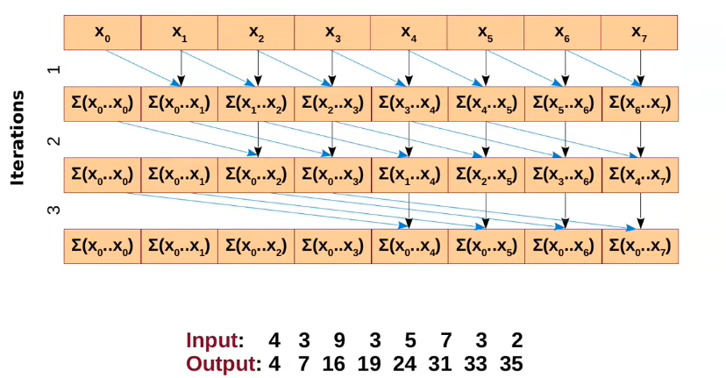

Application of Prefix Sum
- Computing cumulative sum
- Histogramming.
- Area under the curve.
- Fenwick Tree( Binary Indexed Tree).

Youtube tutorial : <L16 Functions in CUDA>
● https://youtu.be/5hed9uleQQE

Cuda Function Declarations
- Host : CPU
- Device : GPU

Type of function | Executed on the | Callable from only the
__device__ | device | device
__global__ | device | host
__host__ | host | host

- __global__ function must return void.

● Example1: Programm with multiple functions
#include<stdio.h>
#include<cuda.h>
__host__ __device__ void dhfun(){
printf(“I can run of both CPU and GPU.\n”);
}
__device__ unsigned dfun(unsigned *vector, unsigned vectorsize, unsigned id){
if(id == 0)
dhfun();
if(id<vectorsize){
vector[id] = id;
return 1;
}else{
return 0;
}
}
__global__ void dkernel(unsigned *vector, unsigned vectorsize){
unsigned id = blockIdx.x * blockDim.x + threadIdx;
dfun(vector,vectorsize,id);
}
__host__ void hostfun(){
printf(“I am simply like another function running on CPU. Calling dhfun\n”);
dhfun();
}
Graphic explanation
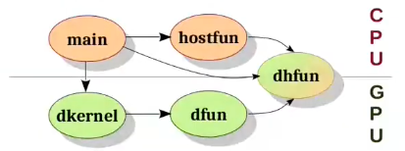

Youtube tutorial : <L17 Support in CUDA>
● https://www.youtube.com/watch?v=9G5yWq-usfk

Thrust
- Thrust is a parallel algorithms library.
- Support vectors and associated transforms.

Makefile
- is a set of commands, are used when we have dependencies among files.
- Usefull for large project.

Syntax
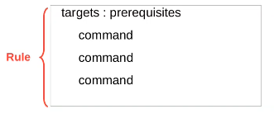
● Example1: “Hello world”
Hello:
echo “hello world”
#call it with $make
● Example2: Simple CUDA programm
clean: blah
rm hello
blah : hello #execute "blah" when "hello" is finished.
./hello
hello :
nvcc hello.cu -o hello
● Example3: All target
all: H1 H2 H3
H1:
nvcc hello1.cu -o hello1
./hello1
H2:
nvcc hello1.cu -o hello1
./hello1
H3:
nvcc hello1.cu -o hello1
./hello1
clean:
rm -f hello1 hello2 hello3

● Example4: Conditions
TARGET_CPU_IS_X86 = 1
all:
ifeq( $(TARGET_CPU) , x86 )
TARGET_CPU_IS_X86 = 1
else ifeq ( $(TARGET_CPU) , x86_64 )
TARGET_CPU_IS_X86 = 1
else
TARGET_CPU_IS_X86 = 0
endif

Debugging
- for debugging CUDA programm on real hardware you can use “cuda-gdb”.
- It allows breakpoints, single-step, read/write memory contents.
● Example5: cuda-gdb
1 nvcc -g -G file.cu
2 cuda-gdb a.out
3 run

Usefull instructions
info cuda kernels → Show info about functions.
Info threads → Show info about threads.
step or s → makes a step.
print <variable> → printing.
break main, break file.cu:223 , break file.cu:23 if threadId.x == 1 && i < 5 → Breakpoint
Info cuda sms → Warps mask.
Info cuda lanes → Warps.

Profiling
- Measuring “indicators” of performance.
- nvprof → command line
- nvvp, nsight → Visual Profilers.

● Example6: nvprof
1 nvprof a.out → Profile all programm
------ to profile a part of programm -------
1 include cuda_profiler_api.h
2 use cudaProfilerStart() and Stop().
3 nvprof –profile-from-start off a.out

Youtube tutorial : <L18 CUDA Topics>
● https://www.youtube.com/watch?v=LC5UdIJaw_g

Dynamic Parallelism
Scenario:
for i…
for j = f(i)…
work(j)
You can solve it by:

- Algorithms using hierarchial data structures
- Algorithms using recursione where each level of recursion has parallelism.
- Algorithms where work naturally splits into independent batches, and each batch involves parallel processing.

● Example1: Child process
#include<stdio.h>
#include<cuda.h>

__global__ void Child(int father){
printf(“Parent %d – Child %d\n” , father , threadIdx.x);
}
__global__ void Parent(int father){
printf(“Parent %d \n“ , father );
Child<<<1,5>>>(threadIdx.x);
}
int main(){
Parent<<<1,3>>>();
cudaDeviceSynchronize();
return 0;
}
- If you want to launch it you need to compile in this way: nvcc -arch=sm_35 dynpar.cu.
- Parent kernel is associated with a parent grid.
- Child kernel is associated with a child grid.
- Parent and child kernels may execute asynchronously.
- A parent grid is not complete unless all its children have completed.

Dynamic Parallelism – Memory
- Parent and children share global and constant memory.
- But they have distinct local and shared memory.

Multiple Devices
- In general, a CPU may have different types of devices, with different compute capabilities.
- However, they all are nicely numbered from 0-N-1.
- cudaSetDevice(i);
cudaSetDevice(0);
cudaMemcpyAsync();
K1<<<...>>>();
...
- cudaGetDeviceCount(&c);
- cudaDeviceCanAccessPeer(&can , from , to);
- cudaDeviceEnablePeerAccess(peer, …);
- Enumerate devices:

int deviceCount;
cudaGetDeviceCount(&deviceCount);
int device;
for(device = 0; device < deviceCount ; ++device ){
cudaDeviceProp deviceProp;
cudaGetDevicePropierties(&deviceProp, device);
printf(“Device %d has compute capability %d. %d.\n” , device , deviceProp.major, deviceProp.minor);

Warp voting (deprecated)
- It makes easier the comunication between warps.
- __all(predicate) → True if all warp threads satisfy the predicate.
- __any(predicate) → True if at least one warp satisfy the predicate.
- __ballot(predicate) → Return a 32bit integer (every bit rappresent true/false of a warp):
<001000000010010111110000000100101>
⚠ This methods are deprecated, now you have to use __all_syn(),__any__sync().

● Example2: Warp voting (⚠deprecated)
__global__ void process_data(float* data, int* valid, int N) {
int idx = threadIdx.x + blockIdx.x * blockDim.x;
if (idx < N) {
// Check if the element is valid
bool is_valid = valid[idx] == 1;
// Check if all elements are valid
bool all_valid = __all(is_valid);
// Check if at least one element is valid
bool any_valid = __any(is_valid);
if (all_valid) {
data[idx] = ...;
}else if (any_valid) {
if (is_valid) {
data[idx] = ...;
}
}
}
}

Youtube tutorial : <L19 Multi-Dimensional arrays in CUDA>
● https://youtu.be/Xknx97eo4ks

● Example1: Matrix Squaring
(CPU)
void squarecpu(unsigned *matrix, unsigned *result , unsigned matrixsize){
for(unsigned ii = 0 ; ii<matrixsize ; ++ii){
for(unsigned jj = 0 ; jj<matrixsize ; ++jj){
for(unsigned kk = 0 ; kk<matrixsize ; ++kk){
result[ii * matrixsize + jj] += matrix[ii * matrixsize + kk] * matrix[kk*matrixsize+jj]
}
}
}
}
(GPU)
//call → sqr<<<BlockPerGrid , ThreadPerBlock>>>(N); // N =32
__device__ int dA[N][N];
__device__ int dB[N][N];
__global__ void sample(int matrixsize){
int j=threadIdx.x + blockDim.x * blockIdx.x;
int i=threadIdx.y + blockDim.y * blockIdx.y;
for(int k=0 ; k<matrixsize ; k++)
dB[i][j] += dA[i][j] * dA[k][j];
}

2D Minium Algoritm
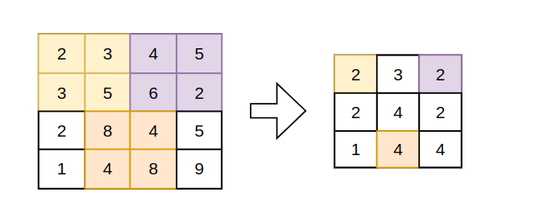

Udacity lections
- https://www.youtube.com/watch?v=F620ommtjqk&list=PLnH7E0IG44jFfiQBd_Ov7FmYHq8SZx6r0&ab_channel=Udacity
Last-lesson → 28

STEP3 – Compilazione ed esecuzione ORB-SLAM – parallelo ✓
Main repository → https://git.hipert.unimore.it/fmuzzini/cuda-accelerated-orb-slam
● Gli step base sono reperibili nello STEP1 – Compilazione ed esecuzione di ORB-SLAM✓

Compilazione ed esecuzione
0. Spostarsi in /ORB-SLAM3
1. Build → ./build.sh
2. Esecuzione → ./Examples/Stereo/stereo_kitti Vocabulary/ORBvoc.txt Examples/Stereo/KITTI04-12.yaml ~/Desktop/dataset/sequences/07
□ Per maggiori dettagli o eventuali problemi→ Compilazione ORB-SLAM3✓
□ Per maggiori dettagli o eventuali problemi → Esecuzione ORB-SLAM3✓

Problemi riscontrati e soluzioni ⚠ → ✓
1. Problema in ORB-SLAM3/CMakeLists.txt e ORB-SLAM3/src/ORBextractor.cc :
- rimossa riga find_package(vpi REQUIRED)
- rimossa riga vpi
- rimossi gli include ineerenti a vpi ( Example : #include <vpi/OpenCVInterop.hpp> … )

2. Se non viene visualizzato il video modificare codice : Examples/Stereo/stereo_kitti.cc ->
ORB_SLAM3::System SLAM(argv[1],argv[2],ORB_SLAM3::System::STEREO,true); ( false -> true )

3 Installare il pacchetto → sudo apt install libboost-dev.
4. Installare il pacchetto → sudo apt-get install libboost-serialization-dev
5.Installare il pacchetto → sudo apt-get install libssl-dev.
6. Aggiungere al file ORB-SLAM3/CmakeLists.txt all’inizio il seguente comando:
- set(CMAKE_CUDA_COMPILER /usr/local/cuda/bin/nvcc)
7. Commentare questa riga di codice: LINE84:SRC/System.cc //cout << (*settings_) << endl;

STEP4 – Analisi e studio di Extract ORB parallelo

● L’obiettivo è analizzare il codice e comprendere a fondo il funzionamento della parte di “Extract ORB” parallelo.
Il codice è reperibile nella seguente directory del repository (sopra) :
ORB-SLAM3/include/ORBextractor.h
ORB-SLAM3/src/ORBexctractor.cc
…

SCHEMA FUNZIONAMENTO – Extract ORB

How it works?
→ Fonte : https://youtu.be/D_Lm7NitBoA
La funzione ORBextractor si occupa di mappare i punti salienti di un immagine. Esistono diversi algoritmi per ottenere i punti salienti. Gli algoritmi principali sono SIFT,SURF,BRIEF e ORB. Per capire al meglio ORB è meglio dare un occhiata a tutti gli algoritmi.

STEP5 – Analisi e studio di Stereo Matching sequenziale
● L’obiettivo è analizzare il codice e comprendere a fondo il funzionamento della parte di “Stereo Matching” sequenziale e cercare di parallelizare dove è possibile.

P.S → Dopo aver fatto qualsiasi modifica al codice per ricompilare ed eseguire:
cd build
cmake .. -DCMAKE_BUILD_TYPE=Release
make
/Examples/Stereo/stereo_kitti Vocabulary/ORBvoc.txt Examples/Stereo/KITTI04-12.yaml ~/Desktop/dataset/sequences/07

Il codice è reperibile nella seguente directory del repository (sopra) :
- ORB-SLAM3/include/ORBmatcher.h
- ORB-SLAM3/src/ORBmatcher.cc
- ORB-SLAM3/src/frame.cc

Analisi file (ORB-SLAM3/src/frame.cc)
Funzione1 → void Frame::ComputeStereoMatches()

● Schema generale :
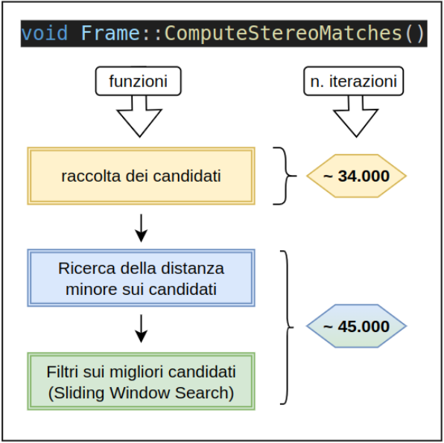

init of candidates → [ for(int iR=0; iR<Nr; iR++) ]
ℹ : Aggiunto il seguente codice di debug alla fine del for :
cout<<"-------------------------------------------------------------\n"
cout<<"Preso il KeyPointRight["<<iR<<"] estraggo -> y = "<<kpY<<endl;
cout<<"Setto il raggio min = "<<minr<<" max = "<<maxr<<endl; cout<<"Eseguito il sotto-ciclo "<<cont<<" volte"<<endl; cout<<"-------------------------------------------------------------\n"

→ Output e analisi:
● ( Numero punti chiave destra [ Nr ] : 2000 circa )
● Sottocicli eseguiti → Min : 5 , Max : 17 .

-------------------------------------------------------------
Preso il KeyPointRight[1992] estraggo -> y = 75.2468
Setto il raggio min = 68 max = 83
Eseguito il sotto-ciclo 16 volte
-------------------------------------------------------------

-------------------------------------------------------------
Preso il KeyPointRight[1993] estraggo -> y = 121.828
Setto il raggio min = 114 max = 129
Eseguito il sotto-ciclo 16 volte
-------------------------------------------------------------

-------------------------------------------------------------
Preso il KeyPointRight[1994] estraggo -> y = 85.9964
Setto il raggio min = 78 max = 94
Eseguito il sotto-ciclo 17 volte
-------------------------------------------------------------

Explanation :
In poche parole per ogni KeyPointRight, prende la coordinata y. E in base ad una raggio calcolato sulla scala del immagine, prende più o meno punti.
Successivamente aggiunge per ogni riga che sta tra min-max, l’indice del KeyPointRight in questione.
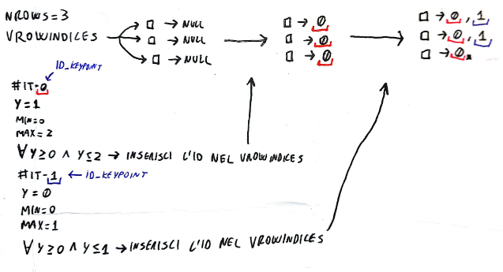

after_for-1 ( Debug )
ℹ : Aggiunto il seguente codice di debug subito dopo il for :
cout<<"Stampa candidati della riga 5 : "<<endl;
for ( unsigned i = 0 ; i<vRowIndices[5].size() ; i++){
cout<<vRowIndices[5][i]<<" ";
}
→ Output :
Stampa candidati della riga 120 :
111 259 327 328 394 418 503 515 561 587 617 644 688 689 749 776 813 825 829 876 898 899 930 931 986 987 1029 1041 1066 1093 1103 1104 1111 1112 1135 1136 1151 1152 1204 1253 1307 1348 1355 1356 1371 1372 1394 1531 1551 1580 1680 1687 1688 1714 1718 1740 1741 1811 1836 1837 1841 1842 1846 1847 1861 1862 1912 1934 1938 1961 1965 1966

Find best candidate (for-2) → [ for(int iL=0; iL<N; iL++) ]
Iterazione eseguite : 44894
Iterazione eseguite : 44400
Iterazione eseguite : 45027
Iterazione eseguite : 44196
Iterazione eseguite : 43659

Graphic explanation:
High level of abstraction
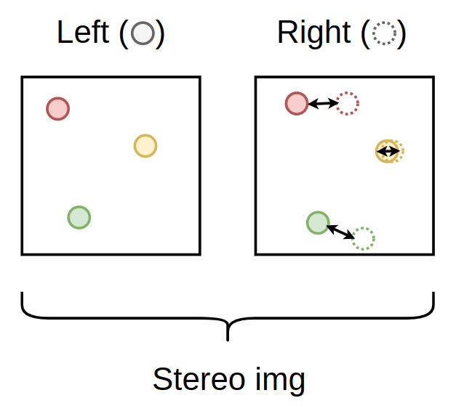
Low level of abstraction
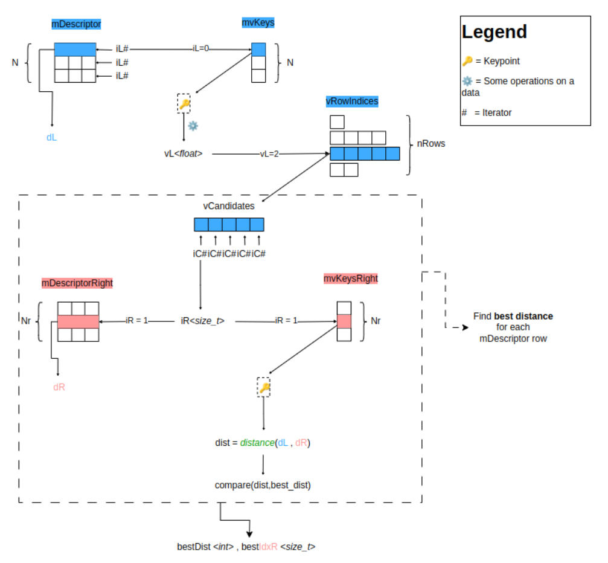

Filter on on best candidate (Sliding Window) [for-2] → [ for(int iL=0; iL<N; iL++) ]
È importante notare che il filtraggio associato alla Sliding Window viene eseguito successivamente al calcolo della distanza minore di un singolo punto chiave. Questo permette, eventualmente, di non attendere il calcolo di tutte le distanze ma di eseguire il filtraggio ad ogni singolo punto chiave.
Rappresentazione ad alto livello (CPU)
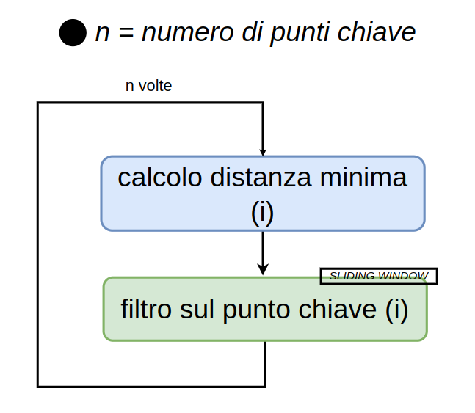
Rappresentazione a basso livello (CPU)
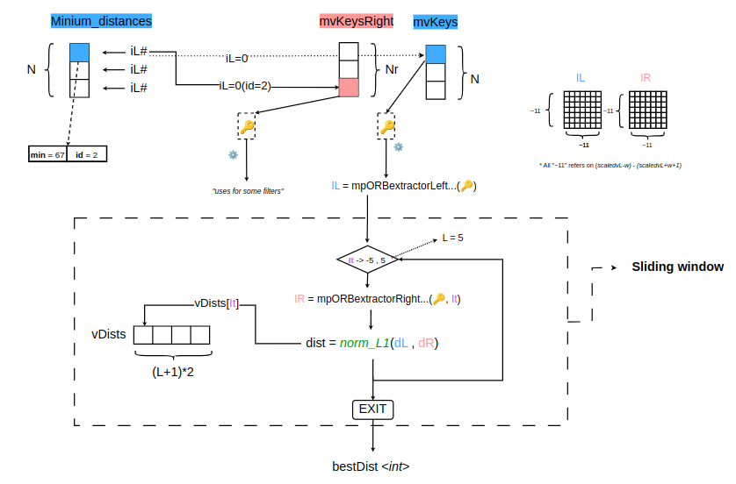

Funzione2→ int ORBmatcher::DescriptorDistance(const cv::Mat &a, const cv::Mat &b) {...}
- Funzione che calcola la distanza di Hamming tra 2 vettori riga.
- Utilizza bitmask e operazioni tra bit.

cv::Mat funzioni principali
cv::Mat mat; //Creazione matrice vuota
cv::Mat mat_zeros(3, 3, CV_32F, cv::Scalar(0)); // Matrice 3x3 di tutti zero
cv::Mat image = cv::imread("immagine.jpg"); // Caricamento immagine da file
// Operazioni
cv::Mat result;
cv::add(mat1, mat2, result); // Somma tra matrici
cv::subtract(mat1, mat2, result); // Sottrazione tra matrici
cv::multiply(mat1, mat2, result); // Moltiplicazione tra matrici
cv::divide(mat1, mat2, result); // Divisione tra matrici
cv::Mat roi = image.row(3); // Estrae la quarta riga della matrice image
cv::Mat pixel = image.at(2,4); //Estrae il pixel in posizione x = 2 e y = 4.

STEP6 – Esperimenti e ottimizazioni su Compute Stereo Matches
● In questo step si andrà a proporre alcune esperimenti sulla funzione void Frame::ComputeStereoMatches() presente in ORB-SLAM3/src/frame.cc.

Esperimento 1 → ✓ ( Changing the radius doesn’t improve the precision )
F1 → init_candidati → …
· In questo caso cambieremo alcuni parametri di init_candidati in modo tale da capire con un determinato cambio di parametri che vantaggi/svantaggi andremo ad avere. In caso gli svantaggi sarenno temporali, potremmo succesivamente andare ad ottimizare su GPU.

STEPS
1. clona repository : https://github.com/Huangying-Zhan/kitti-odom-eval
2. Modifica il file ORB-SLAM3/Examples/Stereo/stereo_kitti.cc
line155 : SLAM.SaveTrajectoryKITTI("CameraTrajectory.txt"); -> Cambia output_file
In "CameraTrajectory.txt" → Abbiamo l’output dell’esecuzione di ORB-SLAM3
⚠ Attenzione : per fare in modo che la traccia venga salvata su CameraTrajectory.txt bisogna aspettare che il programma si chiuda in automatico.

3. Utilizzare lo script eval_odom.py per testare la “bontà” del file "CameraTrajectory.txt".
→ Lo script necessità alcuni parametri fondamentali, tra cui dataset/kitti_odom_gt_poses/<SQ>.txt.
Per gli altri parametri visionare il seguente paper : https://arxiv.org/pdf/1909.09803.pdf.
--align scale → Serve per correggere la scala delle previsioni. (Inutile dato che abbiamo un sensore stereo)
--align 6dof → allinea le previsioni alle pose di riferimento associate durante la valutazione, tenendo conto solo delle traslazioni e delle rotazioni in tre dimensioni, ma non della scala.
--align 7dof → allinea le previsioni alle pose di riferimento associate durante la valutazione, tenendo conto delle traslazioni e delle rotazioni in tutte e tre le dimensioni e la scala.
--align scale_7dof → come il 7dof, ma con particolare attenzione alla scala.
TUTORIAL-Script
1. Spostarsi nella directory /kitti-odom-eval.
2. Mandare il seguente comando : conda env update --file <nome_file.yml> --prune
3. conda activate kitti_eval
4. Spostare il file "CameraTrajectory.txt" nella directory /result e cambiare il nome in "<SEQ>.txt" (Example : 07.txt ).
5. Eseguire il comando: python3 eval_odom.py --result result --seqs 07 --align scale

⚠ Se si hanno problemi con l’inclusione delle dipendenze del file requirement.yml, installare conda → https://www.anaconda.com/download

4. Modifica il file ORB-SLAM3/Examples/Stereo/stereo_kitti.cc:
ORB_SLAM3::System SLAM(argv[1],argv[2],ORB_SLAM3::System::STEREO,false);
In questo modo il debug dei tempi non è influenzato.

5. Attivare il time debugging : andare in /ORB-SLAM3/include/Settings.h e scommentare.
line155 : //#define REGISTER_TIMES

6. Analizzare l’output e fare eventuali grafici in base all’output.
Tempi
ORB Extraction: 6.3607$\pm$29.426
Stereo Matching: 3.5239$\pm$0.63853
Output di esempio
Translational error (%): 0.47671757165018636
Rotational error (deg/100m): 0.2537907685762515
ATE (m): 0.7072996323822534
RPE (m): 0.013294236402536458
RPE (deg): 0.038529163228008145
-------------------- For Copying ------------------------------
0.48
0.25
0.71
0.013
0.039
Spiegazione output:
· Translational error → rappresenta la differenza percentuale tra la posizione stimata e quella reale di un oggetto nello spazio, in termini di spostamento lineare. (%)
· Rotational error → rappresenta la differenza angolare tra l'orientamento stimato e quello reale di un oggetto nello spazio. (0.25°ogni 100m)
· ATE → rappresenta la differenza tra la traiettoria stimata e quella reale di un oggetto nello spazio. Viene solitamente calcolato come la radice quadrata della somma dei quadrati degli errori di traslazione e rotazione. (metri)
· RPE → rappresenta la differenza tra due posizioni stimate consecutive di un oggetto nello spazio. Viene solitamente calcolato come la distanza euclidea tra le due posizioni. ( gradi(°) or metri ).

RISULTATI ESPERIMENTO:
Kitti-07
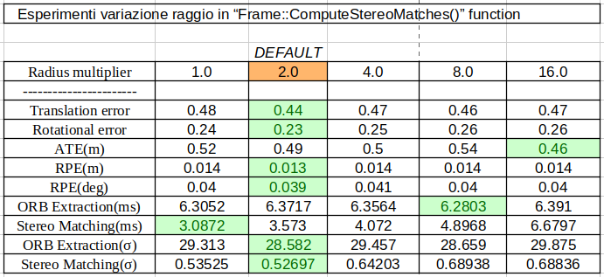

Kitti-04
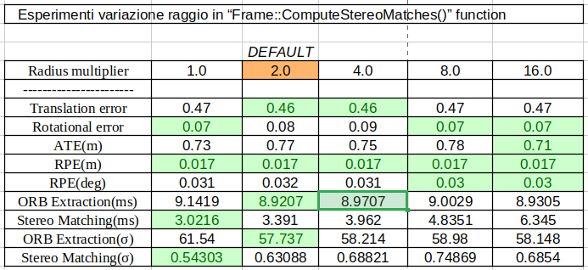

Kitti-06
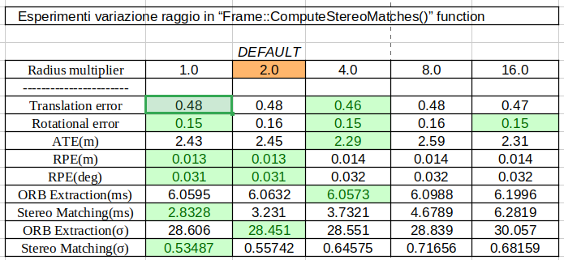

CONCLUSIONI ESPERIMENTO
L’esperimento ha evidenziato che aumentando o diminuendo il raggio non si hanno notevoli miglioramenti a livello di tempi di esecuzione e precisione del benchmark.
Di seguito la tabella con i risultati (radius=2 default)

Esperimento 2 → work in progress...
F1 → init_candidati → load GPU (candidati) → … [GPU]

📄 File utilizzati :
- cuda-accelerated-orb-slam/Clustering/ORB-SLAM3/src/frame.cc
- cuda-accelerated-orb-slam/Clustering/ORB-SLAM3/src/gpu_stereoMatches.cu
- cuda-accelerated-orb-slam/Clustering/ORB-SLAM3/src/Sysyem.cc
- cuda-accelerated-orb-slam/Clustering/ORB-SLAM3/include/gpu_stereoMatches.cu
- cuda-accelerated-orb-slam/Clustering/ORB-SLAM3/include/ORBextractor.h

- In questo caso andremo a migliorare la funzioni successive a init_candidati poiché sono le funzioni più dispensiose ( 40.000/50.000 iterazioni ).

STEPS
1. Per avvicinarsi al risultato finale, creiamo un programma in parte simile in modo tale da avere uno schema base.
Example with Nrows = 4
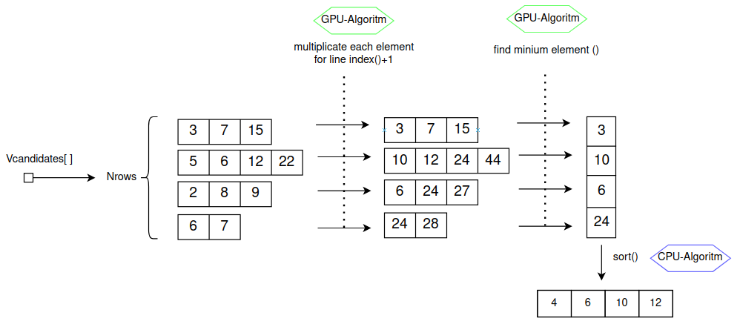

2. Dobbiamo creare un nuovo file <new_file>.cu e <new_file>.h in questi file andremmo a scrivere il codice di parallelizazione della funzione. Per includere questi file nella compilazione dovremmo:
Aggiungere al file /CmakeLists.txt :
  - src/<new_file>.cu
  - include/<new_file>.h
3. Aggiungere l’include → #include "gpu_stereoMatches.h", nel file Frame.cc.
4.Progettazione delle funzioni tipo __kernel__()

Find distance scheme
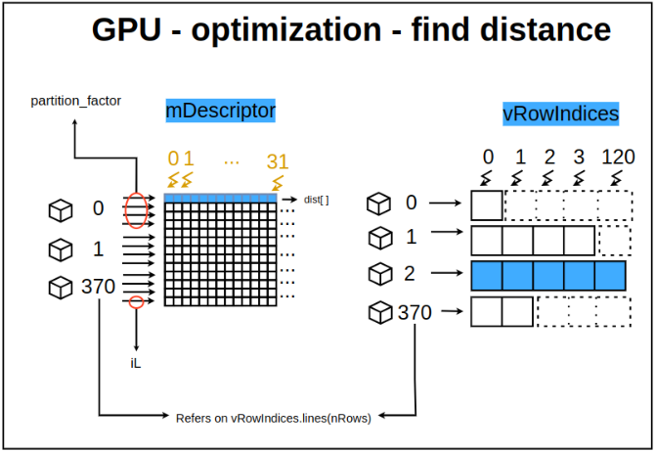

Find minium distance scheme
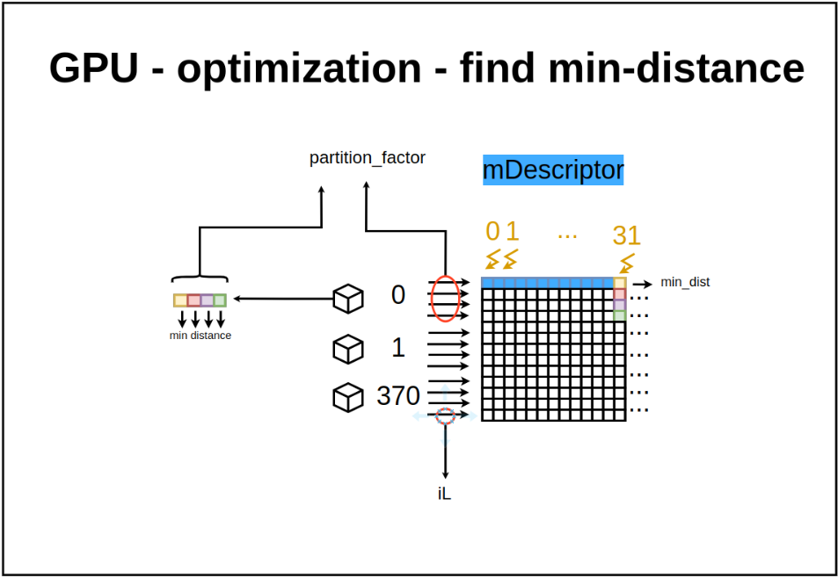
Sliding window scheme

How to use Conda?
conda create --name <name> -> crea un nuovo profilo
conda activate <name> -> accede con il profilo
conda env list -> mostra tutti i pacchetti installati su un profilo
conda env remove –name <name> -> elimina il profilo
conda deactivate -> si slogga dal profilo attuale
conda list -> vedo tutti i pacchetti del profilo
conda env export --file <nome_file.yml> -> esporta i pacchetti attuali nel file requirement.yml
conda env update --file <nome_file.yml> --prune -> importa i pacchetti nel file requirement.yml e ti crea un nuovo profilo.

Suggestions
GPU -> 8.6 ( Versione per la GTX-3060 )

Logs
Day | Topic | Description
27/02/2024 | Tentativo installazione ORB-SLAM3 | Problemi riscontrati con Windows X  ⚬necessario installare Linux.
28/02/2024 | Apprendimento di CUDA | Cuda_tutorial1.pdf
29/02/2024 | Installazione Ubuntu Dual-Boot | Dopo i numerosi problemi riscontrati con Windows, ho eseguito l’installazione Dual Boot di Mint 21.3 ✓
05/03/2024 | Tentativo installazione ORB-SLAM3 + Installazione CUDA | ⚬Installazione CUDA avvenuta con successo. Eseguito alcuni semplici esempi.  ⚬Installazione ORB-SLAM3 Fallita X
06/03/2024 | Lezioni CUDA | L3 : Thread organization and Thread Block ✓  L4 : GPU computation Hierarchy and Matrix Squaring Thread Divergence. ✓
07/03/2024 | Lezioni CUDA + Tentativo installazione ORB-SLAM3 | L5 Thread Divergence in CUDA continue. ✓  ⚬Installazione ORB-SLAM3 Fallita X
12/03/2024 | Tentativo Installazione ORB-SLAM + Tentativo espansione disco su Linux. | ⚬Installazione ORB-SLAM ✓ ⚬Espansione disco ✓
13/03/2024 | Tentativo esecuzione ORB-SLAM | ⚬Esecuzione ORB-SLAM X  → Errore in esecuzione, necessario debug.
14/03/2024 | Tentativo esecuzione ORB-SLAM  Tentativo esecuzione ORB-SLAM versione parallela | ⚬Esecuzione ORB-SLAM ✓  ⚬Esecuzione ORB-SLAM parallelo ✓  ⚬ L6 Types of memories latency and locality. ✓  ⚬ L7 Memory coalescing and AoS vs SoA. ✓
19/03/2024 | Analisi della funzione Frame::ComputeStereoMatches() | ⚬ Analisi in corso...
20/03/2024 | Analisi della funzione Frame::ComputeStereoMatches() | ⚬ Analisi in corso…  ⚬L8 Shared Memory in CUDA ( not finished ) X
21/03/2024 | Analisi della funzione Frame::ComputeStereoMatches() | ⚬ Trovati alcuni possibili idee di ottimizazioni ed esperimenti da fare. ✓
26/03/2024 | Progettazione della prima ottimizazione.  Installazione Anaconda. | ⚬Installazione Anaconda ✓  ⚬Problemi riscontrati con la stampa del file “CameraTrajectory.txt” X
27/03/2024 | Progettazione della prima ottimizazione.  Visione del paper: https://arxiv.org/pdf/1909.09803.pdf | ⚬L8 Shared Memory in CUDA✓  ⚬Esecuzione dello script avvenuta correttamente✓
28/03/2024 | Analisi della funzione Frame::ComputeStereoMatches() | ⚬ Analisi in corso…  ⚬ Experiment4 of Steps6 X
9/04/2024 | Testing on Frame::ComputeStereoMatches() | ⚬ Eseguo il programma cambiando il raggio e valutando il possibile miglioramento di prestazioni  ° Finito Experiment4 of Steps6 ✓
10/04/2024 | Analisi della funzione Frame::ComputeStereoMatches() | ⚬ Analisi completata possibile parallelizazione trovata ✓
11/04/2024 | Avvio scrittura parallelizazione della della funzione Frame::ComputeStereoMatches() | ⚬Parallelizzazione in corso⚠️  ⚬L9 Dinamic Shared Memory Bank Conflicts X
16/04/2024 | Creazione di un programma simile alla funzione Frame::ComputeStereoMatches() in modo tale da testare la parallelizazione. | ⚬L9 Dinamic Shared Memory Bank Conflicts ✓  ⚬Simulazione parallela ✓
17/04/2024 | Parallelizzazione di Frame::ComputeStereoMatches() + lezioni su Cuda. | ⚬ L10 Bank Conflicts Continue Texture, Constant Memory and Compute Capabilities ✓  ⚬Parallelizzazione X
18/04/2024 | Lezioni su CUDA + Parallelizzazione di Frame::ComputeStereoMatches() | ⚬Parallelizzazione X  ⚬Youtube tutorial : < L11 Data Race and Synchronization> ✓
23/04/2024 | Lezioni su CUDA + Parallelizzazione di Frame::ComputeStereoMatches() + Test aggiunta file CUDA | ⚬Youtube tutorial : < L12 Exclusion> ✓  ⚬Aggiunta file CUDA (.cu) nel progetto ORB-SLAM3 ✓  ⚬Parallelizzazione X
30/04/2024 | Lezioni su CUDA + Parallelizzazione di Frame::ComputeStereoMatches() | ⚬Youtube tutorial : < L13 Mutual exclusion> ✓  ⚬Parallelizzazione X
1/05/2024 | FESTA DEI LAVORATORI | ---
2/05/2024 | Lezioni su CUDA  Parallelizzazione di Frame::ComputeStereoMatches() | ⚬Youtube tutorial : < L14 various Atomic functions...> ✓  ⚬Parallelizzazione X
7/05/2024 | Lezioni su CUDA  Parallelizzazione di Frame::ComputeStereoMatches()  Trasformazione funzione DescriptoreDistance per GPU. | ⚬Youtube tutorial : < L15 Barriers,Reductions..> ✓  ⚬Parallelizzazione X  ⚬Custom DescriptorDistance✓
8/05/2024 | Lezioni su CUDA  Parallelizzazione di Frame::ComputeStereoMatches()  Creazione spiegazione grafica per la funzione. | ⚬Youtube tutorial : < L16 Functions in CUDA> ✓  ⚬Parallelizzazione X  ⚬Spiegazione grafica ✓
9/05/2024 | ---------------- | -------------------
14/05/2024 | Lezioni su CUDA  Parallelizzazione di Frame::ComputeStereoMatches() | ⚬Youtube tutorial : < L17 CUDA supports> ✓  ⚬Problemi con ORBSLAM3. “Impossibile ottenre segnale video” X
15/05/2024 | Lezioni su CUDA  Parallelizzazione di Frame::ComputeStereoMatches() | ⚬Youtube tutorial : < L18 CUDA topics> X  ⚬Sistema Operativo irrecuperabile causa driver X
16/05/2024 | Reinstallazione Sistema Operativo.  Reinstallazione CUDA e Driver.  Reinstallazione ORBSLAM3 | ⚬Sistema Operativo ✓  ⚬Cuda + Driver X  ⚬ORBSLAM3 X
21/05/2024 | Reinstallazione CUDA e Driver.  Reinstallazione ORBSLAM3 | ⚬Cuda + Driver ✓  ⚬ORBSLAM3 X
22/05/2024 | Reinstallazione ORBSLAM3  Parallelizzazione di Frame::ComputeStereoMatches() | ⚬ORBSLAM3 ✓  ⚬Parallelizzazione X
23/05/2024 | Parallelizzazione di Frame::ComputeStereoMatches() | ⚬Parallelizazione dalla funzione di distanza ✓  ⚬Parallelizazione dalla funzione di distanza minima X
28/05/2024 | Parallelizzazione di Frame::ComputeStereoMatches() | ⚬Parallelizazione parziale della funzione di distanza minima✓
29/05/2024 | Parallelizzazione di Frame::ComputeStereoMatches() | ⚬Parallelizazione della funzione di distanza minima X
30/05/2024 | Parallelizzazione di Frame::ComputeStereoMatches()  Inizio progettazione parallelizazione sliding window. | ⚬Parallelizazione della funzione di distanza minima✓  ⚬Progettazione ✓  ⚬Parallelizazione della funzione di sliding window X
3/06/2024 | Parallelizzazione di Frame::ComputeStereoMatches()  Funzione che trova oltre al minimo il suo indice. | ⚬Minium Index ✓
4/06/2024 | Parallelizzazione di Frame::ComputeStereoMatches() | ⚬Parallelizazione della funzione di sliding window X
5/06/2024 | Parallelizzazione di Frame::ComputeStereoMatches() | ⚬Parallelizazione della funzione di sliding window X

Questions

1. Non ho capito questa slide. ( Hard question )
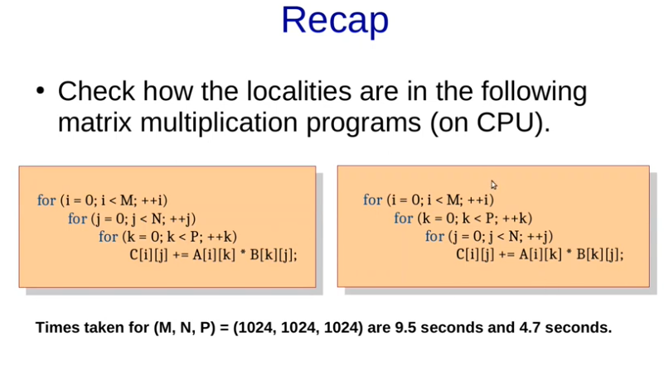

2. Non ho capito example3 della L11 (medium)
3. Non ho capito example4 della L12. Perchè dice che ci potrebbe essere un problema di progressione?

To do
1. Sistemare primo esercizio → page: 33

