GPU - parallelization

STEPS
0. Installazione Linux Mint 21.3 nativo ✓
1. Compilare ORB-SLAM ( versione non parallela ) ed eseguirlo ✓
2. Apprendimento di CUDA → work in progress… ⚠
3. Compilare ORB-SLAM ( versione parallela ). ✓
4. Studiare la parte di Extract ORB. (ORBextractor.cc)
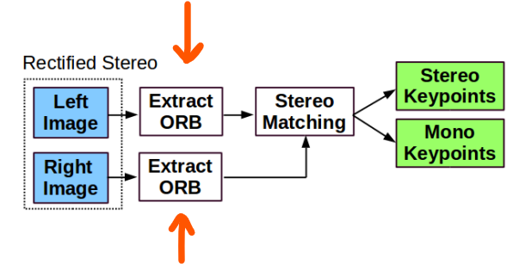
5 Studiare la parte di Stereo Matching ( ORBextractor.cc ).
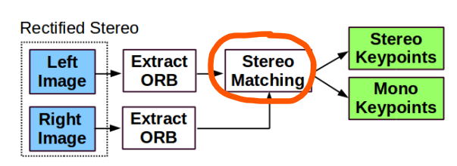

6. Ottimizare la parte di Stereo Matching e cercare di renderla parallela.

STEP0 – Installation of Linux distribution ✓
1. Download ISO file from https://linuxmint.com/
2. Download Rufus and choose the ISO file. (https://rufus.ie/it/)
3. Partiziona il disco

Tasto destro su Windows(C:) e premere “Riduci Volume”
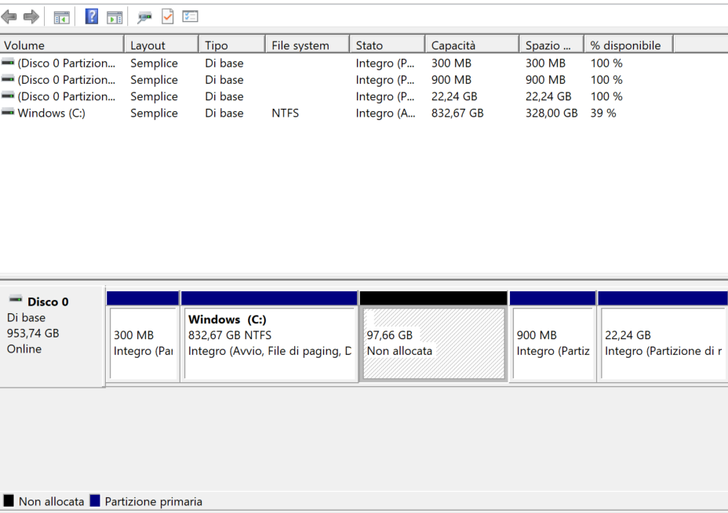

Modificare “Specificare la quantità di spazio da ridurrre,in MB:” ( Ex: 100000Mb )
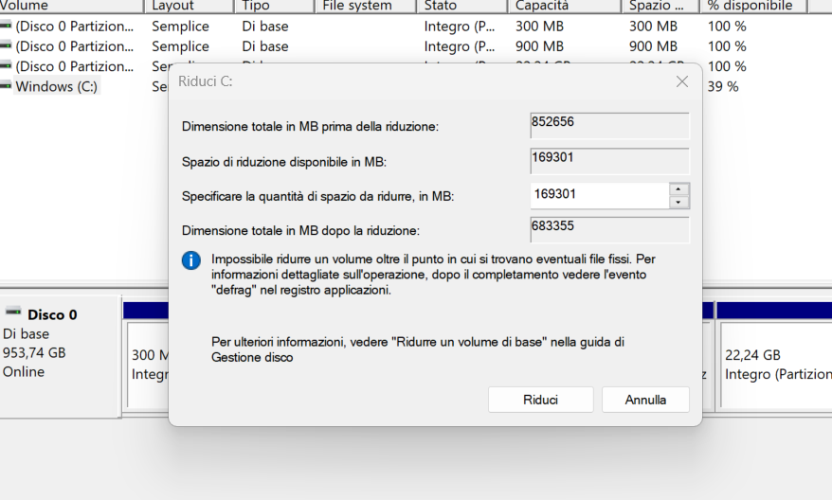
Nuova memoria non allocata
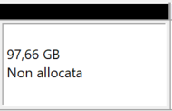

4. Controllare le condizioni del file system di Windows:
□ Aprire come amministratore CMD
fsutil dirty set c:

5. Disattivare avvio rapido! → https://www.youtube.com/watch?v=eIEw4b2QNvM

6. Change BOOT priority on BIOS (Clicca all’avvio F3).
7. Restart PC.

Installation of main programm
1. LibreOffice
2. Visual Studio Code

STEP1 – Compilazione ed esecuzione di ORB-SLAM✓
Main repository → https://github.com/UZ-SLAMLab/ORB_SLAM3

Installazione CUDA – Toolkit ✓
Guide : https://docs.nvidia.com/cuda/cuda-installation-guide-linux/index.html

Scaricare kitty data set ✓
● https://git.hipert.unimore.it/fmuzzini/cuda-accelerated-orb-slam/-/tree/main#6-orb-slam2-with-kitti-dataset

Installazione prerequisiti ✓
1. Pangolin → https://github.com/stevenlovegrove/Pangolin. ✓
git clone https://github.com/Microsoft/vcpkg.git
cd vcpkg
./bootstrap-vcpkg.sh
./vcpkg integrate install
./vcpkg install pangolin
ⓘ Se non funziona l'ultimo comando per Windows, installare tramite Visual Studio Installer le estensioni per il C++.

2. Open-CV → Required at least 3.0. Tested with OpenCV 3.2.0 and 4.4.0. ✓
□ To install ( Linux ) → sudo apt install libopencv-dev
3. Eigen3 → Required at least 3.1.0. ✓
Download at : https://eigen.tuxfamily.org/index.php?title=Main_Page
- Extract the content in a folder.
- You can try your first Eigen programm → g++ <eigen_example.cpp> -I <Eigen_dir> -o <my_program_name>

#include <iostream>
#include <Eigen/Dense>

using Eigen::MatrixXd;

int main()
{
MatrixXd m(2,2);
m(0,0) = 3;
m(1,0) = 2.5;
m(0,1) = -1;
m(1,1) = m(1,0) + m(0,1);
std::cout << m << std::endl;
}

Compilazione ORB-SLAM3✓

--- 1. Clonazione
git clone https://github.com/UZ-SLAMLab/ORB_SLAM3.git ORB_SLAM3
--- 2. Build
cd ORB_SLAM3
chmod +x build.sh
./build.sh
● Se si hanno problemi, andare ad eseguire le sotto-funzioni di ./build.sh per vedere dov’è l’errore.

⚠ Se non funziona modificare C++11 → C++14 ( Presente in /ORB_SLAM3/CmakeLists.txt )
# Check C++11 or C++0x support
include(CheckCXXCompilerFlag)
CHECK_CXX_COMPILER_FLAG("-std=c++11" COMPILER_SUPPORTS_CXX11)
CHECK_CXX_COMPILER_FLAG("-std=c++0x" COMPILER_SUPPORTS_CXX0X)
if(COMPILER_SUPPORTS_CXX11)
set(CMAKE_CXX_FLAGS "${CMAKE_CXX_FLAGS} -std=c++11")
add_definitions(-DCOMPILEDWITHC11)
message(STATUS "Using flag -std=c++11.")

Inoltre commentare il seguente “cout” nel file ORB_SLAM3/src/System.cc ( line 84 )
cv::FileNode node = fsSettings["File.version"];
if(!node.empty() && node.isString() && node.string() == "1.0"){
settings_ = new Settings(strSettingsFile,mSensor);

mStrLoadAtlasFromFile = settings_->atlasLoadFile();
mStrSaveAtlasToFile = settings_->atlasSaveFile();

//cout << (*settings_) << endl;
}

Esecuzione ORB-SLAM3✓
1. Andare nella directory /ORB_SLAM3
2. Eseguire → ./Examples/Stereo/stereo_kitti Vocabulary/ORBvoc.txt Examples/Stereo/KITTIX.yaml ~/Desktop/dataset/sequences/00
□ Le parti in rosa devono essere modificate in base al numero di esempio che vogliamo provare.
□ La parte in verde indica il path contente il kitty data set ( link : sopra )
- KITTI00-02.yaml → sequenze 00,01,02.
- KITTY03.yaml → sequenze 03.
- KITTY04-12.yaml → sequenze 04,05,06,07,08,09,10,11,12.

⚠ Nel caso non funziona debuggare il file :
1. /ORB_SLAM3/Examples/Stereo/stereokitty.cc
2. /ORB_SLAM3/src/System.cc
3. Per compilare vai in /ORB_SLAM3/build ed esegui i seguenti comandi :
# cmake .. -DCMAKE_BUILD_TYPE=Release
# make

STEP2 – Apprendimento di CUDA

● Slide tutorial ( 77 Slide ) : https://cuda-tutorial.github.io/part1_22.pdf
● https://cuda-tutorial.github.io/
● https://cuda-tutorial.readthedocs.io/en/latest/tutorials/tutorial01/

● Youtube tutorial ( 27h , 19 Lections ) : https://www.youtube.com/watch?v=cvo3gnInQ7M&list=PL1ysOEBe5977vlocXuRt6KBCYu_sdu1Ru ( Suggested to watch these lection with multiplier 1.25x )

How to compile ?
nvcc <namefile.cu>

Slide tutorial : <part1_22.pdf>

Exection Model
__global__ → Kernel functions ( called from CPU for GPU )
__device__ → Devices functions (function or variable that is executed or allocated on the device (GPU) only )
__host__ -> Code to be executed on the host (CPU)

Synchronization (Host with Device)
cudaDeviceSynchronize() -> to synchronize CPU and GPU
cudaEventSynchronize() -> to synchronize up to certain event

Execution Hierarchy
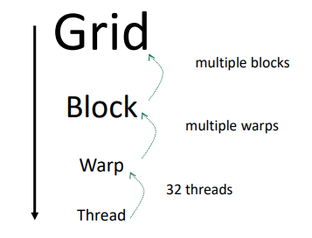
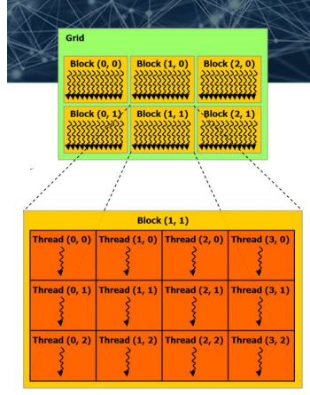

Atomic operations
● atomicAdd(...)
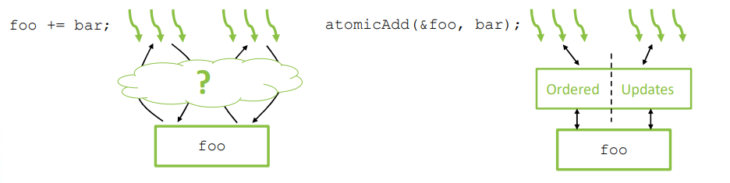

Types of memory
• Registers
• Per-thread, fast, automatically allocated for variables
• Local Memory
• Per-thread, slow, used when registers are unavailable
• Shared Memory
• Per-block, fast, allocated by host or __shared__
• Global Memory
• Per-device, slow, allocated by host or __device__
• Constant Memory
• Per-device, fast uniform access, via __constant__
• Texture Memory
• Per-device, slow, with texture reading functionality
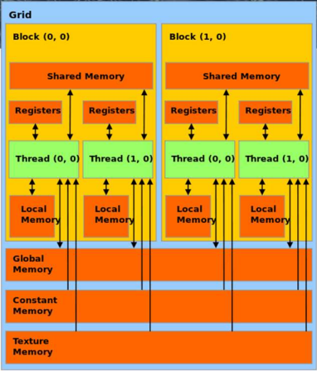

Example on Atomic Redution ( sum )
● Input : [ 1 , 2 , 3 , 4 ]
● Output : 10
Version1 – Atomic Global
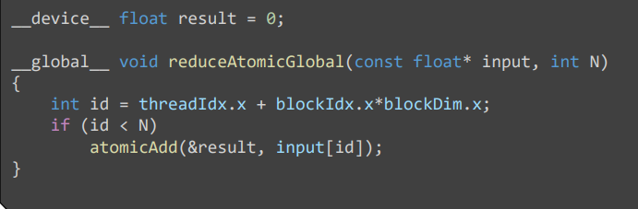
Version2 - Blocks Share Fast Memory
● Ogni blocco gestice una memoria veloce al suo interno, per velocizzare i calcoli. Per accedervi si utilizza __shared__.
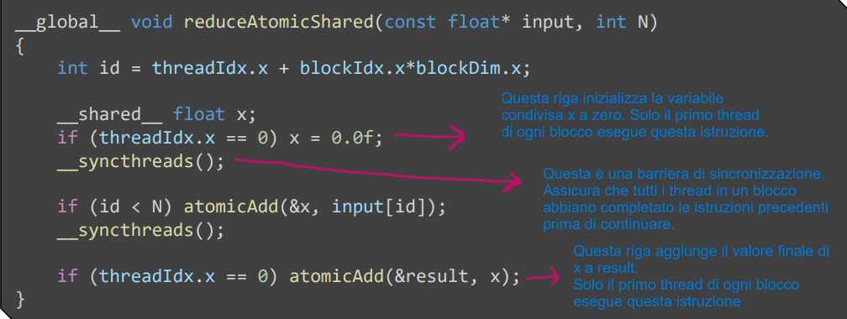
Compute block results in fast, shared memory, update global at end ( &result)
Version3 – Sublinear Runtime
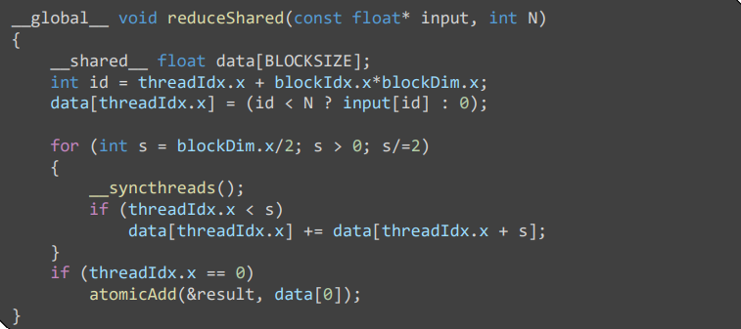
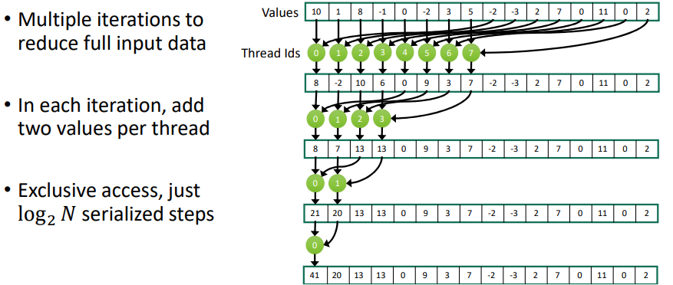
Version4 – Exchangin Registers
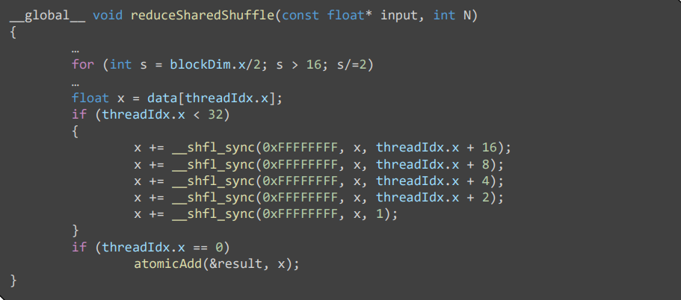

Perfomance comparison
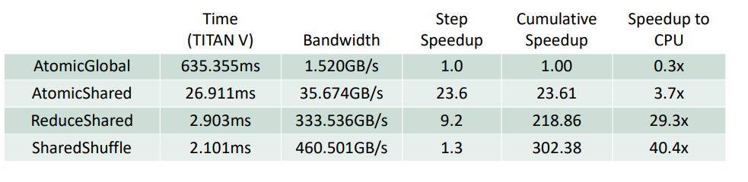

Profiling e Dubugging
● How to print the execution time ?
nvprof ./vector_add_thread

Profiling with Nsight Systems
1. SEQUENTIALLY
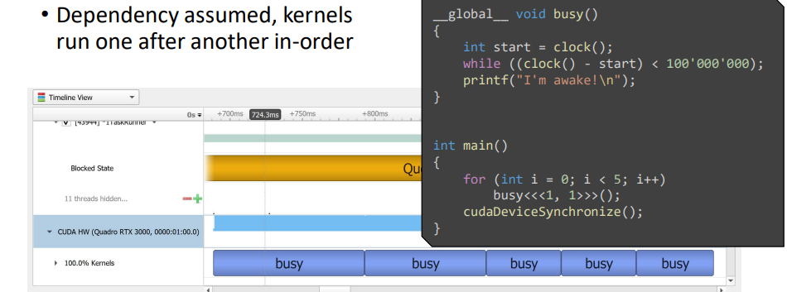
2. STREAMS
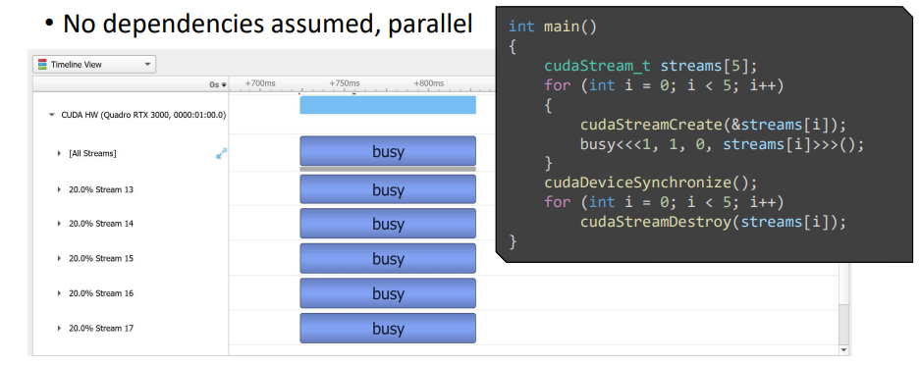

Youtube tutorial : <L1 CUDA Helloworld >
(https://www.youtube.com/watch?v=cvo3gnInQ7M&list=PL1ysOEBe5977vlocXuRt6KBCYu_sdu1Ru)

Introduction
Example1
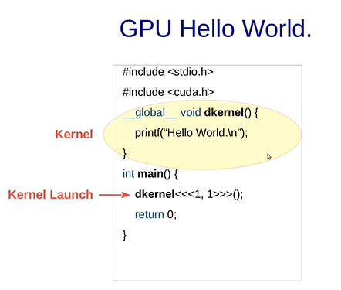
□ Per compilare nvcc hello.cu e poi ./a.out

● Dkernel<<<1,1>>>() →
● Dkernel<<<Block , Thread for block>>>()

● __global__ means it is a Kernel function and it was run by GPU.
→ In questo caso non stamperà nulla perché la CPU non aspetta che la GPU finisce. Il modo per farlo funzionare è aggiungere la funzione cudaDeviceSynchronize();
□ Funzioni CPU (__host__) e GPU(__global__) sono asincrone!

Example2
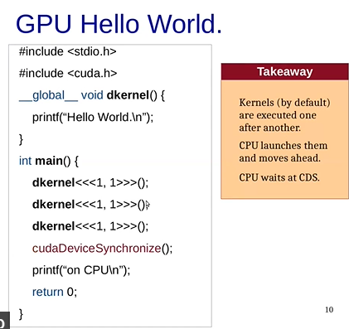
● Ogni chiamata del Kernel viene messa in una lista (FIFO) per poi venire svuotata sequenzialmente.
● Questo succede anche se chiamiamo funzioni diverse di __global__.

Example3
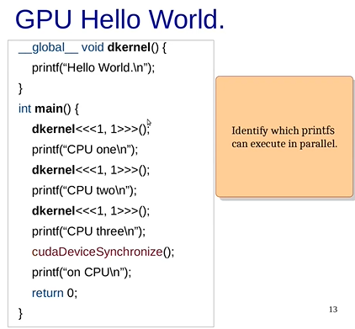
● In questo caso l’input non è deterministico perché le funzioni dkernel verranno mese nella coda.
E non si sa se viene scritto prima “Cpu one\n” o il primo elemento della coda riesce già ad eseguire il codice.

Example4 ( C loop vs possible Cuda parallel loop )
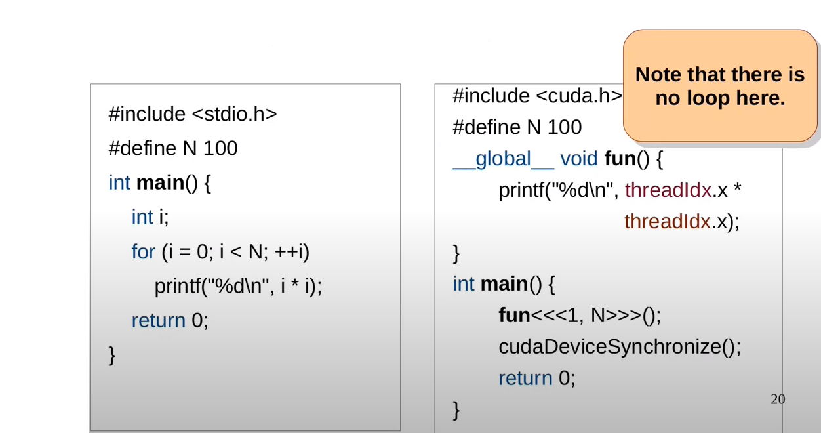
● In questo caso lanciamo, 100 thread all’interno di un blocco.
Ogni thread avrà un id che va da 1 a 100 ( threadIdx.x)

Youtube tutorial : < L2 CUDA program flow and cudamemcopies >
(https://www.youtube.com/watch?v=wgoP4xITs2U)

Example1 → CudaMalloc and CudaMemcpy.
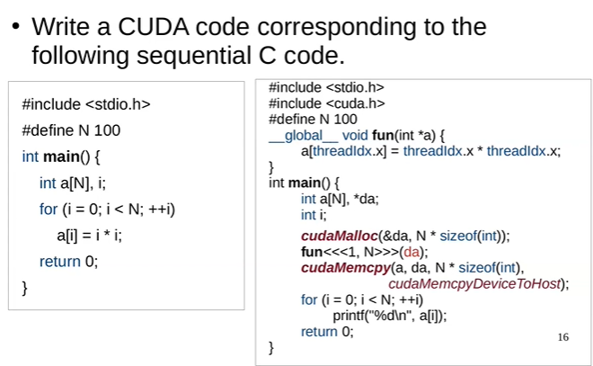
● Osservazione : Non c’è nessuna funzione di sincronizzazione perché cudaMemcpy(...) dato che è un “blocking statements” quindi aspetta che le operazioni precedenti siano finite.
● CudaMalloc → Alloca memoria per la GPU
● CudaMemcpy → Sposta i dati tra una DRAM e l’altra ( Device = GPU , Host = CPU )
Example2
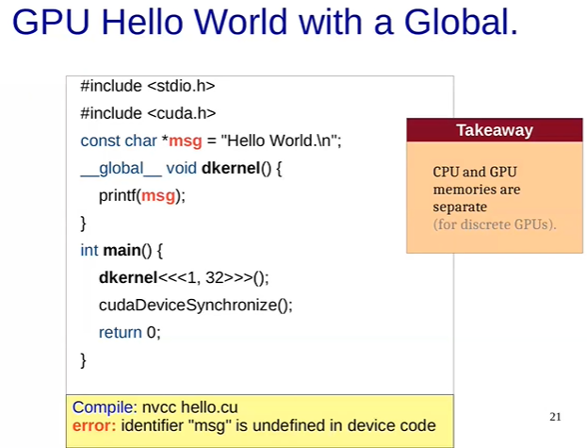
● Le GPU discrete hanno una memoria dedicata.
Quindi non condividono la memoria con la CPU.
↓ ↓ ↓ Solution ↓ ↓ ↓

Solution
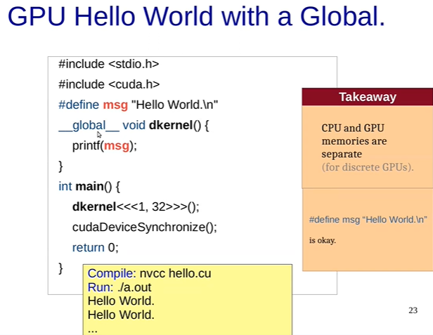

Separate Memories
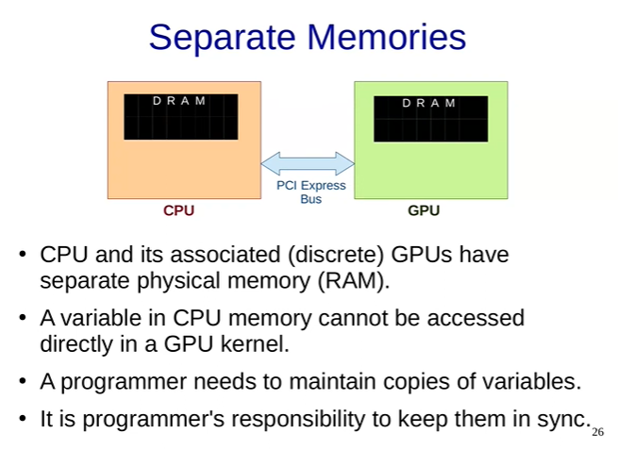

CUDA Program Flow
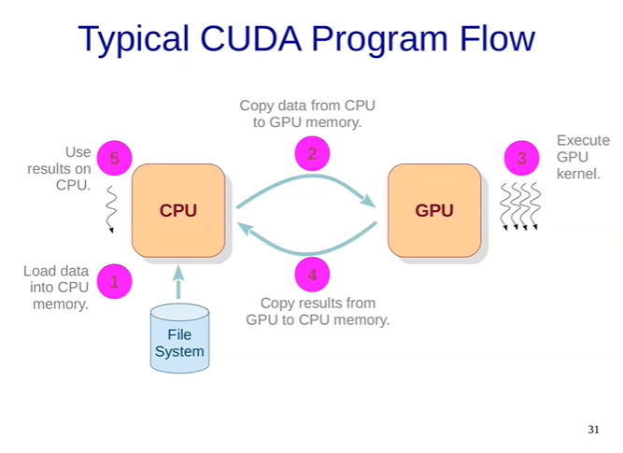
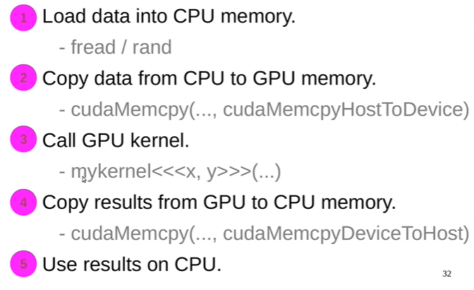

Gpu - Comunication
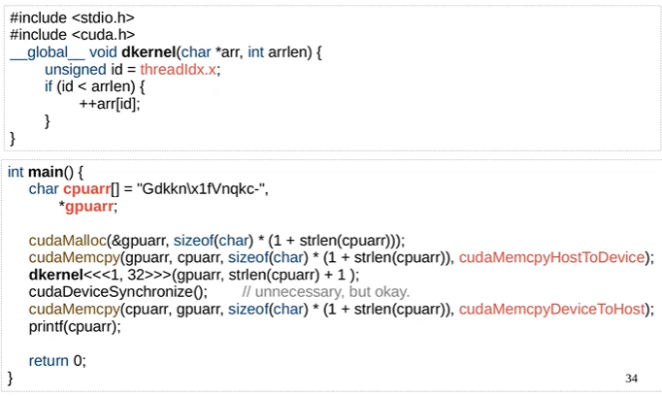
●Output : Hello World! → Questo perché dkernel() incrementa ogni carattere della stringa.
⚠ Don’t switch the ‘\0’ because it could make crash the application.
(1+strlen(cpuarr)) → remove 1+

Homeworks
1. Write a CUDA program to initialize an array of size 32 to all zeros in parallel.
2. Change the array size to 1024
3. Create another kernel that adds i to array[i].
4. Change the array size to 8000.
5. Check if the answer to problem 3 still works.
→ Non funziona sopra 1024 → Poichè BlockDim.x.max = 1024

□ Exercise1
_#include<stdio.h>

__global__ void init_to_zero(int *Arr , int n ){
int id = threadIdx.x;
if(id<n){
Arr[id] = id;
}

}

int main(){

int n = 1024; // n = 1024 , n = 8000
int *GpuArr;
int CpuArr[n];
cudaMalloc(&GpuArr , sizeof(int) * n);
init_to_zero<<<1,n>>>(GpuArr , n);
cudaMemcpy(CpuArr , GpuArr , sizeof(int) * n , cudaMemcpyDeviceToHost );
cudaDeviceSynchronize();

//stampa array finale
for ( int i=0 ; i<n ; i++){
printf("%d\n" , CpuArr[i]);
}

return 0;

}
□ Exercise3 ( include init_to_zero functions)
#include<stdio.h>

// Funzione che aggiunge il valore "index" all'indice "index" dell'array
__global__ void add_to_index(int *Arr , int n){
int id = threadIdx.x;
if(id<n){
Arr[id] = Arr[id] + id;
}
}

// Funzione che inizializza un array a 0
__global__ void init_to_zero(int *Arr , int n ){
int id = threadIdx.x;
if(id<n){
Arr[id] = id;
}
}

int main(){
int n = 2048; // n = 1024 , n = 8000
int *GpuArr;
int CpuArr[n];
cudaMalloc(&GpuArr , sizeof(int) * n);
init_to_zero<<<1,n>>>(GpuArr , n);
add_to_index<<<1,n>>>(GpuArr , n);
cudaMemcpy(CpuArr , GpuArr , sizeof(int) * n , cudaMemcpyDeviceToHost );
cudaDeviceSynchronize();

//stampa array finale
for ( int i=0 ; i<n ; i++){
printf("%d\n" , CpuArr[i]);
}

return 0;
}

Youtube tutorial : < L3 Thread organization and Thread block in CUDA >
https://www.youtube.com/watch?v=3753pgnKLnc

Thread organization
● A kernel is launched as a grid of threads. A grid is a 3d array of thread-blocks ( gridDim.x , gridDim.y , gridDim.z ) with x,y,z. Each block has blockIdx.x , lockIdx.y , lockIdx.z.
● Each thread has threadIdx.x , threadIdx.y , hreadIdx.z.
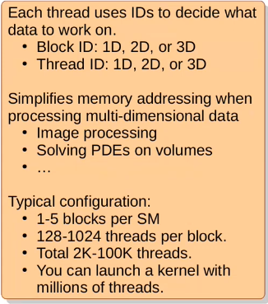
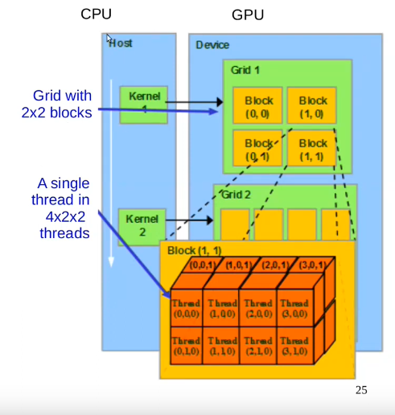

Example1:
#include<stdio.h>

__global__ void dkernel(){

if( threadIdx.x == 0 && blockIdx.x == 0 &&
threadIdx.y == 0 && blockIdx.y == 0 &&
threadIdx.z == 0 && blockIdx.z == 0 ) {
printf("%d %d %d %d %d %d\n" , gridDim.x , gridDim.y , gridDim.z , blockDim.x , blockDim.y , blockDim.z );
}

}

int main(){
dim3 grid(2,3,4); //set size of each grid
dim3 block(5,6,7); // set size of each block
dkernel<<<grid,block>>>();
cudaDeviceSynchronize();
}
● Grafic explanation:

GRID (0) [2 x 3 x 4] Block (0,0,0) [5 x 6 x 7] Thread ( 0,0,0 )


Example2: Init one-dimensional matrix.
#include<stdio.h>
#define N 5
#define M 6

// Init the matrix
__global__ void dkernel (unsigned *matrix) {

//printf("%d , %d\n" , threadIdx.x , threadIdx.y ); //Debugging

unsigned x = threadIdx.y;
unsigned y = threadIdx.x;
unsigned indice = (y * M) + x;

matrix[indice] = indice;

}

int main(){

dim3 block(N,M,1);
unsigned *matrix,*hmatrix;

cudaMalloc(&matrix , N * M * sizeof(unsigned));
hmatrix = (unsigned*) malloc( N * M * sizeof(unsigned int));

dkernel<<<1,block>>>(matrix);

cudaMemcpy(hmatrix , matrix , N*M * sizeof(unsigned int) , cudaMemcpyDeviceToHost);

for(unsigned i = 0 ; i<N ; i++){
for ( unsigned j = 0 ; j<M ; j++){
printf("%2d " , hmatrix[ (i*M) + j]);
}
printf("\n");
}

return 0;

}

Youtube tutorial : < L4 GPU computation Hierarchy and Matrix Squaring Thread Divergence>
https://www.youtube.com/watch?v=Z9K68s9ImJA&list=PL1ysOEBe5977vlocXuRt6KBCYu_sdu1Ru&index=4

GPU Computation Hierarchy
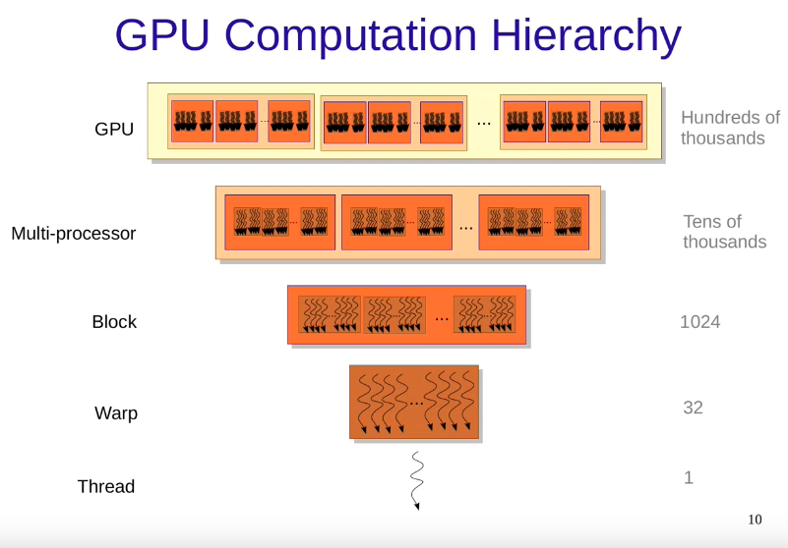
● Notice that every warp has got 32 threads

Warp
A set of consecutive threads ( currently 32 ) that execute in SIMD fashion. SIMD → Single Instruction Multiple Data.
( Very important : Warp-threads are fully synchronized, there is an implicit barrier after each step/instruction ).
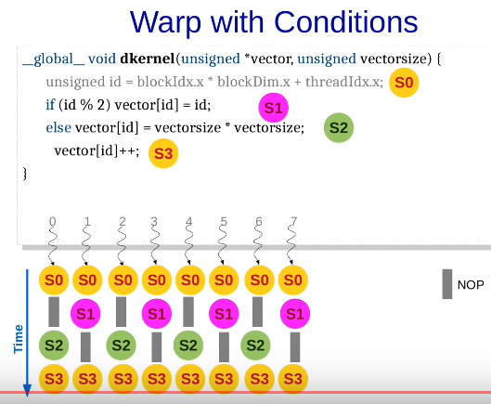
When different warp-threads execute different instructions, threads are said to diverge. Hardware executes threads satisfying same condition together, ensuring that other threads execute a no-op. This adds sequentially to the execution.
This is problem is called thread-divergence. The best way to resolve this is to try to make every thread flow similiar to other.
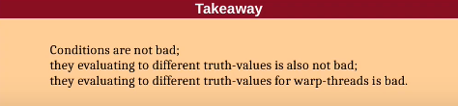
Example:
□ if(vectorsize < N ) S1 ; else S2 ; // they execute in different warp, it is ok!
□ if ( id/32 ) S1 ; else S2 ; // they execute in different warp, it is ok!

Classwork
● Does this code diverge?
__global__ void dkernel( unsigned *vector , unsigned vectorsize ) {
unsigned id = blockIdx.x * blockDIm.x + threadIdx.x;
for ( unsigned ii = 0 ; ii<id ; ++ii ){
vector[id] = ii;
}
}
Solution : yes, it diverge. Because the first thread needs to wait the last thread.
---------------------------→ Start
0 0 0 0
NP 1 1 1
NP NP 2 2
NP NP NP 3
---------------------------→ Finish

● Rewrite the following program fragment to remove thread-divergence.
assert( x == y || x == z );
if( x == y ) x = z;
else x = y;
Solution :
assert ( x == y || x == z );
x = y + z – x;

● How many steps does warp threads take to execute?
__global__ void dkernel( unsigned *vector , unsigned vectorsize ) {
unsigned id = blockIdx.x * blockDIm.x + threadIdx.x;
if ( id <= 0 ){
vector[id] += i;
for ( unsigned i = 1 ; i<=100 ; i++ ){
vector[id] += i;
}
}
else{
vector[id] = 1;
}
}
Solution : 102

Youtube tutorial : < L5 Thread Divergence in CUDA continue>
https://www.youtube.com/watch?v=PuMXrkg09fM

● How many steps does warp threads take to execute?
__global__ void dkernel( unsigned *vector , unsigned vectorsize ) {
unsigned id = blockIdx.x * blockDIm.x + threadIdx.x;
switch(id) {
case 0: vector[id] = 0; break;
case 1: vector[id] = vector[id]; break;
case 2: vector[id] = vector[id-2]; break;
case 3: vector[id] = vector[id+3]; break;
case 4: vector[id] = 4+4+vector[id]; break;
case 5: vector[id] = 5-vector[id]; break;
case 6: vector[id] = vector[6]; break;
case 7: vector[id] = 7+7; break;
case 8: vector[id] = vector[id] + 8; break;
case 9: vector[id] = vector[id] * 9; break;
}
}
Solution : ?

● What is the output?
__global__ void dkernel( unsigned *vector , unsigned vectorsize ) {
if ( threadIdx.x < 16 ) {
printf("Inside If");
Global_Barrier();
}else if ( threadIdx.x >=16 ){
printf("Inside else");
Global_Barrier();
}
}
Solution : “Inside if” x 16 then it crash. ( It is called Deadlock ). Because the first 16 threads are waiting the other that will never execute the first Global_Barrier().

Memory
● Global Memory → Comunicate with the host memory ( CPU ) , long latency access (400-800 cycles ) [ Throughput ⋍ 200GBPS ]
● Texture Memory → Read-only ( 12Kb ) [ Throughput ⋍800GBPS ]
● Costant Memory → Read-only ( 64Kb )
Continue in next chapter...

Youtube tutorial : < L6 Types of memories latency and locality >
● https://www.youtube.com/watch?v=oSHJACJAlgA&list=PL1ysOEBe5977vlocXuRt6KBCYu_sdu1Ru&index=6
P.s → Questa lezione non è stata ascoltata completamente, è stato eseguito un estratto dei concetti principali.

Latency hiding ( I/O )
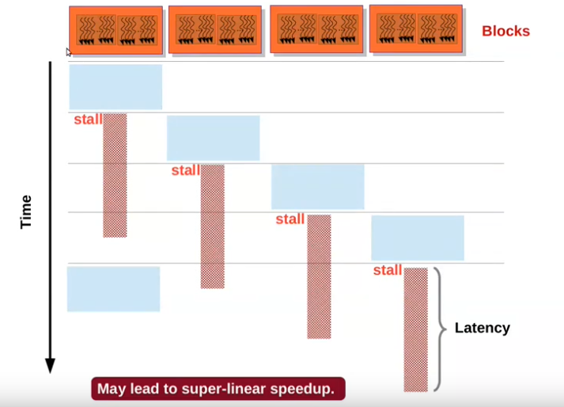

Locality
● All threads in a thread-block access their L1 cache ( usually 64KB )
Spatial
if a[i] is accessed, a[i+k] would also be accessed.
Temporal
if a[i] is accessed now, it would be accessed soon again.

Youtube tutorial : < L7 Memory coalescing and AoS vs SoA>
● https://www.youtube.com/watch?v=6Ulc8EMd_ww&list=PL1ysOEBe5977vlocXuRt6KBCYu_sdu1Ru&index=7&pp=iAQB
P.s → Questa lezione non è stata ascoltata completamente, è stato eseguito un estratto dei concetti principali.

Soa vs Aos
Soa → Structure of Arrays.
Aos → Array of Structurus.
● Example1 : we have to design a struct for a point → int x , int y , int z.
Soa = arrX[] ; arrY[] ; arrZ[] ;
Aos = arrPoints[] ;
● Example2 :
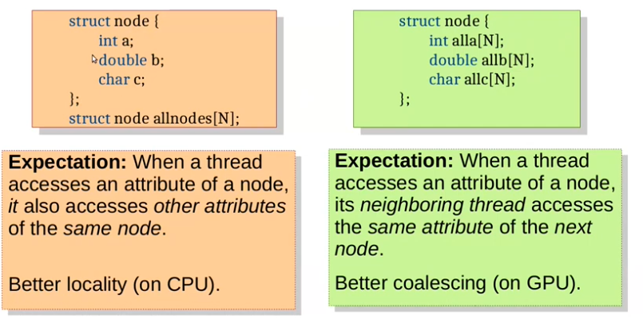

Memory Coalescing ( optimization of load/store instruction )
If warp threads access words from the same block of 32 words, their memory request are clubbed ( raggruppate [IT-Traslation] ) into one.
Without coalescing each load/store instruction would required one memory cicle → A warp would require 32 memory cycles!!! ( in this case GPU would be useful only for compute-heavy kernels, because in the small one load/store would be the majority of the time ).
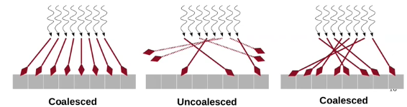

GPU → Is better Coalesced . A chunk should be accessed by consecutive threads. Structure of Arrays ( SoA ) has a better performance.
CPU → Is better Strided. Each thread should accesso consecutive elements of a chunk. Array of Structures (AoS) has a better locality.
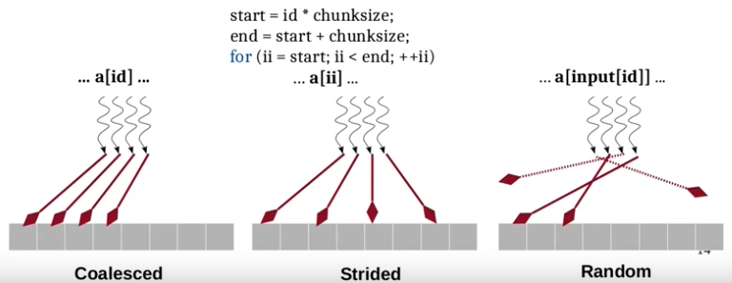

Youtube tutorial : < L8 Shared Memory in CUDA>
● https://youtu.be/6IkIoxuG7Vo?list=PL1ysOEBe5977vlocXuRt6KBCYu_sdu1Ru
P.s → Questa lezione non è stata ascoltata completamente, è stato eseguito un estratto dei concetti principali.

STEP3 – Compilazione ed esecuzione ORB-SLAM – parallelo ✓
Main repository → https://git.hipert.unimore.it/fmuzzini/cuda-accelerated-orb-slam
● Gli step base sono reperibili nello STEP1 – Compilazione ed esecuzione di ORB-SLAM✓

Compilazione ed esecuzione
0. Spostarsi in /ORB-SLAM3
1. Build → ./build.sh
2. Esecuzione → ./Examples/Stereo/stereo_kitti Vocabulary/ORBvoc.txt Examples/Stereo/KITTI04-12.yaml ~/Desktop/dataset/sequences/07
□ Per maggiori dettagli o eventuali problemi→ Compilazione ORB-SLAM3✓
□ Per maggiori dettagli o eventuali problemi → Esecuzione ORB-SLAM3✓

Problemi riscontrati e soluzioni ⚠ → ✓
1. Problema in ORB-SLAM3/CMakeLists.txt e ORB-SLAM3/src/ORBextractor.cc :
- rimossa riga find_package(vpi REQUIRED)
- rimossa riga vpi
- rimossi gli include ineerenti a vpi ( Example : #include <vpi/OpenCVInterop.hpp> … )

2. Se non viene visualizzato il video modificare codice : Examples/Stereo/stereo_kitti.cc ->
ORB_SLAM3::System SLAM(argv[1],argv[2],ORB_SLAM3::System::STEREO,true); ( false -> true )

Suggestions
GPU -> 8.6 ( Versione per la GTX-3060 )

Logs
Day | Topic | Description
27/02/2024 | Tentativo installazione ORB-SLAM3 | Problemi riscontrati con Windows X  ⚬necessario installare Linux.
28/02/2024 | Apprendimento di CUDA | Cuda_tutorial1.pdf
29/02/2024 | Installazione Ubuntu Dual-Boot | Dopo i numerosi problemi riscontrati con Windows, ho eseguito l’installazione Dual Boot di Mint 21.3 ✓
05/03/2024 | Tentativo installazione ORB-SLAM3 + Installazione CUDA | ⚬Installazione CUDA avvenuta con successo. Eseguito alcuni semplici esempi.  ⚬Installazione ORB-SLAM3 Fallita X
06/03/2024 | Lezioni CUDA | L3 : Thread organization and Thread Block  L4 : GPU computation Hierarchy and Matrix Squaring Thread Divergence.
07/03/2024 | Lezioni CUDA + Tentativo installazione ORB-SLAM3 | L5 Thread Divergence in CUDA continue.  ⚬Installazione ORB-SLAM3 Fallita X
12/03/2024 | Tentativo Installazione ORB-SLAM + Tentativo espansione disco su Linux. | ⚬Installazione ORB-SLAM ✓ ⚬Espansione disco ✓
13/03/2024 | Tentativo esecuzione ORB-SLAM | ⚬Esecuzione ORB-SLAM X  → Errore in esecuzione, necessario debug.
14/03/2024 | Tentativo esecuzione ORB-SLAM  Tentativo esecuzione ORB-SLAM versione parallela | ⚬Esecuzione ORB-SLAM ✓  ⚬Esecuzione ORB-SLAM parallelo ✓  ⚬ L6 Types of memories latency and locality.  ⚬ L7 Memory coalescing and AoS vs SoA.
18/03/2024 | ---

Questions

1. Non ho capito questa slide.
