PROMISE Jquery

The .done() method is only called when the Promise resolves (as opposed to .fail(), which is called when the Promise is rejected).

The .then() method accepts a resolved and a rejected callback and is equivalent to using done/fail together, such that:

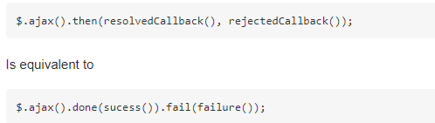

The difference being that multiple .then() can more easily be chained together for more complicated Promise resolution.

The .when() method allows you to encapsulate some logic in a Promise/Deffered/Thenable so that you can use .then(), .done(), and .fail() can be used. This is useful if you have some complex or long running logic you want to execute and need to wrap it in a Promise/Deferred easily. It also make it easier to read:

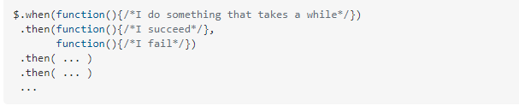

You can then end the chain in an .always() to clean up any sort of result or perform some action that must always happen at the end of your chain,

Using .when(), we can have code wait unit a number of things are complete before proceeding:

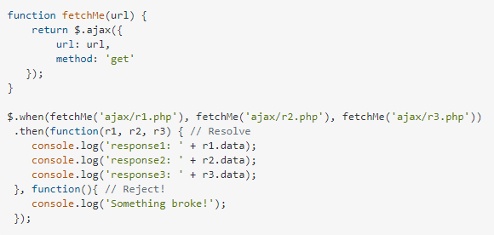

$.Deffered