LINQ

Cosa è:

un linquaggio per lanciare query indipendente dal db (object, xml, db relazionale)

linq lavora con oggetti

LINQ is nothing but the collection of extension methods

for classes that implements IEnumerable and IQueryable interface

**Enumerable** class includes extension methods for the classes that implement [IEnumerable<T>](http://msdn.microsoft.com/en-us/library/9eekhta0(v=vs.110).aspx" \o "IEnumerable<T> class members" \t "_blank) interface, this include all the collection types in [System.Collections.Generic](http://www.tutorialsteacher.com/csharp/csharp-generic-collections" \o "C# Generic collections" \t "_blank) namespaces such as List<T>, Dictionary<T>, SortedList<T>, Queue<T>, HashSet<T>, LinkedList<T> etc.

The**Queryable** class includes extension methods for classes that implement [IQueryable<t>](http://msdn.microsoft.com/en-us/library/vstudio/bb351562(v=vs.100).aspx" \o "IQueryable<T> members" \t "_blank) interface. IQueryable<T> is used to provide querying capabilities against a specific data source where the type of the data is known. For example, Entity Framework api implements IQueryable<T> interface to support LINQ queries with underlaying database like SQL Server.

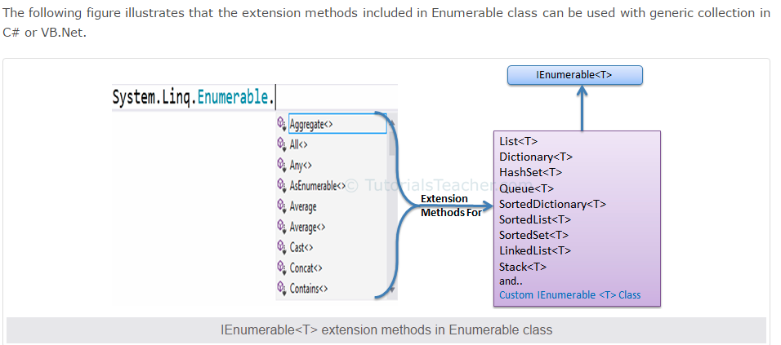

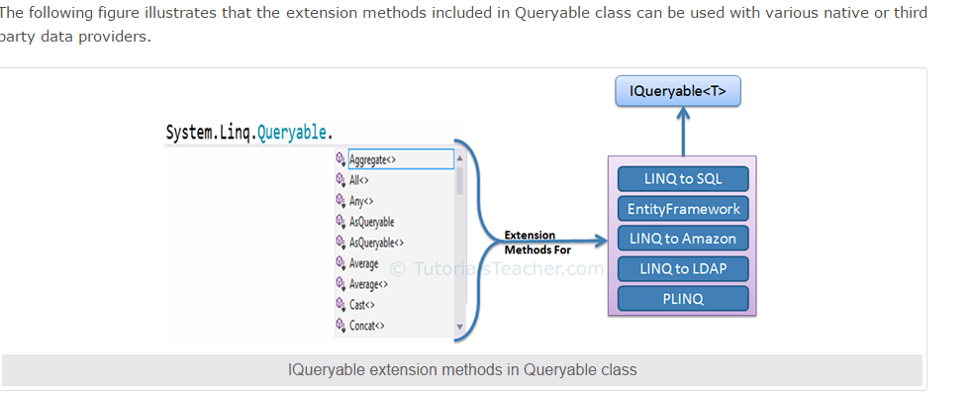

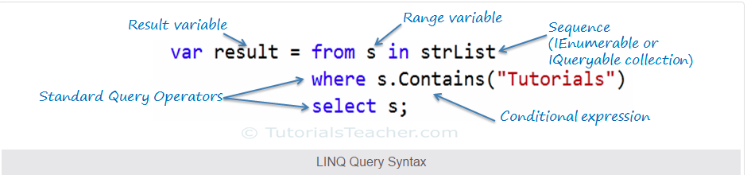



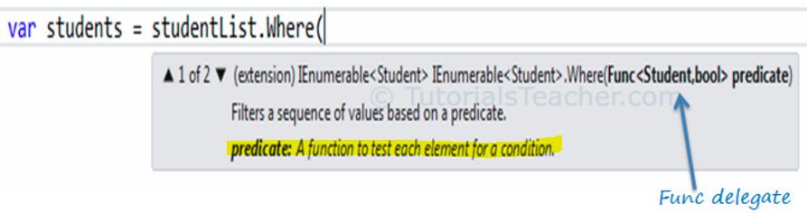

Lambda expression:

The lambda expression is a shorter way of representing [anonymous method](http://www.tutorialsteacher.com/csharp/csharp-anonymous-method) using some special syntax

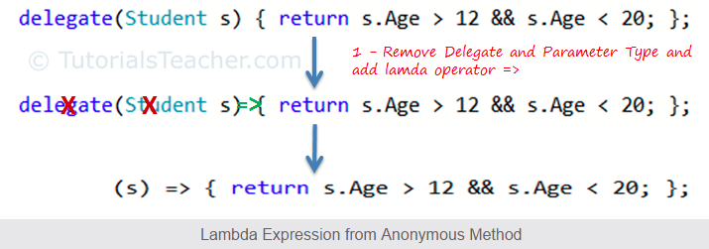

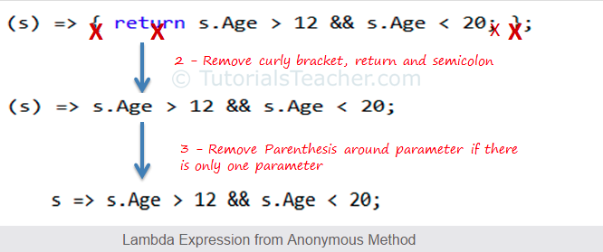

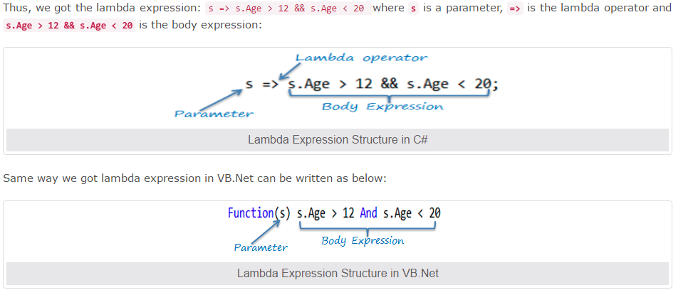

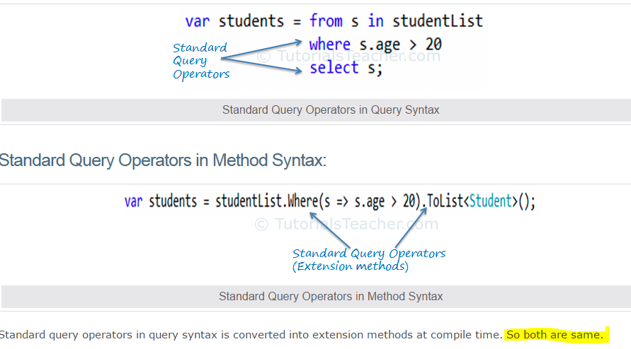

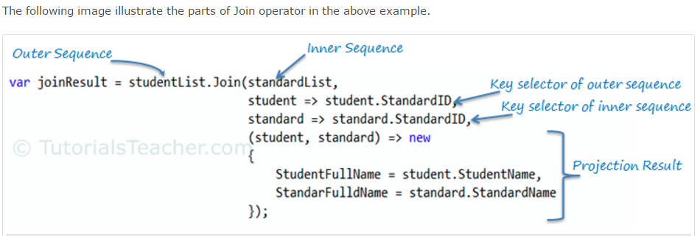

Join operator in query syntax works slightly different than method syntax. It requires outer sequence, inner sequence, key selector and result selector. 'on' keyword is used for key selector where left side of 'equals' operator is outerKeySelector and right side of 'equals' is innerKeySelector.

Group join

