COMPARISON BETWEEN :
1. Combinatorial Gaussian Process Thompson Sampling
2. Combinatorial Gaussian Thompson Sampling

T = 100
exp = 6

1.

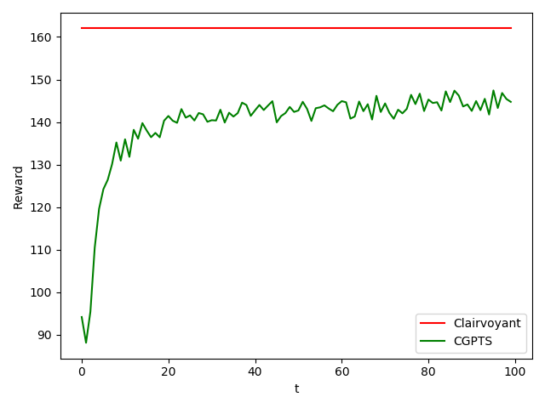

2.
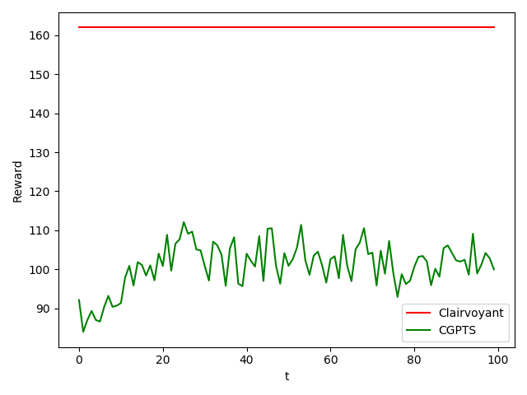
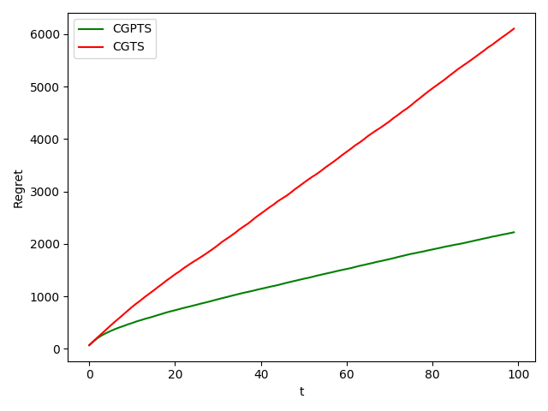

Regret comparison: green (1.), red (2.)

