Combinatorial Gaussian Process Thompson Sampling
forcing to have at least 1-budget for each sub-campaign
T = 100
Exp = 80
optimum = 136
best budgets = []4,1,6,1,7

- CGPTS vs. Clairvoyant reward graph

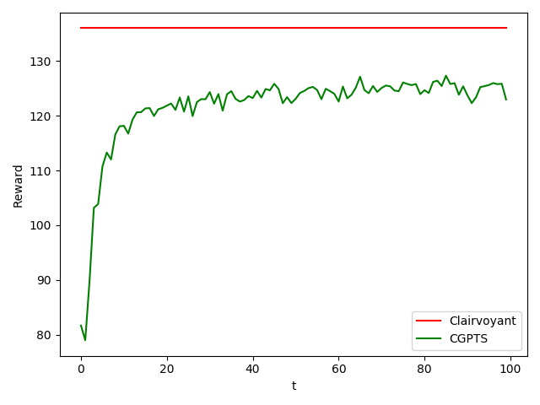

- CGPTS cumulative regret

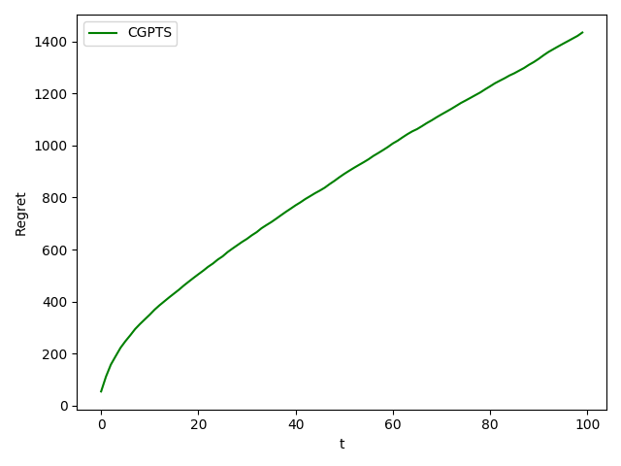

- Gaussian Processes Regression errors

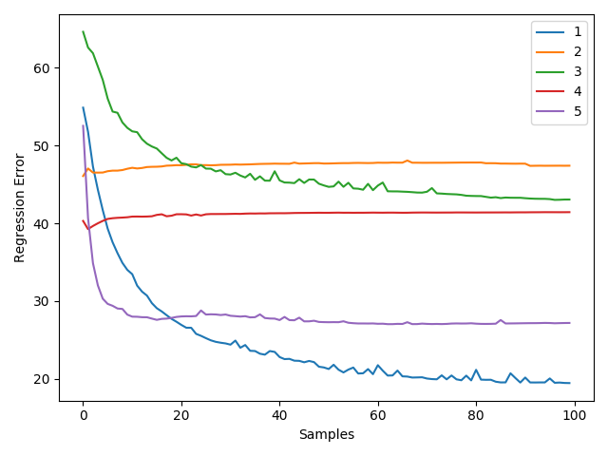

- Gaussian Processes Regression of 1 experiment (optimum 4-1-6-1-7)

