T = 100
Exp = 80
allowing 0-budget for some sub-campaigns

all disaggregated = 62 ← optimum 183 reward ← best budget [0,7,0,7, 0, 5, 0]
disagg c3 = 2
disagg c2 = 16
disagg c1 = 19
no disaggregation = 3

first disaggregation day ~ 28-35
second disaggregation day ~ 42-56

Aggregate reward vs Disaggregate reward
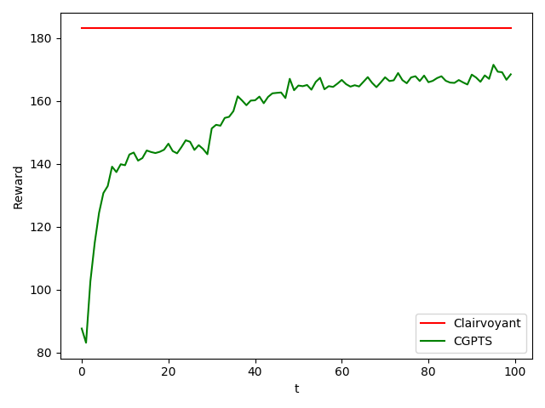
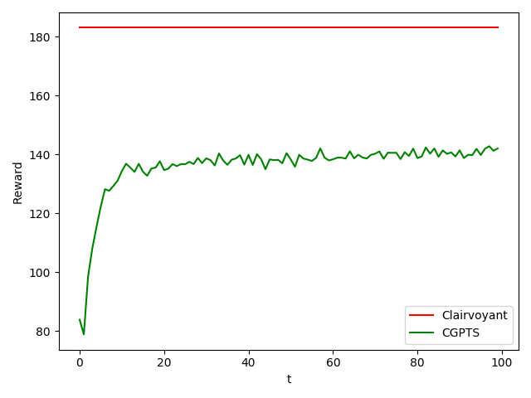

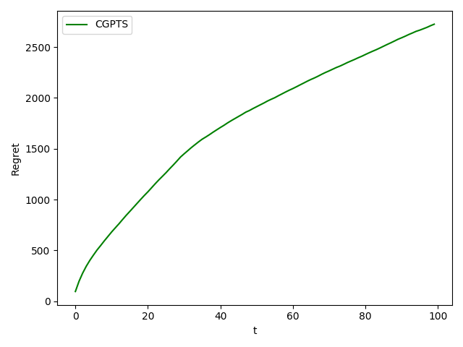
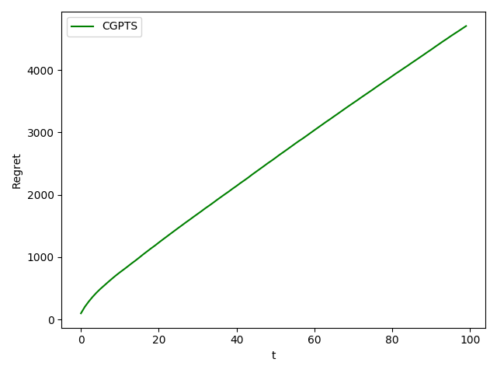
Aggregate regret vs Disaggregate regret

