Data Intelligence Application 2018/19 Project



Pricing

Antoniazzi Matteo (895712)

Bonali Luca (896641)

Chittò Pietro (899045)

Lamparelli Andrea (894005)

Ravelli Leonardo (894222)

Index

1. Introduction

The product we decided to use for this project is the SAMSUNG GALAXY S10. This product is brand new, so we based our assumption on the previous model, the Samsung Galaxy S9 and, more in general, looking at the past trends in the smartphones market.

1.1 Product description

The Samsung Galaxy S10 was released on the 8th March 2019.

It’s an Android smartphone manufactured by Samsung Electronics and, leaving out all the technical specifications, we consider it as a very popular product (Samsung is one of the most popular smartphone brands together with Apple Inc. and Huawei) with a trend like its past models and other competitors’ products.

We consider it as user friendly and less “iconic” than the Apple products.

We hypothesized a production cost of 350€, relying on the information found in Internet.

2. Classes and environment description

2.1 Features Selection

We describe our possible customers by means of 3 main features, with the following values:

* Age: Students, Workers, Retires
* Sex: Male, Female
* Region: Advanced economies, Less developed

We indeed assumed that the behaviour of a male customer is different from a female one and, similarly, a customer from an economic advanced country will behave differently form a less developed one (*See chapter: 2.2 Class descriptions*).

Note: firstly, for the Region feature, we’ve also considered the “Poor countries”, but then we decided to remove them because they’re out of the market we’re considering.

2.2 Class descriptions

In the following tables we show how, using the previous explained features, we’ve created our main class of customers.

For readability, we split the 3D features tensor into 2 tables according to the feature sex. In each cell of the table we reported the probability of a user to belong to that specific class.

Each colour represents one class.

|  |  |  |  |
| --- | --- | --- | --- |
| **MALE 0.5** | Students 0.35 | Workers 0.45 | Retires 0.2 |
| Advanced Economies 0.6 | 0,105 | 0,135 | 0,06 |
| Less Developed 0.4 | 0,07 | 0,09 | 0,04 |

|  |  |  |  |
| --- | --- | --- | --- |
| **FEMALE 0.5** | Students 0.35 | Workers 0.45 | Retires 0.2 |
| Advanced Economies 0.6 | 0,105 | 0,135 | 0,06 |
| Less Developed 0.4 | 0,07 | 0,09 | 0,04 |

* **Class 1:** this class is characterized by the male students and workers of the economic advanced countries and the female workers of these ones. We assume that the members of this class have no problem in paying higher prices for buying our product that is indeed user friendly.
* **Class 2:** in this class we can find the students and the workers of the less developed countries. Young girls of the developed countries behave similarly to the previous customers because, we assumed, that they’re more interested in a more “iconic” and famous phone like the Apple ones. Here, the members prefer to pay our product at lower price because, we supposed, that they have not much money to spend.
* **Class 3:** this class is composed by the male and female retires of all the kind of country. This class’ members are not very interested in buying expensive phones because, we assumed, they prefer simpler and cheaper phones. In this class there also a small group of particularly rich members that consider the goodness of a phone proportionally to its price, but there are very few.

2.3 Phases and curves

We identified 4 different phases in our scenario:

1. Market launch: this is the first phase, when the product enters the market. We assumed that for the first 3 months the demand for all the classes remains approximatively the same, after that, we hypothesized some smooth changes, in particular in the medium-high price range.
   * *Class 1*: here the demand is overall high for the prices below 1000€, after which decreases. We assumed that the customers evaluate our product basing on the price of the previous model at the same phase.
   * *Class 2*: in this class the customers have less money than the previous ones, so the demand decreases if the price exceeds 500€.
   * *Class 3*: the demand is generally low since the customers of this class are not very interested in buying our product.

|  |  |  |
| --- | --- | --- |
| Phase | Period | Duration |
| Market launch | From February to August | 7 months |

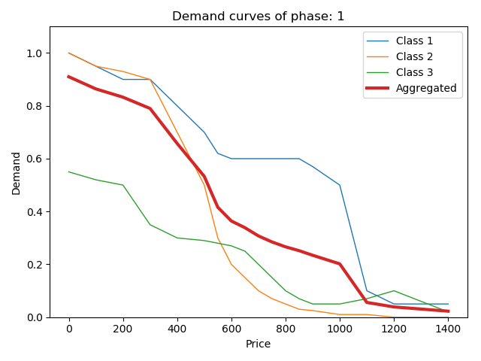Demand curves:

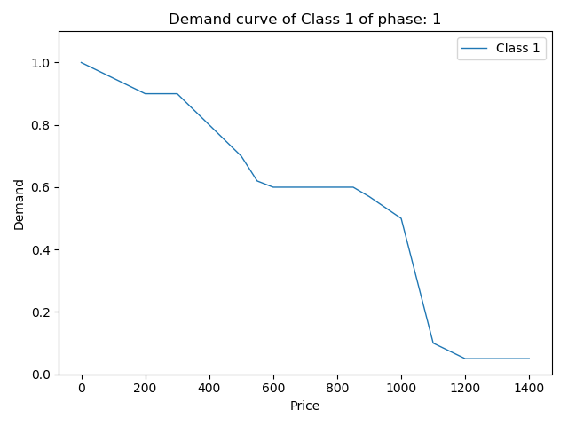

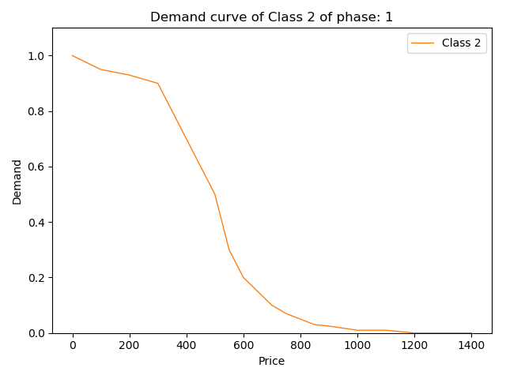

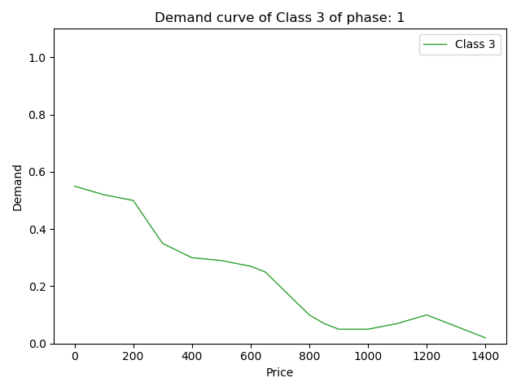

1. Competitors’ new products: we assumed that in September the 2 main Samsung’s competitors (Apple Inc. and Huawei) decide to release their new products. This leads to an abrupt change in the demand that decrease drastically for high prices.
   * *Class 1*: the demand falls for prices above 400€; we assumed that this kind of customers prefers, cost being equal, to buy the new smartphone in the market (we’ve assumed the new iPhone model).
   * *Class 2*: similar consideration for this type of customers, that prefers to buy a new and cheaper phone (the new Huawei model in this case).
   * *Class 3*: the demand softly decreases and there is a flattening of the demand of what we previously called rich members. As we already said, these few people consider the last released smartphone as the best in the market.

|  |  |  |
| --- | --- | --- |
| Phase | Period | Duration |
| Competitors’ new product | From September to November | 3 months |

Demand curves:

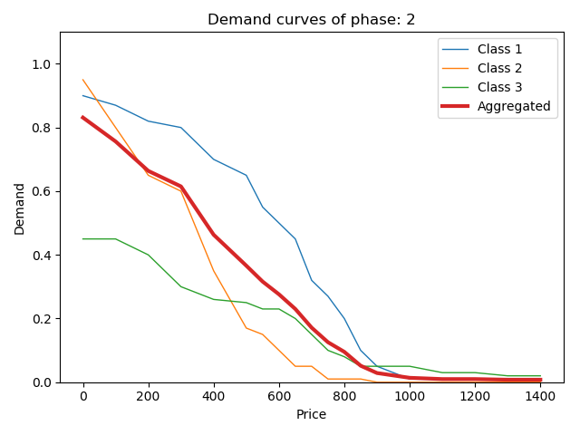

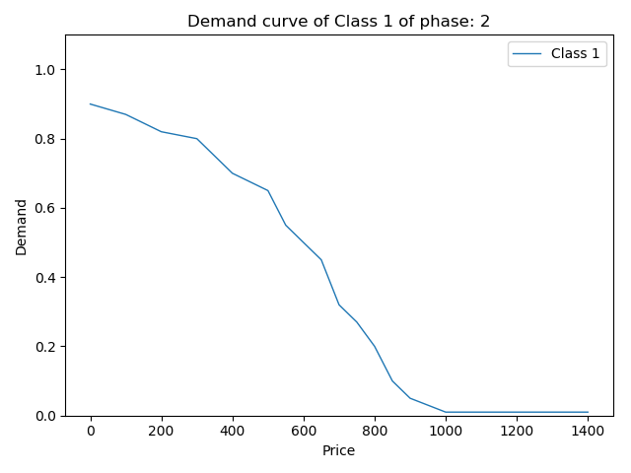

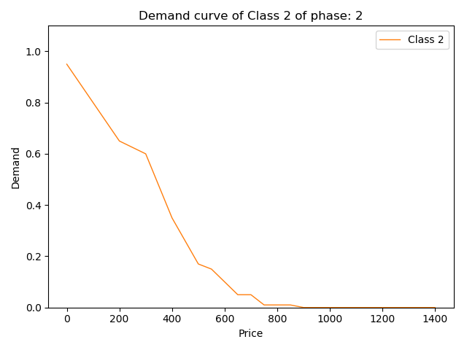

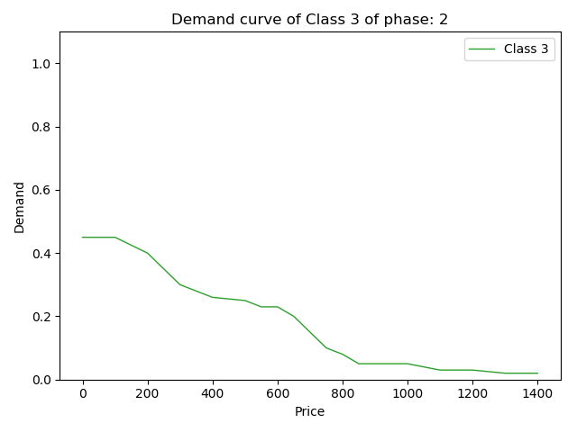

1. Holiday: we hypothesized that during winter holidays, due to the fact that there are several festivities, people increase the demand, because, usually, technologic product are a very popular gift.
   * *Class 1*: the demand remains more or less the same for lower prices (people take advantage of holiday offers for example) and increase a little bit for medium-higher prices (this kind of customers allows himself to spend a little more for a gift)
   * *Class 2*: here the demand increases a little bit for lower prices (again for holiday offers) and remains the same for the others.
   * *Class 3*: also in this class the demand increases a little, especially for very high prices, due to the rich members. However, it decreases for medium prices range (we assumed that retirees – not the rich group – don’t spend too much money for a not well-known product).

|  |  |  |
| --- | --- | --- |
| Phase | Period | Duration |
| Holiday | From December to January | 2 months |

Demand curves

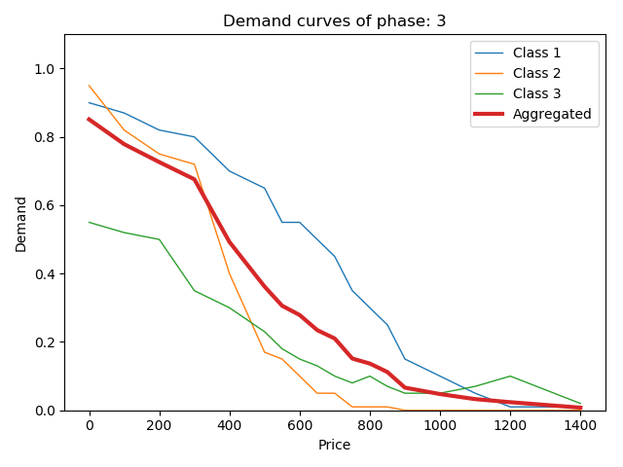

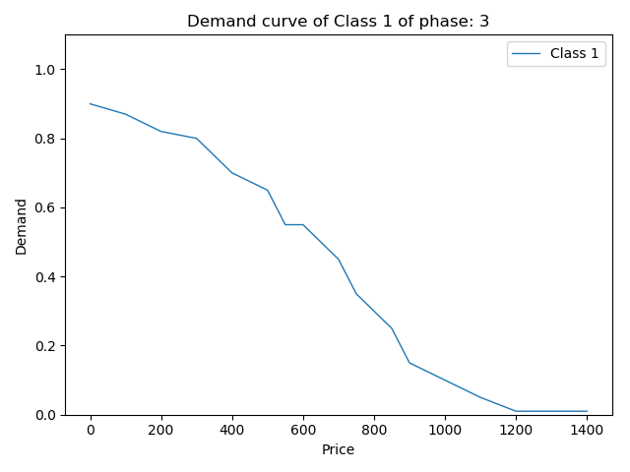

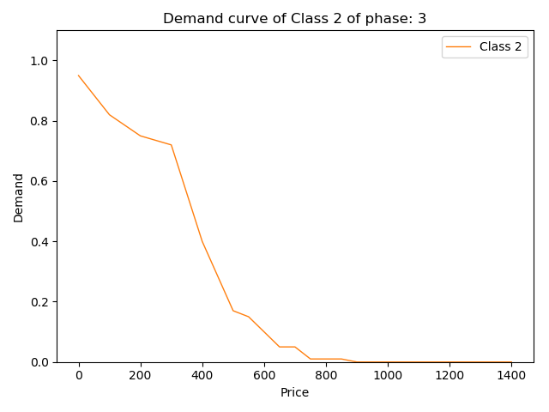

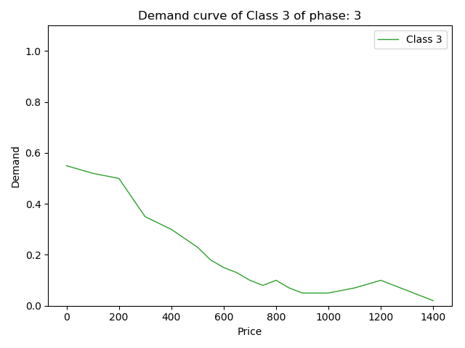

1. New model: Samsung releases the new smartphone model (Samsung Galaxy S11). This is the last phase we decided to consider.
   * *Class 1*: because this class of customer is predominantly composed by wealthy people, as soon as the new model of a smartphone is released, the demand strongly decreases, also due to the fact that, in general, the price of the new model is close to the previous model release price.
   * *Class 2*: the demand increases for low prices because usually, as soon as the new model is released, the prices of the previous models decrease. Instead, for higher prices it decreases due to the fact that this kind of customers prefer to keep their money for the new model.
   * *Class 3*: the demand trend returns as in the competitors’ new product phase. The motivations are very similar of the ones expressed in the aforementioned phase.

|  |  |  |
| --- | --- | --- |
| Phase | Period | Duration |
| New model | From February to April | 3 months |

Demand curves:

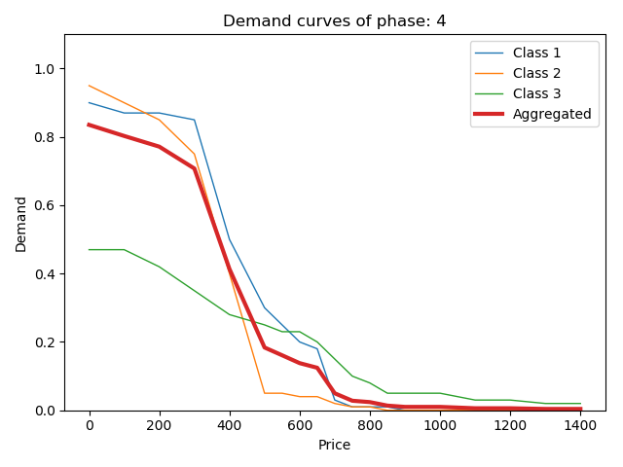

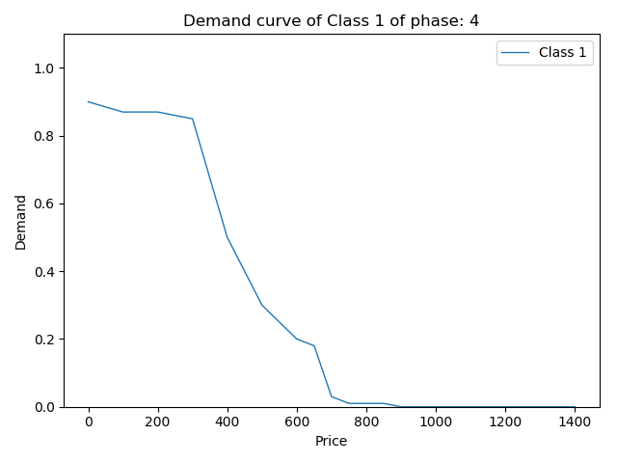

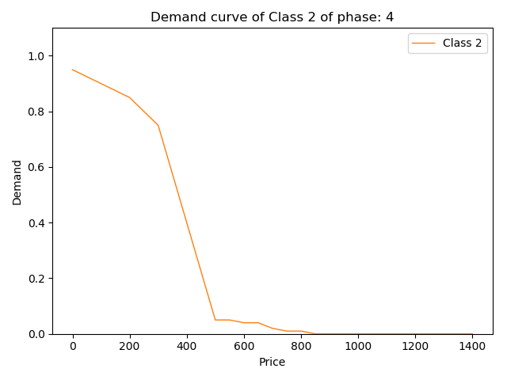

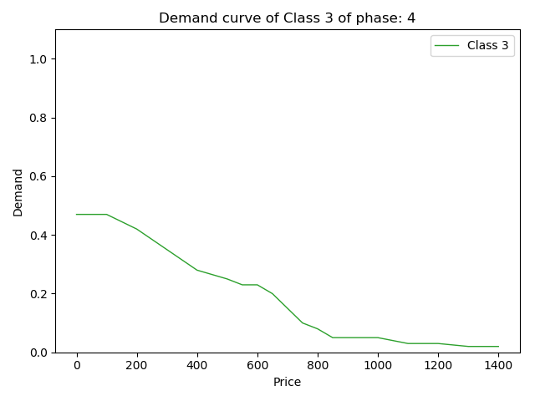

3. Time horizon and candidates

3.1 Time horizon

The time horizon we decided to consider (as already introduced in the phases description) starts from February 2019 and it ends in April 2020. Considering an average of 30 days per month and a total of 15 months we obtain a time horizon of 450 days.

3.2 Candidates selection

We considered a price range from 0€ to 1400€ and we identified 19 possible prices/candidates:

We divided the range into intervals of 100€, except for the prices from 500€ to 900€ where we reduced the interval to 50€, because we assumed that in this range a small variation of the price would lead in a significant variation in customers behaviour and so in the demand curve.

|  |  |  |  |  |  |  |  |  |  |  |
| --- | --- | --- | --- | --- | --- | --- | --- | --- | --- | --- |
| 0 | 100 | 200 | 300 | 400 |  | 1000 | 1100 | 1200 | 1300 | 1400 |

|  |  |  |  |  |  |  |  |  |
| --- | --- | --- | --- | --- | --- | --- | --- | --- |
| 500 | 550 | 600 | 650 | 700 | 750 | 800 | 850 | 900 |

Despite we already known that the **highlighted prices** would get us a negative reward (since we supposed a production cost of 350€ for unit) we decided to leave them in our algorithm to have a more complete analysis.

4. Aggregated demand curve

In this section we’ll show the result we obtained considering the aggregated demand curve. This curve is computed as the weighted sum of the demands of the single classes:

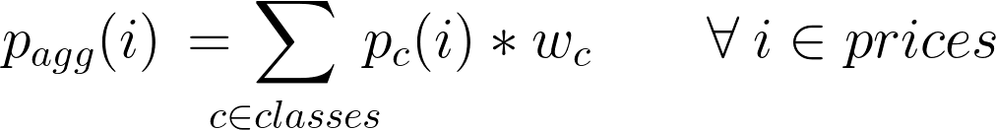

Where pagg(i) is the percentage of customers that would buy our product at price *i*. In our experiment we use these percentage as probabilities for the conversion rate.

4.1 K-testing

Because the Sequential A/B testing is not practical and difficult to perform in a non-stationary environment, we decided to consider only the first phase demand curve during all the time of the test.

We perform the sequential A/B testing comparing the candidates 2 by 2 from the lower to the higher.

* Hypothesis definition:

|  |  |  |
| --- | --- | --- |
| Hypothesis | | Action performed |
| H0 | u1 = u2 | Select the new price/candidate |
| H1 | u1 > u2 | Keep the old price/candidate |

* Accuracy selection:

|  |  |
| --- | --- |
| Parameter | Value |
| Significance level | 0.005 |
| Power level | 0.85 |
| Alternative hypothesis relaxing coefficient | 0.05 |

* Number of sample selection. Each time we perform the single A/B testing we compute the minimum number of samples needed to take a good decision. This is done at every comparison because the number of samples is dependent by the standard deviation of the two current candidates:

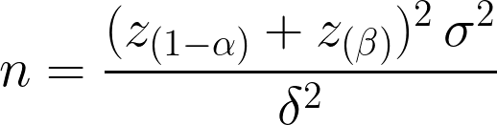

With:

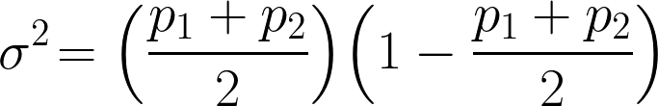

* Statistic computation: if *z* is greater than *z(1-α)* then the null hypothesis is rejected.

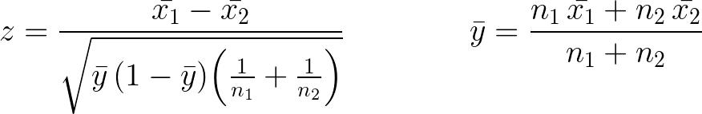

If, for some reason, one between x1 or x2 is 0, we directly use the probability associated to each candidate (respectively p1 and p2).

At the end of the experiment the Sequential A/B testing gave us that the best-selling price for the first phase is *1000 €*.

4.2 UCB1/TS

Results of the UCB1 and Thomson Sampling algorithms applied in the non-stationary environment that we’ve described previously (*See chapter: 2.3 Phases*).

We decided to set *20 samples per day* and to run 100 experiments. So, considering the time horizon of 450 days, we have a total number of 9000 sample per experiment.

4.2.1 UCB1

Here we report the reward and the regret of the UCB1 algorithm:

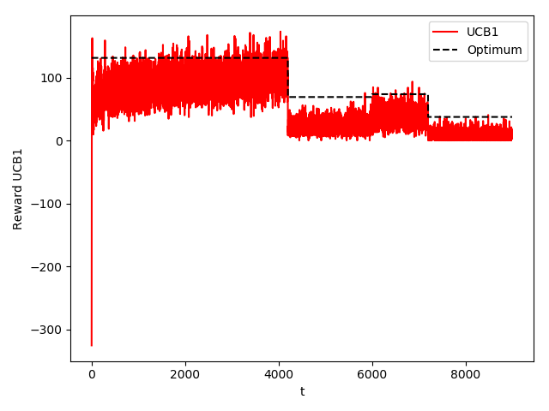

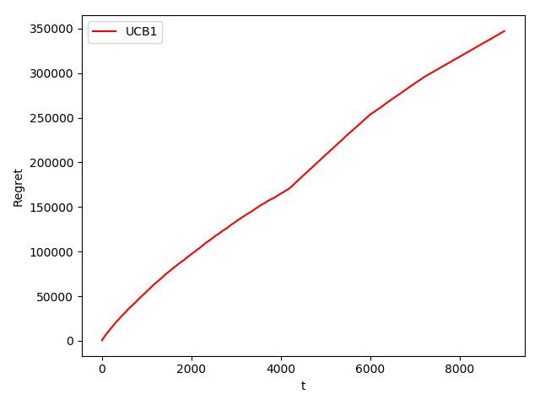

4.2.2 TS

Here we report the reward and the regret of the Thomson Sampling algorithm:

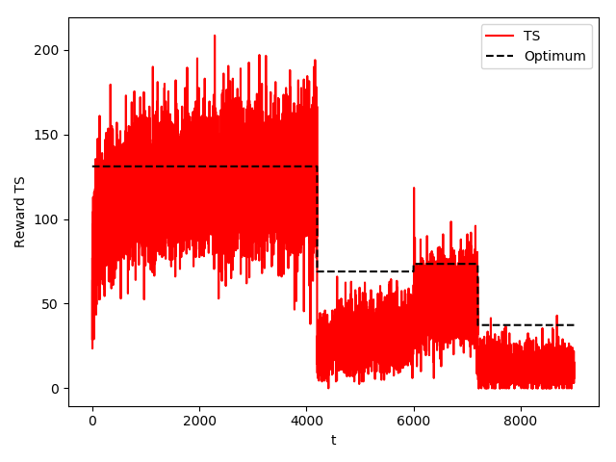

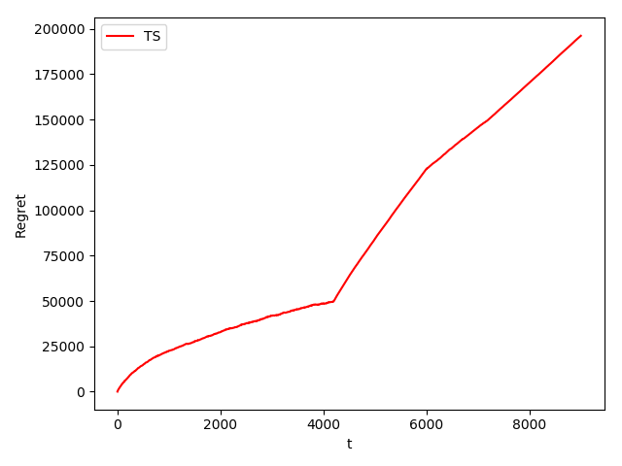

Since the environment is non-stationary the 2 algorithms don’t perform very well. The last three phases are too short and the algorithms haven’t the time to learn the optimum.

4.3 SW-UCB1/SW-TS

Results of the Sliding Window UCB1 and Sliding Window Thomson Sampling algorithms applied in the non-stationary environment that we’ve described previously (*See chapter: 2.3 Phases*).

Here we set the length of the Sliding Window as: $\sqrt[2]{9000}$

4.3.1 SW-UCB1

Here we report the reward and the regret of the Sliding Window UCB1 algorithm:

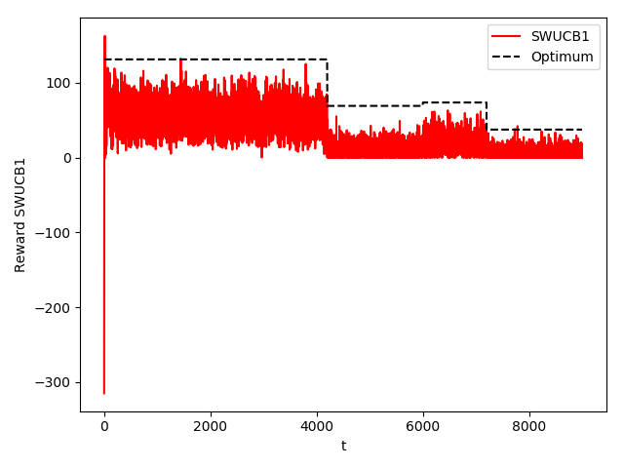

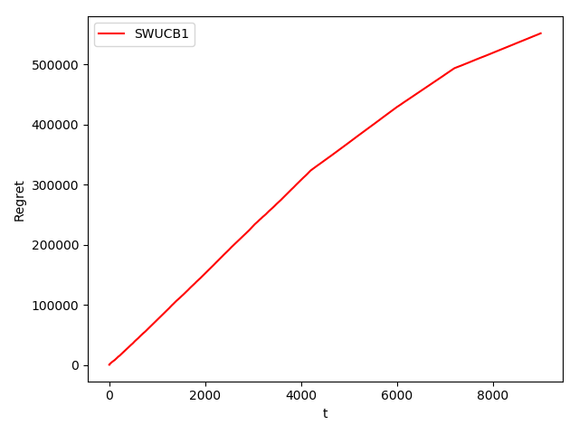

4.3.2 SW-TS

Here we report the reward and the regret of the Sliding Window Thomson Sampling algorithm:

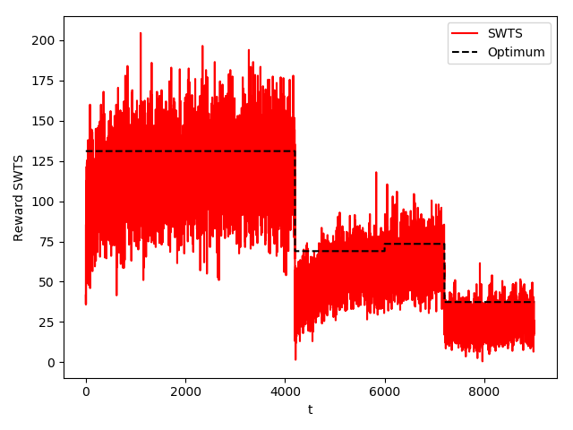

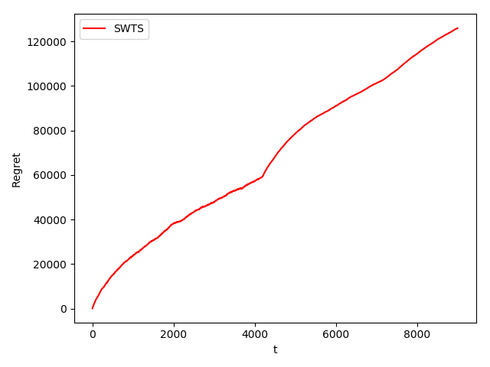

5. Disaggregation

5.1 Description

5.2 UCB/TS

5.2.1 UCB1

5.2.2 TS

5.3 SW-UCB1/SW-TS

5.3.1 SW-UCB1

5.3.2 SW-TS

6. Conclusion

Everything is fine!