**CustomerSvc – short description**

**1. Structure of the application**

CustomerSvc consists of 6 projects:

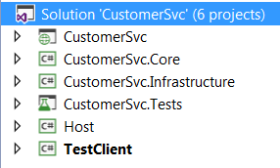

- **CustomerSvc** –includes exposed methods which can be used by client

- **CustomerSvc.Core** – includes interfaces for repositories and model’s classes

- **CustomerSvc.Infrastructure** – includes database context and repositories

- **CustomerSvc.Tests** – includes unit tests for the solution

- **Host** – additional project for running the service

- **TestClient** – additional project for running the test client.

**2. How to start?**

Before you start, ensure that every *App.Config* and *Web.Config* file is updated with the correct connection string’s **Data Source** parameter:



Change it to your local database server’s name.

First it is necessary to build **Host** project and run **Host.exe** to start the service. The following console should appear:

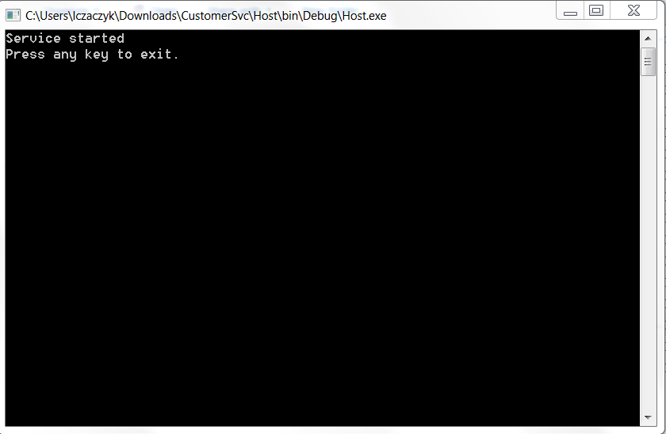

Then the solution can be run with **TestClient** as a startup project. In the main program class there are some test calls showing the data processing in the console application.

