**CHAPELLE Luca & CHEVALLIER Nathan**

**TP1:**

**Question 1**

**a)**

USING PERIODIC COMMIT 10

LOAD CSV WITH HEADERS FROM "file:///Restaurant_3sur4_50.txt" AS row

MERGE (:receipt{Client:row.receipt})

MERGE (:product_name{Produit:row.product_name})

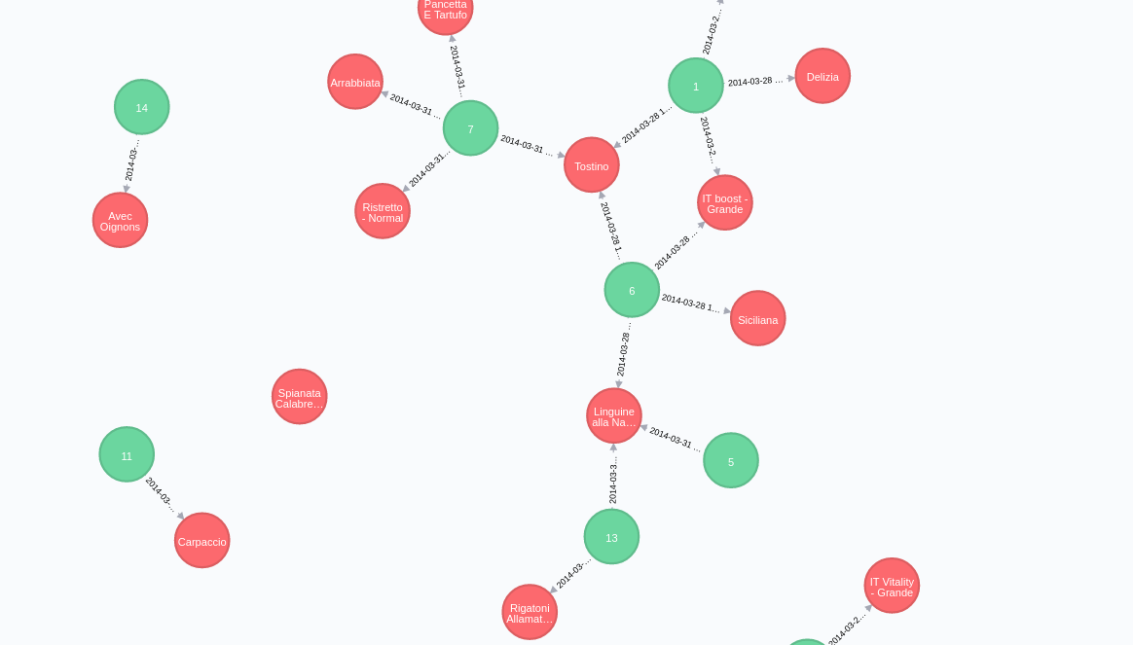

MATCH (n) RETURN n LIMIT 25

--> voir tt limite a 25

**C)**

USING PERIODIC COMMIT 10

LOAD CSV WITH HEADERS FROM "file:///Restaurant_3sur4_50.txt" AS row

MATCH (r:receipt{Client:row.receipt})

MATCH (p:product_name{Produit:row.product_name})

MERGE (r)-[c:commande]->(p)

**E) F) G) Rajout de la quantité, le prix et date :**

USING PERIODIC COMMIT 10

LOAD CSV WITH HEADERS FROM "file:///Restaurant_3sur4_50.txt" AS row

MATCH (r:receipt{Client:row.receipt})

MATCH (p:product_name{Produit:row.product_name})

MERGE (r)-[c:commande]->(p)

SET c.quantite = row.quantity

SET c.date = row.date

SET p.prix = row.price

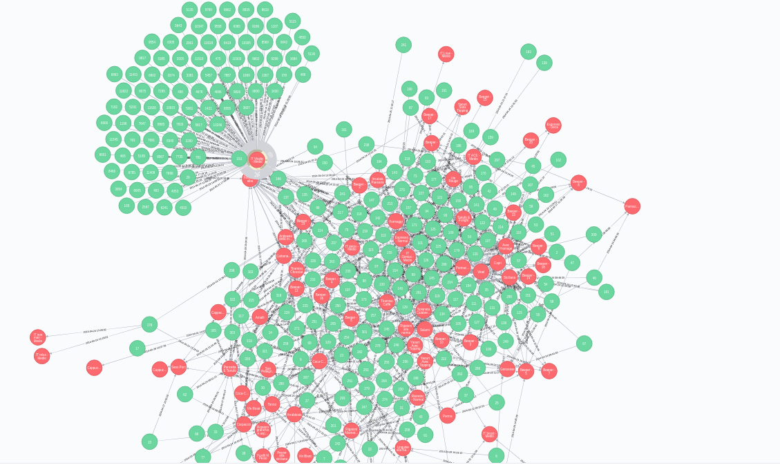

Question 2

**Créé le noeud Vin :**

MERGE (:Vin)

**Voir tous les produits ou il y a le mot vin dedans**

MATCH (n:product_name)

WHERE n.Produit =~'.*Vin .*'

RETURN n.Produit

**Rajoutez liaisons vins**

MATCH (n:Vin),(m:product_name)

WHERE m.Produit=~'.*Vin .*'

MERGE (n)-[:estunVin]-(m)

**Voir tous les produits ou il y a le mot Biere dedans**

MATCH (n:product_name)

WHERE n.Produit =~'.*Birra .*'

RETURN n.Produit

**Voir tous les produits ou il y a le mot Boisson gazeuse dedans**

MATCH (n:BoissonG),(m:product_name)

WHERE m.Produit=~'.*(Coca|San Pellegrino|Limonata|Ga).*'

MERGE (n)-[:estuneBoissonGazeuse]-(m)

**Top 5 vin**

MATCH (r:receipt)

MATCH (p:product_name)

MATCH (r)-[c:commande]->(p)--(:Vin)

RETURN p, count(r) order by count(r) desc limit 5

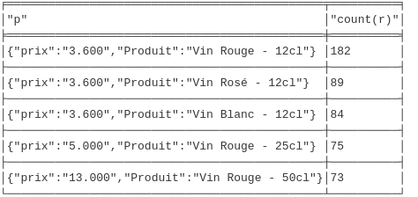

**Top 5 bierre**

MATCH (r:receipt)

MATCH (p:product_name)

MATCH (r)-[c:commande]->(p)--(:Birra)

RETURN p, count(r) order by count(r) desc limit 5

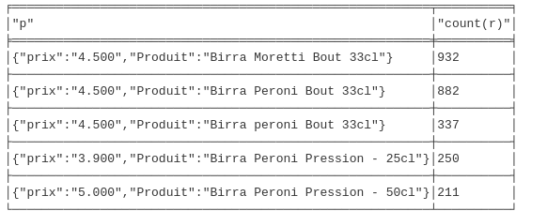

**Top 5 boisson gazeuse**

MATCH (r:receipt)

MATCH (p:product_name)

MATCH (r)-[c:commande]->(p)--(: BoissonG)

RETURN p, count(r) order by count(r) desc limit 5

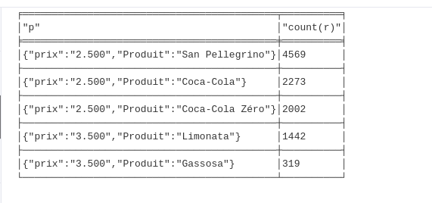

**Top5 des plats**

MATCH (r:receipt)

MATCH (p:product_name)

MATCH (r)-[c:commande]->(p)

WHERE not (p)--(:BoissonG) and not p.Produit=~'.*(Espresso|Vittel|Caffè).*'

RETURN p, count(r) order by count(r) desc limit 5

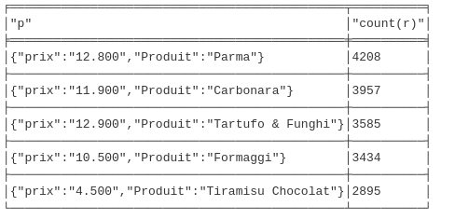

**Top 5 des plats en 05-2014**

MATCH (r:receipt)

MATCH (p:product_name)

MATCH (r)-[c:commande]->(p)

WHERE SUBSTRING(c.date,0,7) = "2014-05"

RETURN p, count(r) order by count(r) desc limit 5

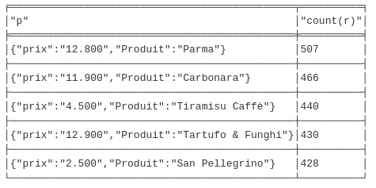

TOP 5 mois par mois

MATCH (r:receipt)-[c:commande]->(p:product_name)

WITH SUBSTRING(c.date,0,7) AS date,p,count(r) AS qte order by qte desc

RETURN date,collect([p.Produit,qte])[..5] order by date

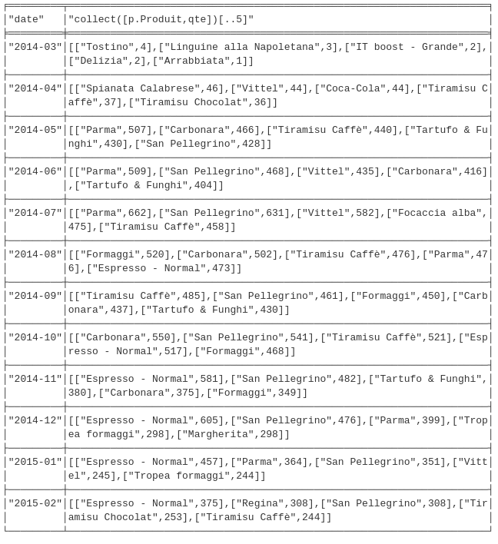

--------------------------------------------------------------------------------

**TP2**

**a)**

iMATCH (r:receipt)-[c:commande]->(p:product_name)

RETURN r,collect(p.Produit)

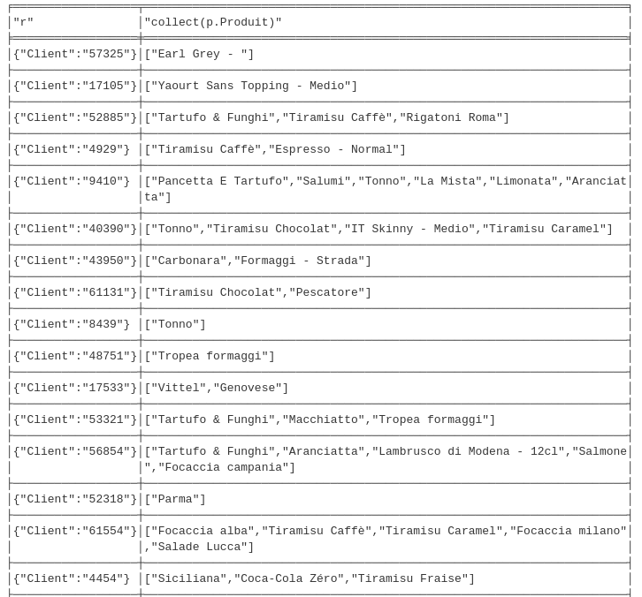

**b)**

MATCH (p:product_name)-[c:commande]-(r:receipt)

WITH r,collect(toFloat(p.prix)*toFloat(c.quantite)) AS total

RETURN r,Reduce(t=0.0, val IN total | t+val)AS prix_total order by prix_total desc

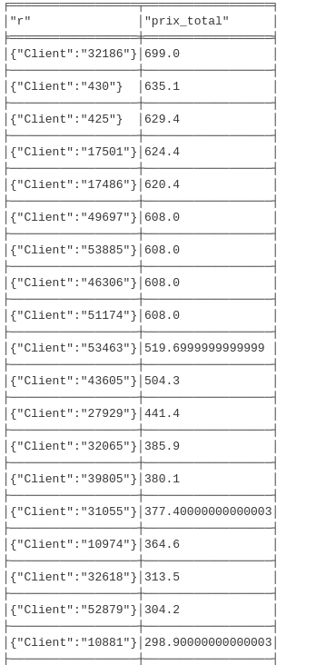

**c)**

MATCH (p:product_name)-[c:commande]-(r:receipt)

WITH r,collect(toFloat(p.prix)*toFloat(c.quantite)) AS total

WITH r,Reduce(t=0.0, val IN total | t+val)AS prix_total

with collect(prix_total) as variable

return Reduce(t=0.0, val IN variable | t+val)/size(variable) AS moyenne

