Background:

I’m using a Sentiment Analysis engine to process a number of texts (scrips, books, plays, etc…) in an attempt to try and classify them into categories as proposed by writer Kurt Vonnegut. The engine processes natural language, assigning each sentence a score based largely, but not wholly, on how positive or negative the words in the sentence are. Scores are between -1 (negative sentiment) and 1 (positive sentiment) at points throughout the course of the text. The scores for ranges of sentences are averaged to produce a smoothed graph.

As a sub-study, I am looking at the accuracy of the produced graphs when compared to people’s expectations of given texts, specifically various Shakespeare plays.

# A Midsummer Night’s Dream

## Please draw what you would expect the graph of this play to look like:

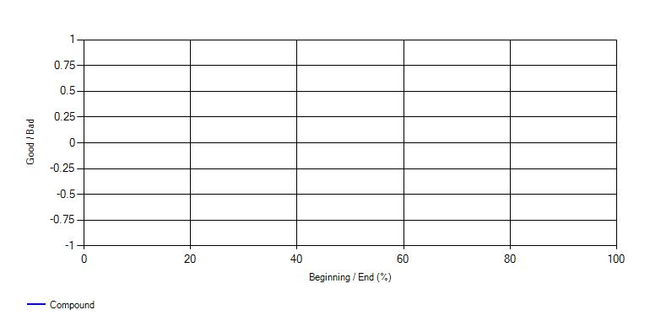

## Can you explain briefly the reasons for any peaks or troughs in your graph?

## This graph produced. Can you justify differences between this and your graph?

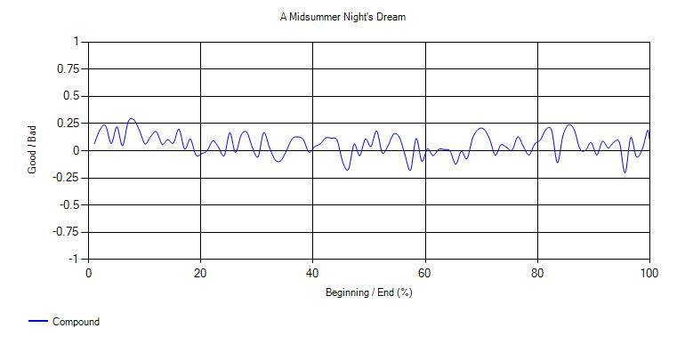

# Hamlet

## Please draw what you would expect the graph of this play to look like:



## Can you explain briefly the reasons for any peaks or troughs in your graph?

## This graph produced. Can you justify differences between this and your graph?

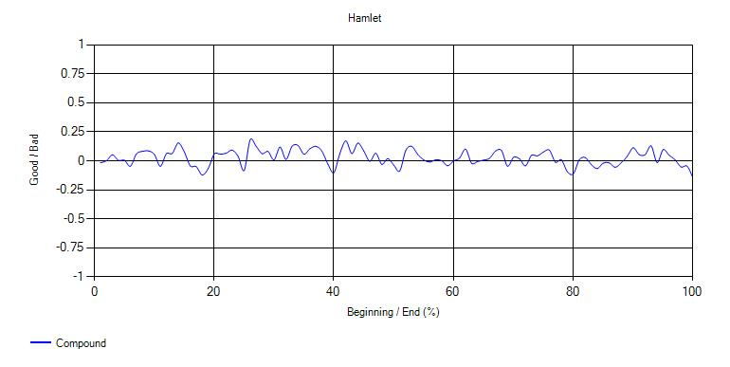

# Macbeth

## Please draw what you would expect the graph of this play to look like:



## Can you explain briefly the reasons for any peaks or troughs in your graph?

## This graph produced. Can you justify differences between this and your graph?

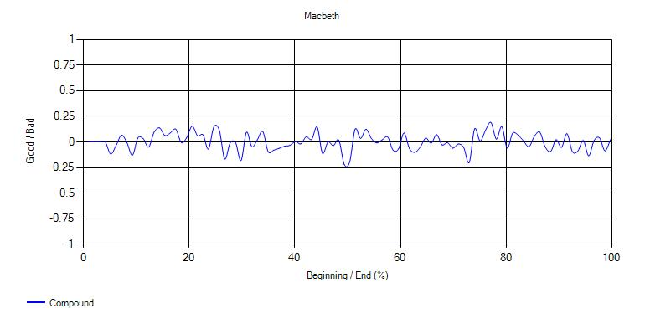

# Romeo and Juliet

## Please draw what you would expect the graph of this play to look like:



## Can you explain briefly the reasons for any peaks or troughs in your graph?

## This graph produced. Can you justify differences between this and your graph?

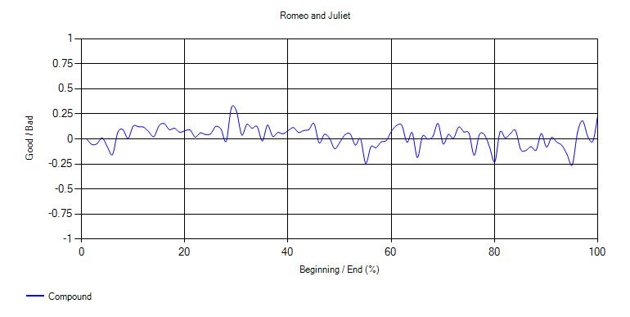

# The Tempest

## Please draw what you would expect the graph of this play to look like:



## Can you explain briefly the reasons for any peaks or troughs in your graph?

## This graph produced. Can you justify differences between this and your graph?

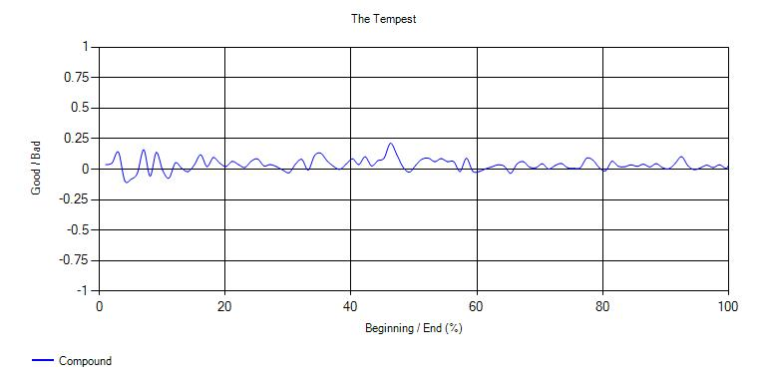

# Twelfth Night

## Please draw what you would expect the graph of this play to look like:



## Can you explain briefly the reasons for any peaks or troughs in your graph?

## This graph produced. Can you justify differences between this and your graph?

