# ----------------------------------------------------------------------

# Name Type Size Value

# ----------------------------------------------------------------------

# uvm_test_top udp_reader_uvm_test - @359

# env udp_reader_uvm_env - @371

# agent udp_reader_uvm_agent - @379

# agent_ap_compare uvm_analysis_port - @413

# agent_ap_output uvm_analysis_port - @404

# drvr udp_reader_uvm_driver - @545

# rsp_port uvm_analysis_port - @562

# seq_item_port uvm_seq_item_pull_port - @553

# mon_cmp udp_reader_uvm_monitor_compare - @579

# mon_ap_compare uvm_analysis_port - @589

# mon_out udp_reader_uvm_monitor_output - @571

# mon_ap_output uvm_analysis_port - @599

# seqr uvm_sequencer - @422

# rsp_export uvm_analysis_export - @430

# seq_item_export uvm_seq_item_pull_imp - @536

# arbitration_queue array 0 -

# lock_queue array 0 -

# num_last_reqs integral 32 'd1

# num_last_rsps integral 32 'd1

# sb udp_reader_uvm_scoreboard - @387

# compare_fifo uvm_tlm_analysis_fifo #(T) - @684

# analysis_export uvm_analysis_imp - @728

# get_ap uvm_analysis_port - @719

# get_peek_export uvm_get_peek_imp - @701

# put_ap uvm_analysis_port - @710

# put_export uvm_put_imp - @692

# output_fifo uvm_tlm_analysis_fifo #(T) - @631

# analysis_export uvm_analysis_imp - @675

# get_ap uvm_analysis_port - @666

# get_peek_export uvm_get_peek_imp - @648

# put_ap uvm_analysis_port - @657

# put_export uvm_put_imp - @639

# sb_export_compare uvm_analysis_export - @622

# sb_export_output uvm_analysis_export - @613

# ----------------------------------------------------------------------

#

# UVM_INFO ../uvm/udp_reader_uvm_sequence.sv(37) @ 0: uvm_test_top.env.agent.seqr@@seq [SEQ_RUN] Loading file ../source/test.pcap...

# UVM_INFO ../uvm/udp_reader_uvm_sequence.sv(54) @ 0: uvm_test_top.env.agent.seqr@@seq [SEQ_RUN] Packet size: 1066

# UVM_INFO ../uvm/udp_reader_uvm_sequence.sv(54) @ 10665: uvm_test_top.env.agent.seqr@@seq [SEQ_RUN] Packet size: 1066

# UVM_INFO ../uvm/udp_reader_uvm_sequence.sv(54) @ 21325: uvm_test_top.env.agent.seqr@@seq [SEQ_RUN] Packet size: 1066

# UVM_INFO ../uvm/udp_reader_uvm_sequence.sv(54) @ 31985: uvm_test_top.env.agent.seqr@@seq [SEQ_RUN] Packet size: 949

# UVM_INFO ../uvm/udp_reader_uvm_sequence.sv(54) @ 41475: uvm_test_top.env.agent.seqr@@seq [SEQ_RUN] Packet size: 0

# UVM_INFO ../uvm/udp_reader_uvm_sequence.sv(70) @ 41475: uvm_test_top.env.agent.seqr@@seq [SEQ_RUN] Closing file ../source/test.pcap...

# UVM_INFO /vol/mentor/questa_sim-2019.3_2/questasim/verilog_src/uvm-1.2/src/base/uvm_objection.svh(1270) @ 51565: reporter [TEST_DONE] 'run' phase is ready to proceed to the 'extract' phase

# UVM_INFO ../uvm/udp_reader_uvm_monitor.sv(129) @ 51565: uvm_test_top.env.agent.mon_cmp [MON_CMP_FINAL] Closing file ../source/test.txt...

# UVM_INFO ../uvm/udp_reader_uvm_monitor.sv(59) @ 51565: uvm_test_top.env.agent.mon_out [MON_OUT_FINAL] Closing file ../source/test_output.txt...

# UVM_INFO /vol/mentor/questa_sim-2019.3_2/questasim/verilog_src/uvm-1.2/src/base/uvm_report_server.svh(847) @ 51565: reporter [UVM/REPORT/SERVER]

# --- UVM Report Summary ---

#

# ** Report counts by severity

# UVM_INFO : 15

# UVM_WARNING : 0

# UVM_ERROR : 0

# UVM_FATAL : 0

# ** Report counts by id

# [MON_CMP_FINAL] 1

# [MON_OUT_FINAL] 1

# [Questa UVM] 2

# [RNTST] 1

# [SEQ_RUN] 7

# [TEST_DONE] 1

# [UVM/RELNOTES] 1

# [UVMTOP] 1

#

# ** Note: $finish : /vol/mentor/questa_sim-2019.3_2/questasim/verilog_src/uvm-1.2/src/base/uvm_root.svh(517)

# Time: 51565 ns Iteration: 70 Instance: /udp_reader_uvm_tb

# End time: 13:39:08 on Feb 19,2024, Elapsed time: 0:00:01

# Errors: 0, Warnings: 0

Simulation Cycle Count = **5166 cycles** (UVM simulation)

Simulation Total Time = **51,656 ns** (UVM simulation)

Throughput = **77,435 packets/second** (4 packets / 51656 ns or 0.000051656 s)

Max Frequency = **108.5 MHz**

Total combinational functions 625 of 6272 ( 9%)

Logic element usage by number of inputs

4 input functions 311

3 input functions 94

[=2 input functions 220

Logic elements by mode

normal mode 460

arithmetic mode 165

Total registers 361 of 6272 ( 5%)

I/O pins 24 of 180 (13%), total I/O based on largest package of this part.

Number of I/O registers

Input DDRs :0

Output DDRs :0

DSP Blocks: 0 (0 nine-bit DSP elements).

DSP Utilization: 0.00% of available 15 blocks (30 nine-bit).

ShiftTap: 0 (0 registers)

Total ESB: 8192 bits

**fifo_ctrl:**

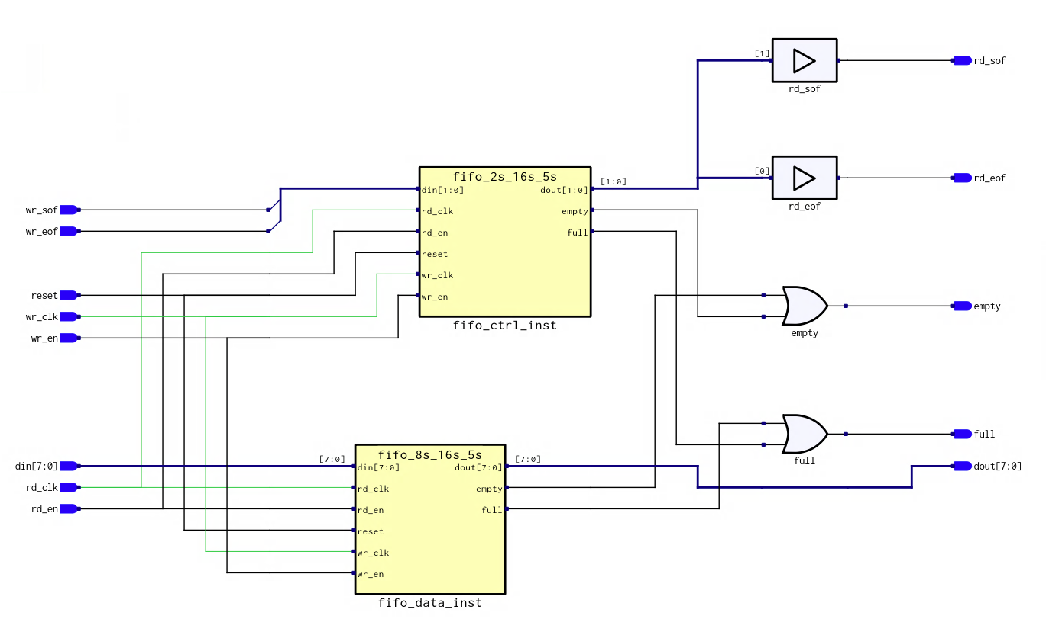

**FSM State Diagram:**

**Architecture discussion:**

My udp_reader works like how we discussed it in class: a fifo_ctrl buffer that includes a start of file and end of file signal takes in the UDP packet from the PCAP file, and then feeds it byte by byte to udp_reader. There are 4 packets back-to-back inside the PCAP file so as soon as an end of file is asserted, the start of file signal for the next packer is asserted in the next clock cycle.

Once a start of file signal has been detected, the udp_reader goes through each header field, checking those than need to be checked against a default value and adding the necessary ones into a checksum buffer. When the header has been read, the reader goes into a data reading state where it takes in the data bytes byte at a time per clock cycle and adds them to the checksum buffer. When the end of file signal is asserted, it goes back into WAIT_FOR_SOF_STATE to wait for the next start of file signal. This data is passed directly into an output FIFO buffer that will hold the data while the checksum is being validated.

After this happens, in a parallel process outside of the state machine, the checksum is folded down to 16 bits and its two's complement value is taken. This value is then compared to the checksum value that was given in the UDP header. If the checksum value calculated does not match up, an error signal is asserted, and the output FIFO buffer is reset or cleared. If it is correct, then the output FIFO buffer can start bursting out data byte by byte. A counter, set to the UDP data length (excluding header bytes), is decremented every clock cycle to make sure that the correct number of bytes is burst out of the output FIFO buffer. This is because while the data is being burst out, another UDP packet's data could be streaming into the output buffer, but we cannot burst that data yet as its checksum has not yet been validated. While the checksum is being validated, a checksum_valid signal is kept low which asserts the output FIFO buffer's empty signal, not allowing any data to be streamed out even if the FIFO itself is not empty. When checksum is validated, then checksum_valid is asserted causing the output FIFO buffer's empty signal to be pulled low and for data to be burst out.