List Of Technologies:
- ASP MVC 4
- Rest Api
- C#
- Linq
- MS Sql Server 2012
Solution Design
- A Library “IdentityManager.Library” to handle LDAP related operation.
- A Library “HttpModules” which check if the request is authorized or not. I
- A Rest Api project “IdentityManagerRestApis” which references “IdentityManager.Library” and provide authentication for given user.
- A web application “SSOApp”. Which provide Login for allthe client application.
- Two test web application, TestApp1 and TestApp2.These aap. These application uses “HttpModule” described in step to check if request is authenticated. If not the user is redirected to Login page of SSOApp.
Request processing steps:
Use case 1: Unauthorized user trying to access Home page of TestApp1 or TestApp2
1.User send the request for TestApp1 Home page.
2.Request is intercepted by “IdentityHttpModule”.
a.If authorized Home page of TestApp1 is returned to the user.
b.If not authorized User is redirected to SSOApp Login page.

Use case 2: User login against LDAP from SSOApp.
- User enter credentials in SSOApp login page.
- Details are send to Rest Api,which authenticate the user against configured LDAP server.
- If validation is successful. Api create a authentication token and save it to validate future request for same user.
- If validation failed user is redirected to SSOApp Login page.

Use case 3: Sign out from TestApp1 or TestApp2
- User click on Signout link on TestApp1 Home page.
- Token created by Api to authenticate the user is marked as Expired.
- Authentication cookies is expired and User is redirected to SSOApp login page.

Component Interaction Diagrm:

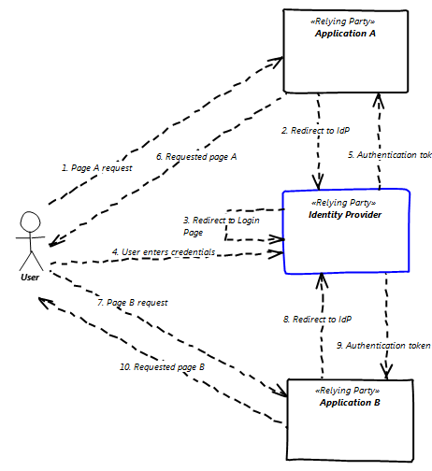
Project Interaction

IdentityManger Library
Authentication Api
SSOApp

IdentityHttpModule
TestApp1
Authentication
TestApp2

