Lab 2 report – Computer Vision 19/20 – Luca Moroldo – Mat: 1234011

With the Camera Calibration Lab I learned how to calibrate a camera in order to suppress the distortion effects that affect the quality of the captured pictures.

The calibration process is based on the acquisition of a good set of pictures containing a checkerboard in order to estimate the distortion parameters by solving a linear system built on a list of homographies that link the 3D checkerboard corners coordinates with their 2D coordinates.

With a “good” set of pictures, I mean a set of pictures that captures any distortion in any part of the image.
For instance, by calibrating the camera using pictures containing the checkerboard only on the left part of the image we would still notice a distortion (this can be seen by removing a part of the images from the image set, not shown for brevity), while calibrating the camera with a complete set of pictures yields a better result:

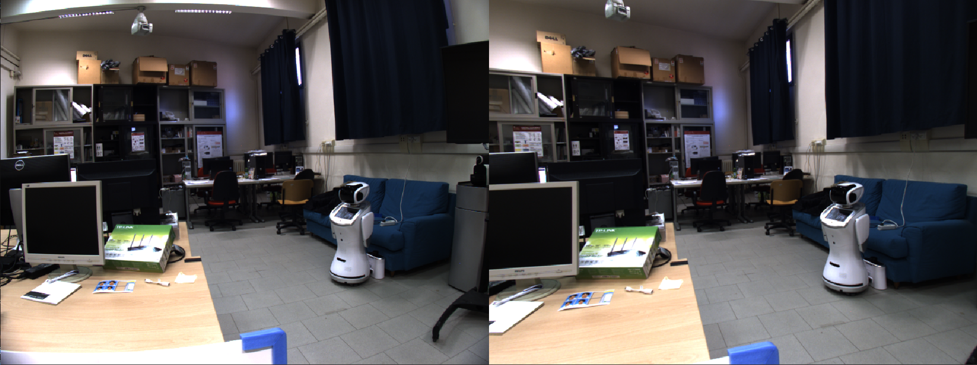
The images with highest (left, img id: 27) and lowest (right, img id: 39) error are the following:

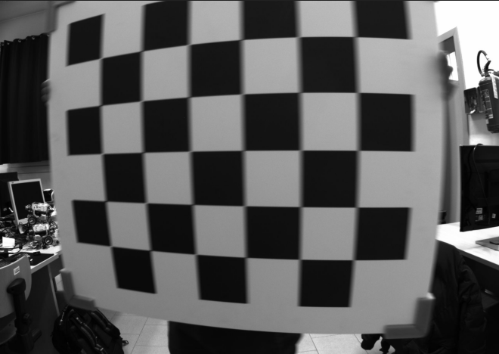
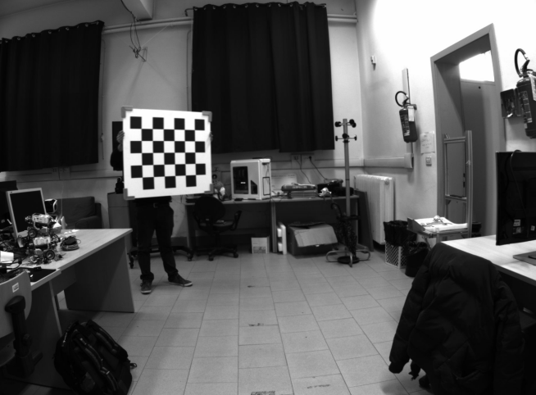

The reasons that cause the reprojection error (that is the mean Euclididian distance between 3D and 2D corners) to be 2.07 and 0.06 respectevly are multiple, e.g. blurry image and distorted checkerboard.

The avarage reprojection error is 2.9.

