Lab 3 report – Computer Vision 19/20 – Luca Moroldo – Mat: 1234011

The equalization of the RGB channels leads to an unnatural result: the image contains a too wide range of colors. Instead, the equalization of the HSV channels may lead to a very good result, especially in the case of the Value channel thanks to the brightness equalization, while the equalization of the Saturation channel yields a very colorful image that might appear unnatural but artistic:

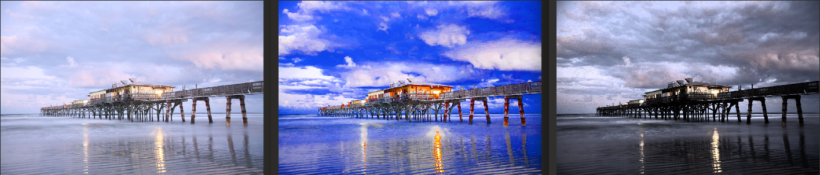1: Original, 2: S channel equalization, 3: V channel equalization
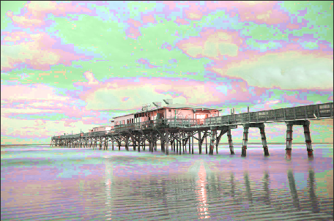
On the other side, the equalization of the Hue channel yields the worst result and seems to have no applications within this context.

Regarding the image filtering part, the Median and Gaussian filters are capable of reducing the noise at the cost of image details (i.e. the image appear blurred, edges are less defined):
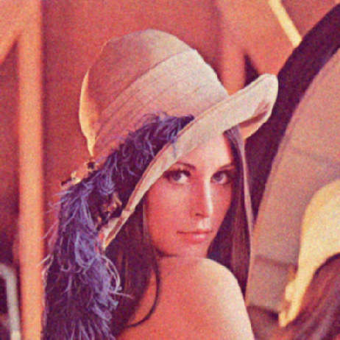Gaussian 5x5
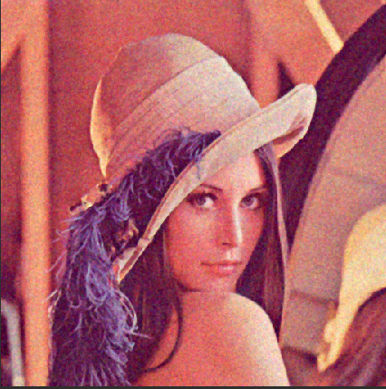Median 3x3
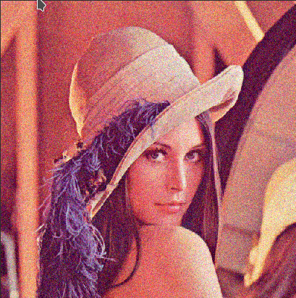Original
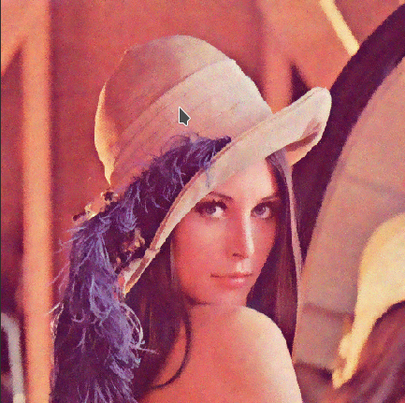Bilateral

The Bilateral filter performs definitively better, but this improvement comes with a higher computational cost (depending on the parameters) and might not be applicable to real-time streams of images like videos. Therefore in such applications, the best solution might be the Gaussian filter.

Anyway, each filter improved the quality of the original image.

