Lab 5 report – Computer Vision 19/20 – Luca Moroldo – Mat: 1234011

In order to successfully compose the panoramic image, it’s very important to find a good set of matches that relate consecutive images.
To find a good set of matches it’s necessary to discard outliers: this was done by discarding matches with descriptors distance not too far from the smallest distance and then by further discarding outliers exploiting RANSAC method.
For example, with a minimum distance ratio of 3, a great number of matches is discarded but few wrong matches still survive:
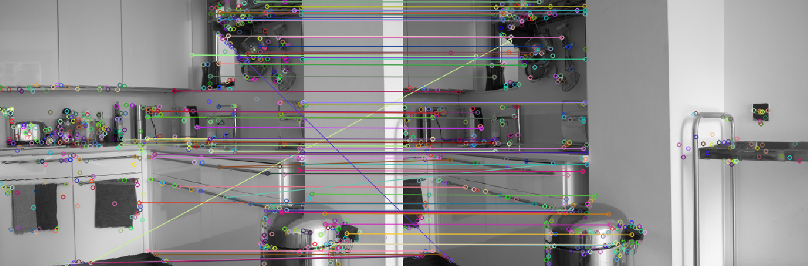
But thanks to RANSAC these outliers are completely removed.
The first refinement step doesn’t seem to be as necessary as the second but provides the first improvement. Nevertheless by setting a small ratio too many matches could be discarded, ruining the calculation of the translations.
The composed panoramic image might not appear smooth due to brightness changes:
After equalizing Value and Saturation histograms (HSV space) we can notice a small improvement, but the final result doesn’t appear smooth yet:

