/*Sa se ilustreze printr-un exemplu pe schema aleasa pentru proiect aparitia erorii mutating table si sa se trateze aceasta eroare. Se va implementa trigger-ul care genereaza eroarea cu comenzile de declansare si solutia.   
Studiati exemplul 8 din laborator6_PLSQL.pdf si exemplul 8.17 din fisierul Materiale/cursuri/SGBD8 - PLSQL Triggeri - mutating - trigger-compus.sql.*/

/*Causes mutating table error*/

CREATE OR REPLACE TRIGGER get_sal_sum_for_each

BEFORE UPDATE OF salary ON hospitals_medics_t

FOR EACH ROW

DECLARE curr_salary_sum hospitals_medics_t.salary%TYPE;

BEGIN

SELECT sum(salary) INTO curr_salary_sum FROM hospitals_medics_t;

DBMS_OUTPUT.PUT_LINE(curr_salary_sum);

END;

/

UPDATE hospitals_medics_t SET salary = 3700 WHERE medic_id > 2;

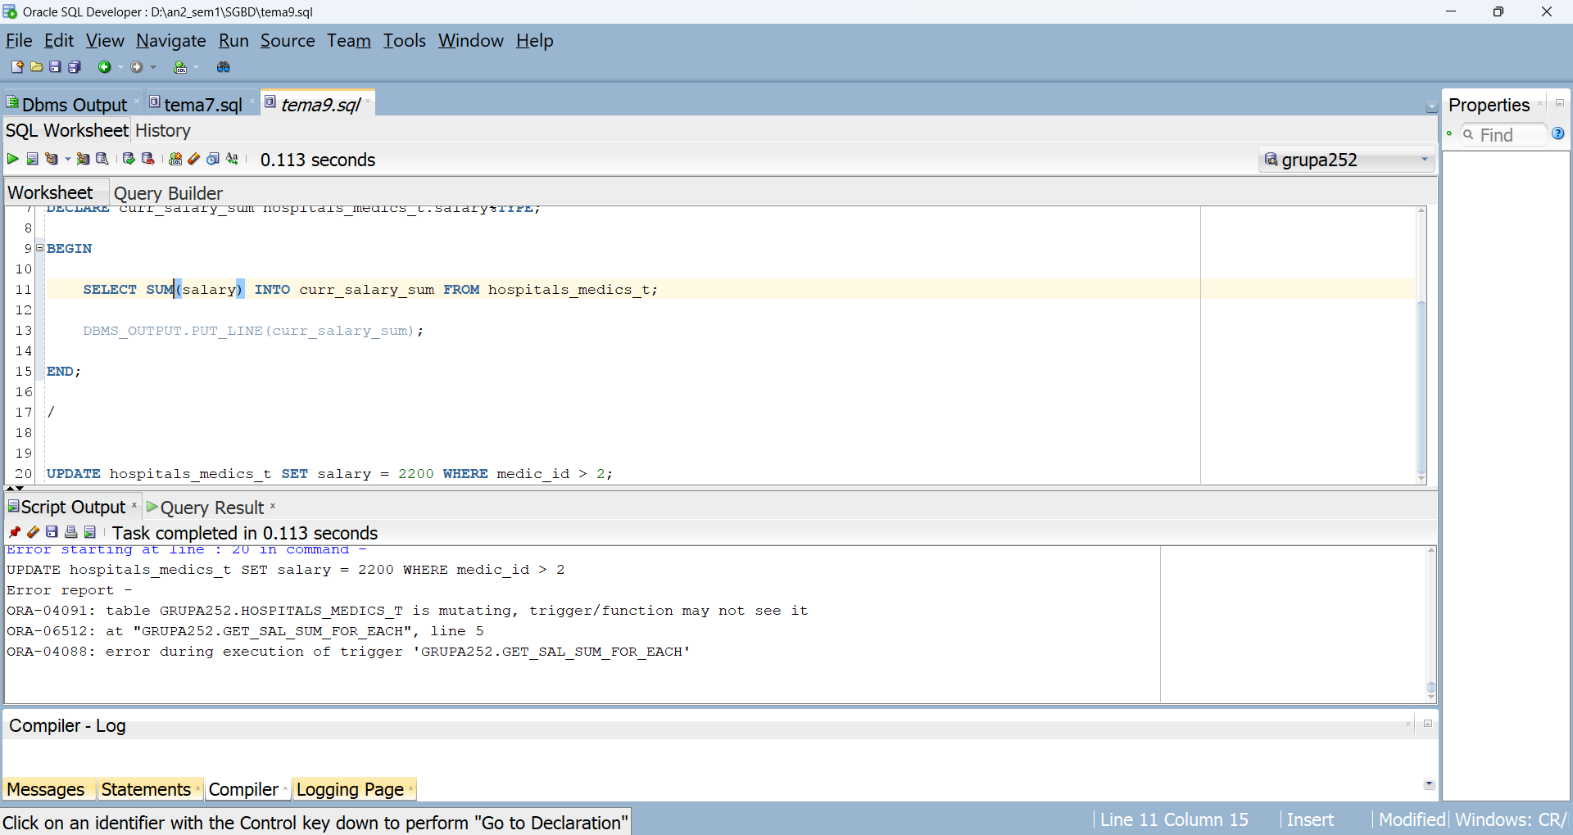

/*Solution*/

CREATE OR REPLACE PACKAGE salary_package AS

curr_salary_sum hospitals_medics_t.salary%TYPE;

END salary_package;

/

CREATE OR REPLACE TRIGGER get_sal_sum

BEFORE UPDATE OF salary ON hospitals_medics_t

BEGIN

SELECT sum(salary) INTO salary_package.curr_salary_sum FROM hospitals_medics_t;

END;

/

CREATE OR REPLACE TRIGGER get_sal_sum_for_each

BEFORE UPDATE OF salary ON hospitals_medics_t

FOR EACH ROW

BEGIN

salary_package.curr_salary_sum := salary_package.curr_salary_sum + (:new.salary - :old.salary);

DBMS_OUTPUT.PUT_LINE(salary_package.curr_salary_sum);

END;

/

UPDATE hospitals_medics_t SET salary = 2200 WHERE medic_id > 2;