--Adaptare cerinta 5: Id-ul spitalului cu cei mai multi medici

VARIABLE hosp_id NUMBER

BEGIN

SELECT hospital_id

INTO :hosp_id

FROM hospitals_medics_t

GROUP BY hospital_id

HAVING COUNT(medic_id) =

(SELECT MAX(COUNT(medic_id))

FROM hospitals_medics_t

GROUP BY hospital_id);

dbms_output.put_line('Spitalul cu numar maxim de angajati: ' || :hosp_id);

EXCEPTION

WHEN TOO_MANY_ROWS THEN

dbms_output.put_line('Mai mult de un spital are numar maxim de medici');

END;

/

PRINT hosp_id;

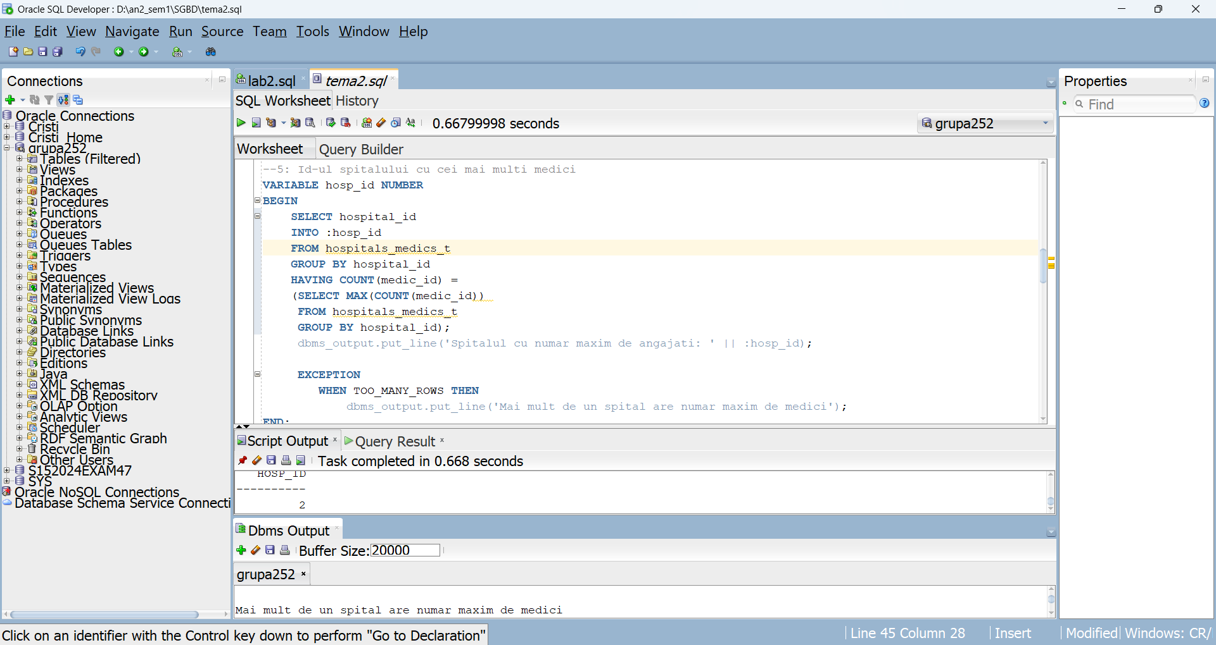

/*Adaptare cerinta 7: Salariul anual si bonusul unui medic primit de la tastatura

Avand in vedere ca un medic poate lucra la mai multe spitale

Vom insuma salariile anuale de la fiecare

Regula de bonus este prezentata mai jos*/

VARIABLE m_salary NUMBER

VARIABLE m_bonus NUMBER

DECLARE medic_id_in medics.medic_id%TYPE := '&medic_id_in';

BEGIN

SELECT SUM(salary * 12) INTO :m_salary

FROM hospitals_medics_t

GROUP BY medic_id HAVING medic_id = medic_id_in;

IF :m_salary >= 100000

THEN :m_bonus:= 20000;

ELSIF :m_salary BETWEEN 55000 AND 100000

THEN :m_bonus:= 10000;

ELSE :m_bonus:= 5500;

END IF;

dbms_output.put_line('Medicul cu id-ul ' || medic_id_in || ' are bonusul ' || :m_bonus);

--In cazul in care id_ul nu se afla in baza de date afisam pe ecran astfel

EXCEPTION

WHEN NO_DATA_FOUND THEN

dbms_output.put_line('Medicul cu id-ul ' || medic_id_in || ' nu exista in baza de date!');

END;

/

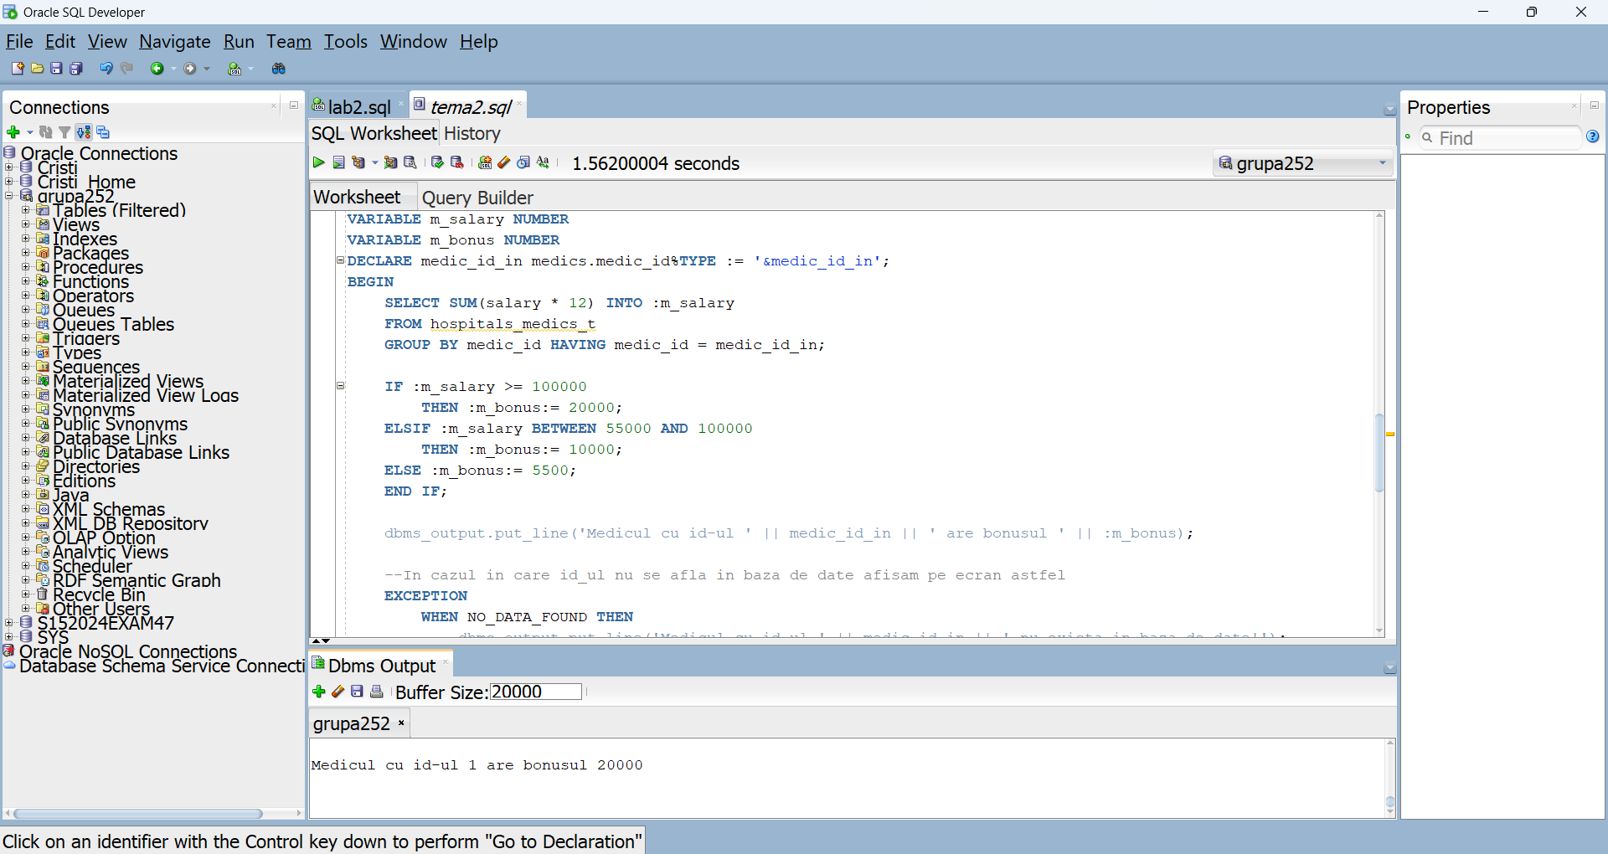

/*Adaptare cerinta 9: Primind de la tastatura

un medic_id, o specializare, si un procent

schimbam specializare medicului si la anii de experienta adaugam procentul*/

SET VERIFY OFF;

--Inainte de update

SELECT * FROM medics_t;

DECLARE

v_medic_id medics_t.medic_id%TYPE := '&m_id';

v_spec_id medics_t.specialization_id%TYPE := '&spec_id';

v_year_percent NUMBER(8) := '&y_percent';

BEGIN

UPDATE medics_t SET

specialization_id = v_spec_id,

years_exp = years_exp + (v_year_percent * years_exp) / 100

WHERE medic_id = v_medic_id;

--Daca medicul nu se afla in baza de date afisam astfel

IF SQL%ROWCOUNT =0 THEN

dbms_output.put_line('Medicul cu id-ul ' || v_medic_id || ' nu exista in baza de date!');

ELSE DBMS_OUTPUT.PUT_LINE('Actualizare realizata');

END IF;

END;

/

--Dupa update

SELECT * FROM medics_t;

ROLLBACK;

SET VERIFY ON;

