/*Adaptare exercitiu 7:

Sa se afiseze numele si salariul unui medic care lucreaza intr-un spital.

Id-ul medicul si al spitalului vor fi primite de la user.

Sa se trateze cazul in care medicul nu lucreaza in spitalul specificat. Tratarea excepţie se va face in

sectiunea de tratare a erorilor.*/

SET VERIFY OFF

SET SERVEROUTPUT ON

/*Getting user input*/

ACCEPT i_m_id PROMPT 'Please insert a medic id: ';

ACCEPT i_h_id PROMPT 'Please insert the id of the hospital in which the medic works: ';

DECLARE

v_m_id NUMBER := &i_m_id;

v_h_id NUMBER := &i_h_id;

v_medic_name medics_t.medic_name%TYPE;

v_salary hospitals_medics_t.salary%TYPE;

BEGIN

/*Storing the medic's name and salary into variables and printing them*/

SELECT m.medic_name, hm.salary INTO v_medic_name, v_salary

FROM hospitals_medics_t hm JOIN medics_t m ON m.medic_id = hm.medic_id

WHERE m.medic_id = v_m_id AND hm.hospital_id = v_h_id;

DBMS_OUTPUT.PUT_LINE('Medic with id ' || v_m_id || ' is called ' || v_medic_name || ' and makes ' || v_salary || ' ron a month working for hospital with id ' || v_h_id);

EXCEPTION

/*If no medic exists throw error*/

WHEN NO_DATA_FOUND THEN

RAISE_APPLICATION_ERROR(-20999, 'Medic with id ' || v_m_id || ' does not work for hospital with id ' || v_h_id);

END;

/

SET VERIFY ON

SET SERVEROUTPUT OFF

Invalid input:

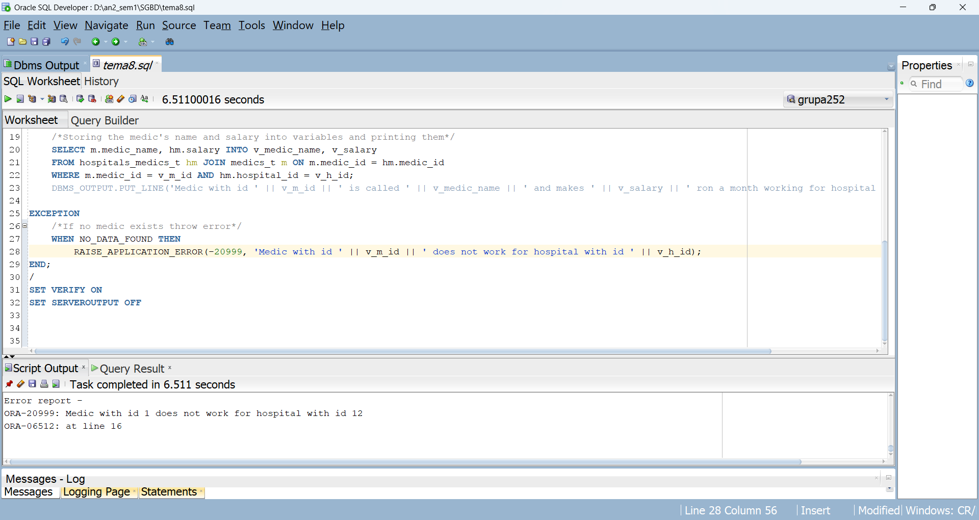

Valid input:

