/* E1. Adaptati cerinta exercitiului 4 din fisierul Laborator8_PLSQL_optional.pdf pe schema aleasa pentru proiect.*/

/*4. Sa se creeze un pachet care sa contina:

- o functie prin care se vor returna toti medicii care indeplinesc o anumita conditie, data ca

parametru;

- o functie prin care se vor returna toti medicii care lucreaza intr-un anumit spital al carui id e dat ca parametru

*/

-- Define package declarations

CREATE OR REPLACE PACKAGE test_package AS

TYPE r_cursor IS REF CURSOR;

FUNCTION get_by_cond(cond VARCHAR2) RETURN r_cursor;

FUNCTION get_by_h_id(h_id hospitals_medics_t.hospital_id%TYPE) RETURN r_cursor;

END test_package;

/

-- Define package body

CREATE OR REPLACE PACKAGE BODY test_package AS

FUNCTION get_by_cond(cond VARCHAR2) RETURN r_cursor IS

by_cond_cursor r_cursor ;

query_stmt VARCHAR(500);

BEGIN

query_stmt := 'SELECT * FROM medics_t ' || cond;

OPEN by_cond_cursor FOR query_stmt;

RETURN by_cond_cursor;

END;

FUNCTION get_by_h_id(h_id hospitals_medics_t.hospital_id%TYPE) RETURN r_cursor IS

by_h_id_cursor r_cursor;

query_stmt VARCHAR(500);

BEGIN

query_stmt := 'SELECT m.medic_id, m.medic_name, m.years_exp, m.specialization_id

FROM hospitals_medics_t hm

JOIN medics_t m ON m.medic_id = hm.medic_id

WHERE hospital_id = :h_id';

OPEN by_h_id_cursor FOR query_stmt USING h_id;

RETURN by_h_id_cursor;

END;

END test_package;

/

-- Test package

DECLARE

test_cursor test_package.r_cursor;

medic_rec medics_t%ROWTYPE;

BEGIN

DBMS_OUTPUT.PUT_LINE('By condition test');

test_cursor := test_package.get_by_cond('WHERE years_exp > 5');

LOOP

FETCH test_cursor INTO medic_rec;

EXIT WHEN test_cursor%NOTFOUND;

DBMS_OUTPUT.PUT_LINE('Medic with id ' || medic_rec.medic_id || ' is called ' || medic_rec.medic_name || ' has specialization ' ||

medic_rec.specialization_id || ' and has ' || medic_rec.years_exp || ' years experience');

END LOOP;

CLOSE test_cursor;

DBMS_OUTPUT.PUT_LINE('********************************************************');

DBMS_OUTPUT.PUT_LINE('By hospital_id test');

test_cursor := test_package.get_by_h_id(4);

LOOP

FETCH test_cursor INTO medic_rec;

EXIT WHEN test_cursor%NOTFOUND;

DBMS_OUTPUT.PUT_LINE('Medic with id ' || medic_rec.medic_id || ' is called ' || medic_rec.medic_name || ' has specialization ' ||

medic_rec.specialization_id || ' and has ' || medic_rec.years_exp || ' years experience');

END LOOP;

CLOSE test_cursor;

END;

/

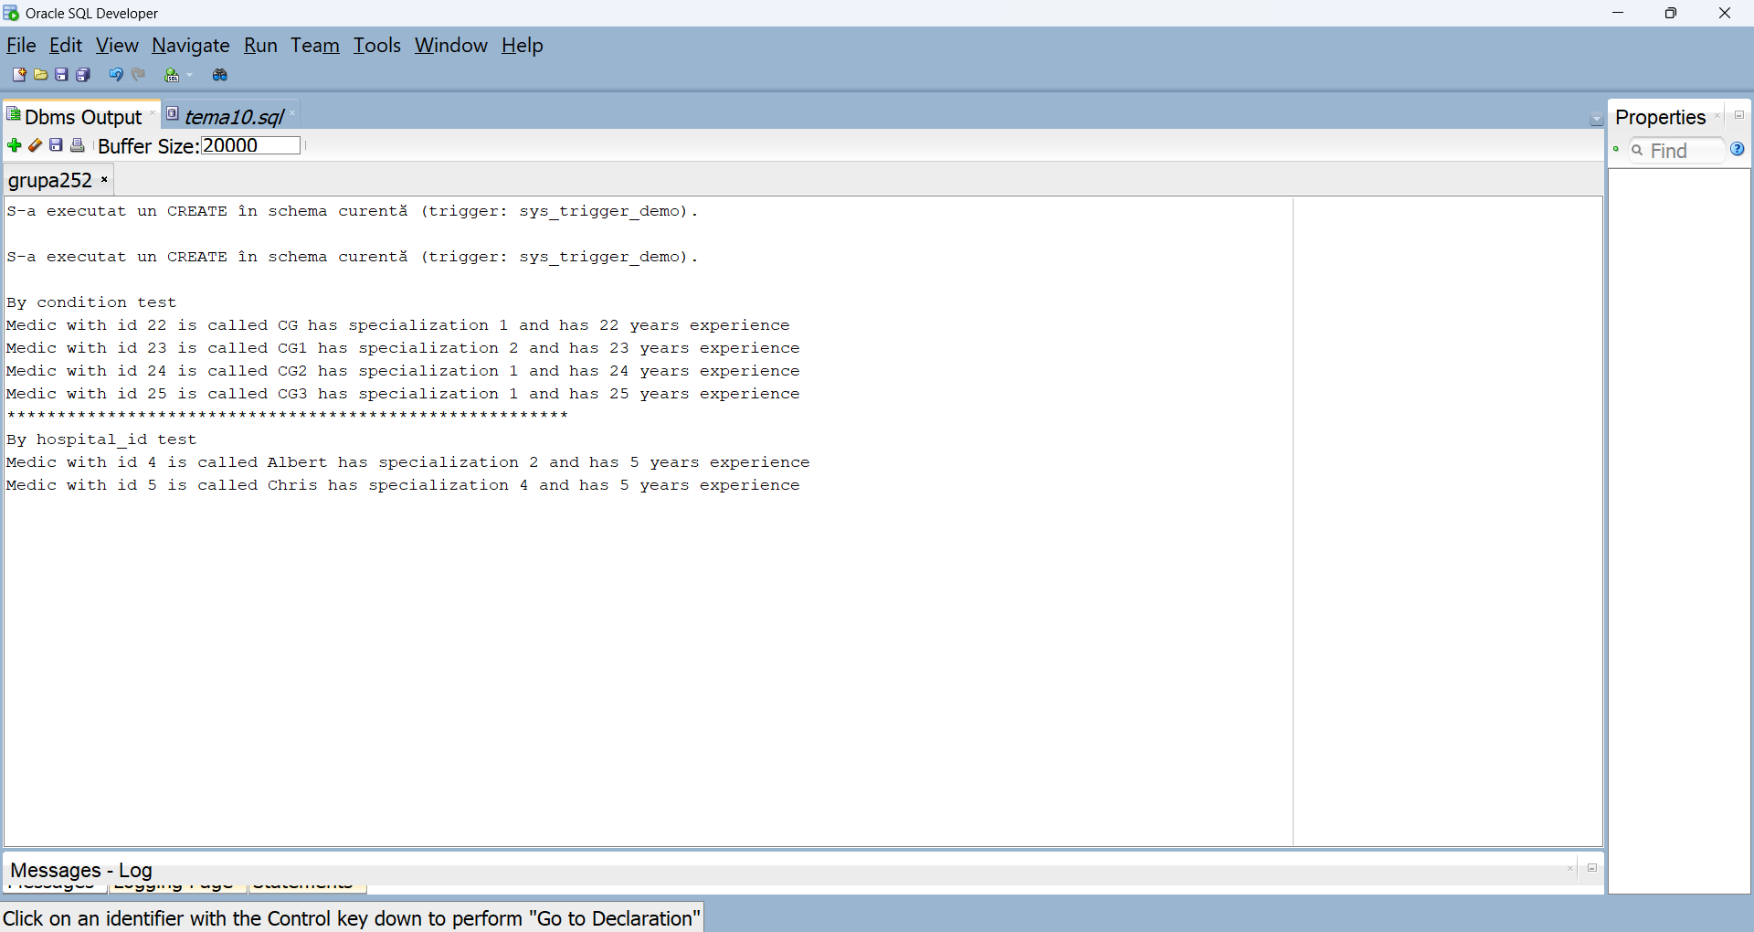

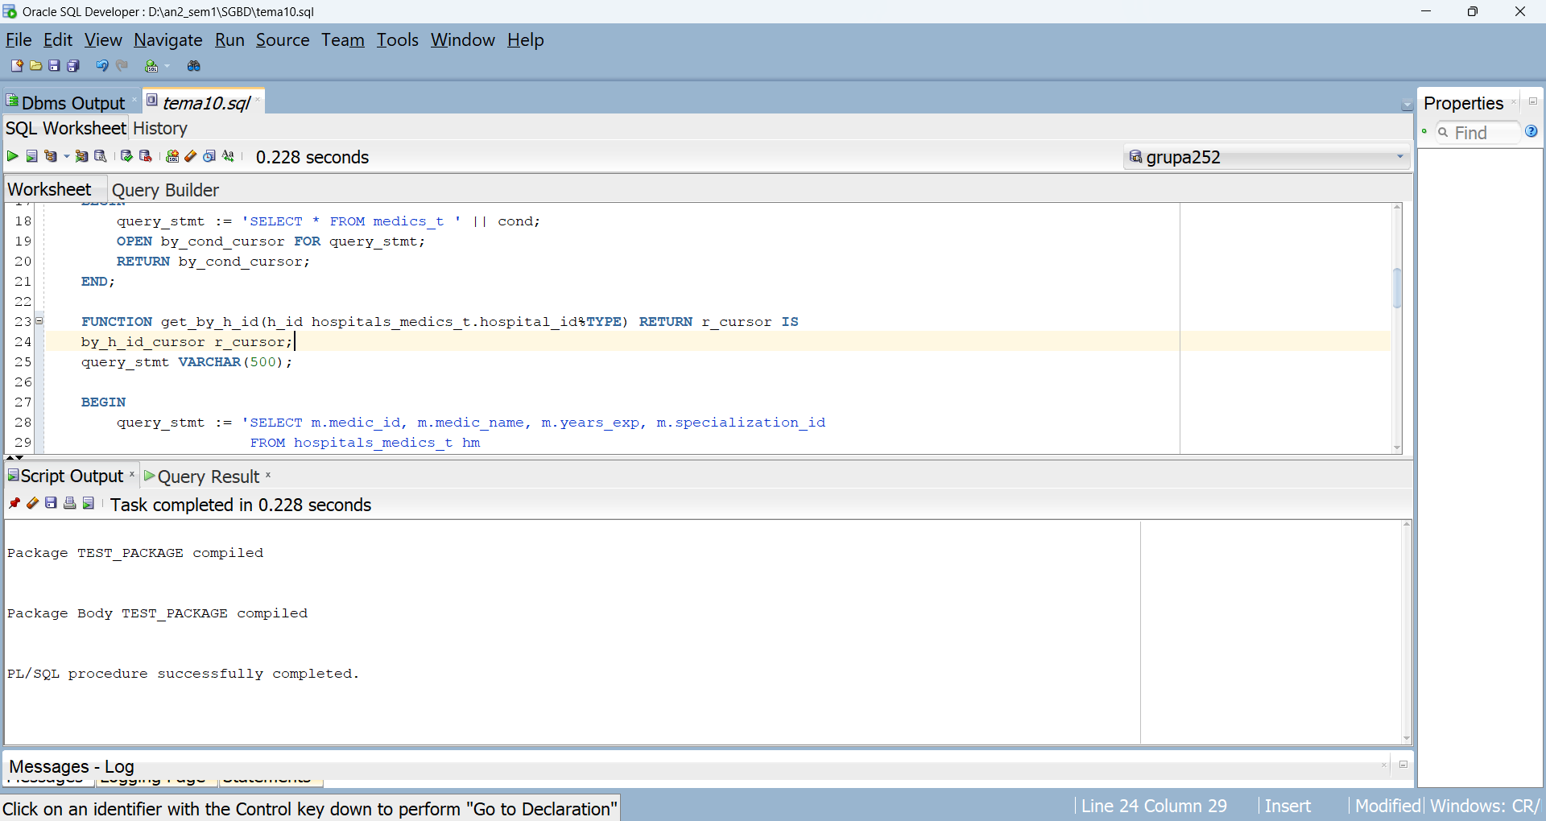

/*E2. Implementati o procedură care declanseaza trigger-ul sistem creat pentru proiect.*/

CREATE OR REPLACE PROCEDURE test_trigger_proc IS

BEGIN

EXECUTE IMMEDIATE 'DROP TABLE programari';

END;

/

BEGIN

test_trigger_proc;

END;

/