/*9

Definiti tipul medici_sub (vector, dimensiune maxima 10, mentine numere). Creati tabelul

medici_sefi cu urmatoarele câmpuri: cod_ms NUMBER(10), nume VARCHAR2(20), lista

medici_sub. Introduceti 3 linii în tabel. Afisati informatiile din tabel. Stergeti tabelul creat,

apoi tipul.*/

CREATE OR REPLACE TYPE medici_sub AS VARRAY(10) OF NUMBER(4);

/

CREATE TABLE medici_sefi (

cod_ms NUMBER(10),

nume VARCHAR2(20),

lista medici_sub

);

DECLARE

v_sub medici_sub:= medici_sub(1,3,2);

v_lista medici_sefi.lista%TYPE;

BEGIN

INSERT INTO medici_sefi

VALUES (1, 'Jack', v_sub);

INSERT INTO medici_sefi

VALUES (2, 'Alex', null);

INSERT INTO medici_sefi

VALUES (3, 'John', medici_sub(1,2));

SELECT lista

INTO v_lista

FROM medici_sefi

WHERE cod_ms=1;

FOR j IN v_lista.FIRST..v_lista.LAST loop

DBMS_OUTPUT.PUT_LINE (v_lista(j));

END LOOP;

END;

/

SELECT * FROM medici_sefi;

DROP TABLE medici_sefi;

DROP TYPE medici_sub;

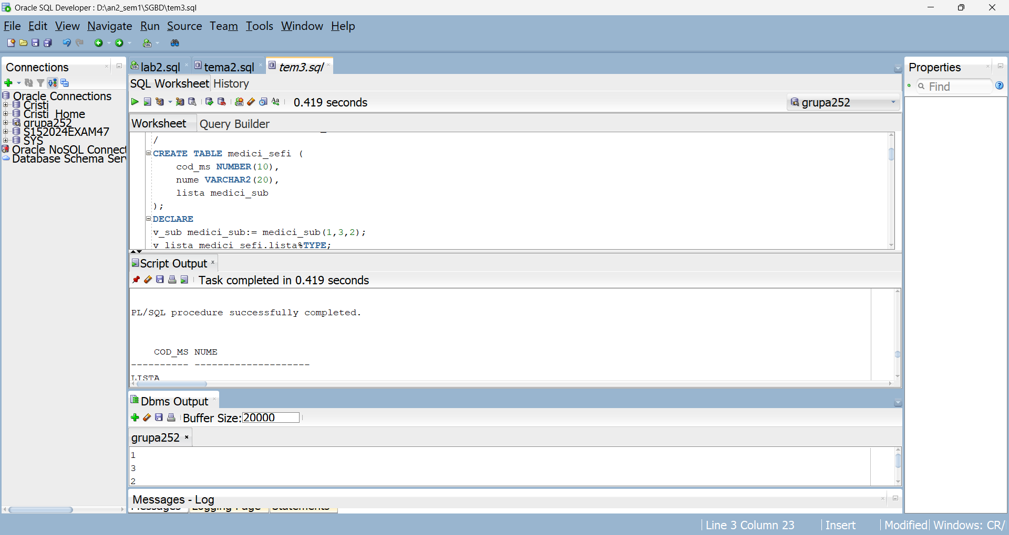

/*10:

Creati tabelul medics_test cu coloanele medic_id si medic_name din tabelul medics_t.

Adauga in acest tabel un nou camp numit phone de tip tablou imbricat. Acest tablou va mentine

pentru fiecare medic toate numerele de telefon la care poate fi contactat. Inserati o linie noua in

tabel. Actualizati o linie din tabel. Afisati informatiile din tabel. Stergeti tabelul si tipul.*/

CREATE TABLE medics_test AS

SELECT medic_id, medic_name FROM medics_t

WHERE ROWNUM <= 2;

SELECT * FROM medics_test;

CREATE OR REPLACE TYPE phone_type IS TABLE OF VARCHAR(12);

/

ALTER TABLE medics_test

ADD (phone phone_type)

NESTED TABLE phone STORE AS phone_table;

INSERT INTO medics_test

VALUES (6, 'Arda', phone_type('0741234561', '0213123123', '0374451550'));

UPDATE medics_test

SET phone = phone_type('0736657344', '0111233981')

WHERE medic_id=1;

SELECT * FROM medics_test;

SELECT a.medic_id, b.*

FROM medics_test a, TABLE (a.phone) b;

DROP TABLE medics_test;

DROP TYPE phone_type;

