/*Adaptare ex 2:

Creati un pachet ce include actiuni pentru adaugarea unui nou spital in tabelul hospitals_t si

a unui nou medic in tabelul medics_t . Se va verifica dacă judetul si numarul de telefon al spitalului exista. De asemenea se va verifica daca specializarea medicului exista.

CREATE table counties_t(

county_id NUMBER PRIMARY KEY,

county_name VARCHAR(15) UNIQUE NOT NULL

);

INSERT INTO counties_t VALUES(1, 'Bucuresti');

INSERT INTO counties_t VALUES(2, 'Arges');

INSERT INTO counties_t VALUES(3, 'Brasov');

INSERT INTO counties_t VALUES(4, 'Valcea');

INSERT INTO counties_t VALUES(5, 'Iasi');

ALTER TABLE hospitals_t ADD county_id NUMBER;

ALTER TABLE hospitals_t ADD FOREIGN KEY(county_id) REFERENCES counties_t(county_id);

UPDATE hospitals_t SET county_id = hospital_id;

CREATE OR REPLACE PACKAGE medics_hosp_pack AS

PROCEDURE add_hosp (hosp_id hospitals_t.hospital_id%TYPE,

phone_nr hospitals_t.phone_number%TYPE,

county_id hospitals_t.county_id%TYPE);

PROCEDURE add_medic (medic_id medics_t.medic_id%TYPE,

medic_name medics_t.medic_name%TYPE,

years_exp medics_t.years_exp%TYPE,

spec_id medics_t.specialization_id%TYPE);

FUNCTION valid_spec(spec_id medics_t.specialization_id%TYPE) RETURN NUMBER;

FUNCTION valid_county(i_county_id counties_t.county_id%TYPE) RETURN NUMBER;

FUNCTION valid_phone(phone_number hospitals_t.phone_number%TYPE) RETURN NUMBER;

END medics_hosp_pack;

/

CREATE OR REPLACE PACKAGE BODY medics_hosp_pack AS

PROCEDURE add_hosp (hosp_id hospitals_t.hospital_id%TYPE,

phone_nr hospitals_t.phone_number%TYPE,

county_id hospitals_t.county_id%TYPE) IS

BEGIN

IF valid_county(county_id) = 0 THEN

DBMS_OUTPUT.PUT_LINE('Invalid hospital county ' || county_id);

ELSE IF valid_phone(phone_nr) = 0 THEN

DBMS_OUTPUT.PUT_LINE('Invalid hospital phone number ' || phone_nr);

ELSE

INSERT INTO hospitals_t VALUES(hosp_id, phone_nr, county_id);

END IF;

END IF;

END add_hosp;

PROCEDURE add_medic (medic_id medics_t.medic_id%TYPE,

medic_name medics_t.medic_name%TYPE,

years_exp medics_t.years_exp%TYPE,

spec_id medics_t.specialization_id%TYPE) IS

BEGIN

IF valid_spec(spec_id) = 0 THEN

DBMS_OUTPUT.PUT_LINE('Invalid medic specialization ' || spec_id);

ELSE

INSERT INTO medics_t VALUES(medic_id, medic_name, years_exp, spec_id);

END IF;

END add_medic;

FUNCTION valid_spec(spec_id medics_t.specialization_id%TYPE) RETURN NUMBER IS ret_val NUMBER;

BEGIN

SELECT COUNT(*) INTO ret_val FROM specializations_t WHERE specialization_id = spec_id;

RETURN ret_val;

END;

FUNCTION valid_county(i_county_id counties_t.county_id%TYPE) RETURN NUMBER IS ret_val NUMBER;

BEGIN

SELECT COUNT(*) INTO ret_val FROM counties_t WHERE county_id = i_county_id;

RETURN ret_val;

END;

FUNCTION valid_phone(phone_number hospitals_t.phone_number%TYPE) RETURN NUMBER IS

ret_val NUMBER := 1;

curr_char CHAR(1);

BEGIN

FOR i IN 1..length(phone_number) LOOP

curr_char := substr(phone_number, i, 1);

IF curr_char < '0' OR curr_char > '9' THEN

ret_val := 0;

END IF;

END LOOP;

RETURN ret_val;

END;

END medics_hosp_pack;

/

EXECUTE medics_hosp_pack.add_hosp(12, '0758.93022', 1);

EXECUTE medics_hosp_pack.add_medic(8, 'Reaper', 4, 1);

select * from medics_t;

select * from hospitals_t;

BEGIN

medics_hosp_pack.add_hosp(15, '0458330231', 2);

medics_hosp_pack.add_medic(15, 'CvrreveveG', 3, 1);

END;

/

SELECT * FROM medics_t;

SELECT * FROM hospitals_t;

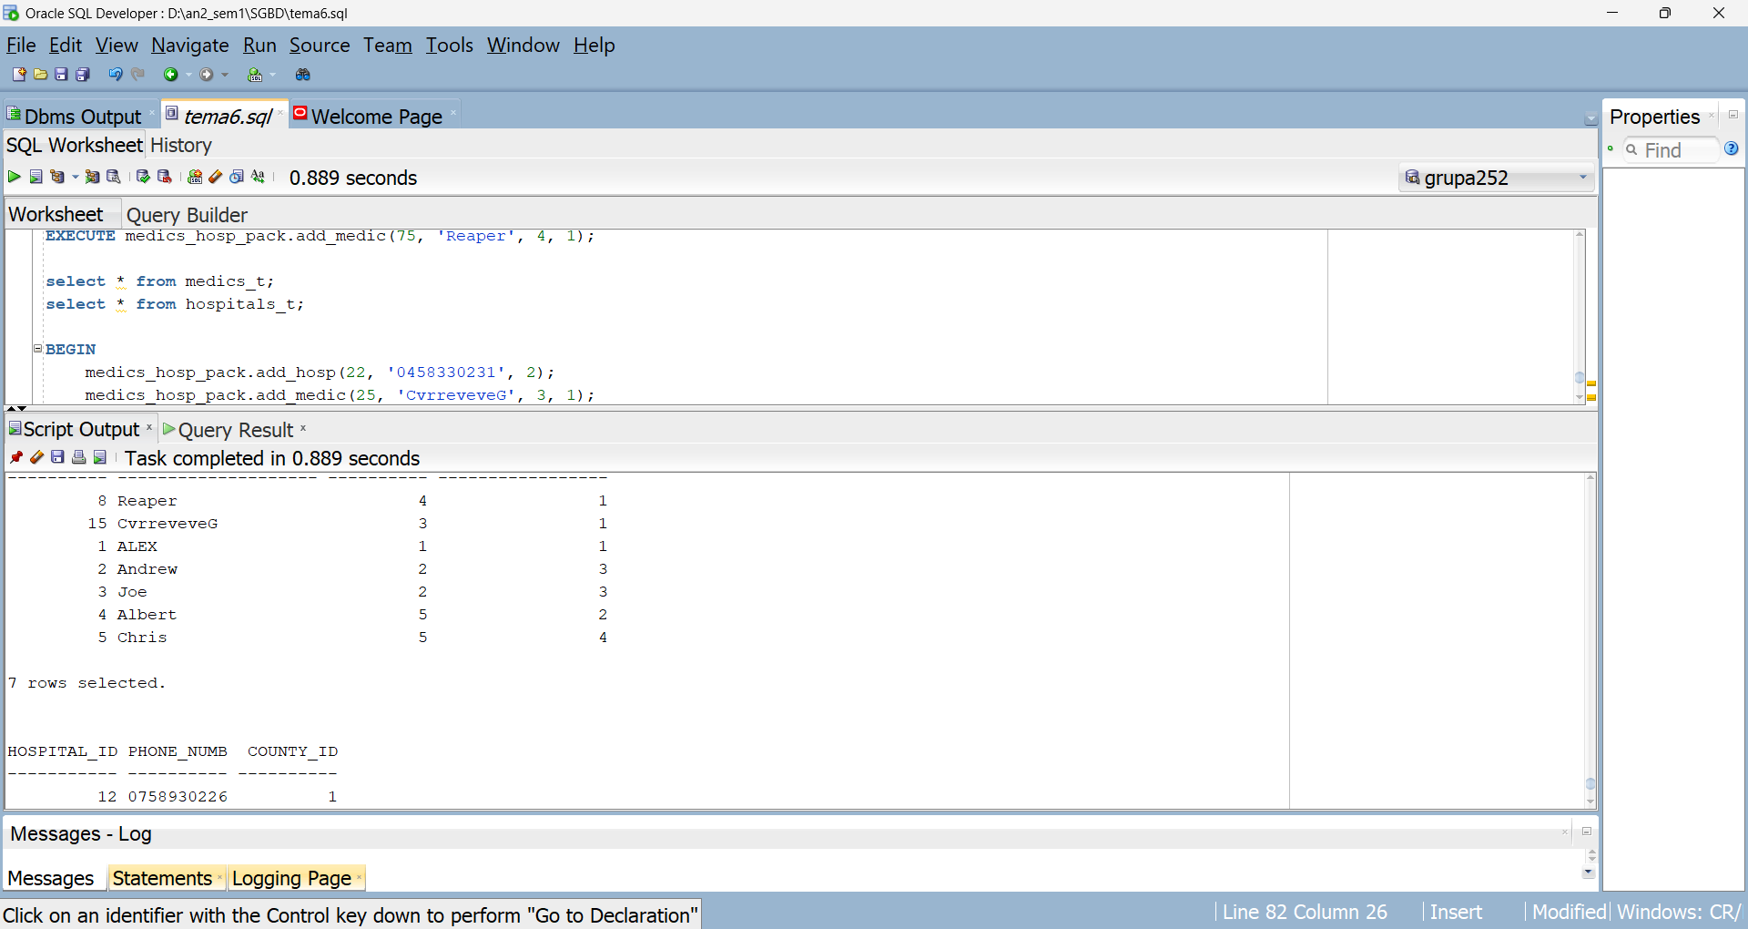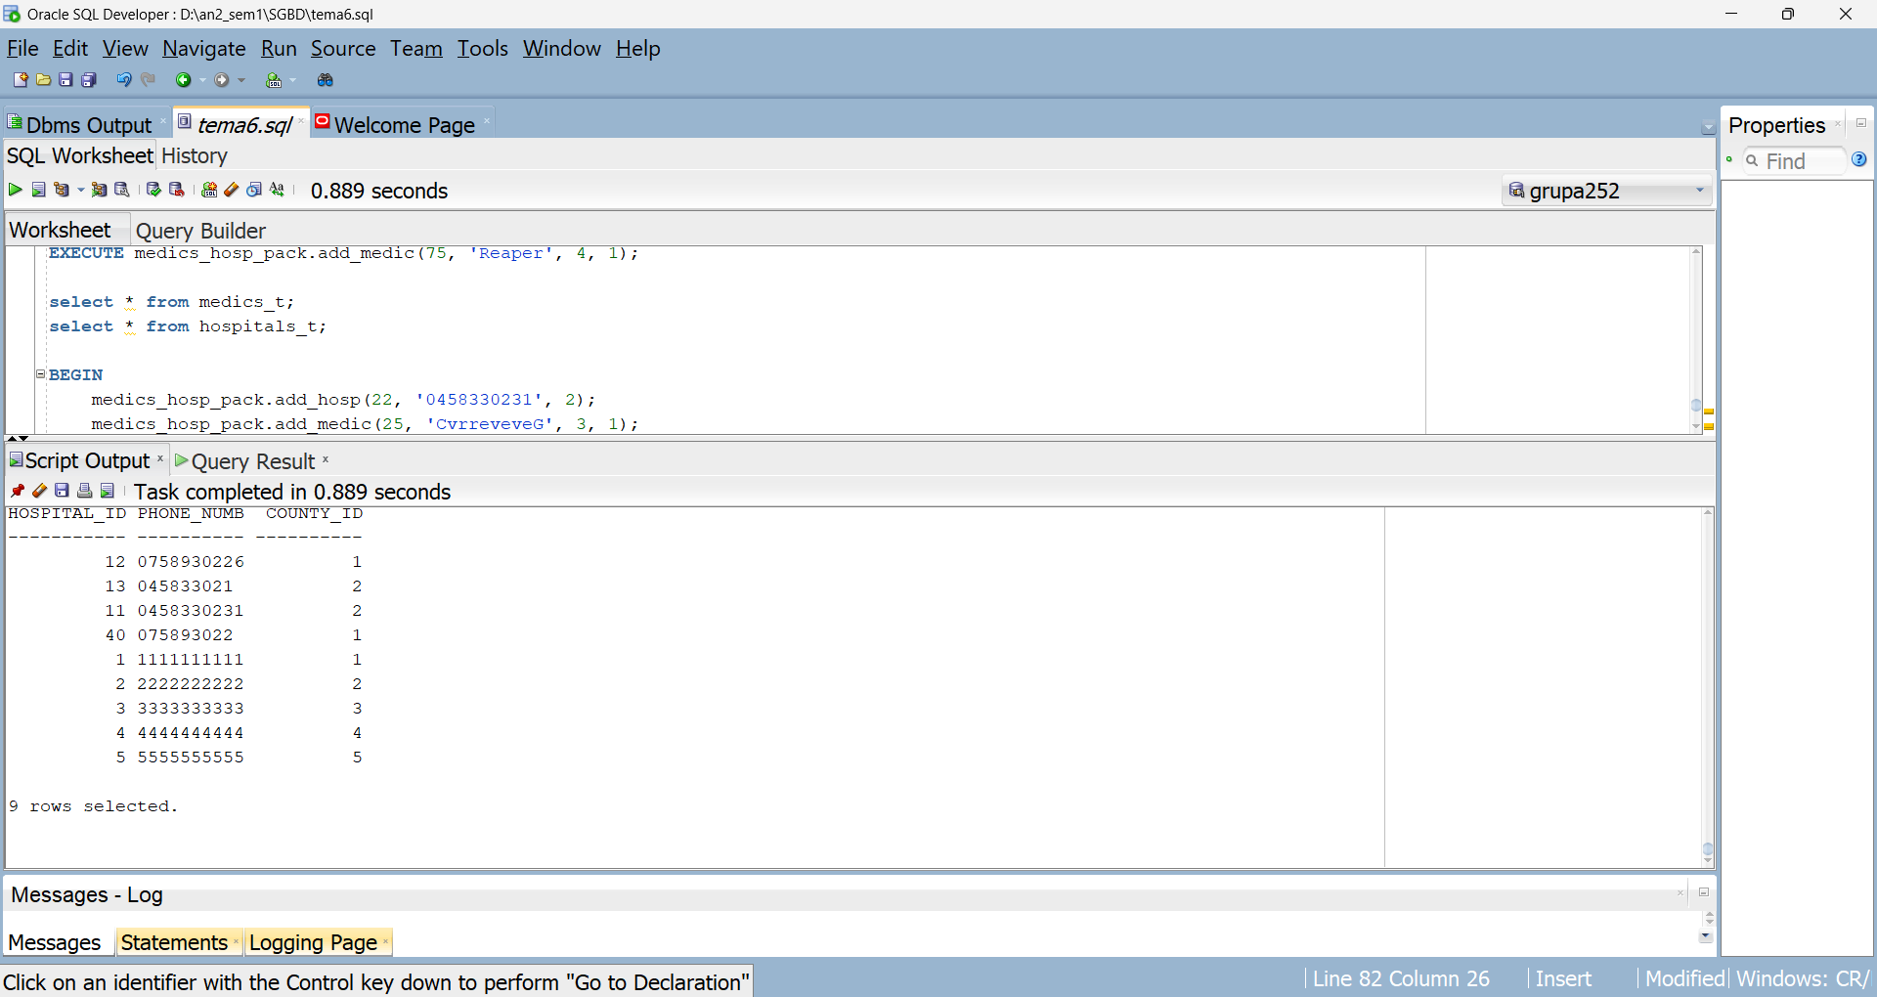Pentru inputuri gresite:

