Milestone 2 – Database Design

# Group 4 Members:

**Luca Novello || Philip Graham || Jaseem Villan Thenkodath**

# ERD (Entity Relationship Diagram):

| Users  * + **UserID (Primary Key)**   + Username   + Password   + Email   + ProfilePicture | Artists  * + **ArtistID (Primary Key)**   + ArtistName   + Genre   + Country | Albums  * + **AlbumID (Primary Key)**   + AlbumName   + ReleaseDate   + ArtistID (Foreign Key) |
| --- | --- | --- |
| Songs  * + **SongID (Primary Key)**   + SongName   + Duration   + AlbumID (Foreign Key)   + ArtistID (Foreign Key)   + Genre | Playlists  * + **PlaylistID (Primary Key)**   + PlaylistName   + UserID (Foreign Key) | PlaylistSongs  * + **PlaylistID (Primary Key, Foreign Key)**   + **SongID (Primary Key, Foreign Key)** |

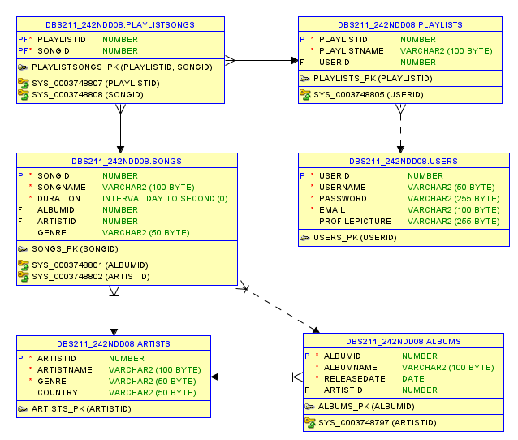

# Data Dictionary:

| **Table** | **Column** | **Data Type** | **Size** | **Default** | **PK/FK** | **Required** | **Range** | **Sample Data** | **Notes** |
| --- | --- | --- | --- | --- | --- | --- | --- | --- | --- |
| Users | UserID | INT | 11 |  | PK | Y | 1-999999 | 1 | Autonumbered identity |
| Users | Username | VARCHAR | 50 |  |  | Y |  | johndoe |  |
| Users | Password | VARCHAR | 255 |  |  | Y |  | password123 |  |
| Users | Email | VARCHAR | 100 |  |  | Y |  | johndoe@mail.com |  |
| Users | ProfilePicture | VARCHAR | 255 |  |  | N |  | profile.jpg |  |
| Artists | ArtistID | INT | 11 |  | PK | Y | 1-999999 | 1 | Autonumbered identity |
| Artists | ArtistName | VARCHAR | 100 |  |  | Y |  | The Beatles |  |
| Artists | Genre | VARCHAR | 50 |  |  | Y |  | Rock |  |
| Artists | Country | VARCHAR | 50 |  |  | N |  | UK |  |
| Albums | AlbumID | INT | 11 |  | PK | Y | 1-999999 | 1 | Autonumbered identity |
| Albums | AlbumName | VARCHAR | 100 |  |  | Y |  | Abbey Road |  |
| Albums | ReleaseDate | DATE |  |  |  | Y |  | 1969-09-26 |  |
| Albums | ArtistID | INT | 11 |  | FK | Y | 1-999999 | 1 | References Artists(ArtistID) |
| Songs | SongID | INT | 11 |  | PK | Y | 1-999999 | 1 | Autonumbered identity |
| Songs | SongName | VARCHAR | 100 |  |  | Y |  | Come Together |  |
| Songs | Duration | TIME |  |  |  | Y |  | 0:04:20 |  |
| Songs | AlbumID | INT | 11 |  | FK | Y | 1-999999 | 1 | References Albums(AlbumID) |
| Songs | ArtistID | INT | 11 |  | FK | Y | 1-999999 | 1 | References Artists(ArtistID) |
| Songs | Genre | VARCHAR | 50 |  |  | N |  | Rock |  |
| Playlists | PlaylistID | INT | 11 |  | PK | Y | 1-999999 | 1 | Autonumbered identity |
| Playlists | PlaylistName | VARCHAR | 100 |  |  | Y |  | My Favorites |  |
| Playlists | UserID | INT | 11 |  | FK | Y | 1-999999 | 1 | References Users(UserID) |
| PlaylistSongs | PlaylistID | INT | 11 |  | PK, FK | Y | 1-999999 | 1 | Composite PK, References PlaylistID |
| PlaylistSongs | SongID | INT | 11 |  | PK, FK | Y | 1-999999 | 1 | Composite PK, References SongID |