# Week 5 - Inventory Lab

Luca Novello | 038515003 | gnovello | October 12, 2024

## Product Classes:

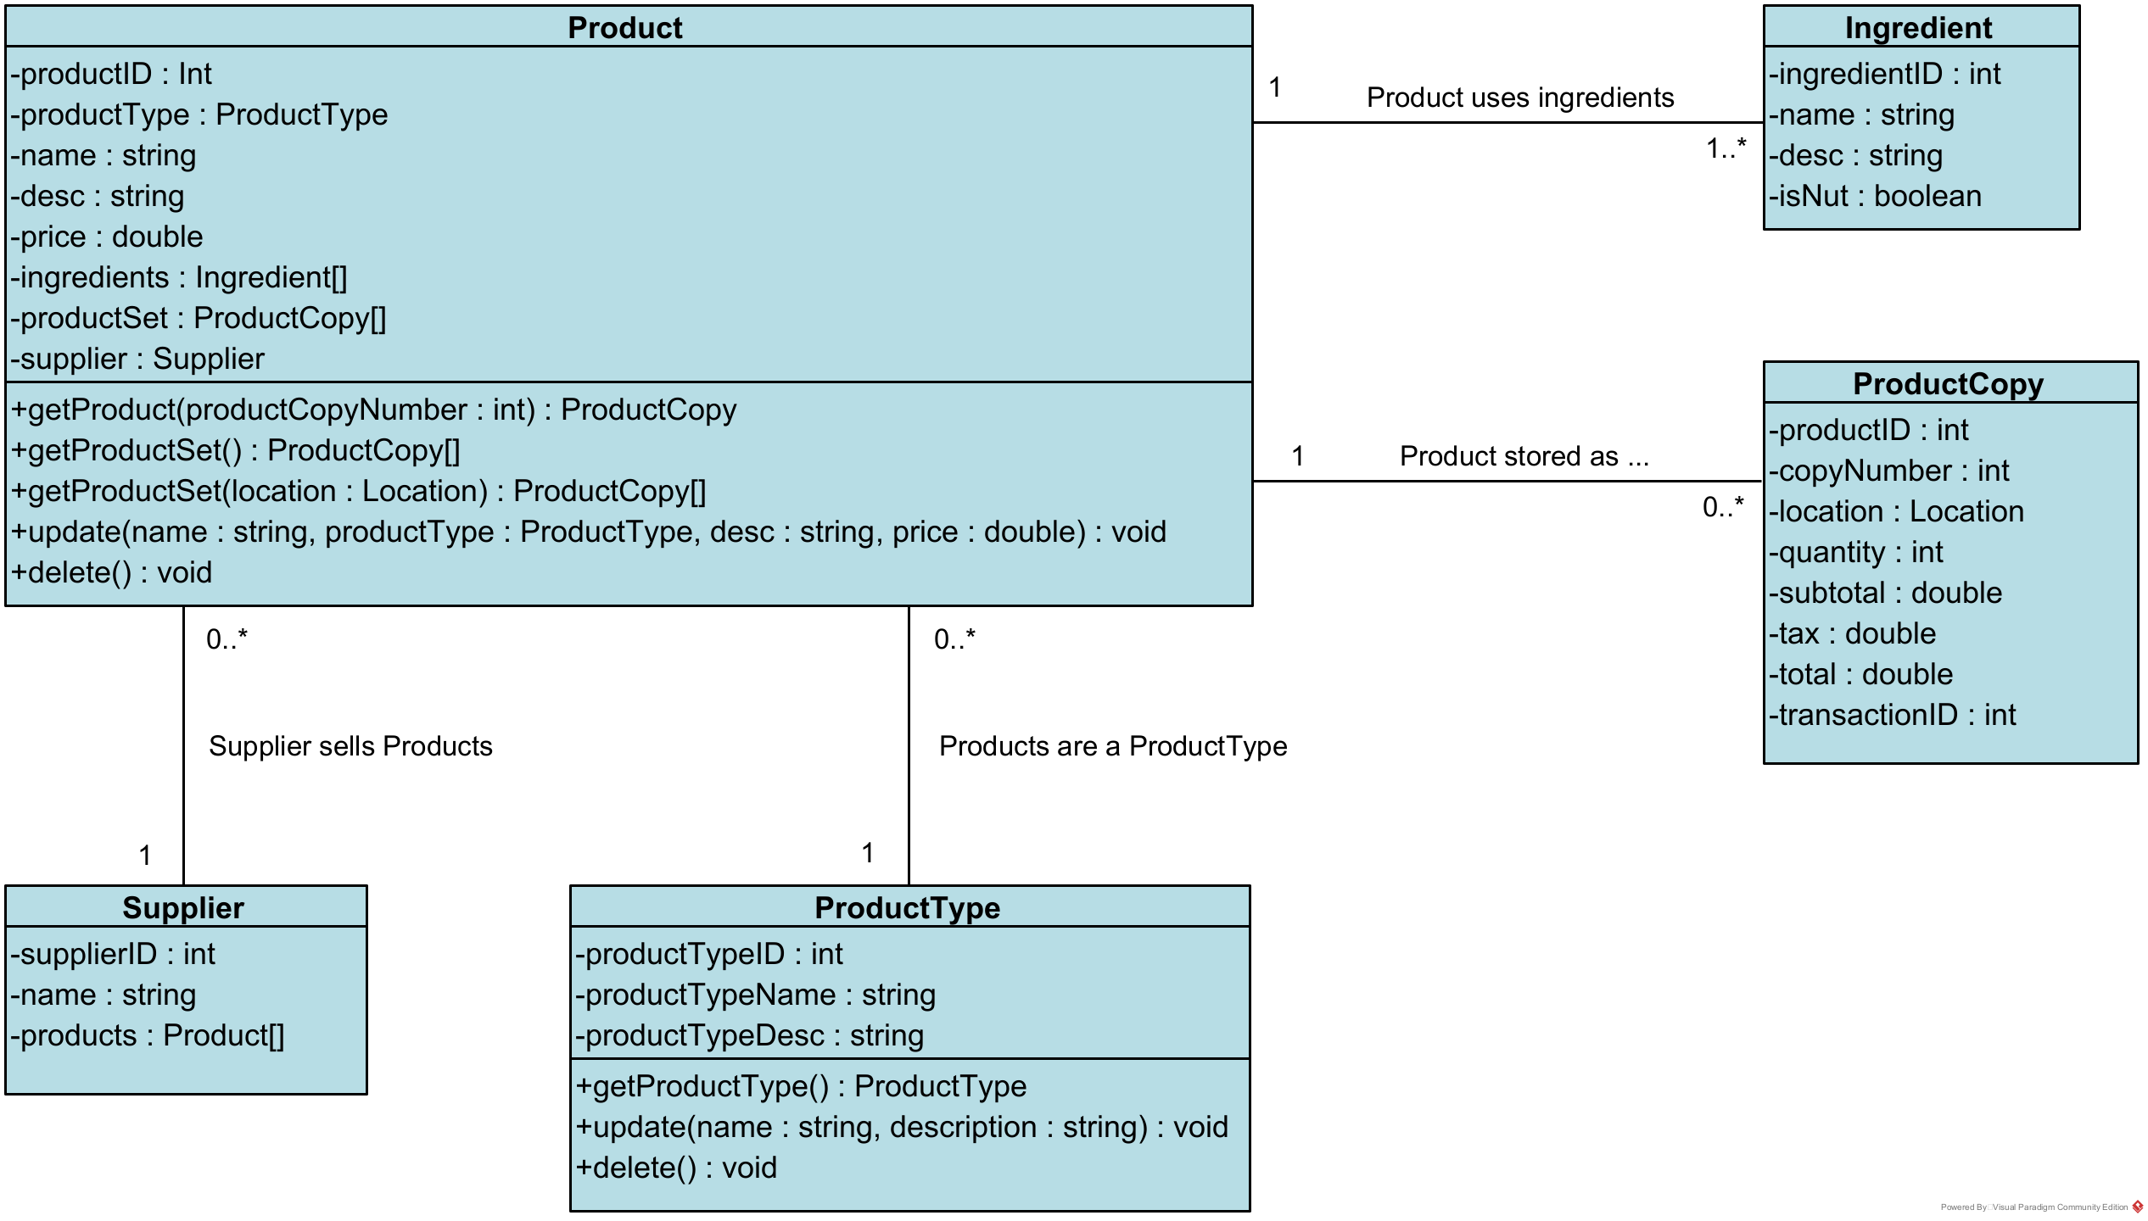

## Create New Product:

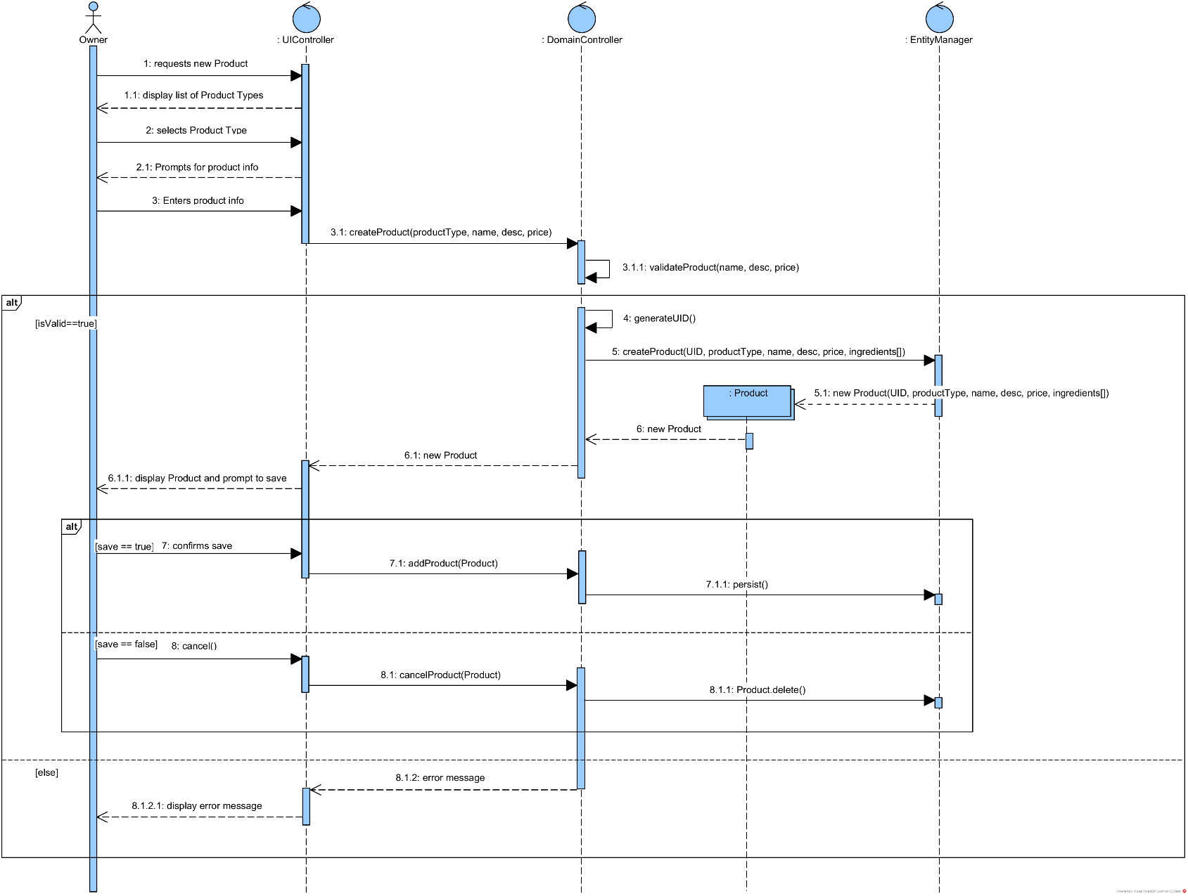

## Query Products by Product Type:

Owner can select either a product type from a list or cancel. Loop to get each Product for list of products by product type.

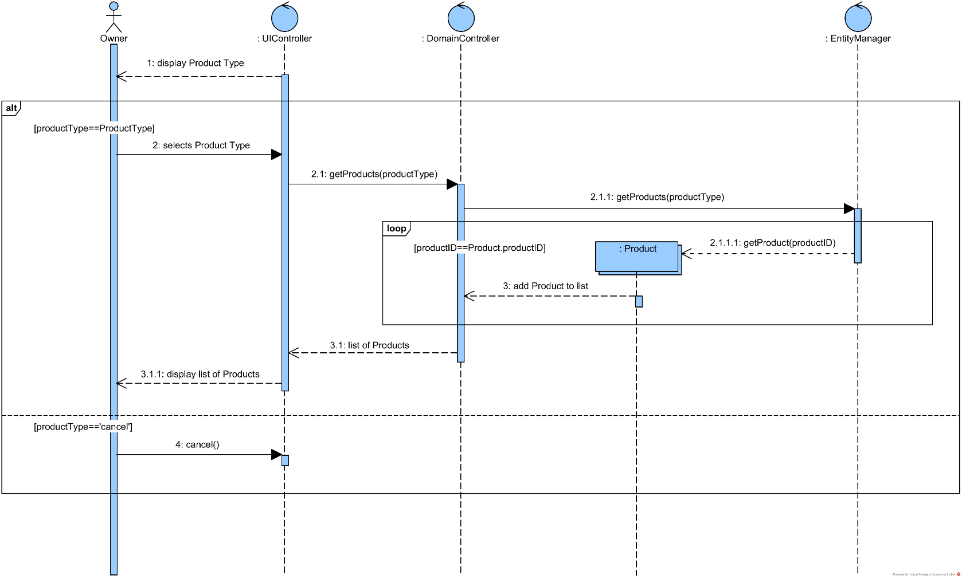

## Create Purchase:

This creates multiple ProductCopys in a loop. There are multiple alts to account for Owner canceling out of the process. Create ProductCopy is similar to create Product but with some additional variables and steps.

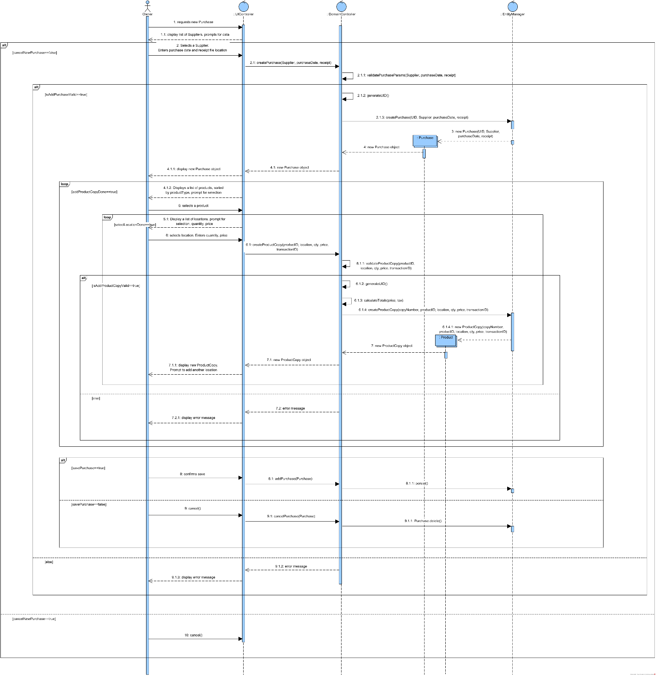

## All Classes:

These are all the current classes for the bakery.

