# Group 4 – Sales Lab

John Richard Bozar | Rickson Bozar | Diego Felipe | Luca Novello

November 10, 2024

## Classes:

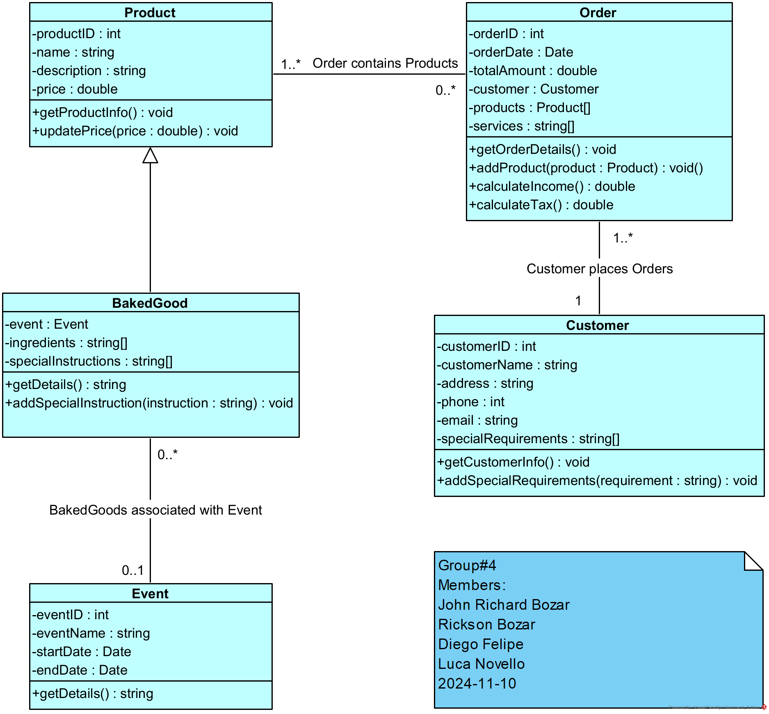

## Controller Classes:

## 

Sequence Diagram - Create New Customer:

Sequence Diagram - Query Sales:

## Sequence Diagram - Create Sale:

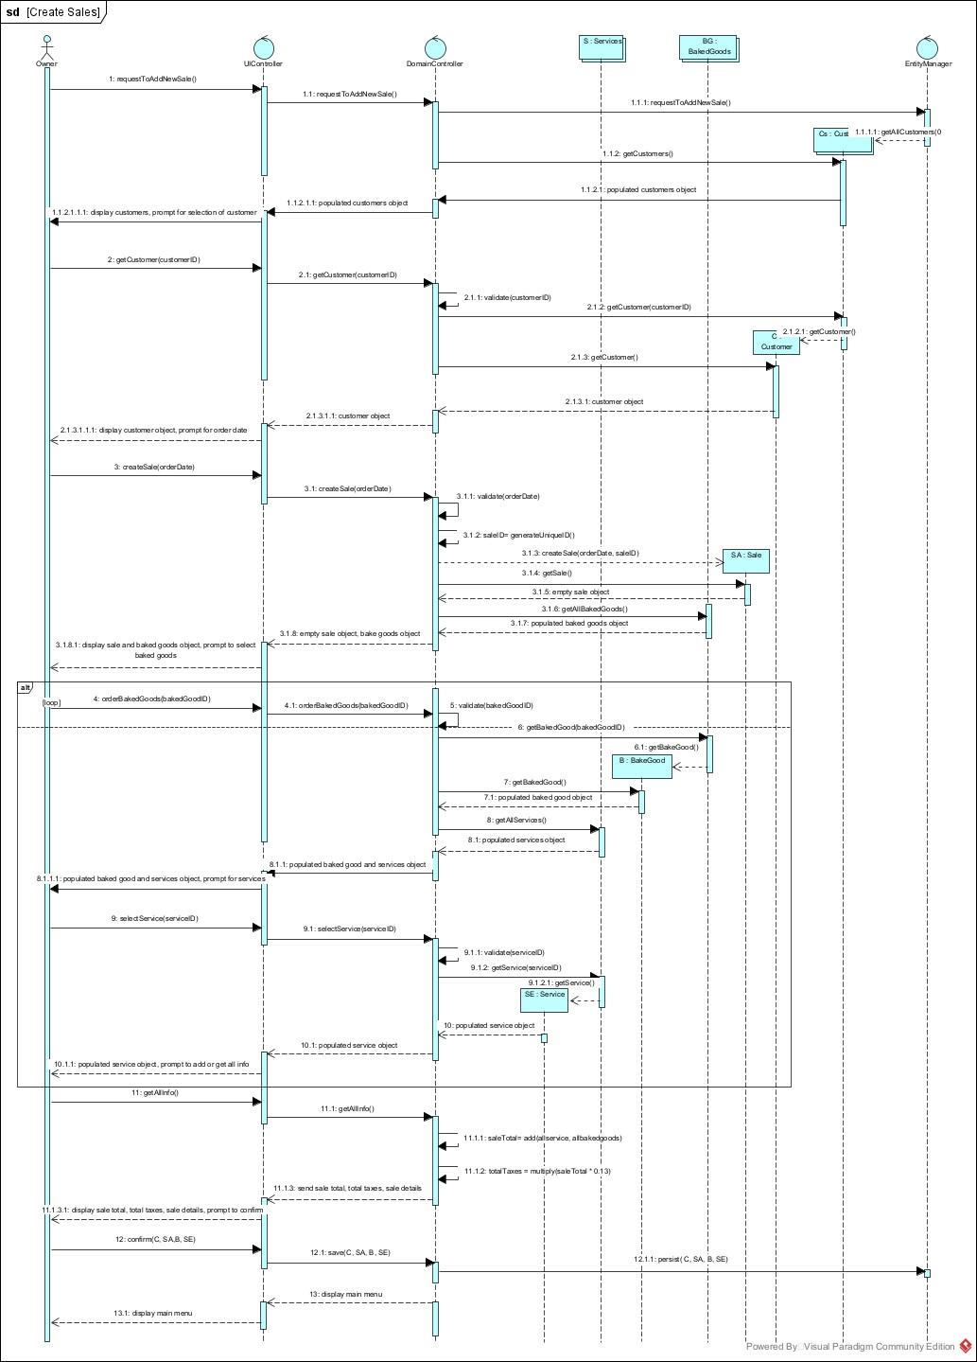

## Wireframe – Home

## 

**Logo:** At the top left, there’s a space for the company logo.

**Menu:** On the left side, there’s a menu with options:

* Dashboard: Main page showing business stats.
* Customers: Page with customer information.
* Sales: Page to check sales details.
* Settings: Page for adjusting preferences.

**Dashboard Main Section:**

* Summary Boxes: At the top, there are boxes showing key numbers like:
  + Total Sales
  + Total Income
  + Total Expenses
  + Total Taxes
* Sales Performance: Shows how well the sales are doing.
* Customers: List of customers and their information.

Wireframe – Create New Customer

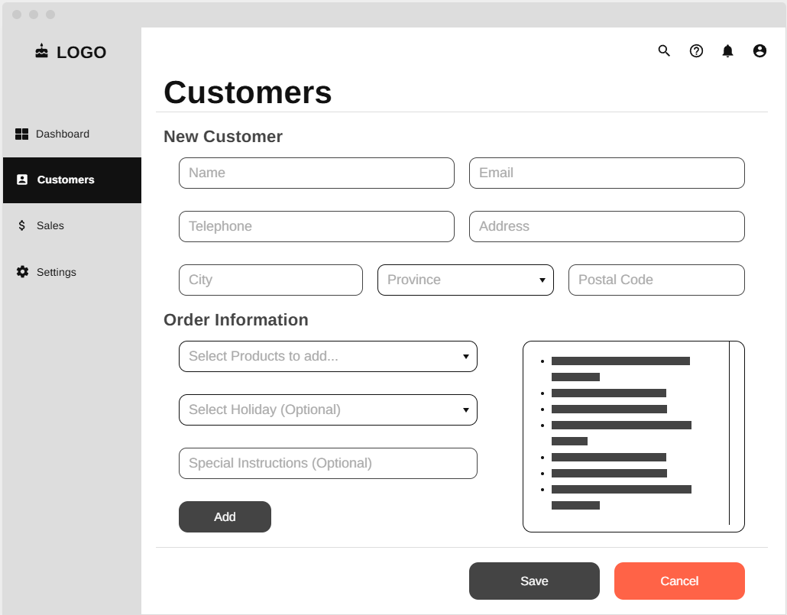

**Logo & Menu:** Same as Home Page

**Customer Main Section:**

* Form to enter customer details such as:
  + Name
  + Address
  + Email
  + Telephone
  + Products ordered
  + Any holidays associated with the product
  + Any special instructions associated with the product
* Save and Cancel buttons