# Group 4 – Scheduling Lab

John Richard Bozar | Rickson Bozar | Diego Felipe | Luca Novello

November 17, 2024

## Classes:

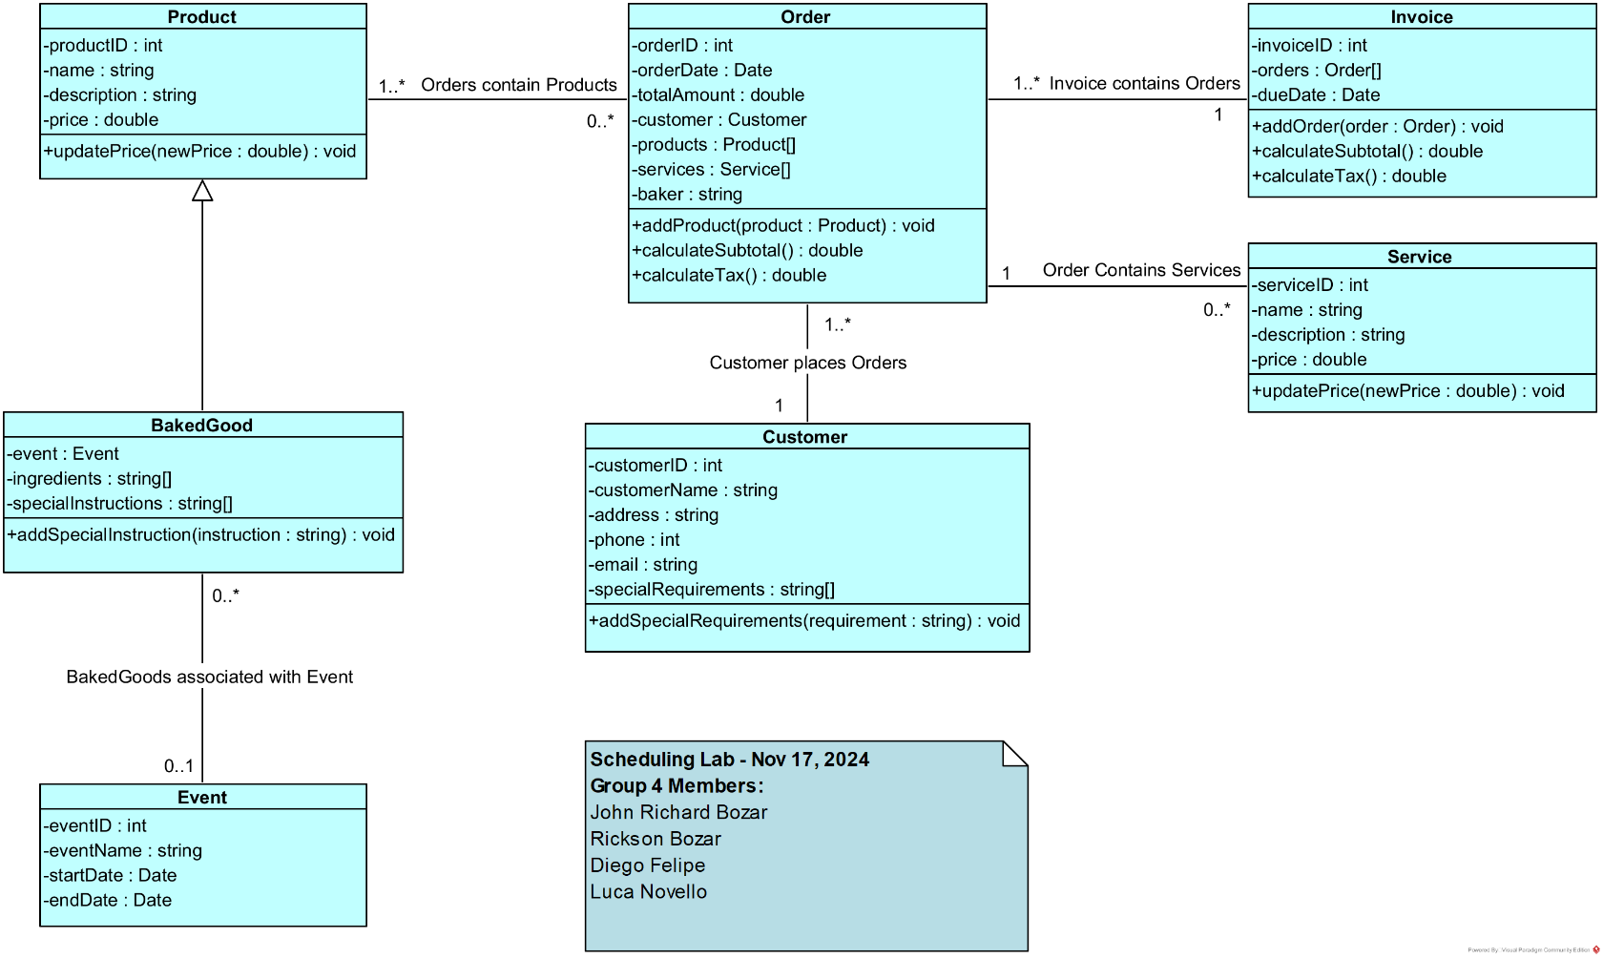

The Invoice and Service classes were added from the previous lab.

## Controller Classes:

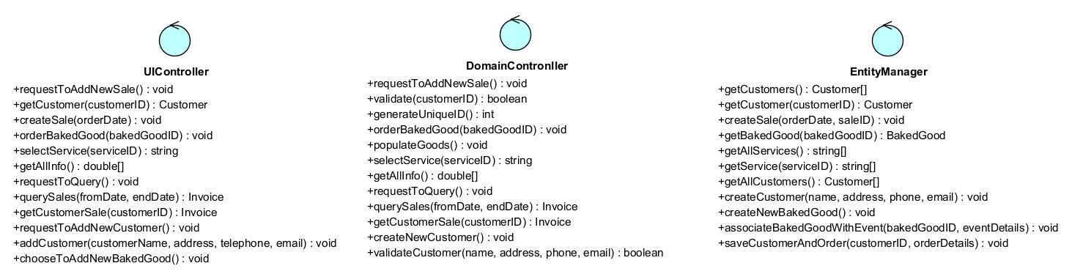

## Sequence Diagram - Create Customer Order:

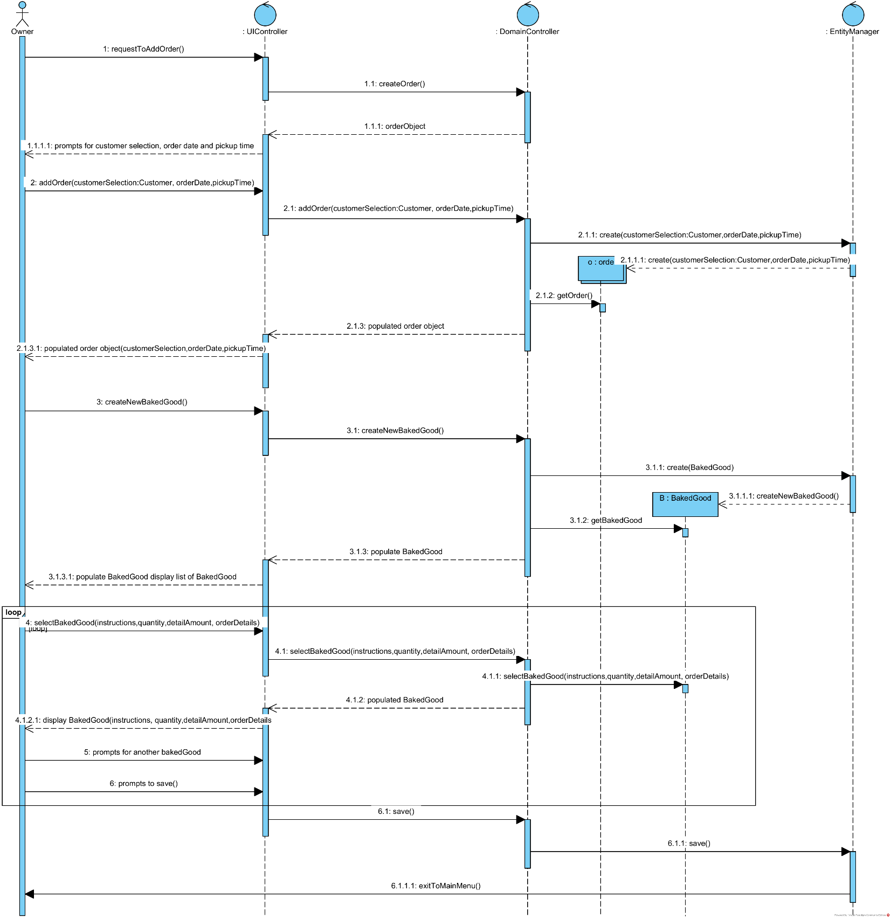

## Wireframe – Create Customer Order

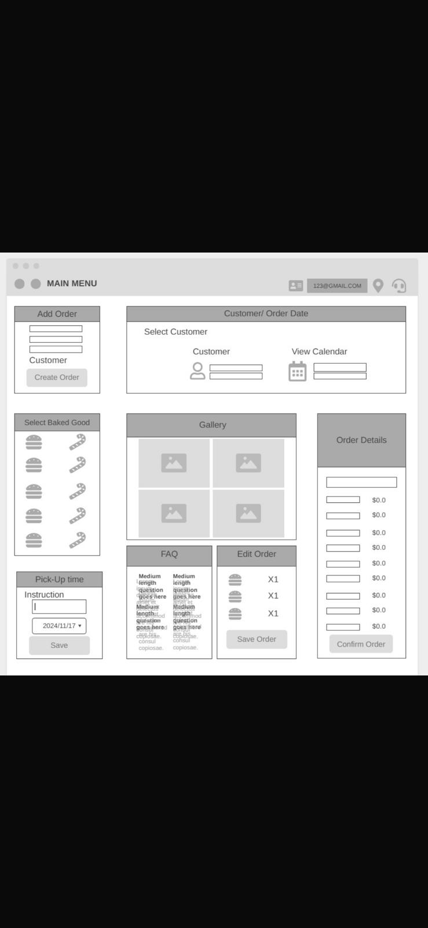

**Menu:** Account Information and additional options.

**Order Main Section:**

* Form to enter details such as:
  + Customer
  + Baked Goods
  + Date and Time
  + Order Details
  + FAQ section

## .h File

### UIController Class:

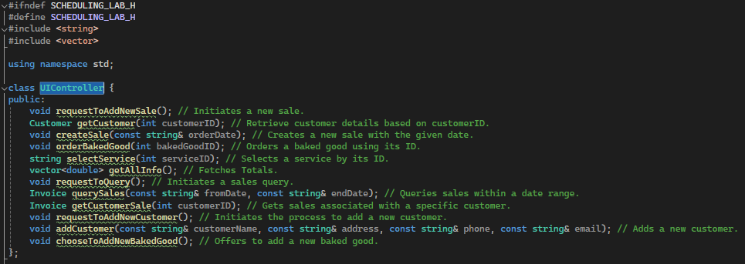

### DomainController Class:

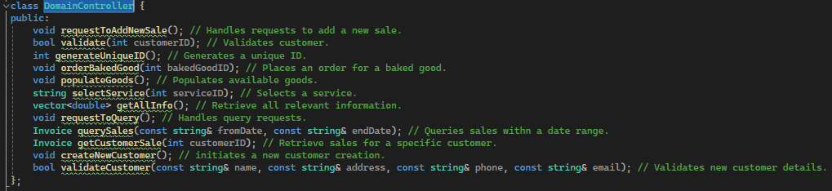

### EntityManager Class:

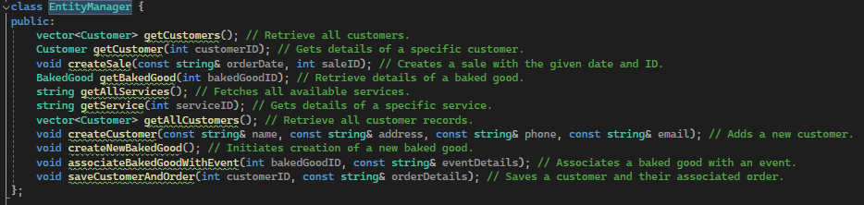

### Order Class:

### Invoice Class:

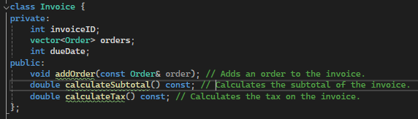

### Customer Class:

### Service Class:

### Product Class:

### BakedGood Class:

### Event Class:

