**Baza de date a unui lant de restaurante**

Realizat de: Petchi Andrei Luca Grupa 234

1. **Prezentati pe scurt baza de date ( utilitatea ei ).**

Pentru acest proiect , am ales realizarea bazei de date a unui lant de restaurante cu specific japonez , format din ,,Japanos Fusion’’, ,,Japanos By The Lake ”, ,, Japanos Tineretului ”, ,, Japanos Takeaway ” si ,,Japanos Dorobanti”. Restaurantele functioneaza pe un sistem clasic, clientului ii este preluata comanda de catre un ospatar, urmand ca aceasta sa fie preparata de un bucatar. Acesta plateste la final nota, avand posibilitatea platii cash sau card. Clientii au posibilitatea de a face rezervari sau comenzi online. In cazul comenziilor online , comanda este livrata de catre un curier din cadrul restaurantului solicitat . Baza de date propusa faciliteaza managementul restaurantelor din retea, angajatii , clientii si comenziile fiind reprezentati de entitatile “ANGAJATI” , “CLIENTI” respectiv “COMANDA” tinand evidenta rolului fiecarui angajat, performanta lor si datele fiecarei comenzi. De asemenea , baza de date ofera informatii despre stocuri, vanzari cat si preferintele clientilor, ajuta la luarea deciziilor informate, optimizand costurile, cresterea eficientei operationale si imbunatatirea experientei clientilor.

**Reguli**

-Fiecare angajat lucreaza intr-o singura locatie, iar fiecare locatie la randul ei are cel putin un angajat pentru fiecare departament.

-Rezervarea unei mese este posibila cat si comandarea prin livrare.

-Angajatii sunt impartiti in :chefi,staff si curieri, fiecare angajat avand id-ul unic de angajat dar si id-ul pentru departamentul din care fac parte.

-Fiecare comanda este unica,identifiabila prin id. -Orice comanda are nota de plata.

-O comanda trimisa prin livrare este preluata de un curier. -Meniul contine diferite preparate,pretul lor fiind flexibil in functie de perioada.

-Angajatii au salariul in functie de vechimea lor.

-Fiecare curier are o masina pentru livrare, costurile ei fiind decontate de catre restaurant.

**2. Realizați diagrama entitate-relație (ERD): entitățile, relațiile și atributele trebuie definite în limba română.**

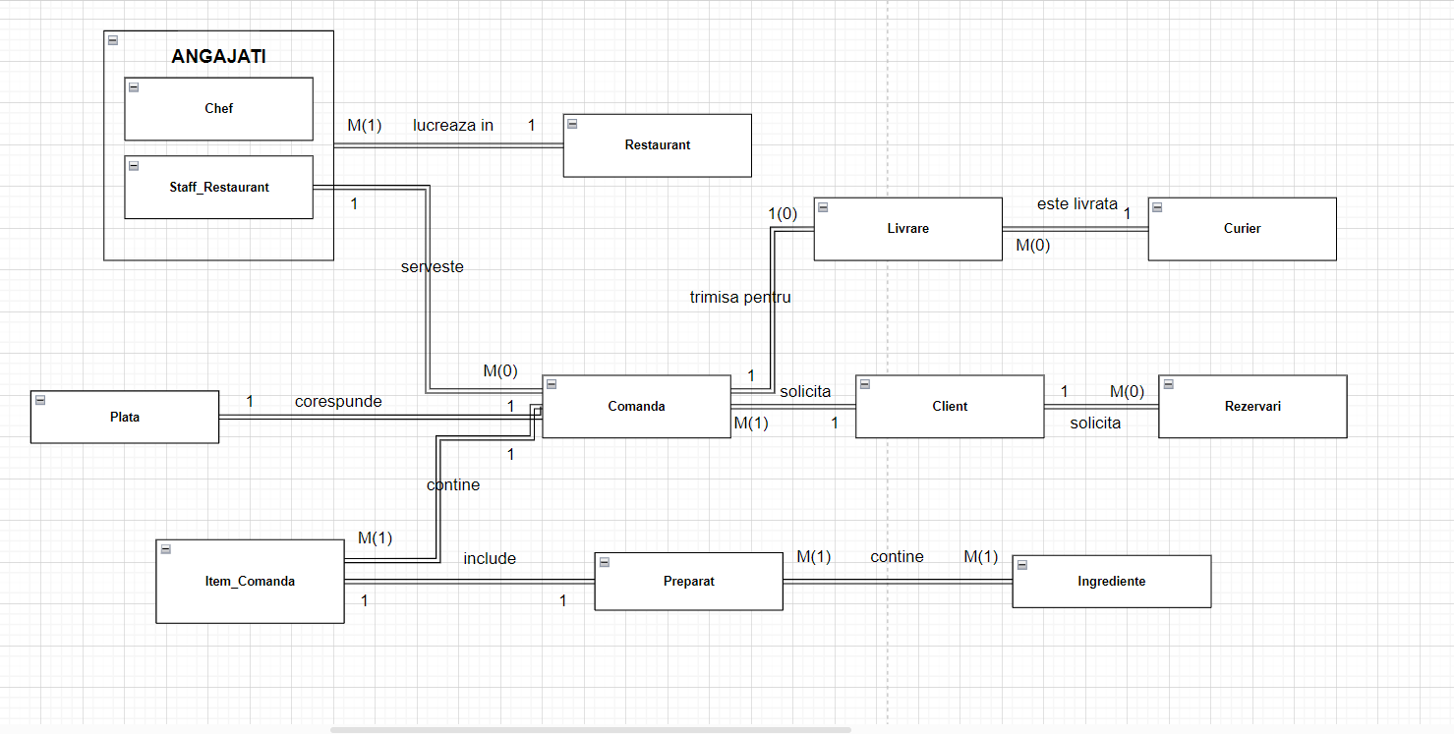

**3. Pornind de la diagrama entitate-relație realizați diagrama conceptuală a modelului propus, integrând toate atributele necesare: entitățile, relațiile și atributele trebuie definite în limba română.**

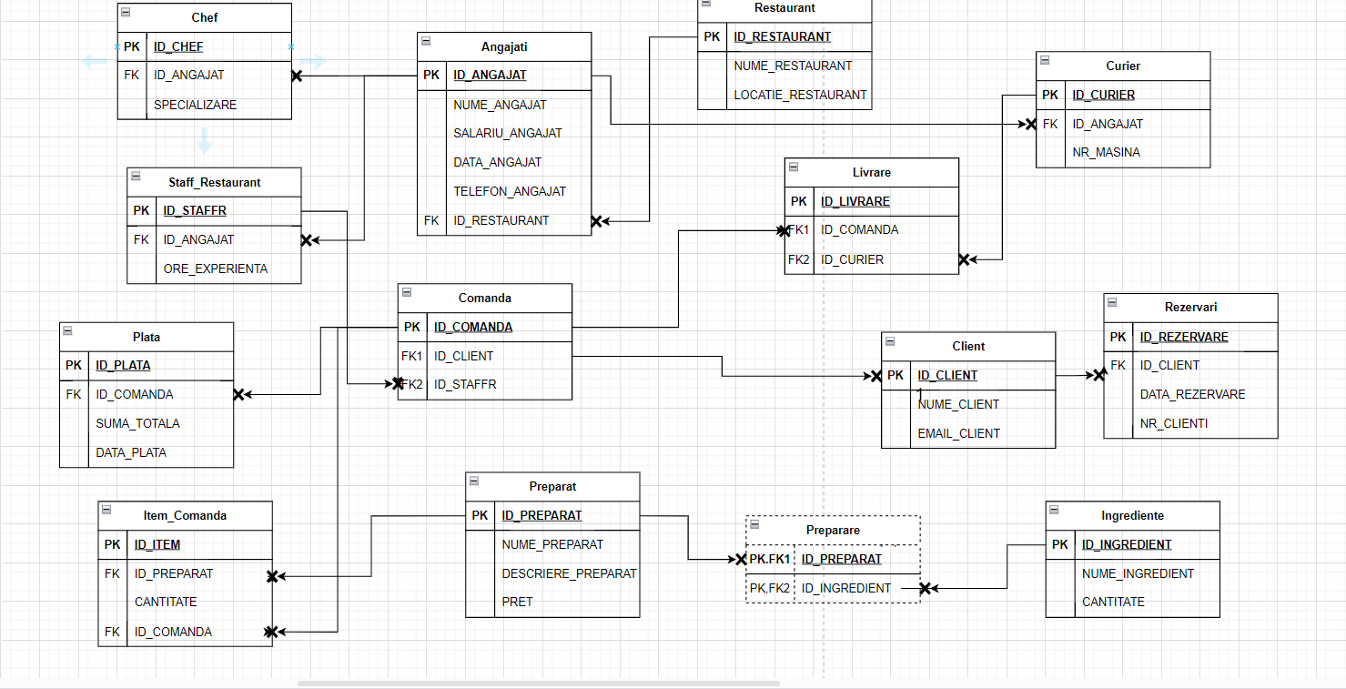

**4. Implementați în Oracle diagrama conceptuală realizată: definiți toate tabelele, definind toate constrângerile de integritate necesare (chei primare, cheile externe etc).**

create TABLE RESTAURANT(

ID_RESTAURANT int not null primary key,

NUME_RESTAURANT varchar2(50),

LOCATIE_RESTAURANT varchar2(50)

);

create TABLE ANGAJATI(

ID_ANGAJAT int not null primary key,

NUME_ANGAJAT varchar2(50),

SALARIU_ANGAJAT int ,

DATA_ANGAJAT date,

TELEFON_ANGAJAT varchar2(10),

ID_RESTAURANT not null,

foreign key(ID_RESTAURANT) references RESTAURANT(ID_RESTAURANT)

);

create TABLE STAFF_RESTAURANT(

ID_STAFFR int not null primary key,

ID_ANGAJAT not null,

LUNI_EXPERIENTA int,

foreign key(ID_ANGAJAT) references ANGAJATI(ID_ANGAJAT)

);

create TABLE CHEF(

ID_CHEF int not null primary key,

ID_ANGAJAT not null,

SPECIALIZARE varchar2(20),

foreign key(ID_ANGAJAT) references ANGAJATI(ID_ANGAJAT)

);

create TABLE CLIENTI(

ID_CLIENT int not null primary key,

NUME_CLIENT varchar2(50),

EMAIL_CLIENT varchar2(50)

);

create TABLE REZERVARI(

ID_REZERVARE int not null primary key,

ID_CLIENT not null,

DATA_REZERVARE date,

NR_CLIENTI int,

foreign key(ID_CLIENT) references CLIENT(ID_CLIENT)

);

create TABLE COMANDA(

ID_COMANDA int not null primary key,

ID_CLIENT not null,

ID_STAFFR not null,

foreign key(ID_CLIENT) references CLIENT(ID_CLIENT),

foreign key(ID_STAFFR) references STAFF_RESTAURANT(ID_STAFFR)

);

create TABLE PREPARAT(

ID_PREPARAT int not null primary key,

NUME_PREPARAT varchar2(20),

DESCRIERE_PREPARAT varchar2(200)

PRET int,

);

create TABLE INGREDIENTE(

ID_INGREDIENT int not null primary key,

NUME_INGREDIENT varchar2(50),

Cantitate int,

foreign key(ID_COMANDA) references COMANDA(ID_COMANDA)

);

create TABLE PLATA(

ID_PLATA int not null primary key,

ID_COMANDA not null,

SUMA_TOTALA decimal,

DATA_PLATA date,

foreign key(ID_COMANDA)references COMANDA(ID_COMANDA)

);

create TABLE CURIER(

ID_CURIER int not null primary key,

ID_ANGAJAT not null,

NR_MASINA int,

foreign key(ID_ANGAJAT)references ANGAJATI(ID_ANGAJAT)

);

create TABLE LIVRARE(

ID_LIVRARE int not null primary key,

ID_COMANDA not null,

ID_CURIER not null,

foreign key(ID_COMANDA) references COMANDA(ID_COMANDA),

foreign key(ID_CURIER) references CURIER(ID_CURIER)

);

create TABLE ITEM_COMANDA(

ID_ITEM int not null primary key,

CANTITATE int,

ID_PREPARAT not null,

ID_COMANDA not null,

foreign key(ID_PREPARAT) references PREPARAT(ID_PREPARAT),

foreign key(ID_COMANDA) references COMANDA(ID_COMANDA)

);

Create TABLE PREPARARE(

ID_PREPARAT not null,

ID_INGREDIENT not null,

Foreign key(ID_PREPARAT) references PREPARAT(ID_PREPARAT),

Foreign key(ID_INGREDIENT) references INGREDIENT(ID_INGREDIENT)

);

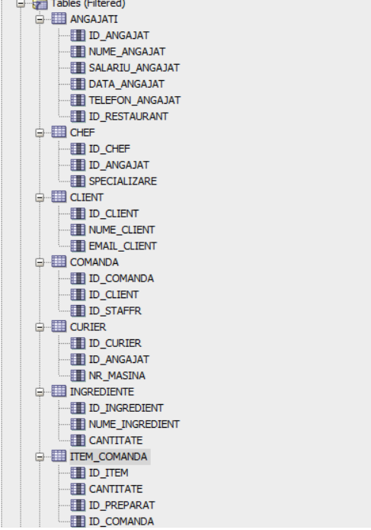

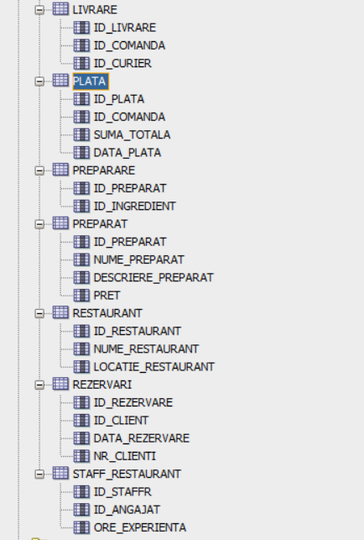

**5. Adăugați informații coerente în tabelele create (minim 5 înregistrări pentru fiecare entitate independentă; minim 10 înregistrări pentru tabela asociativă).**

insert into RESTAURANT VALUES(1,'Japanos Fusion','Soseaua Nordului');

insert into RESTAURANT VALUES(2,'Japanos by the Lake','Parcul Herastrau');

insert into RESTAURANT VALUES(3,'Japanos Tineretului','Bvd. Dimitrie Cantemir');

insert into RESTAURANT VALUES(4,'Japanos Takeaway','Bulevardul Lacul Tei');

insert into RESTAURANT VALUES(5,'Japanos Dorobanti','Strada George Calinescu');

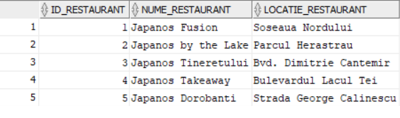

SELECT * FROM ANGAJATI;

insert into ANGAJATI VALUES(111,'Popescu Radu',4400,to_date('01/03/2022','dd/mm/yyyy'),'0721020282',1);

insert into ANGAJATI VALUES(112,'Antonescu Mihai',5000,to_date('02/05/2021','dd/mm/yyyy'),'0724040502',2);

insert into ANGAJATI VALUES(113,'Andrei Stefan Catalin',5500,to_date('10/07/2020','dd/mm/yyyy'),'0732028213',3);

insert into ANGAJATI VALUES(114,'Nastea Calin',4400,to_date('01/10/2022','dd/mm/yyyy'),'0743209876',4);

insert into ANGAJATI VALUES(115,'Georgescu Maria',4400,to_date('25/05/2022','dd/mm/yyyy'),'0721384821',5);

insert into ANGAJATI VALUES(116,'Ionescu Ana',6000,to_date('14/03/2017','dd/mm/yyyy'),'0755338212',1);

insert into ANGAJATI VALUES(117,'Nedelcu Ana',5000,to_date('20/04/2020','dd/mm/yyyy'),'0722308202',2);

insert into ANGAJATI VALUES(118,'Ionita Alexandru',5000,to_date('14/12/2021','dd/mm/yyyy'),'0723458922',3);

insert into ANGAJATI VALUES(119,'Oprea Laurentiu',5000,to_date('01/06/2021','dd/mm/yyyy'),'0744994421',4);

insert into ANGAJATI VALUES(120,'Voinea Alexandru',6000,to_date('12/03/2019','dd/mm/yyyy'),'0721982394',5);

insert into ANGAJATI VALUES(121,'Ceausu Florina',7500,to_date('04/06/2016','dd/mm/yyyy'),'0721992182',1);

insert into ANGAJATI VALUES(122,'Velcea Maria',5500,to_date('05/02/2020','dd/mm/yyyy'),'0723402345',1);

insert into ANGAJATI VALUES(123,'Ammari Abdul',7500,to_date('06/10/2015','dd/mm/yyyy'),'0723449942',2);

insert into ANGAJATI VALUES(124,'Dumitru Tudor',4400,to_date('20/09/2022','dd/mm/yyyy'),'0728992314',3);

insert into ANGAJATI VALUES(125,'Spataru Vlad',5000,to_date('10/07/2021','dd/mm/yyyy'),'0788991234',4);

insert into ANGAJATI VALUES(126,'Dumitru Vlad',5000,to_date('15/05/2021','dd/mm/yyyy'),'0799124422',5);

insert into ANGAJATI VALUES(127,'Draghici Rares',5500,to_date('23/09/2021','dd/mm/yyyy'),'0723934412',1);

insert into ANGAJATI VALUES(128,'West Kanye',4400,to_date('21/07/2021','dd/mm/yyyy'),'0721349821',2);

insert into ANGAJATI VALUES(129,'Dragomir Stefania',6000,to_date('13/05/2020','dd/mm/yyyy'),'0788239124',3);

insert into ANGAJATI VALUES(130,'Iliescu Ionut',5000,to_date('04/07/2021','dd/mm/yyyy'),'0728445503',4);

insert into ANGAJATI VALUES(131,'Turcu Denisa',5500,to_date('01/04/2021','dd/mm/yyyy'),'0723557705',5);

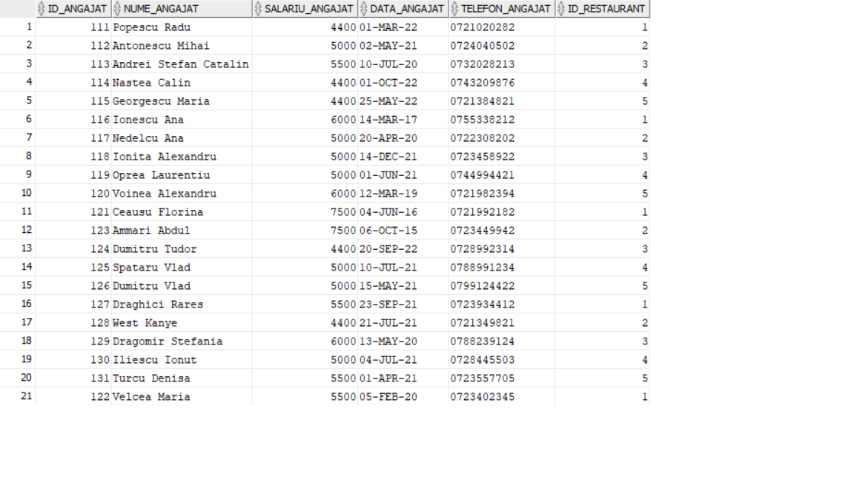

SELECT * FROM CLIENT;

insert into CLIENT(ID_CLIENT,NUME_CLIENT,EMAIL_CLIENT)

VALUES(seq_id_client.NEXTVAL,'Ion Dan','iondan@gmail.com');

insert into CLIENT (ID_CLIENT,NUME_CLIENT,EMAIL_CLIENT)

VALUES(seq_id_client.NEXTVAL,'Oprea Ion','oprion@gmail.com');

insert into CLIENT (ID_CLIENT,NUME_CLIENT,EMAIL_CLIENT)

VALUES(seq_id_client.NEXTVAL,'Letea Radu','letear@gmail.com');

insert into CLIENT (ID_CLIENT,NUME_CLIENT,EMAIL_CLIENT)

VALUES(seq_id_client.NEXTVAL,'Dobrin Letitia','dobr@gmail.com');

insert into CLIENT (ID_CLIENT,NUME_CLIENT,EMAIL_CLIENT)

VALUES(seq_id_client.NEXTVAL,'Camelia Carmen','carmeliac@gmail.com');

insert into CLIENT (ID_CLIENT,NUME_CLIENT,EMAIL_CLIENT)

VALUES(seq_id_client.NEXTVAL,'Rosoiu Luca','lucarosoiu@gmail.com');

insert into CLIENT (ID_CLIENT,NUME_CLIENT,EMAIL_CLIENT)

VALUES(seq_id_client.NEXTVAL,'Florea Andrei','floreandr@gmail.com');

insert into CLIENT (ID_CLIENT,NUME_CLIENT,EMAIL_CLIENT)

VALUES(seq_id_client.NEXTVAL,'Pintilie Ana','anapintilie@gmail.com');

insert into CLIENT (ID_CLIENT,NUME_CLIENT,EMAIL_CLIENT)

VALUES(seq_id_client.NEXTVAL,'Mihail Alexandra','alexandramihail@gmail.com');

insert into CLIENT (ID_CLIENT,NUME_CLIENT,EMAIL_CLIENT)

VALUES(seq_id_client.NEXTVAL,'Omar Ismail ','ismailomul@gmail.com');

insert into CLIENT (ID_CLIENT,NUME_CLIENT,EMAIL_CLIENT)

VALUES(seq_id_client.NEXTVAL,'Bisoc Alina','alinab@gmail.com');

insert into CLIENT (ID_CLIENT,NUME_CLIENT,EMAIL_CLIENT)

VALUES(seq_id_client.NEXTVAL,'Pene Florin','peneflorin@gmail.com');

insert into CLIENT (ID_CLIENT,NUME_CLIENT,EMAIL_CLIENT)

VALUES(seq_id_client.NEXTVAL,'Nitu Miruna','mirunadent@gmail.com');

insert into CLIENT (ID_CLIENT,NUME_CLIENT,EMAIL_CLIENT)

VALUES(seq_id_client.NEXTVAL,'Popovici David','davidpopovici@gmail.com');

insert into CLIENT (ID_CLIENT,NUME_CLIENT,EMAIL_CLIENT)

VALUES(seq_id_client.NEXTVAL,'Anghel Luminita','luminitaanghel@gmail.com');

insert into CLIENT (ID_CLIENT,NUME_CLIENT,EMAIL_CLIENT)

VALUES(seq_id_client.NEXTVAL,'Traistariu Mihai','mihaitraistariu@gmail.com');

insert into CLIENT (ID_CLIENT,NUME_CLIENT,EMAIL_CLIENT)

VALUES(seq_id_client.NEXTVAL,'Dumitrescu Bogdan','bogdand@gmail.com');

insert into CLIENT (ID_CLIENT,NUME_CLIENT,EMAIL_CLIENT)

VALUES(seq_id_client.NEXTVAL,'Dumitrascu Maria','mariadum@gmail.com');

insert into CLIENT (ID_CLIENT,NUME_CLIENT,EMAIL_CLIENT)

VALUES(seq_id_client.NEXTVAL,'Pavel Alina','pavelalina@gmail.com');

insert into CLIENT (ID_CLIENT,NUME_CLIENT,EMAIL_CLIENT)

VALUES(seq_id_client.NEXTVAL,'Ionescu Roxana','roxanaione@gmail.com');

insert into CLIENT (ID_CLIENT,NUME_CLIENT,EMAIL_CLIENT)

VALUES(seq_id_client.NEXTVAL,'Ionescu Mihai','ionescumihai@gmail.com');

insert into CLIENT (ID_CLIENT,NUME_CLIENT,EMAIL_CLIENT)

VALUES(seq_id_client.NEXTVAL,'Panait Razvan','panaitrazvan@gmail.com');

insert into CLIENT (ID_CLIENT,NUME_CLIENT,EMAIL_CLIENT)

VALUES(seq_id_client.NEXTVAL,'Stoian Radu','stoianradu@gmail.com');

insert into CLIENT (ID_CLIENT,NUME_CLIENT,EMAIL_CLIENT)

VALUES(seq_id_client.NEXTVAL,'Mihail Roxana','miharox@gmail.com');

insert into CLIENT (ID_CLIENT,NUME_CLIENT,EMAIL_CLIENT)

VALUES(seq_id_client.NEXTVAL,'Ivan Mihai','csgod@gmail.com');

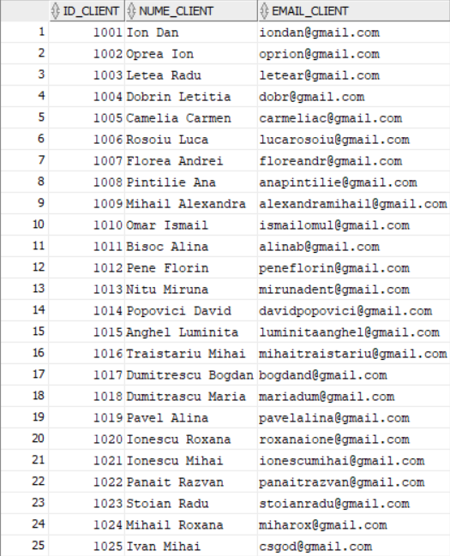

SELECT * FROM STAFF_RESTAURANT;

insert into STAFF_RESTAURANT VALUES(501,114,7);

insert into STAFF_RESTAURANT VALUES(502,111,14);

insert into STAFF_RESTAURANT VALUES(503,117,25);

insert into STAFF_RESTAURANT VALUES(504,128,22);

insert into STAFF_RESTAURANT VALUES(505,125,20);

insert into STAFF_RESTAURANT VALUES(506,131,25);

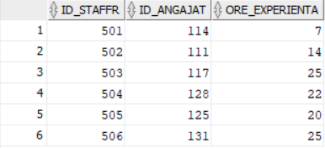

SELECT * FROM COMANDA;

insert into COMANDA VALUES(10,1004,501);

insert into COMANDA VALUES(11,1001,501);

insert into COMANDA VALUES(12,1010,502);

insert into COMANDA VALUES(13,1012,502);

insert into COMANDA VALUES(14,1014,503);

insert into COMANDA VALUES(15,1013,503);

insert into COMANDA VALUES(16,1001,503);

insert into COMANDA VALUES(17,1009,503);

insert into COMANDA VALUES(18,1008,503);

insert into COMANDA VALUES(19,1006,504);

insert into COMANDA VALUES(20,1013,504);

insert into COMANDA VALUES(21,1015,505);

insert into COMANDA VALUES(22,1020,506);

insert into COMANDA VALUES(23,1021,503);

insert into COMANDA VALUES(24,1022,505);

insert into COMANDA VALUES(25,1023,503);

insert into COMANDA VALUES(26,1024,501);

insert into COMANDA VALUES(27,1025,503);

insert into COMANDA VALUES(28,1001,501);

insert into COMANDA VALUES(29,1001,505);

insert into COMANDA VALUES(30,1001,505);

insert into COMANDA VALUES(31,1001,506);

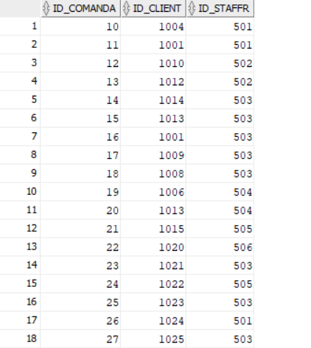

SELECT * FROM CHEF;

insert into CHEF VALUES(701,120,'Sushi');

insert into CHEF VALUES(702,121,'Sushi');

insert into CHEF VALUES(703,123,'Sushi');

insert into CHEF VALUES(704,116,'Ramen');

insert into CHEF VALUES(705,112,'Ramen');

insert into CHEF VALUES(706,119,'Ramen');

insert into CHEF VALUES(707,113,'Dessert');

insert into CHEF VALUES(708,118,'Dessert');

insert into CHEF VALUES(709,127,'Sushi');

insert into CHEF VALUES(710,130,'Ramen');

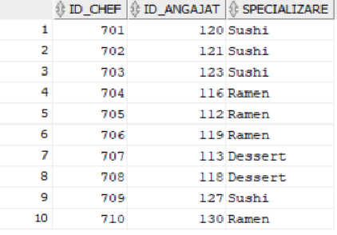

SELECT * FROM INGREDIENTE;

insert into INGREDIENTE VALUES(801,'Ton',90);

insert into INGREDIENTE VALUES(802,'Somon',55);

insert into INGREDIENTE VALUES(803,'Orez',231);

insert into INGREDIENTE VALUES(804,'Sos Soia',30);

insert into INGREDIENTE VALUES(805,'Creveti',40);

insert into INGREDIENTE VALUES(806,'Wasabi',70);

insert into INGREDIENTE VALUES(807,'Crab',220);

insert into INGREDIENTE VALUES(808,'Ciuperci',300);

insert into INGREDIENTE VALUES(809,'Pasta Miso',120);

insert into INGREDIENTE VALUES(810,'Porc',50);

insert into INGREDIENTE VALUES(811,'Avocado',80);

insert into INGREDIENTE VALUES(812,'Castravete',90);

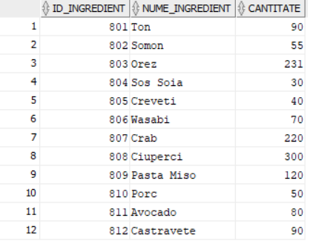

SELECT * FROM PREPARAT;

insert into PREPARAT VALUES(901,'Nigiri Ton','File de ton pe un pat de orez presat ',801);

insert into PREPARAT VALUES(902,'Nigiri Somon','File de somon pe un pat de orez presat ',802);

insert into PREPARAT VALUES(903,'Maki Ton','Rulou Maki clasic cu ton',801);

insert into PREPARAT VALUES(904,'Maki Somon','Rulou Maki clasic cu somon',802);

insert into PREPARAT VALUES(905,'Maki Avocado','Rulou Maki clasic cu avocado',811);

insert into PREPARAT VALUES(906,'Maki Spicy Somon','Rulou Maki clasic somon cu sosul spicy Japanos',802);

insert into PREPARAT VALUES(907,'Maki California','Rulou Maki care contine crab,avocado , castravete si seminte de susan',807);

insert into PREPARAT VALUES(908,'Maki Philadelphia','Rulou Maki care contine somon, cream cheese si castravete',802);

insert into PREPARAT VALUES(909,'Ramen Veggie','Ramen vegetarian pe baza de ciuperci shiitake',808);

insert into PREPARAT VALUES(910,'Ramen Porc','Ramenul clasic, construit in jurul porcului in stil chashu ',810);

insert into PREPARAT VALUES(911,'Supa Miso','Supa traditionala japoneza, ingredientul principal fiind pasta miso',809);

insert into PREPARAT VALUES(912,'Mochi','Prajitura japoneza facuta din orez',803);

UPDATE PREPARAT SET PRET = 20 WHERE ID_PREPARAT=901;

UPDATE PREPARAT SET PRET = 21 WHERE ID_PREPARAT=902;

UPDATE PREPARAT SET PRET = 25 WHERE ID_PREPARAT=903;

UPDATE PREPARAT SET PRET = 30 WHERE ID_PREPARAT=904;

UPDATE PREPARAT SET PRET = 20 WHERE ID_PREPARAT=905;

UPDATE PREPARAT SET PRET = 30 WHERE ID_PREPARAT=906;

UPDATE PREPARAT SET PRET = 30 WHERE ID_PREPARAT=907;

UPDATE PREPARAT SET PRET = 30 WHERE ID_PREPARAT=908;

UPDATE PREPARAT SET PRET = 25 WHERE ID_PREPARAT=909;

UPDATE PREPARAT SET PRET = 25 WHERE ID_PREPARAT=910;

UPDATE PREPARAT SET PRET = 20 WHERE ID_PREPARAT=911;

UPDATE PREPARAT SET PRET = 12 WHERE ID_PREPARAT=912;

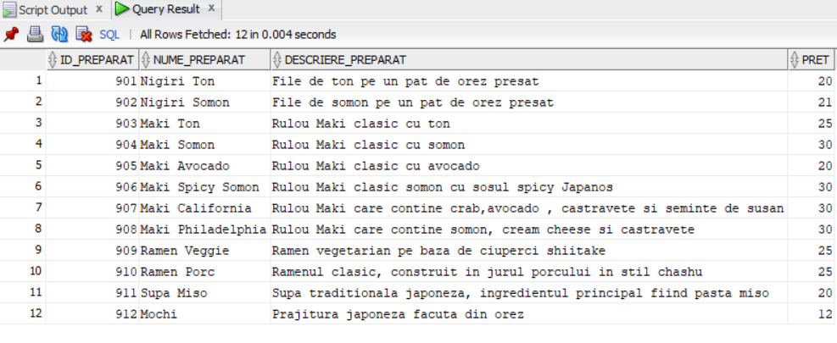

SELECT * FROM CURIER;

insert into CURIER VALUES(1501,115,111);

insert into CURIER VALUES(1502,122,222);

insert into CURIER VALUES(1503,124,333);

insert into CURIER VALUES(1504,126,444);

insert into CURIER VALUES(1505,129,555);

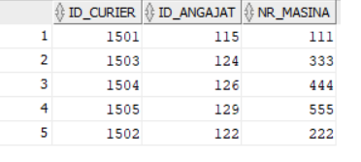

SELECT * FROM ITEM_COMANDA;

insert into ITEM_COMANDA VALUES(651,1,901,10);

insert into ITEM_COMANDA VALUES(652,2,905,11);

insert into ITEM_COMANDA VALUES(653,4,903,12);

insert into ITEM_COMANDA VALUES(654,3,906,13);

insert into ITEM_COMANDA VALUES(655,1,907,14);

insert into ITEM_COMANDA VALUES(656,1,910,15);

insert into ITEM_COMANDA VALUES(657,2,910,16);

insert into ITEM_COMANDA VALUES(658,2,903,17);

insert into ITEM_COMANDA VALUES(659,1,901,18);

insert into ITEM_COMANDA VALUES(660,3,902,19);

insert into ITEM_COMANDA VALUES(661,4,904,20);

insert into ITEM_COMANDA VALUES(662,5,905,21);

insert into ITEM_COMANDA VALUES(663,6,912,22);

insert into ITEM_COMANDA VALUES(664,2,911,13);

insert into ITEM_COMANDA VALUES(665,3,906,14);

insert into ITEM_COMANDA VALUES(666,4,908,13);

insert into ITEM_COMANDA VALUES(667,1,909,16);

insert into ITEM_COMANDA VALUES(668,2,903,17);

insert into ITEM_COMANDA VALUES(669,1,902,18);

insert into ITEM_COMANDA VALUES(670,1,906,13);

insert into ITEM_COMANDA VALUES(671,3,909,14);

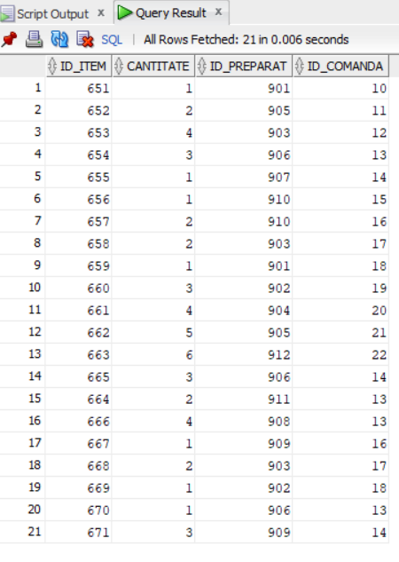

SELECT * FROM PLATA;

insert into PLATA VALUES(350,10,48,to_date('10/05/2023','dd/mm/yyyy'));

insert into PLATA VALUES(351,11,50,to_date('08/05/2023','dd/mm/yyyy'));

insert into PLATA VALUES(352,12,80,to_date('19/05/2023','dd/mm/yyyy'));

insert into PLATA VALUES(353,13,33,to_date('18/05/2023','dd/mm/yyyy'));

insert into PLATA VALUES(354,14,166,to_date('16/05/2023','dd/mm/yyyy'));

insert into PLATA VALUES(355,15,35,to_date('18/05/2023','dd/mm/yyyy'));

insert into PLATA VALUES(356,16,61,to_date('19/05/2023','dd/mm/yyyy'));

insert into PLATA VALUES(357,17,118,to_date('18/05/2023','dd/mm/yyyy'));

insert into PLATA VALUES(358,18,141,to_date('16/05/2023','dd/mm/yyyy'));

insert into PLATA VALUES(359,19,25,to_date('17/05/2023','dd/mm/yyyy'));

insert into PLATA VALUES(360,20,60,to_date('20/05/2023','dd/mm/yyyy'));

insert into PLATA VALUES(361,21,32,to_date('21/05/2023','dd/mm/yyyy'));

insert into PLATA VALUES(362,22,20,to_date('22/05/2023','dd/mm/yyyy'));

insert into PLATA VALUES(363,23,210,to_date('02/01/2022','dd/mm/yyyy'));

insert into PLATA VALUES(364,24,42,to_date('17/05/2023','dd/mm/yyyy'));

insert into PLATA VALUES(365,25,60,to_date('23/06/2023','dd/mm/yyyy'));

insert into PLATA VALUES(366,26,22,to_date('23/04/2023','dd/mm/yyyy'));

insert into PLATA VALUES(367,27,80,to_date('20/04/2021','dd/mm/yyyy'));

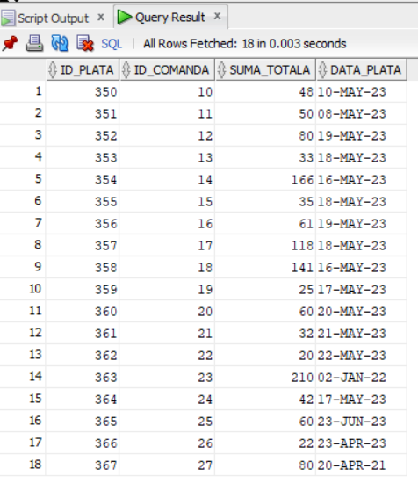

SELECT * FROM REZERVARI;

insert into REZERVARI VALUES(6001,1001,to_date('10/05/2023','dd/mm/yyyy'),3);

insert into REZERVARI VALUES(6002,1002,to_date('08/05/2023','dd/mm/yyyy'),2);

insert into REZERVARI VALUES(6003,1003,to_date('19/05/2023','dd/mm/yyyy'),4);

insert into REZERVARI VALUES(6004,1004,to_date('18/05/2023','dd/mm/yyyy'),2);

insert into REZERVARI VALUES(6005,1005,to_date('16/05/2023','dd/mm/yyyy'),2);

insert into REZERVARI VALUES(6006,1006,to_date('18/05/2023','dd/mm/yyyy'),2);

insert into REZERVARI VALUES(6007,1007,to_date('19/05/2023','dd/mm/yyyy'),3);

insert into REZERVARI VALUES(6008,1008,to_date('18/05/2023','dd/mm/yyyy'),5);

insert into REZERVARI VALUES(6009,1009,to_date('16/05/2023','dd/mm/yyyy'),2);

insert into REZERVARI VALUES(6010,1010,to_date('17/05/2023','dd/mm/yyyy'),3);

insert into REZERVARI VALUES(6011,1020,to_date('17/05/2023','dd/mm/yyyy'),3);

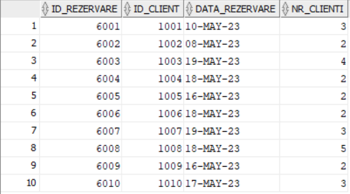

SELECT * FROM LIVRARE;

insert into LIVRARE VALUES(2301,23,1501);

insert into LIVRARE VALUES(2302,24,1502);

insert into LIVRARE VALUES(2303,25,1503);

insert into LIVRARE VALUES(2304,26,1504);

insert into LIVRARE VALUES(2305,27,1505);

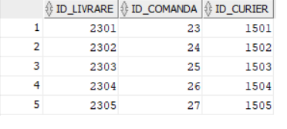

SELECT * FROM PREPARARE;

Insert into PREPARARE VALUES(901,802);

Insert into PREPARARE VALUES(902,809);

Insert into PREPARARE VALUES(903,808);

Insert into PREPARARE VALUES(904,804);

Insert into PREPARARE VALUES(905,801);

Insert into PREPARARE VALUES(906,801);

Insert into PREPARARE VALUES(907,803);

Insert into PREPARARE VALUES(908,803);

Insert into PREPARARE VALUES(909,806);

Insert into PREPARARE VALUES(910,807);

Insert into PREPARARE VALUES(911,802);

Insert into PREPARARE VALUES(912,802);

Insert into PREPARARE VALUES(901,803);

Insert into PREPARARE VALUES(901,803);

Insert into PREPARARE VALUES(901,804);

Insert into PREPARARE VALUES(901,805);

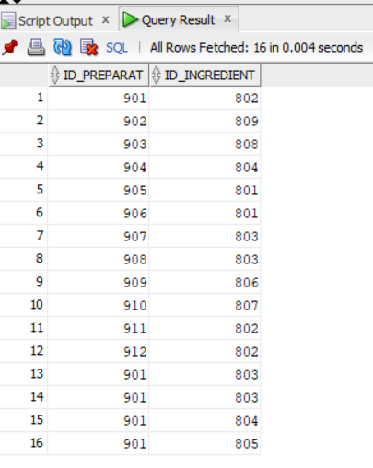

**6. Formulați în limbaj natural o problemă pe care să o rezolvați folosind un subprogram stocat independent care să utilizeze toate cele 3 tipuri de colecții studiate. Apelați subprogramul.**

**Sa se afiseze angajatii unui restaurant al carui id este dat, salariul mediu pe toate restaurantele, salariul mediu pe restaurantul specificat, si daca angajatii din restaurantul specificat au salariu sub/peste medie.**

CREATE OR REPLACE PROCEDURE EX_6(id RESTAURANT.ID_RESTAURANT%type)

IS

TYPE Tablou_Angajati is TABLE OF ANGAJATI%ROWTYPE index by pls_integer;

TYPE tablou_imbricat is TABLE OF ANGAJATI%ROWTYPE;

TYPE vector is varray(100) of ANGAJATI%rowtype;

toti_ang tablou_angajati;

tt vector;

ts tablou_imbricat;

medie_total int;

medie_t int;

BEGIN

SELECT * BULK COLLECT INTO toti_ang from ANGAJATI;

DBMS_OUTPUT.PUT_LINE('TOTI ANGAJATII:');

DBMS_OUTPUT.PUT_LINE('---------------');

FOR i in 1..toti_ang.COUNT loop

DBMS_OUTPUT.PUT_LINE(toti_ang(i).nume_angajat || ' --salariu : ' || toti_ang(i).salariu_angajat );

end loop;

select round(avg(salariu_angajat))

into medie_total

from angajati;

select round(avg(salariu_angajat))

into medie_t

from angajati where id_restaurant=id;

DBMS_OUTPUT.PUT_LINE('SALARIU GENERAL MEDIU: ' || medie_total);

DBMS_OUTPUT.PUT_LINE('SALARIU PE RESTAURANTUL ' || id || ' : ' || medie_t);

SELECT * BULK COLLECT INTO tt FROM ANGAJATI WHERE ID_RESTAURANT= id AND SALARIU_ANGAJAT > medie_total;

SELECT * BULK COLLECT INTO ts FROM ANGAJATI WHERE ID_RESTAURANT= id AND SALARIU_ANGAJAT < medie_total;

FOR i in 1..tt.COUNT loop

DBMS_OUTPUT.PUT_LINE('Peste Medie: ' || tt(i).nume_angajat || ' --salariu : ' || tt(i).salariu_angajat );

end loop;

FOR i in 1..ts.COUNT loop

DBMS_OUTPUT.PUT_LINE('Sub Medie: ' || ts(i).nume_angajat || ' --salariu : ' || ts(i).salariu_angajat );

end loop;

END;

/

BEGIN

EX_6(1);

END;

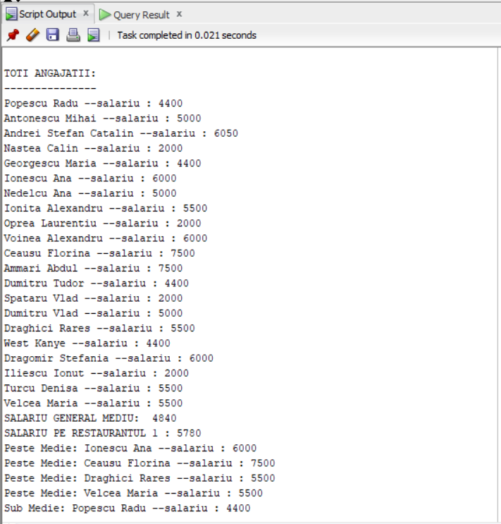

**7. Formulați în limbaj natural o problemă pe care să o rezolvați folosind un subprogram stocat independent care să utilizeze 2 tipuri diferite de cursoare studiate, unul dintre acestea fiind cursor parametrizat, dependent de celălalt cursor. Apelați subprogramul.**

**Sa se afiseze angajatii unui restaurant al carui id este dat , apoi sa se afiseze staff-ul restaurantului.Se cere si afisarea chefilor din restaurantul respectiv a caror specialitate este data .**

CREATE OR REPLACE PROCEDURE ex7 (id_rest IN RESTAURANT.ID_RESTAURANT%type,p_spec IN VARCHAR2)

AS

cursor c_ang(id_rest IN RESTAURANT.ID_RESTAURANT%type) is

select * from ANGAJATI a

where a.id_restaurant=id_rest;

cursor c_chefi is

select * from chef ch

join angajati a on ch.id_angajat=a.id_angajat

where a.id_restaurant=id_rest AND ch.specializare=p_spec;

v_angajati c_ang%ROWTYPE;

v_chefi c_chefi%ROWTYPE;

cursor c_staffr(id_rest IN RESTAURANT.ID_RESTAURANT%TYPE) IS

select * from STAFF_RESTAURANT s JOIN ANGAJATI a ON s.ID_ANGAJAT=a.id_angajat

where a.id_restaurant=id_rest;

v_staffr c_staffr%ROWTYPE;

BEGIN

DBMS_OUTPUT.PUT_LINE(' ANGAJATI RESTAURANTULUI ' || id_rest);

DBMS_OUTPUT.PUT_LINE('--------------------------');

OPEN c_ang(id_rest);

LOOP

FETCH c_ang INTO v_angajati;

EXIT WHEN c_ang%NOTFOUND;

DBMS_OUTPUT.PUT_LINE(v_angajati.NUME_ANGAJAT);

END LOOP;

CLOSE c_ang;

DBMS_OUTPUT.PUT_LINE('--------------------------');

DBMS_OUTPUT.PUT_LINE(' STAFF-UL RESTAURANTULUI ');

DBMS_OUTPUT.PUT_LINE('--------------------------');

OPEN c_staffr(id_rest);

LOOP

FETCH c_staffr INTO v_staffr;

EXIT WHEN c_staffr%NOTFOUND;

DBMS_OUTPUT.PUT_LINE('STAFF : '||v_staffr.NUME_ANGAJAT ||' Salariu: ' ||v_staffr.SALARIU_ANGAJAT );

END LOOP;

DBMS_OUTPUT.PUT_LINE('--------------------------');

DBMS_OUTPUT.PUT_LINE('CHEFII RESTAURANTULUI ');

DBMS_OUTPUT.PUT_LINE('--------------------------');

OPEN c_chefi;

LOOP

FETCH c_chefi INTO v_chefi;

EXIT WHEN c_chefi%NOTFOUND;

DBMS_OUTPUT.PUT_LINE('Chef: '||v_chefi.nume_angajat ||' Specializare: '|| v_chefi.specializare);

END LOOP;

CLOSE c_chefi;

END;

/

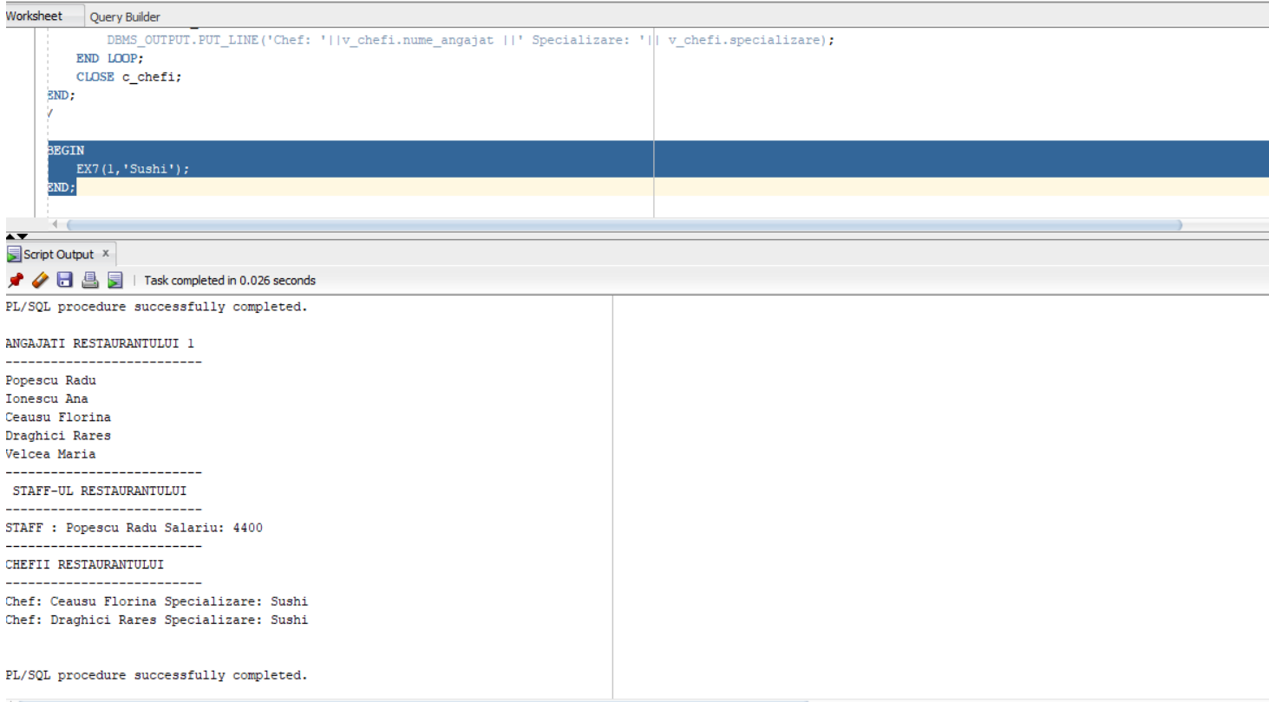

**8. Formulați în limbaj natural o problemă pe care să o rezolvați folosind un subprogram stocat independent de tip funcție care să utilizeze într-o singură comandă SQL 3 dintre tabelele definite.**

**Definiți minim 2 excepții proprii. Apelați subprogramul astfel încât să evidențiați toate cazurile definite și tratate.**

**Pentru un membru din staff al carui id este dat, sa se afiseze suma totala din comenzile efectuate de acesta. Membrii din staff care nu au cel putin 20 de ore de experinta sau cel putin 2 comenzi efectuate nu sunt luati in considerare.**

CREATE OR REPLACE FUNCTION EX8(p_id_staffr IN NUMBER) RETURN VARCHAR2 AS

v_suma NUMBER;

v_total NUMBER;

v_cnt NUMBER;

v_cursor SYS_REFCURSOR;

v_ore_experienta NUMBER;

ID_INVALID EXCEPTION;

PREA_PUTINE_COMENZI EXCEPTION;

EXPERIENTA_INSUFICIENTA EXCEPTION;

BEGIN

IF p_id_staffr < 501 OR p_id_staffr > 506 THEN

RAISE ID_INVALID;

END IF;

SELECT ORE_EXPERIENTA INTO v_ore_experienta FROM STAFF_RESTAURANT

WHERE ID_STAFFR=p_id_staffr;

IF v_ore_experienta < 20 THEN

RAISE EXPERIENTA_INSUFICIENTA;

END IF;

OPEN v_cursor FOR

SELECT p.SUMA_TOTALA FROM PLATA p

JOIN COMANDA c ON p.ID_COMANDA = c.ID_COMANDA

JOIN STAFF_RESTAURANT s ON c.ID_STAFFR = s.ID_STAFFR

WHERE s.ID_STAFFR=p_id_staffr;

v_suma :=0;

v_total:=0;

v_cnt:=0;

LOOP

FETCH v_cursor INTO v_suma;

EXIT WHEN v_cursor%NOTFOUND;

v_total:= v_total + v_suma;

v_cnt:=v_cnt+1;

END LOOP;

CLOSE v_cursor;

IF v_cnt < 3 THEN

RAISE PREA_PUTINE_COMENZI;

END IF;

RETURN v_total;

EXCEPTION

WHEN ID_INVALID THEN

DBMS_OUTPUT.PUT_LINE('ID-ul introdus este invalid!');

RETURN NULL;

WHEN PREA_PUTINE_COMENZI THEN

DBMS_OUTPUT.PUT_LINE('Membrul staff nu a efectuat suficiente comenzi!');

RETURN NULL;

WHEN EXPERIENTA_INSUFICIENTA THEN

DBMS_OUTPUT.PUT_LINE('Membrul staff cu id-ul introdus nu are inca destula experienta!');

RETURN NULL;

END;

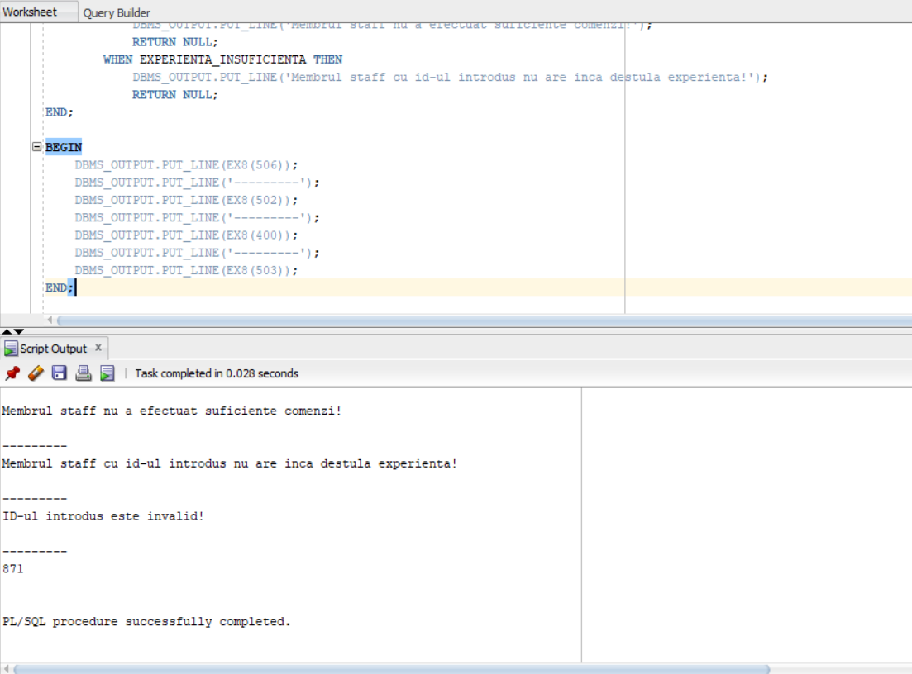

**9. Formulați în limbaj natural o problemă pe care să o rezolvați folosind un subprogram stocat independent de tip procedură care să utilizeze într-o singură comandă SQL 5 dintre tabelele definite. Tratați toate excepțiile care pot apărea, incluzând excepțiile NO_DATA_FOUND și TOO_MANY_ROWS. Apelați subprogramul astfel încât să evidențiați toate cazurile tratate.**

**Sa se afiseze pentru un client al carui nume ii este dat, cel mai scump preparat comandat(nume+pret) impreuna cu id-ul platii respective .**

CREATE OR REPLACE PROCEDURE ex9(p_nume_client IN VARCHAR2) AS

v_nume_preparat PREPARAT.NUME_PREPARAT%TYPE;

v_pret_preparat PREPARAT.PRET%TYPE;

v_id_plata PLATA.ID_PLATA%TYPE;

v_nume_client CLIENT.NUME_CLIENT%TYPE;

v_init CLIENT.NUME_CLIENT%TYPE := 'gol';

final_nume_preparat PREPARAT.NUME_PREPARAT%TYPE;

final_pret_preparat PREPARAT.PRET%TYPE := 0;

final_id_plata PLATA.ID_PLATA%TYPE;

final_nume_client CLIENT.NUME_CLIENT%TYPE;

CURSOR c_items IS

SELECT pr.NUME_PREPARAT,pr.PRET,p.ID_PLATA,cl.NUME_CLIENT

FROM CLIENT cl

JOIN COMANDA co ON co.id_client = cl.id_client

JOIN PLATA p ON p.id_comanda=co.id_comanda

JOIN ITEM_COMANDA i ON i.id_comanda=co.id_comanda

JOIN PREPARAT pr ON pr.ID_PREPARAT=i.id_preparat

WHERE UPPER(cl.NUME_CLIENT) LIKE '%' || UPPER(p_nume_client) || '%';

INPUT_INVALID EXCEPTION;

WRONG_TYPE EXCEPTION;

BEGIN

IF regexp_like (p_nume_client,'[0-9]') THEN

RAISE WRONG_TYPE;

END IF;

IF p_nume_client IS NULL THEN

RAISE INPUT_INVALID;

END IF;

OPEN c_items;

LOOP

FETCH c_items INTO v_nume_preparat,v_pret_preparat,v_id_plata,v_nume_client;

EXIT WHEN c_items%NOTFOUND;

if v_init !=v_nume_client and v_init!='gol' then

raise TOO_MANY_ROWS;

END IF;

v_init:= v_nume_client;

IF(v_pret_preparat > final_pret_preparat) THEN

final_nume_preparat := v_nume_preparat;

final_pret_preparat :=v_pret_preparat;

final_id_plata :=v_id_plata;

final_nume_client :=v_nume_client;

END IF;

END LOOP;

IF v_init = 'gol' then

RAISE NO_DATA_FOUND;

END IF;

DBMS_OUTPUT.PUT_LINE( ' Nume preparat si pret: '||final_nume_preparat || ' ' || final_pret_preparat|| ' Id plata: ' || final_id_plata || ' Nume Client: ' ||final_nume_client);

EXCEPTION

WHEN TOO_MANY_ROWS THEN

DBMS_OUTPUT.PUT_LINE('Exista mai multi clienti cu acest nume!');

RETURN;

WHEN WRONG_TYPE THEN

DBMS_OUTPUT.PUT_LINE('Numele clientului nu poate contine cifre!');

RETURN;

WHEN NO_DATA_FOUND THEN

DBMS_OUTPUT.PUT_LINE('Nu exista niciun client cu numele '|| p_nume_client );

RETURN;

WHEN INPUT_INVALID THEN

DBMS_OUTPUT.PUT_LINE('Numele clientului nu poate sa fie null!' );

RETURN;

WHEN OTHERS THEN

DBMS_OUTPUT.PUT_LINE('Alta eroare!');

RETURN;

END;

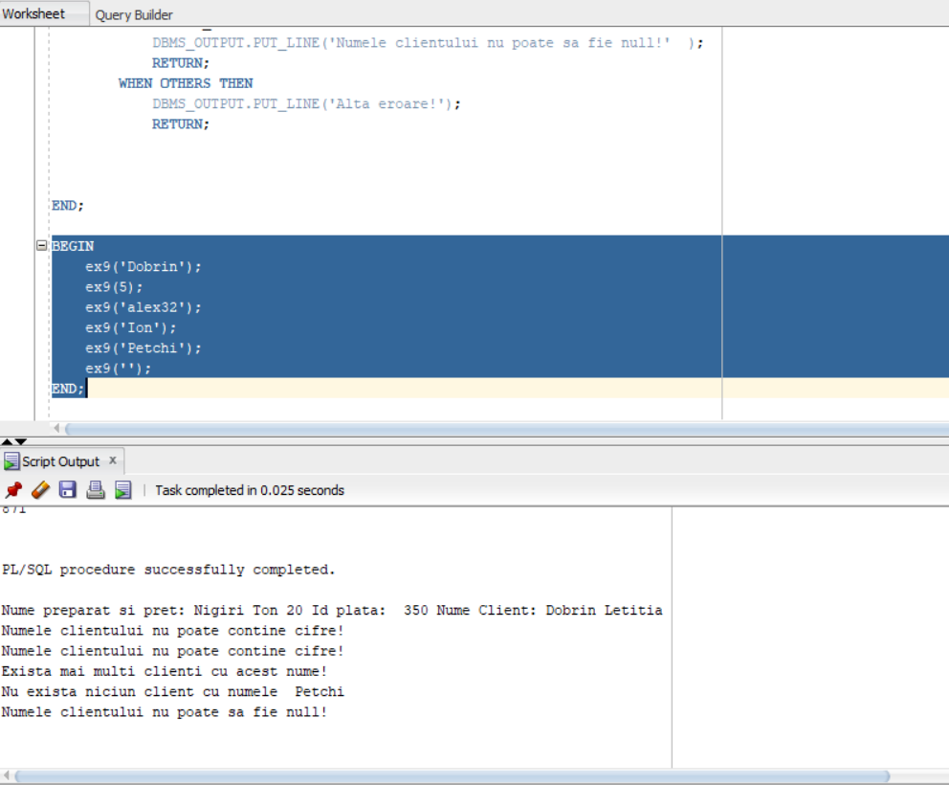

**10. Definiți un trigger de tip LMD la nivel de comandă. Declanșați trigger-ul.**

**Creati un trigger care interzice angajarea personalului in luna ianuarie.**

CREATE OR REPLACE TRIGGER ex10

BEFORE INSERT OR UPDATE ON ANGAJATI

BEGIN

if(to_char(sysdate,'DD-MM')>'01-01' and to_char(sysdate,'DD-MM')<'31-01')

then raise_application_error(-20001,'Nu se poate angaja personal in luna ianuarie');

end if;

end;

/

DROP TRIGGER EX10;

BEGIN

insert into ANGAJATI VALUES(155,'Lica Ghita',4400,to_date('21/07/2021','dd/mm/yyyy'),'0721349821',2);

END;

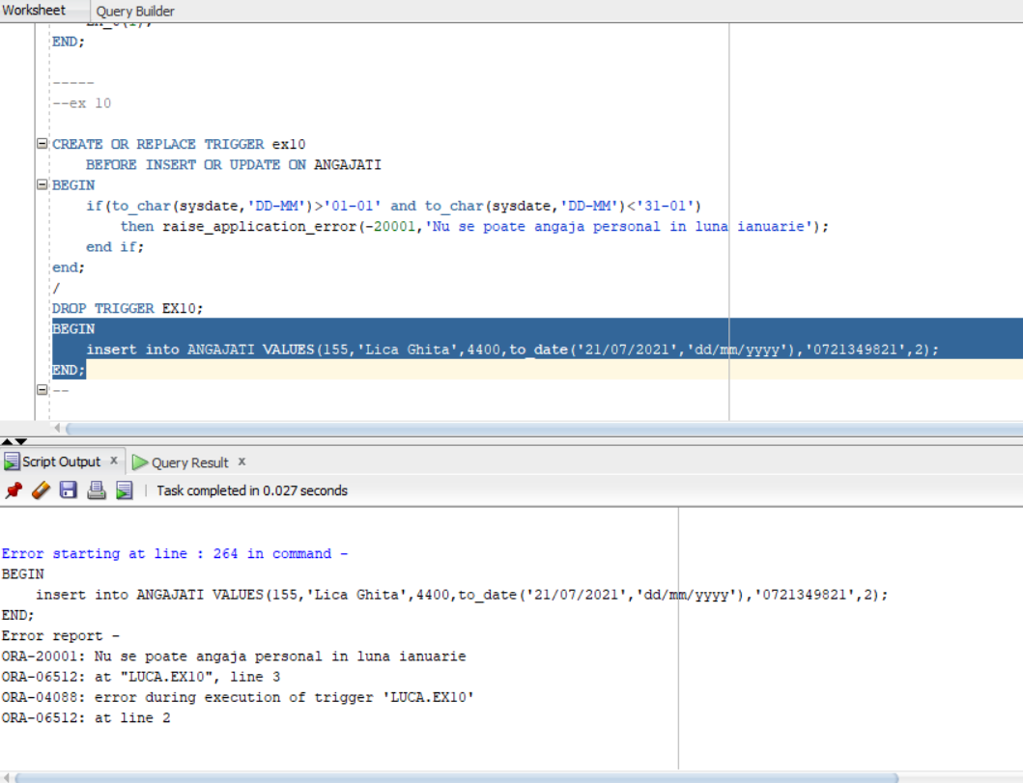

**11. Definiți un trigger de tip LMD la nivel de linie. Declanșați trigger-ul.**

**Creati un trigger care interzice modificarea datelor de nastere a angajatilor**

CREATE OR REPLACE TRIGGER ex11

BEFORE UPDATE OF DATA_ANGAJAT ON ANGAJATI

FOR EACH ROW

WHEN (NEW.DATA_ANGAJAT!= OLD.DATA_ANGAJAT)

BEGIN

RAISE_APPLICATION_ERROR(-20005,'Nu se poate modifica data de nastere!');

END;

BEGIN

UPDATE ANGAJATI SET DATA_ANGAJAT = '01-MAR-2024' WHERE ANGAJATI.ID_ANGAJAT>115;

END;

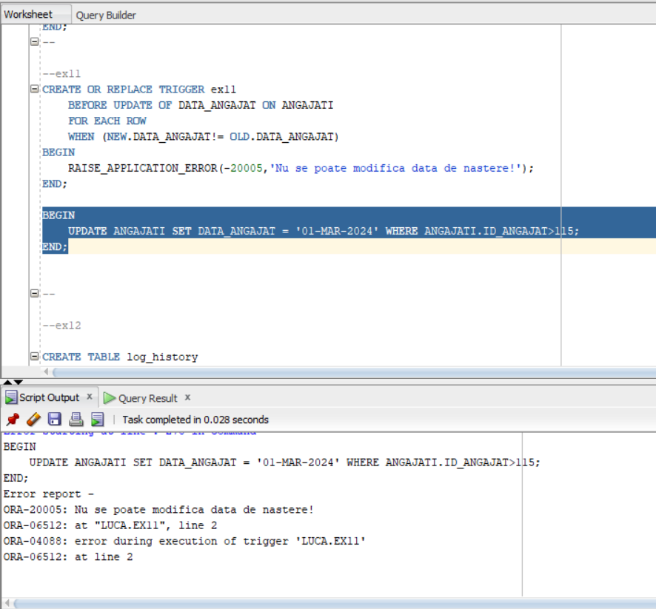

**12. Definiți un trigger de tip LDD. Declanșați trigger-ul.**

**Creati un trigger care sa permita modificarea schemei doar de utilizatorul Luca. Sa se salveze modificarile facute asupra schemei.**

CREATE TABLE log_history

(

username VARCHAR2(20),

log_date DATE,

event varchar2(100)

);

CREATE OR REPLACE TRIGGER ex12

AFTER CREATE OR DROP OR ALTER ON SCHEMA

BEGIN

IF USER != 'Paul' THEN

RAISE_APPLICATION_ERROR(-20910,'Numai administratorul bazei de date poate realiza operatia');

END IF;

INSERT INTO log_history VALUES(SYS.LOGIN_USER,SYSDATE,SYS.SYSEVENT);

END;

/

DROP TRIGGER EX12;

CREATE TABLE testt(id NUMBER);

SELECT * FROM log_history;

