In this journey of mine not all is creating self aware AI to destroy humanity. One very important part of the process, the one that Data Wizards say you’ll spend the most time with, is to wrangle data. This means to be able to manipulate it as you wish. That is the focus of this practical example.

Ok, a few days ago there were a big storm in Buenos Aires, and more than 150,000 people were left without power for two days. So it occurred to me that I could map the places where there is no power. Sadly it took me a day more, and by the time I finished the problem were mostly solved. Luckly that didn’t prevent me to learn quite a few things. So next time, I’ll be able to run the code and show the map much quicker.

This was the steps.

This is the web in which the ENRE (government office which regulates the energy sector) shows where there is no energy

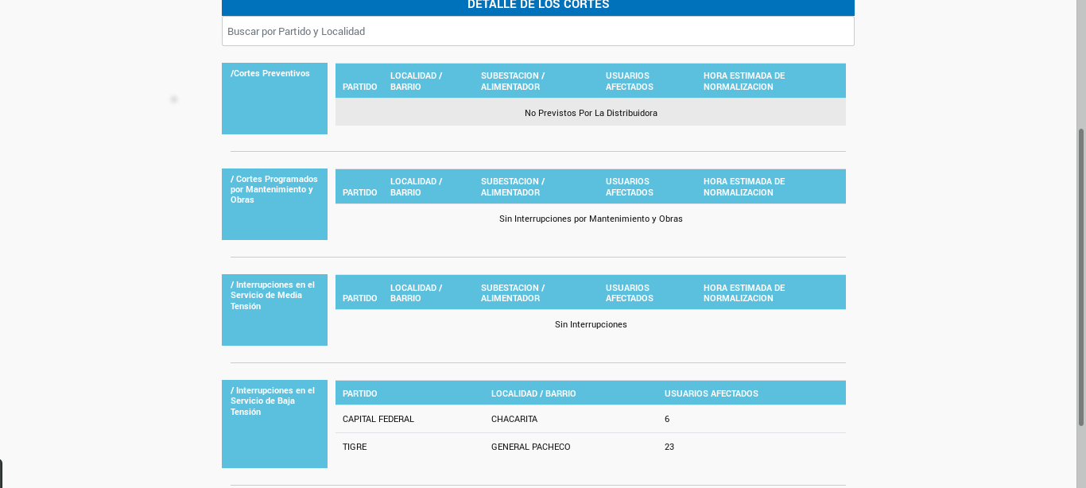

“That is not a very beautiful way to look at geographical data” I though.

The first step was to mine the data from the webpage and turn it in a data frame to work with that in Rstudio. For that you need Python’s Beautiful Soup. This was the original code:

XXXXXXXXXXXXX

But this was the result
XXXXXXXXXXXXXXX

After scratching my chin for a minute or two a figure that it must be dynamically generated and that’s way I couldn’t mine it directly. That is when Selenium package for Python came to the rescue.
“Selenium automates browsers” says in it’s home page and that was exactly what I needed.
First I had to load the page before I mine it; so this was the resulting code:

XXXXXXX
Great! I already have my data in a nice and workable data frame. Let’s go to R to map it!

But wait… how do you map something in R?

First you need a .shp, .dbf or an another file extension which give you the necessary data. Here (https://en.wikipedia.org/wiki/GIS_file_formats) you can see which might work.
Looking for a while for the data with enough detail I found it here (https://data.humdata.org/dataset/argentina-administrative-level-0-boundaries)
From this page you can download the 3 levels of administrative divisions of the country:

Level 0: Country’s borders
Level 1: Province’s borders
Level 2: Municipal’s borders.

The one I needed was, of course, Level 2 since I wanted to map there in the Gran Buenos Aires (https://en.wikipedia.org/wiki/Greater_Buenos_Aires)

But this cointains all the country’s data. I had to filter the cities I needed

XXXXXXXXXXXXXX

Putting the columns in the right format so it can be join with the imported data mined in the ENRE.

XXXXXXXXXXXXXXX

Joining both datasets was difficult, since I hadn’t work with geodata before. So manipulate the object SpatialPointsDataFrame (SPDF) was a challenge. I did join them but when I map it the added column wasn’t there, so the choropleth map couldn’t be made

Finally I understood that I had to convert the SPDF to a normal and harmless data.frame with the fortify() function from the tidyverse package.

Finally, plotted with ggplot2:

