Using Quarto for reproducible article writing

Lucas A. Meyer

2022-07-07

# 1. Introduction

The purpose of this article is to show how to use Quarto to generate an article just like this, hopefully with better content. This is just a demonstration of how powerful Quarto is to generate multiple artifacts from substantially the same content/code.

You can see how I have done this in <https://www.meyerperin.com/using-quarto>.

# 2. Population changes

Over the last few decades, the number of children per woman has been declining and overall longevity has been increasing.

This has been markedly the case in Asia. Although Japan is frequently remembered as a country with low fertility rates, several other countries now have a fertility rate at or below Japan’s levels, even China, as shown in Figure 1.

|  |
| --- |
| Figure 1: Fertility rates in Asia |

The outcome of these changes is that over the next few decades, the proportion of children and working adults will go down in many countries, and the proportion of older adults will increase. This is detailed in Section 2.1 and the projected status for several countries is shown in Section 3.

## 2.1 Dependency ratio

Demographers use a metric called **Dependency Ratio** (Equation 1) to evaluate how many non-working people are supported by 100 working people.

$$\text{Dependency Ratio}=100×\frac{\text{Non-working population}}{\text{Working population}} \left(1\right)$$

# 3. World tour

In the figures below, I further decompose the dependency ratio into Young (0-20 years-old), Old (65-79 years-old) and Very Old (80+ years-old). Note that Young, Old and Very Old are terms used by demographers.

I don’t mean any personal judgment when using this classification of “young”, “old” and “very old”. One of my favorite writers, Jared Diamond, who wrote *Guns, Germs and Steel*1 and *Collapse*2, is currently 84-years old and I hope to have his disposition at that age.

## 3.1 Age and Population Pyramids for Italy

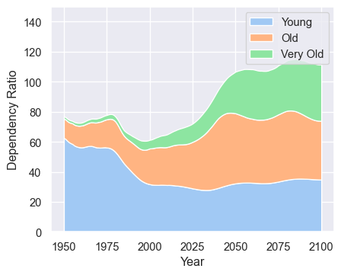

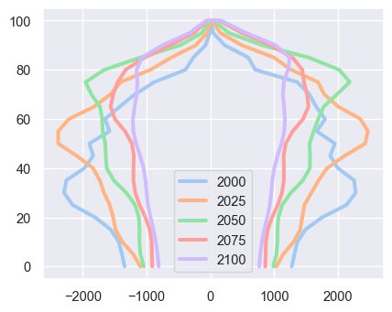

## 3.2 Age and Population Pyramids for China

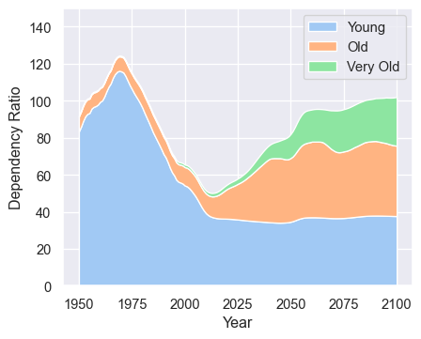

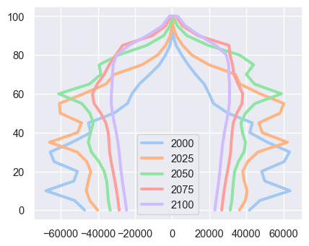

## 3.3 Age and Population Pyramids for Brazil

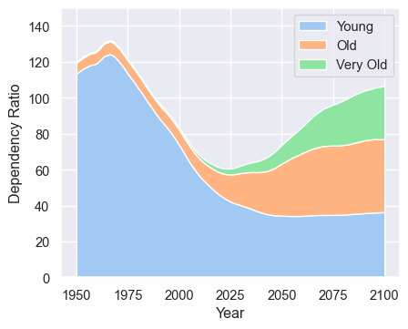

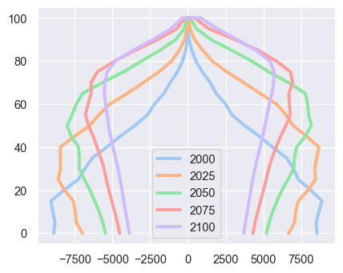

## 3.4 Age and Population Pyramids for India

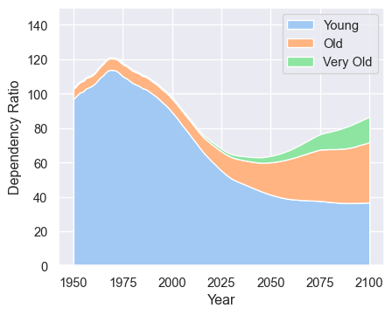

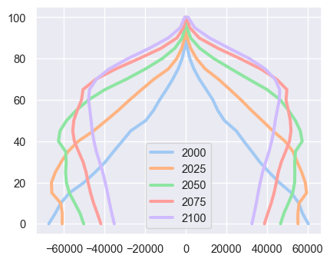

## 3.5 Age and Population Pyramids for Japan

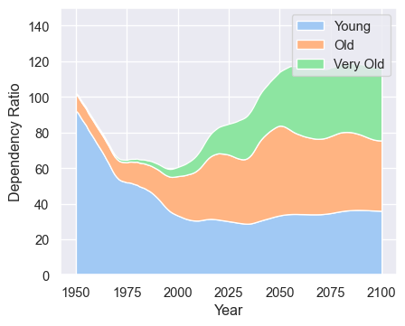

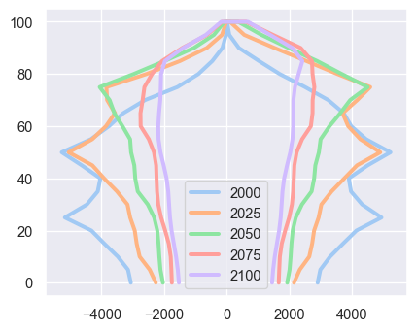

## 3.6 Age and Population Pyramids for Nigeria

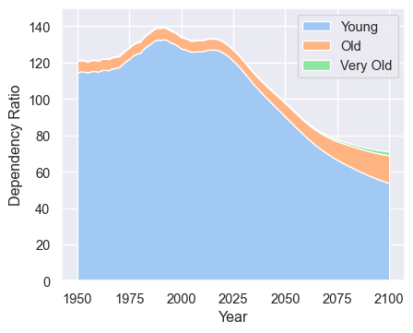

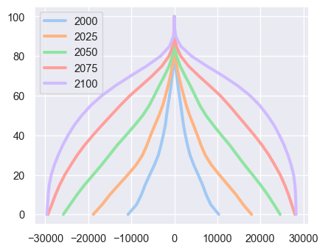

# 4. References

1. Diamond, J. *Guns, germs, and steel*. (WW Norton Publishing, 1997).

2. Diamond, J. *Collapse: How societies choose to fail or succeed: Revised edition*. (Penguin, 2011).