# **C****ompras**

*Package in package 'Casos de uso del negocio'*

Compras

Version 1.0 Phase 1.0 Proposed

crossover created on 06/05/2021. Last modified 06/05/2021

## **Compras diagram**

*Use Case diagram in package 'Compras'*

Compras

Version 1.0

crossover created on 06/05/2021. Last modified 27/05/2021

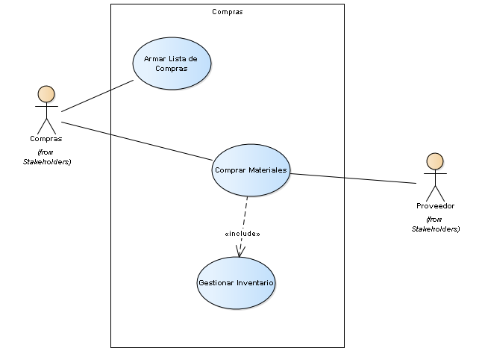

Compras

## **Armar Lista de Compras**

*UseCase in package 'Compras'*

Armar Lista de Compras

Version 1.0 Phase 1.0 Proposed

crossover created on 06/05/2021. Last modified 06/05/2021

## **Comprar Materiales**

*UseCase in package 'Compras'*

Comprar Materiales

Version 1.0 Phase 1.0 Proposed

crossover created on 06/05/2021. Last modified 06/05/2021

## **Gestionar Inventario**

*UseCase in package 'Compras'*

Gestionar Inventario

Version 1.0 Phase 1.0 Proposed

crossover created on 06/05/2021. Last modified 06/05/2021