Bookdown project template for reproducible manuscript writing

Lucas Etzel1

1 Department of Radiation Oncology, Klinikum Rechts der Isar, School of Medicine, Technical University of Munich (TUM), Ismaninger Straße 22, 81675 Munich, Germany

**Corresponding author**  
Lucas Etzel  
Department of Radiation Oncology, Klinikum Rechts der Isar  
School of Medicine, Technical University of Munich (TUM)  
Ismaninger Straße 22, 81675 Munich, Germany  
E-mail: lucas.etzel@tum.de

Contents

# Abstract

# Introduction

# Methods

# Results

An exemplary Figure is depicted in Figure 1.

An exemplary Table 1.

# Discussion

# Conclusions

# Declarations

# References

# Tables

Table 1: Mean sepal width dependent on species

| Species | mean(Sepal.Width) | n() |
| --- | --- | --- |
| setosa | 3.428 | 50 |
| versicolor | 2.770 | 50 |
| virginica | 2.974 | 50 |

Table 2: Mean sepal width dependent on species

| Species | mean(Sepal.Width) | n() |
| --- | --- | --- |
| setosa | 3.428 | 50 |
| versicolor | 2.770 | 50 |
| virginica | 2.974 | 50 |

# Figures

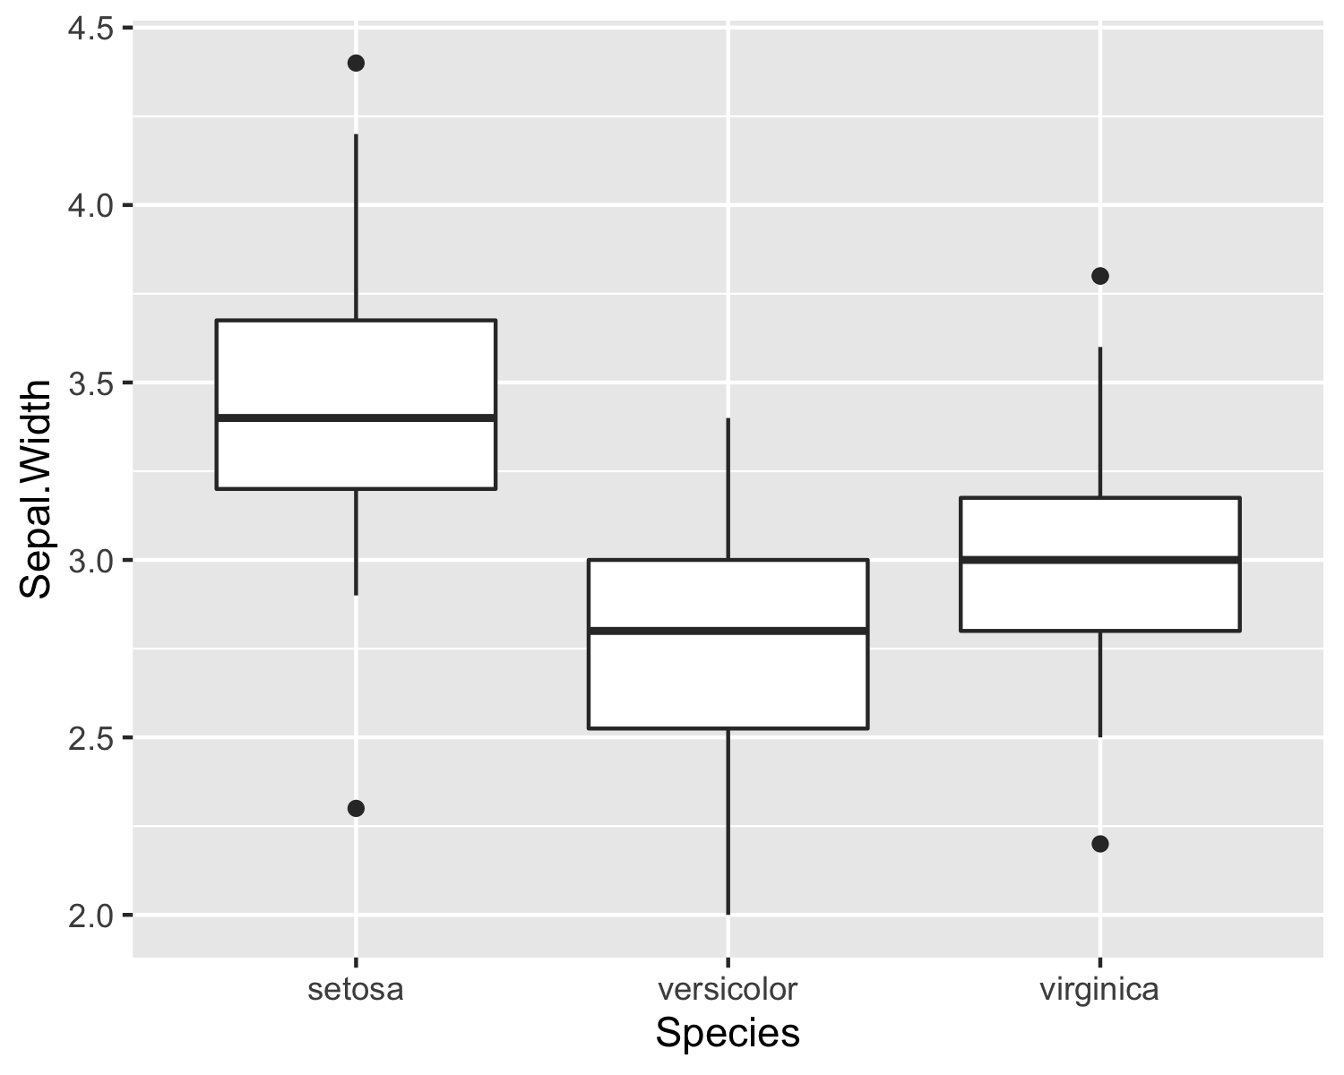

Figure 1: Sepal width dependent on species



Figure 2: Sepal width dependent on species