Template for manuscript writing based on R Markdown and the bookdown package to create GitBook and Word document outputs.

Lucas Etzel

2021-01-03

Table of Contents

# Title page

This project is designed as a template for manuscript writing based on R Markdown and the [bookdown package](https://bookdown.org/) to create GitBook and Word document outputs.

# Abstract

# Introduction

# Methods

## First section

Between x and x, patients were offered study enrollment.

## Second section

asdasgadgs

asdggasdasdgsag

adsgagsd asgdgs

# Results

# Discussion

# Conclusions

# References

# Figures

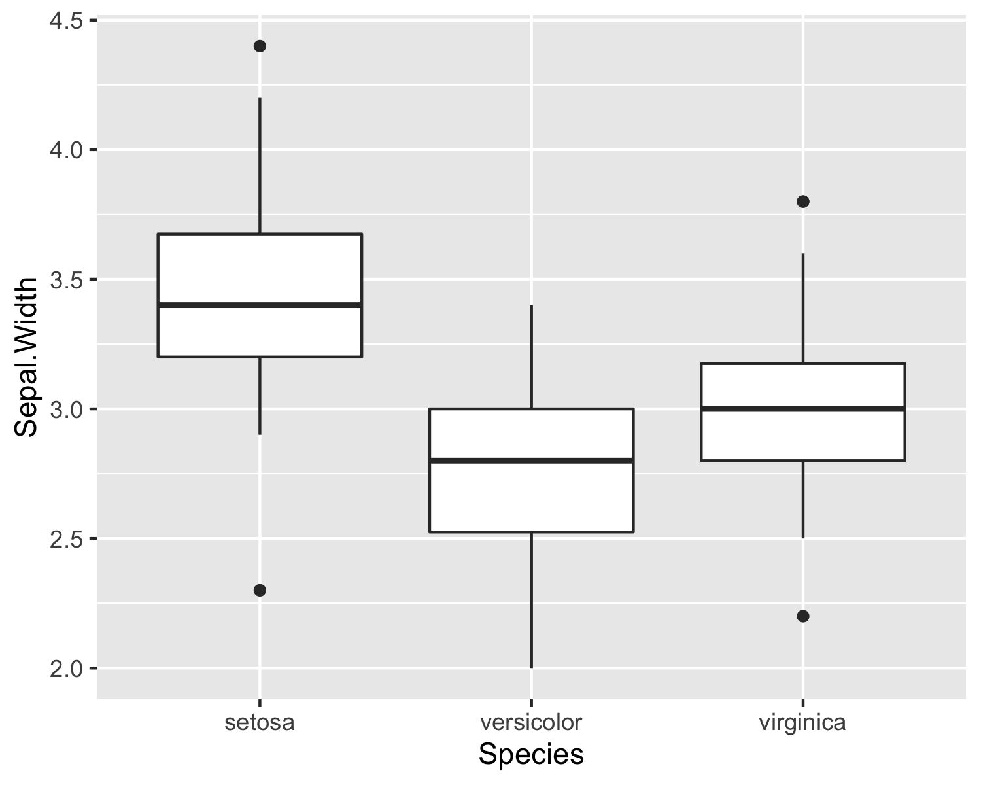

Figure 1: Sepal width dependent on species

# Tables

* Mean sepal width dependent on species 1
* Mean sepal width dependent on species 2

## Table example 1

Table 1: Mean sepal width dependent on species

|  |  |  |
| --- | --- | --- |
| Species | mean(Sepal.Width) | n() |
| setosa | 3.428 | 50 |
| versicolor | 2.770 | 50 |
| virginica | 2.974 | 50 |

## Table example 2

Table 2: Mean sepal width dependent on species

|  |  |  |
| --- | --- | --- |
| Species | mean(Sepal.Width) | n() |
| setosa | 3.428 | 50 |
| versicolor | 2.770 | 50 |
| virginica | 2.974 | 50 |