CPU – central processing unit – the main component and responsible for carrying out all tasks. Usually sits on the same physical chip as other components.

RAM – Random access memory – high-speed storage that uses temporary data. Used for systems that are run in constant use. Quick in loading and unloading depending on application and use.

Motherboard – connectivity between the different hardware components

Chipset – communication between the components on the motherboard. Determines high-speed components and what the motherboard can/can’t do

CMOS battery – maintains basic functions and configuration settings in a separate memory. Keeps the clock running and powers memory chips. Stores hardware settings and startup settings. Keeps track of hardware data.

e

PCI-e (peripheral component interconnect express) – standard for connecting devices to computers. Point-to-point serial transmission. Affects speed at which graphics hardware and the rest of the computer communicate. Refers to expansion slots on the motherboard. Cards that can be added are Video, sound, network interface. SSD si also available.

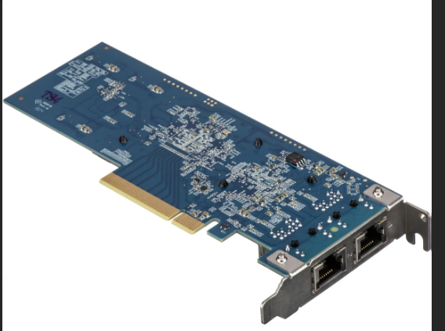

HDD – (hard disk drive) – houses OS. Data isn’t written sequentially. They’re slow when large applications or files are pulled up.

SSD – (solid state drive) – uses flash memory to store data. All data is electronically altered. (stored, written, transferred, erased). Most laptops are using SSD’s now. Also, pricier.

Optical Disk Drive – writes data on a compact disk. Can be used as input and output.

Heat sink – disperses head from other objects. Thermal conductor that prevents overheating (typically for CPU)

Power supply – converts AC (alternating current) to DC (Direct current) for computer. The power supply is separate for laptops. Integrated into charging cables. Main purpose is to convert current to charge or run device.

USB (universal serial bus) – common port for charging or transferring data.

USB-A – the original rectangle. Typically used along side another port at the other end of the connection.

USB-B – used on older devices like scanners printers. Found often at goodwill

Micro-USB – was the standard for portable devices (phones, kindle, hand-held concoles, etc.). type a is a little more phased out than type b and some manufacturers prefer them for cost benefit.

Mini-USB – like micro, but used for older devices. Not legacy but close

USB-C – current standard as it uses data delivery with power

USB gen 1,2,3 – essentially how fast data speeds can be when transferring data. The higher the generation, the faster it will transfer. Older generations are phased out and the current gen 3 ranges from 5 GBPS to 20 GBPS

M.2 – type of SSD that is typically faster and more expensive. To use, must have and M.2 slot in motherboard. M.2 is smaller than older SSD’s. can be plugged into the motherboard. Without cables.

SATA (serial ATA) – how nearly everything storage related connect to the motherboard. Uses SATA interface. Need cables.

Display port (DP) – audio and video interface standard. Computer focus.

MiniDP – less common than DP. Used mostly in MAC and apple products.

HDMI, MiniHDMI, MicroHDMI (high-definition Multimedia Interface) – standard for transmitting digital video and audio from a source. Widely adapted. MiniHDMI does the same as an HDMI and is usually used for connecting tablets and DSLR cameras. MicroHDMI is the smallest and still has the same functions as its siblings. Used for portable devices like phones.

DVI (digital visual interface) – used to maximized the quality of monitors. Replaced P&D standard. Market settled for HDMI for its multi-use purpose

VGA (video graphics array) – analog interface for PC and monitor, used before other cables. Considered legacy and not used

Ethernet – standard medium to transport data. Ports use RJ45 jacks. Transports packets (information/queries) over network to communicate with destination.

Serial – port used for data transmit. Allows for duplex as well. Still use widely in industry, not so much in commercial

Audio – audio is digital when played on a system, but analog when on speaker systems analog. Digital recordings transfer soundwaves into a series of bits

Headers – what you plug in sata cables

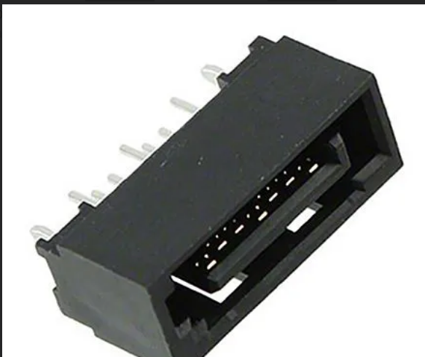

Passed off by Anika