Project Report

**Data Storage Paradigms, IV1351**

Lucas Larsson

lulars@kth.se

09-01-2022

Tips for Report Writing

REMOVE THIS SECTION BEFORE SUBMITTING THE REPORT.

*The target audience has exactly the same skills as the author, except they do not know anything at all about the specific application described in the report.*

Consider the following:

The report must be *centered around the requirements*. Which are they (Introduction), how did you work to meet them (Method), what is the solution that meets them (Result), and how can you be sure they are met (Discussion). This is the IMRaD method.

**The report must show that you have done the work yourself and that you have understood what you have done. Both of these goals are met by carefully explaining your application (both database and program).**

Is spelling and grammar correct? Is spoken language avoided?

Does the report have a good structure with sections, subsections and paragraphs?

Is the solution clearly explained? Will the reader understand the application? What would you yourself want to know if you read about the application, is that included in the report?

Is the solution analyzed and evaluated? Are important properties of the application explained? Should there have been more extensive evaluation?

Is the text clarified with images and/or other figures, and with links to the code in your Git repository? Remember that all figures (images, tables, graphs, code listings, etc) shall be numbered and have a short explaining text.

Introduction

This section tells *what* are you going to do.

Explain the task and the requirements on the solution. It’s important to clearly state the requirements. *Also specify which other student you worked with when solving the tasks, or if you worked alone.* Write one single introduction covering all tasks; do not split it into one subsection per task.

Literature Study

This section must prove that you collected sufficient knowledge before starting devel- opment, instead of just hacking away without knowing how to complete a task. State what you have read and briefly summarize what you have learned. It is your choice if you include literature study for all tasks in the same section, or if you divide this section into one subsection per task.

Method

This section tells *how* you solved the task.

Explain how you worked when solving the tasks and how you evaluated that your solution met the requirements. Mention diagram editor(s), IDE(s), DBMS(s) and other tools you used. This section *must be split into four subsections*, one per task. *Do not explain your solution and do not refer to code*, that belongs to the *Result* section.

Result

**This section explains *the result* of what you did.**

Present the solution. Explain your code and prove that it meets the requirements. It’s very important to *state each requirement that is met* and explain *how you met it*. It’s also important to include links to your code in your Git repository, and to also include diagrams, see Figure 1, and other figures to illustrate your reasoning. Also remember that these figures must be referenced in the text. This section *must be split into four subsections*, one per task.



Figure 1: A sample diagram, included to illustrate caption (this text), numbering and reference in text.

Discussion

This section *analysis* the result presented in the previous section.

Summarize the requirements and *clearly state which of them you have met*. What lessons have you learned and what problems did you face? How were the problems solved? Should you have done something differently? This section *must be split into four sub- sections*, one per task.

Comments About the Course

This section is optional.

Any comment(s) related to this course offering or to coming offerings is much appre- ciated. *Please also tell approximately how much time you spent on the assignment*, including lectures and labs. This is of great help for course evaluation.

Introduction

This section tells *what* are you going to do.

Explain the task and the requirements on the solution. It’s important to clearly state the requirements. *Also specify which other student you worked with when solving the tasks, or if you worked alone.* Write one single introduction covering all tasks; do not split it into one subsection per task.

The following project compose of one task namely building a database for a music school to be able to store all needed data for their operations, the task is divided into 4 sub-tasks below that starts with designing a conceptual model then a logical/physical model that follows with building a database to contain the information needed and finally building a program that can perform operation such as renting instruments or terminating already rented instrument to name a few.

The purpose is to facilitate information handling and business transactions for the Soundgood music school company, by developing a database which handles all the school's data and also an application that can handle some of the transactions.

I worked on all project tasks with Dennis Hadzialic.

Literature Study

This section must prove that you collected sufficient knowledge before starting devel- opment, instead of just hacking away without knowing how to complete a task. State what you have read and briefly summarize what you have learned. It is your choice if you include literature study for all tasks in the same section, or if you divide this section into one subsection per task.

Method

After doing the necessary research and reading the requirements I with my project partner started designing the conceptual model, the program used for the design is Astah since we have used it before and is the program used in the lectures by the teacher, we first wrote a list with all the requirements needed from the requirement text on the project site on canvas.

We started with noun identification from the provided requirements, where we go through the text and mark each noun and add it to the design as an entity, after getting all the nouns from the text we started thinking of entities that may be needed but not existing as nouns in the text requirements, this step is also known as category list search, and is basically exactly how it sound, we think of different situations or categories and if we have all the necessary entities we continue otherwise we create new entities for them. Next step was to remove unnecessary entities that has no purpose in the design, following step is to start considering attributes, which entities has attributes and which entities can be replaced as attributes in other entities.

Once we had found all entities needed and their attributes, we start looking for the relations between them, associations between entities and how they connect we label each association to show the reasoning behind the connection.

Lastly, we remove all entities without attributes since there is no reason for having a table that does not contain data columns, we define cardinality for the attributes, weather they are allowed to be without value, or if they are unique or can be duplicated and the data types specified for them.

A method that we thought was helpful is to work together on different designs from the same requirements and then compare the designs to see what one has missed, and how was the interpretation of the text to prevent mistakes or misinterpretation, after compering designs we then created one design as a final design.

Result

Figure 1 is the result of flowing the method above and it shows the conceptual model build by us, it is a small model compared to other models build by other students from the same class following the same requirements, but we feel that it does contain all the needed information.

The model shows where information of a new applicant will be stored and how will be able to handle them, to process a new applicant, staff need to be able to see whether there are vaccines, which they can see in the schedule entity.

All information regarding a lesson can be viewed i.e number of places, instrument used for the lesson, genre, student level, time for group and ensemble and appointment for individual lessons.

Staff can make bookings that get registered then on the schedule and can look up vaccines in case of new applicants.

Payment is modeled as two separate entities; instructor payment is based on the number of lessons they give, and student payment is based on the number of the lessons they take, if they have rented instrument from the school and if they have sibling attending the school which can result in a discount.

Renting instruments is shown as a single entity to demonstrate that it is a possibility for the students to rent instrument, this entity is changed in the next task for more clarity, for now it is only added a note to preserve the business rule that a student is allowed to have a max of 2 instrument a time.

Student, applicant and instructor are inherited from the entity person, which has all the information that need to be stored of a person.

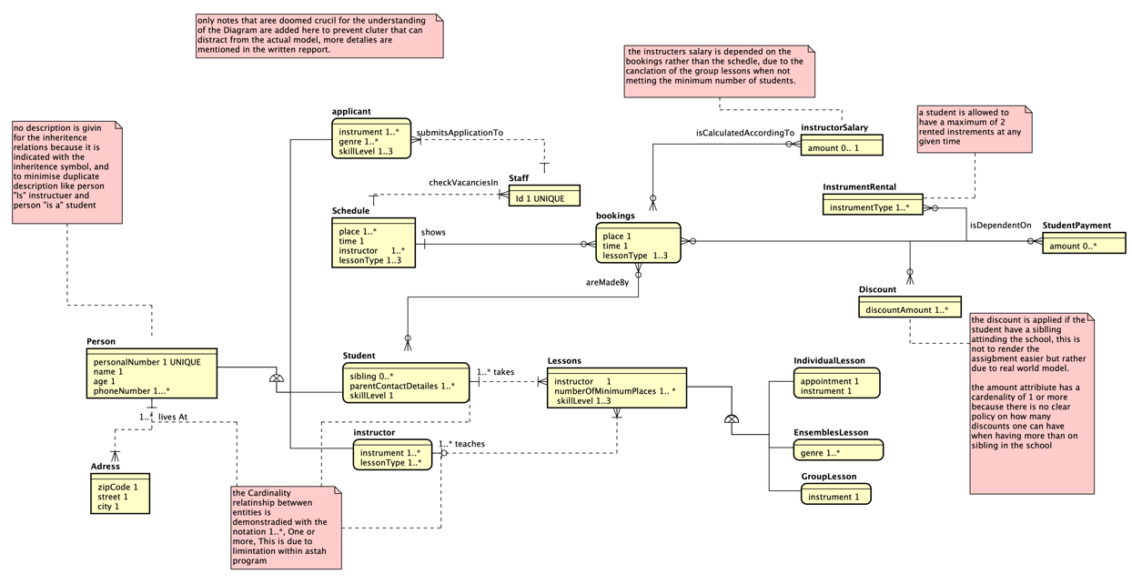

Figure 1: Conceptual model representing task-1 of the project.

Discussion

“*Soundgood sells music lessons to students who want to learn to play an instrument. When someone wants to attend the school, they apply by submitting contact details, which instrument they want to learn, and their present skill. “*

The above quoted phrase is the first requirement which we fulfil by having the schedule entity where staff can check for vacancies and the applicant entity where an applicant data will be stored.

There are 3 type of lessons which are represented with three entities that inherit the mutual attributes to minimize repatriation and maximize normalization in the database. A lesson is not given unless minimum number of participant attend the lesson which is modeled by the min/max number of student’s attribute. This means that the higher-grade points are also fulfilled by using inherits in at least one place.

All information listed in sections 1.1 and 1.2 on the project website on canvas [here](https://canvas.kth.se/courses/27118/pages/project) are modeled in the conceptual model in figure 1.

The notation used in the conceptual model is the crow foot notation, at some places notes are placed indicating a different cardinality that is due to limitation in the astah soft wear, where it is not possible to specify cardinality such as 1...*. In total the model has 16 entities which is sufficient to accommodate for all the data that need to be stored in the database, this is controlled by checking that all the data needed to be stored in the database application is accounted for.

As mentioned above we used inheritance to avoid repetition of the same attributes in the different lesson entities, for an example: all lessons have an instructor, number of participance and a skill level, so those are the attributes placed in the lessons entity to be inherited to the other three entities. Individual_lesson entity has 1 attribute that is unique to it appointment and instrument, ensembles_lesson entity has one unique attribute “genre”, and group_lesson has the attribute instrument. This design is to avoid null values in the entities. There are multiple different ways to model the entities one way without inheritance would be, to have the same three lesson entities with the three attributes in the entity lessons in them and remove the lessons entity, which can work as well but is not preferable because it does not bring any more value or help the understanding of the diagram in whole, it will only serve to clutter it more and would result in a database application that is hard to maintain, that is if one would like to add an attribute to all lessons it would need to be added to all three entities, where in the case of inheritance if a attribute is needed in all lesson types it would need to be added at only one place in the lessons entity that is inherited, the same is true for removal as well.

Method

The same diagram editor is used here as in the previous task Astah, no other software is used. The DBMS is PostgreSQL.

I started by creating a table for each entity present in the diagram from figure 1, after creating the tables, I created a column for each attribute that has cardinality of maximum 1 in the tables, all attributes with cardinality higher than 1 are replaced with a table in the logical/ physical model, after creating the necessary tables I started considering the data type to be used for the columns, such a choice is mainly the client responsibility to specify the data they want to store in the columns, since this is a school project I took the freedom to decide myself the datatypes after a discussion with my project partner.

Next step is to consider column constrains, mainly 2 choices are important, whether the column can be without a value and if it is unique, after that I started assigning Primary Keys to strong entities, all primary keys are surrogate keys, and then foreign keys.

As in the previous task after finishing work on the separate tables I started considering relations between them, the difference here is that one table cannot have many to many relationships with another table, (notice that I am using the word table to describe the actual table and relationship to describe connection between two tables).

The relationship creation in the logical/physical table is in multilabel steps, first is creating the relation, second assigning the PK of the strong entity as a FK in the weak entity, if the weak entity has a meaning in existing by itself it is assigned its own PK otherwise the foreign key assigned to it from the strong entity acts as its PK, after finishing the connection we need to consider the FK constraints, as in what should happen in case of updating or deletion on the table rows both the strong and weak entity.

Last step is the many to many relations from the table in figure 1, if now other work around can be made to change the many to many relation, a cross-reference table is needed, a cross reference table act as a solution to be able to map the multiple rows of a tables to each other, the PK assigned to the cross-reference table is either its own surrogate PK or a two combined FKs from the two tables, the method used in this design is the latter, and again as previously we consider FK constrains, finally we can add more columns to the newly created table if needed.

Result

The diagram present in figure 2 is the result of task 2, as shown below some design changes were made compared to the diagram from task 1, for an example the address entity was removed and added inside the person entity, which is a denormalization in a way, but it is seen as a better fit from the designer’s perspective.

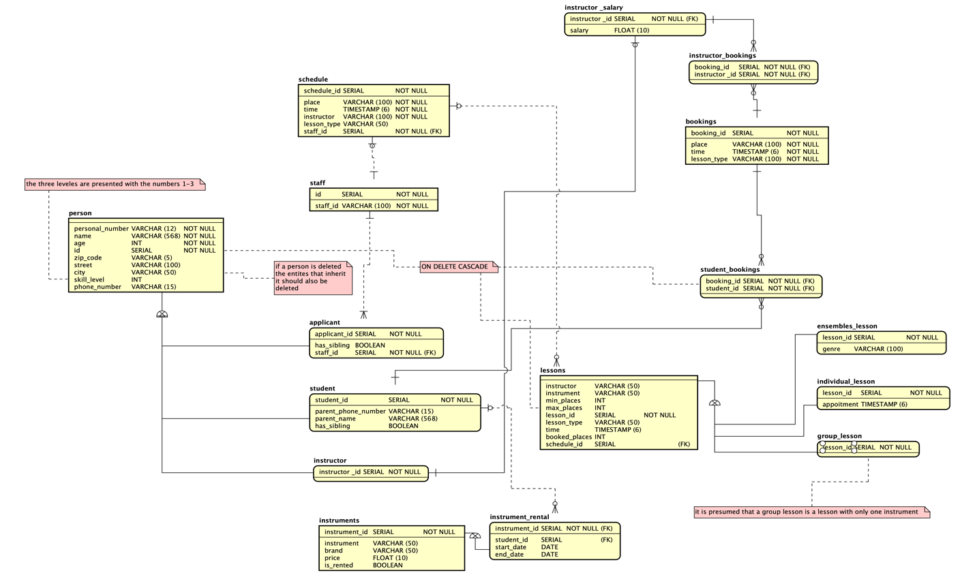

Figure 2: logical / physical diagram.

Two new cross-reference tables are created to solve the many to many relations from task 1, student bookings and instructor bookings, they both have combination of FKs as their primary key to solve the rows between the entities booking--student and booking--instructor_salary respectively.

The data type SERIAL is used for all ids as I am using postgres and it is a postgres native data type, all ids are NOT NULL since they are used as PK for the entities.

The name attribute has a maximum of 568 since it is the longest recoded name, and there is no client to consult on the data type, no PK is given for entities person or lesson, the reasoning behind that is that it is not interesting to search for a person in the data base or for lessons entity, it is however relevant to search for student or instructor and a specific type of lesson.

The has_siblling attribute contains a integer value representing sibling count, where a student get discount percentage depending on the sibling count, this modeling not render the task easier, it is rather build on real world application, if you are a member of a school/ gym it is often that you can get a discount if two persons from the same house-hold are members, so it is reasonable to assume the same for this situation.

The skill_ level attribute is represented with a string which can hold the three levels a student/ applicant can have beginner, intermediate and advanced.

Discussion

Task 2 is about building the data base that is going to be used in task 3, but after working on the project the I think they should be combined into one bigger part, since after creating the model shown in figure 2 and starting on the third task a lot of changes were made that impacted the design to the point that it is not the same design any more, where I needed to go back to Task 2 and change it.

As mentioned before datatypes are the clients responsibility, it is their database and choice, but some choices are the programmer/designer, simply due to the client often not having experience in the field of computer science, attributes such as personal number and identifications are better stored as strings even though they are numbers, this is to avoid mistakes later, such as someone born in year 2000, would have their personal number stating with 2 zeros that has no value and won’t be represented in a integer datatype where on the other side string will present each character with no regard to their value, and in doing so preserving the data.

The skill_ level attribute is represented with a string which can hold the three levels a student/ applicant can have beginner, intermediate and advanced. It is true that when having the skill_level attribute in the person entity it means it is inherited to the instructor where it is a redundant attribute, but the other choice was to have it in two separate places, and after considering both solutions we decided to have it in the person entity.

Method

The DBMS used in this task is the same used to model the previous one namely PostgreSQL.

The tools used to develop the queries are Jet-Brains IntelliJ, DataGrip ideas and the Mac OS terminal.

There is no specific reasoning behind the choice of the tools and the DBMS, it simply because the lecturer uses PostgreSQL in the lectures giving on the project and my own experience of IntelliJ and the good integration between all Jet-Brains tools, the MacOS terminal is an extra edition just for quick access and to get familiar with the SQL queries from another interface to maximize learning outcome, and since we are building a application that would have a CLI.

The sql script that creates the database application is generated at first from the task 2 diagram using astah soft-wear and then tweaked furthermore by adding more sql statements to satisfy all the requirements, an example of the added sql statements is all script regarding inheritance since astah does not support it and does not export the inherited entities as intended.

The next couple of steps are straight forward, I started reading on the queries that need to be performed on the database and started doing research accordingly, in this step is basically all internet research on the specific DBMS and what functions are built in and which functions need to be created to be able to extract the data requested.

At sometimes more columns needed to be added, which showed flowed design, example of that is the price column for the table lessons, and at other times whole tables needed to be added in order to satisfy the conditions for the higher-grade tasks, more about the specific tables in the result section.

Finally, I needed to generate a script to insert data to be able to evaluate that the sql queries works.

Result

The result is in the following [link](https://github.com/lucas-larsson/IV1351-Data-Lagrning) to the git-hub repository, read the README.md file for instructions on running the database and the scripts for inserting mock data and querying the database.

Figure 3.1 a snippet showing the first query, representing a table with a count of how many ensembles lessons are given per month.

Figure 3.2 a snippet showing the second query, representing a table with a count of how many individual lessons are given per month.

Figure 3.3 a snippet showing the third query, representing a table with a count of how many group lessons are given per month.

Figure 3.4 a snippet showing the fourth query, representing a table with a count of how many lessons are given per month, regardless of the type.

Figures 3.1-3.4 are the solution for first query on the third task, the tables show one number for how many lessons are given of a specific type per month and the last one shoes one number regardless of the lesson type, it is shown as only two rows in this example, but the query work for any number, it is showing only 2 rows due to the data only covering 2 months forward from today’s date.

The queries have the same structure where one select first the time column and with the postgres built in function DATE_TURNC that returns the result over an entire month, and then the count column where the COUNT function count the id column to return a number of the lessons per month, the id column is used for the count because it is always guaranteed to have distinct values for each lesson, then the FROM statement says from which table should this function run and finally the whole statement is grouped and ordered by time, using the respective function.

Figure 3.5 a snippet showing query number 5, representing a table with an average of how many ensembles lessons are given per month.

Figure 3.6 a snippet showing query number 6, representing a table with an average of how many individual lessons are given per month.

Figure 3.7 a snippet showing query number 7, representing a table with an average of how many group lessons are given per month.

Figure 3.8 a snippet showing query number 8, representing a table with an average of how many lessons are given per month, regardless of lesson type.

Queries in figures 3.5-3.8 represent the solution for the second query on the third task, they return a table with an average of the number of lessons for a giving month.

Not much is different here from the previously explained query the main difference is that after counting the number of lessons per month, the count result gets divided on 12 to get an average over the entire year, the count function returns number as a string that get casted to a numerical value and get specified to max of 2 decimal precision.

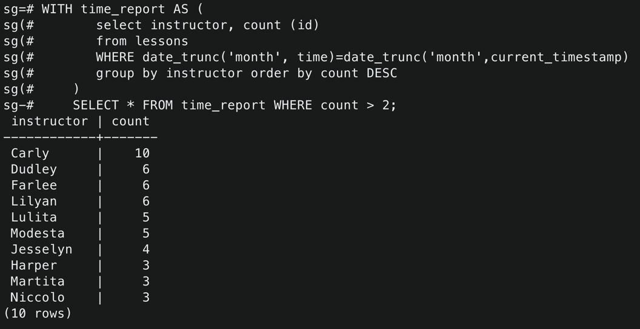

Figure 3.9 a snippet showing query number 9, representing a table with two columns with instructors and their lesson count, that is any instructors that have worked over 2 lessons per month.

The query present in figure 3.9 first creates a variable called time_report with a count of instructors given lessons over the period of the current month using the postgres function date_trunc for the current month as shown in the query and then it selects only instructors that have over the specified number of lessons, the number is 2 in this example, but it can be used with any variable as requested in the requirements.

Figure 3.10 a snippet showing query number 10, representing a table that shows place availability in the ensembles_lesson table for the coming week.

The above query in figure 3.10 use a CASE statement as instructed in the project web-page on canvas.

For this specific query a new column was needed and added which is booked_places, the query is straight forward, if the condition inside the case statement evaluate to true then the THEN statement is executed and returnes as a string with the string specified as shown in the figure 3.10, extract statement is used to specify the period that the query should search during. The requested time is next week, and this is implemented with an extract statement that search for intervals of week with a difference of 1 week ahead, which will always return the next week from the current week. ([Postgres documentation](https://www.postgresql.org/docs/8.1/functions-datetime.html))

Figure 3.11 a snippet showing query number 11, a query to archive given lessons in the database as a part of the high-grade task.

The query in figure 3.11 inserts student_id, lesson_type and price from the lessons table for all the lesson types given today.

This query is for the sound good school to be able to know which lesson was given to which student at what price, for this query a new table was created lessons_archive.

Discussion

One thing to address right away is the amount of data inserted into the database, there is not a big amount of data in the database, but it has sufficient amount, which the only thing that matters.

In the project webpage it is instructed to discuss the choice of creating views or not, no views are created in this task simply because they are never used or needed.

Not much is there to write in the discussion part, as I mentioned before I feel that task 2 and 3 would be a better fit as one task, since after learning about the queries needed to be performed on the database I needed to change it and redesign the task 2 diagram, some changes were not important to the understanding of the application such as rental archive and lesson archive, so they were not added to the design.

Furthermore are the inheritance