**Apresentação do cronograma para o desenvolvimento do sistema proposto**

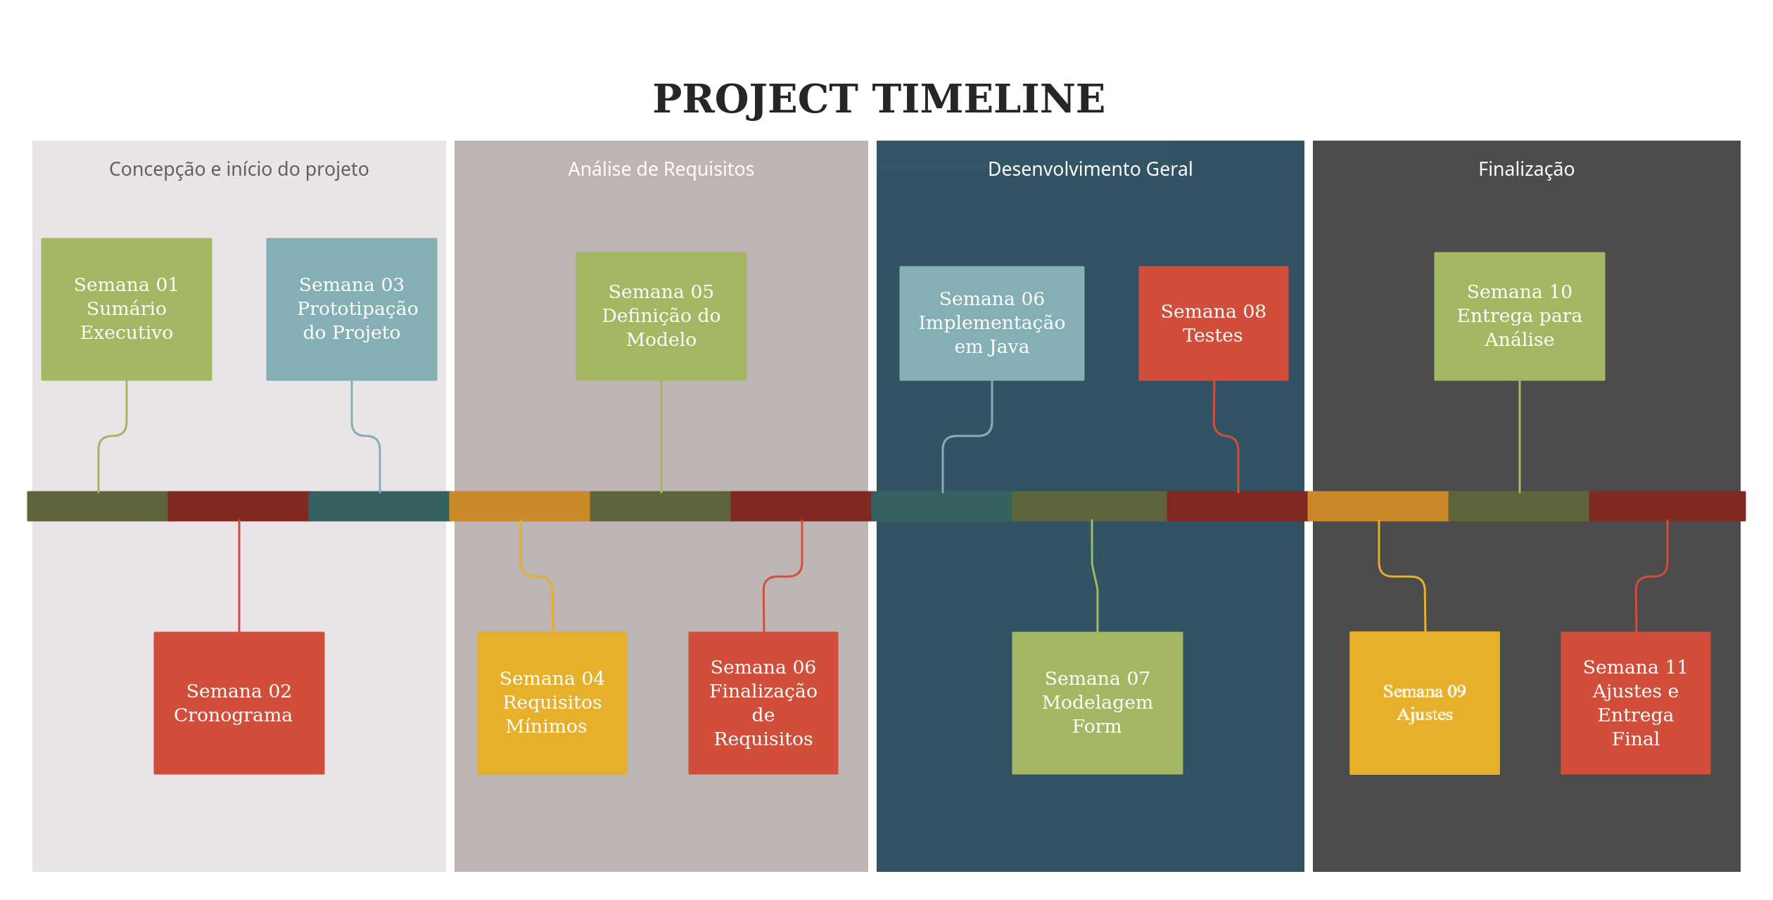Lucas Bedin Marchi

**Progress Bar**

|  |  |  |  |  |  |  |  |  |  |  |
| --- | --- | --- | --- | --- | --- | --- | --- | --- | --- | --- |
| Semana 1 | Semana 2 | Semana 3 | Semana 4 | Semana 5 | Semana 6 | Semana 7 | Semana 8 | Semana 9 | Semana 10 | Semana 11 |