**DOCUMENTAÇAO DO SITE**

**1-PALETA DE CORES**

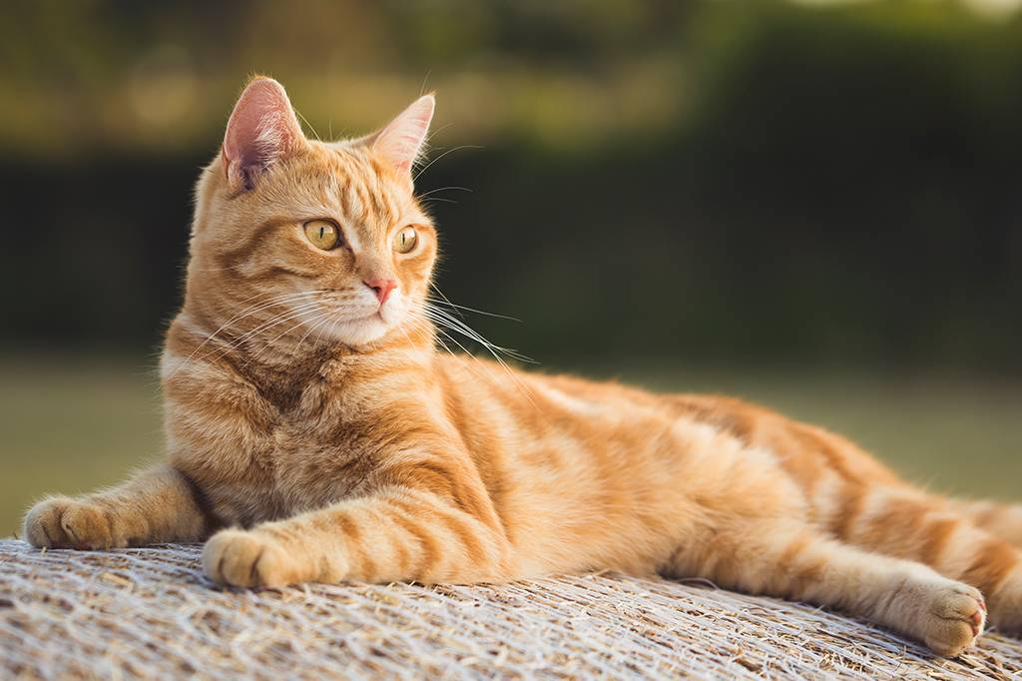

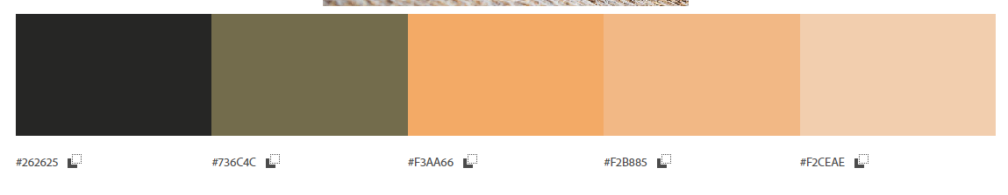

**2-Fonte escolhida**

[**https://www.dafont.com/pt/awesome-possum-shine.font**](https://www.dafont.com/pt/awesome-possum-shine.font)

**Amostra da fonte escolhida**

<https://color.adobe.com/pt/create/color-wheel>

<https://www.dafont.com/pt/>