# Buyonline system

URL for project 2:
https://mercury.swin.edu.au/cos80021/s103527269/Project2/buyonline.htm

## How to use
- Customer:
In the homepage, there’s a register option for customer to create a new account, customer need to provide some basic information to create an account. If the email has already exist, user need to try another one or login with the email.
After successfully register, customer can login, if login success, user can go to buying page.
Buying page automatically display all available items in the store, each item come with a ‘add one to cart’ button, if click, customer can add it to cart, the cart will display under shop items.
If customer don’t want an item, they can press ‘remove from cart’ item to remove corresponding item, or ‘cancel purchase’ to cancel all items in the cart, or press ‘confirm purchase’ to purchase the item, the system will display the total amount for the customer to pay.
- Admin
Admin can login by press ‘admin login’ on homepage, if admin do not have an account, they can click ‘register here’. After successfully register, an admin will have a manager id, admin need to use manager id to login.
After successfully login, admin will be able to select from 3 operations, processing, listing or logout.
In processing page, admin can see all items with sold quantity greater than 0, if admin press ‘process’, all sold items will be processed and disappear from the table.
In listing page, admin can add a new item to store, it will store in goods.xml.

- # List of all files
- Client side
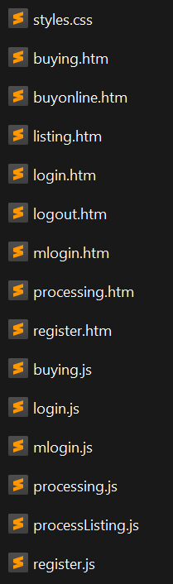
- Server side
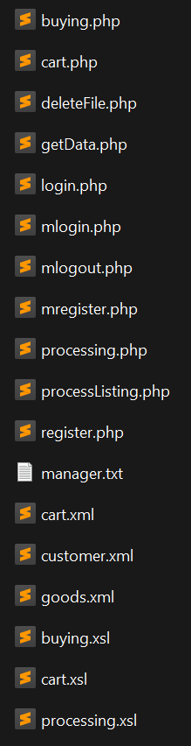
- Checklist-Project2.doc & readme.doc

