**Changes to DS1000**

Text 3.3.2.5:

* **Add: The information labeled at the time of packaging onto the back of the case shall be labeled in the area to the left of the ID logo. The label shall be placed vertically aligned to the ID logo and centered.**

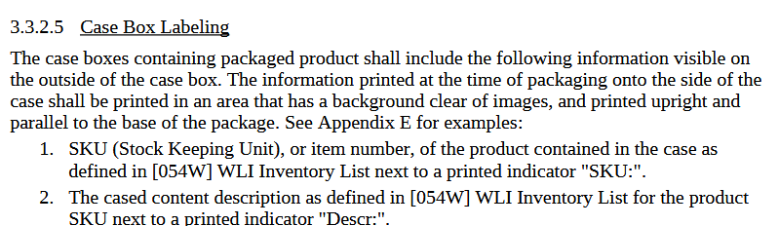

Appendix D:

* **Replace “Qr code” with “Matrix code”**

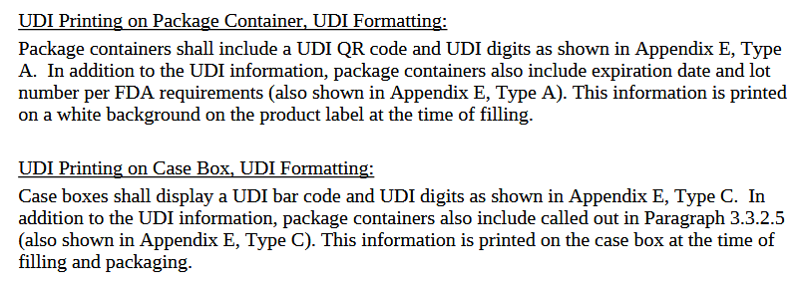

* **For bottle products: This information is printed…**
* **For tubes, foils and pillows: This information is printed on a label prior packaging.**



Appendix E:

* **Add Type F with the following picture and clarify It is the label for tubes, foils and pillow cases.**

