Lattice-Boltzmann Method in Acoustics – Prof. Andrey R. Silva

Lucas Schroeder - Mar. 4th, 2021

Exercise List II

# Boundary Condition Implementation

Objective: Implement solid no-slip boundary condition and different acoustic treatments at the termination a duct and measure its acoustic impedance.

In this section, a 2DQ9 lattice-Boltzmann scheme will be used to simulate an acoustic disturbance propagating inside a duct with three different types of termination:

1. Closed-closed
2. Closed-open
3. Closed-absorbing layer

The scheme adopts the BGK collision operator with an arbitrary relaxation frequency and it runs in a 2D lattice space of 252 by 62 cells. The walls have a no-slip boundary condition implemented using specular reflection method, and the absorbing layer used to simulate an anechoic duct termination were implemented using the Absorbing Boundary Condition (ABC) scheme, based on the Perfectly Matched Layer (PML) theory.

The geometry used is described in Figure 1, including a pair of extra layers of cells in each direction to implement the no-slip wall boundary condition. An acoustic disturbance was implemented by setting the density in a vertical line, tangent to the left wall at , 10% higher than the rest of the domain. This disturbance propagates in the speed of sound, and the simulation time was set to , where is the number of cells in the x direction. This resulted in 8730 timesteps, which took 1 min 10 sec to be computed in a Dell 7567, for each condition.

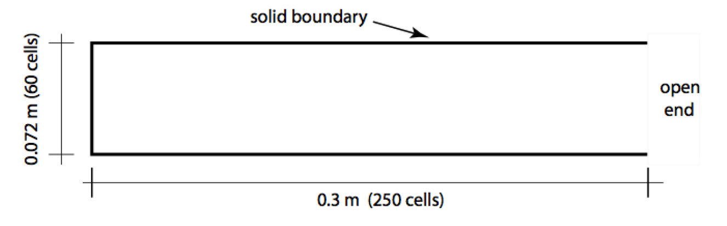

Figure - Duct geometry description.

The pressure and acoustic velocity were measured near the duct termination (), averaged across a vertical line that contained the entire cross section of the duct. The impedance was then measured using the pressure and acoustic velocity in frequency domain, obtained via FFT. It was then calculated for the three cases using

|  |  |  |
| --- | --- | --- |
|  |  | Eq. |

## Closed-Closed

In this simulation case, the right termination of the tube is also closed, so the acoustic perturbance reflect in both walls.

The pressure history (Figure 2) shows that the pressure wave was reflected with the same phase by the right rigid wall, as expected.



Figure 2 - Closed-closed pressure and particle velocity history.

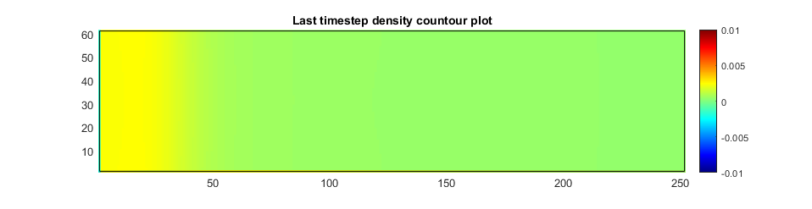

Figure 3 - Density contour plot in the domain in lattice units. The black lines represent the walls.

The date plotted in Figure 2 was used to calculate the acoustic impedance. The results are plotted in Figure 4, as a function of Helmholtz number , where is the wavenumber and is the height of the tube.

From Figure 4 it can be noted that the resistance (real part) is very close to zero, indicating low energy dissipation at the wall. As for the reactance, it negative through the entire spectrum, as it should be, since the reflected wave is expected to have the same phase as the incident wave.



Figure 4 - Closed-closed acoustic impedance in the right-most plane.

## Closed-Open

In this simulation case, the right termination of the tube is open, so the acoustic perturbance encounters a different impedance and is reflected with an opposite phase.

The pressure history in Figure 5 shows that the pressure wave was reflected with inverted phase by the open termination, as expected.



Figure 5 - Closed-open pressure and particle velocity history.

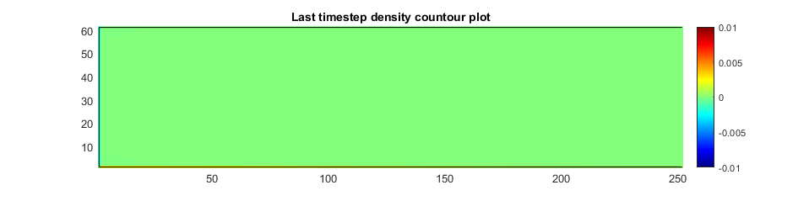

Figure 6 - Density contour plot in the domain in lattice units.

The date plotted in Figure 2 was used to calculate the acoustic impedance. The results are plotted in Figure 4, as a function of Helmholtz number



Figure 7 - Closed-open acoustic impedance in the right-most plane.

### Closed-open – Another Model

A perhaps better model to the open-ended case is to leave an open part of the domain after the duct termination. This was implemented adding 100 cells after the termination with an absorbing layer of thickness . Figure 8 illustrates the modified computational domain by plotting the density in four different instants of time. In Figure 8 (a) we can see the initial disturbance propagating in the positive x direction; in (b) the disturbance gets to the end of the duct and interacts with the open termination; between (c) and (d) we can see the outer propagating wave being absorbed by an ABC condition near the end of the domain.

The pressure and acoustic particle velocity data were acquired in a line at the very end of the duct (cell 249). The time history plotted in Figure 9 is quite different from that plotted in Figure 5.

The same happened to the absolute value of impedance, shown in Figure 7 and Figure 11, although the signal and overall tendency kept the same.

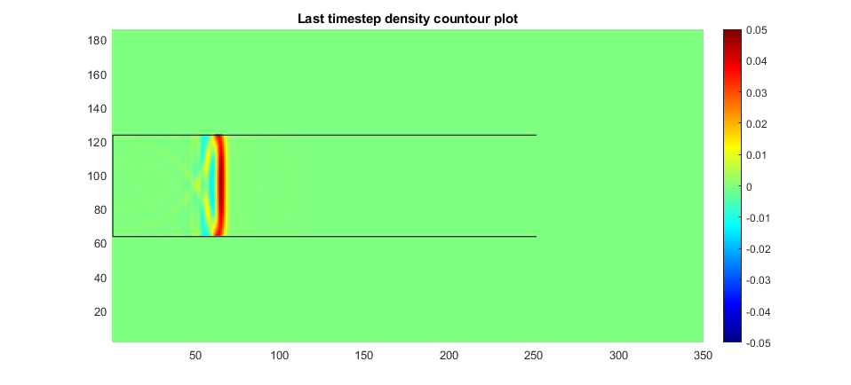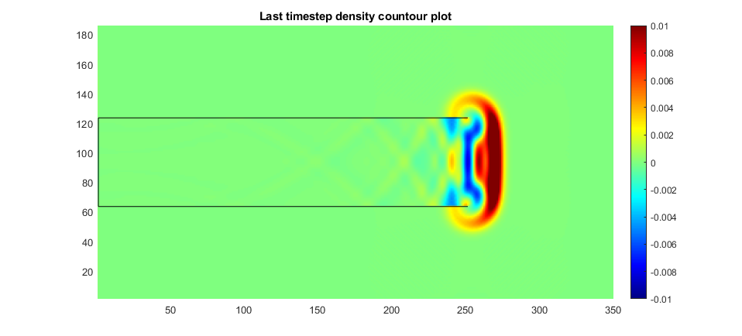

(a) (b)

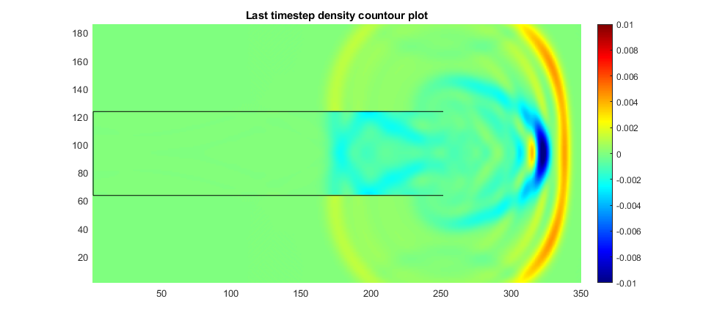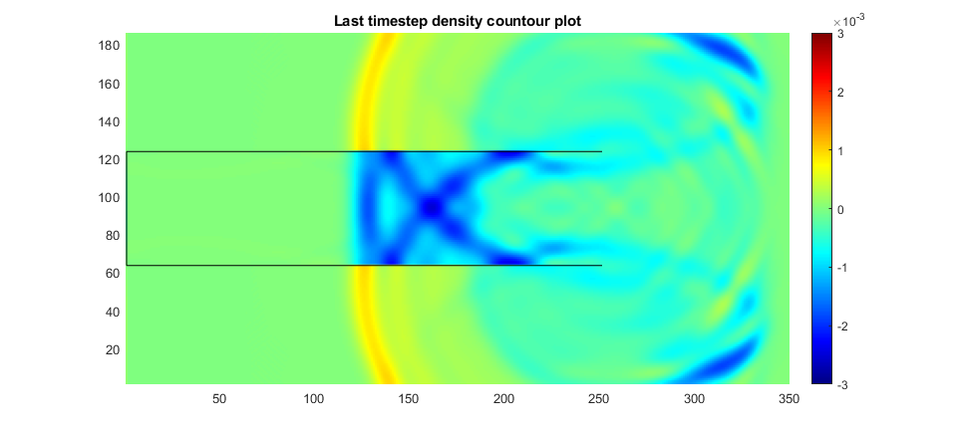

(c) (d)

Figure 8 - Density contour plot for four different instants at the simulation



Figure 9 - Closed-open pressure and particle velocity history.

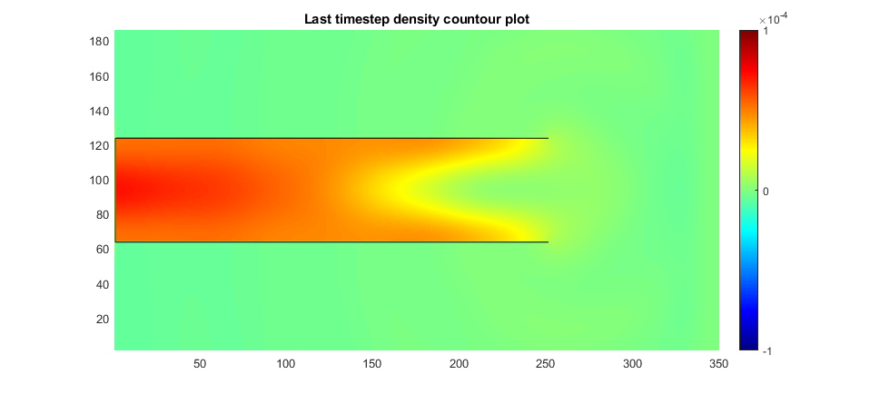

Figure 10 - Density contour plot in the domain in lattice units.



Figure 11 - Closed-open acoustic impedance in the right-most plane (different model).

## Closed-ABC

In this simulation case, the right termination of the tube is treated with an anechoic boundary condition, implemented using an ABC scheme. The right most wall had a 30-cell layer to absorb any acoustic disturbance and by changing the impedance gradually, avoiding sudden changes.

The pressure history (Figure 12) shows that the pressure wave was attenuated by the anechoic termination, working as expected. The measurements were made in a line immediately before the beginning of the ABC layer (cell 222, in the x direction).



Figure 12 - Closed-open pressure and particle velocity history.

The following figure shows the disturbance crossing the ABC layer with more details.



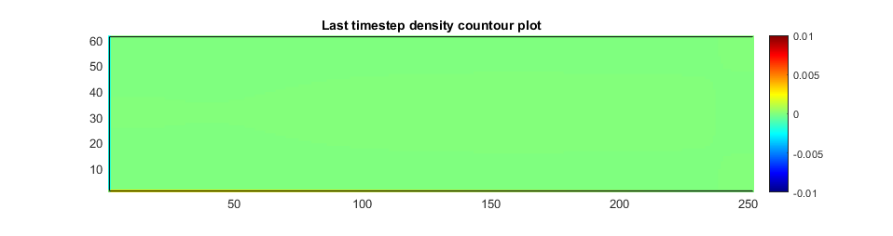



Figure 13 - Closed-open acoustic impedance with ABC termination.

# Muffler

Objective: implement a 2D model of an acoustic filter and measure its transfer function.

In this section, a 2DQ9 lattice-Boltzmann scheme will be used to simulate an acoustic disturbance propagating inside an acoustic filter known as muffler. The scheme adopts the BGK collision operator with an arbitrary relaxation frequency and it runs in a 2D lattice space of 790 by 214 cells.

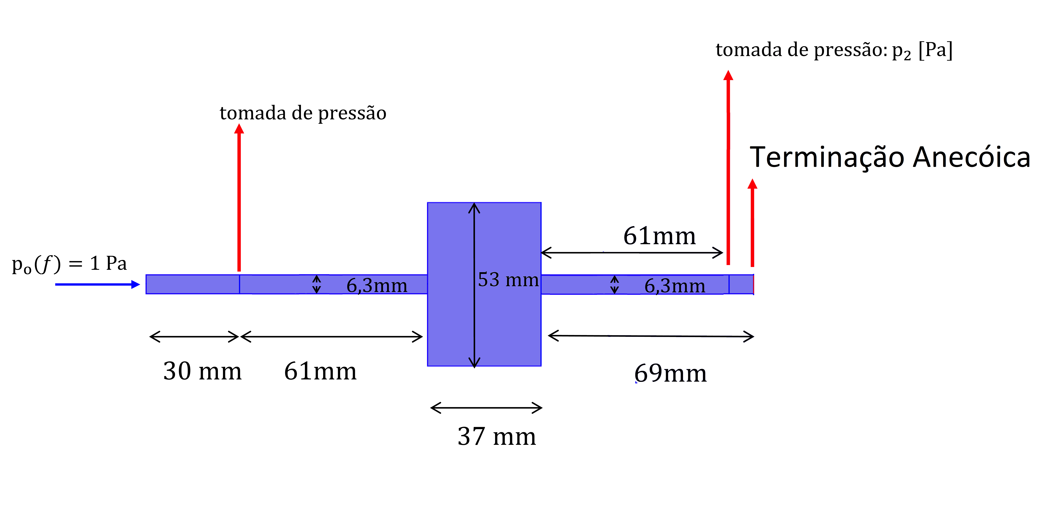

Figure - Muffler geometry.

The geometry (shown in Figure 14) was discretized using a resolution of or . The walls have a no-slip boundary condition implemented using specular reflection method, and the absorbing layer used to simulate an anechoic duct termination were implemented using the Absorbing Boundary Condition (ABC) scheme, based on the Perfectly Matched Layer (PML) theory. It has a thickness of and is located at the inlet and outlet of the muffler.

A chirp density excitation is applied, from to , with amplitude of . The chirp has a linear frequency increment of , where is the time taken to a sound wave travel two times across the domain, resulting in .

The pressure history measurements were taken in the location shown in Figure 14, and then transformed into the frequency domain using Matlab’s FFT function to obtain and . The transfer function (), in dB, was calculated using

|  |  |  |
| --- | --- | --- |
|  |  | Eq. |

## No-flow

The first case, there is no flow inside the duct. A total time of 13684 timesteps was used, equivalent to 10 wave passes. This took 14 minutes to compute in a Dell 7567.

Figure 17 shows the transfer function obtained using this procedure, which agreed quite well to results obtained with FEM simulation of this case.



Figure - Chirp excitation



Figure - Inlet and outlet pressure history.



Figure - Acoustic filter transfer function. Comparison between the FEM and LBGK models.

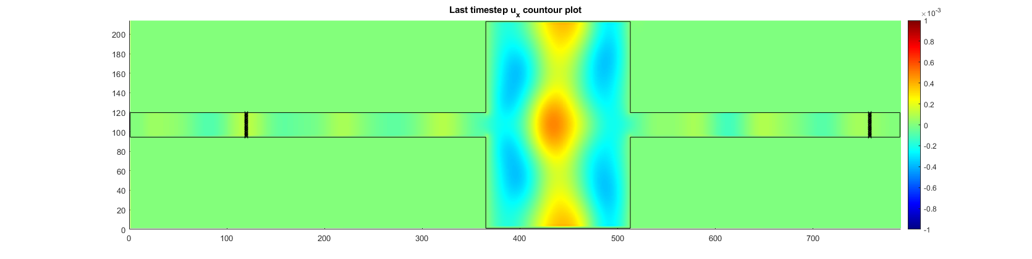

Figure - Acoustic particle velocity at the last timestep, in lattice units. The thick vertical lines indicate the regions where the inlet and outlet pressure were taken and spatially averaged.

## With flow

In this case, an inlet flow with x velocity of was implemented using an ABC termination at the inlet. For convergence purposes, a transient time equivalent to 10 wave passes was added before the excitation, and after the excitation a time equivalent of 3 wave passes were also added, as can be seen in Figure 19, totaling 18 wave passes, or 24630 timesteps. This took 26 minutes to compute in a Dell 7567.

As we can see in Figure 20, the flow convergence was guaranteed before the beginning of the excitation.



Figure - Chirp excitation waiting for transient time.



Figure - Inlet and outlet pressure history.

Figure 21 shows the transfer function obtained with flow, which is very similar to the one obtained without flow in the FEM simulation. Figure 23 shows the 2D velocity profile in a section of the duct far from the inlet and the expansion chamber, at , which has a quadratic profile with a peak Mach number of , agreeing well with theory for 2D Poiseuille flow.



Figure - Acoustic filter transfer function with flow. Comparison between the FEM and LBGK models.

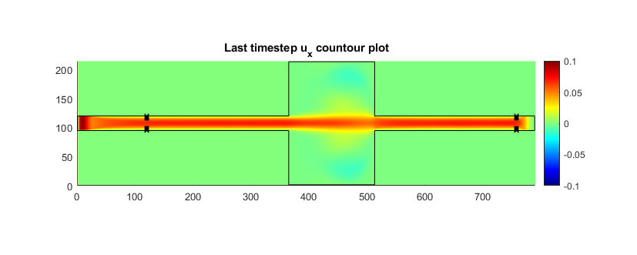

Figure – Fluid velocity at the last timestep, in lattice units. The thick vertical lines indicate the regions where the inlet and outlet pressure were taken and spatially averaged.

 

(a) (b)

Figure - Velocity profile in the cross section: (a) lattice units, (b) Mach number.