Lattice-Boltzmann Method in Acoustics – Prof. Andrey R. Silva

Lucas Schroeder - Mar. 18th, 2021

Exercise List III

Axisymmetric Model of a Duct

|  |
| --- |
| Problem Description 1  Reis and Phillips’s Model 2  Zhou’s Model 2  Boundary Conditions 2  1 2D Channel 3  1.1 Without Flow 3  1.2 With Flow 5  2 Reis and Phillips’s Model 7  2.1 Without Flow 7  2.2 With Flow 9  3 Zhou’s Model 11  3.1 Without Flow 11  3.2 With Flow 13  4 Results 15 |

# Problem Description

In this work, a 2DQ9 lattice-Boltzmann scheme will be used to simulate an acoustic disturbance propagating inside an axisymmetric duct with an open not-flanged termination. The scheme adopts the BGK collision operator with an arbitrary relaxation frequency and it runs in a 2D lattice space of 502 by 252 cells as presented below.

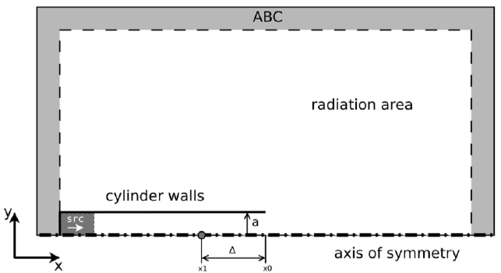

Figure - Simulation case sketch

To implement the axisymmetric condition that allow us to simulate that duct using only a single plane, adjustments must be made in the LBGK equation. Two models will be tested here, one proposed by Reis and Philips and another proposed by Zhou that will be briefly discussed in the following sections.

A chirp acoustic excitation will be configured in the inlet of the duct. It will sweep frequencies from up to , where is the acoustic wavenumber and is the duct radius, making the Helmholtz number. The acoustic impedance will be measured in a plane in the outlet of the duct and its value will be used to calculate the reflection coefficient, as per

|  |  |  |
| --- | --- | --- |
|  |  | Eq. |

where is the fluid’s characteristic impedance.

## Reis and Phillips’s Model

Here, the strategy to implement an axisymmetric condition is to add a source term in the LBKG equation

|  |  |  |
| --- | --- | --- |
|  |  | Eq. |

where and are the first and second order terms, respectively, that we need to compensate for the axisymmetric condition. The first order term is a linear function of (the radial component of the velocity) and inversely proportional to the distance from the symmetry axis.

However, the second order term depends on the spatial derivative of velocities components in both directions, which is computationally demanding since it must be done in every timestep.

## Zhou’s Model

The same approach is done by Zhou, and the term turns out to be quite similar, however, significantly different and much less computationally demanding, since now we must calculate only one spatial derivative.

## Boundary Conditions

For this simulation case, a free-slip boundary condition (BC) was implemented in the symmetry axis using specular reflection. The duct’s wall has a no-slip BC implemented using bounce-back. All three outside walls of the domain have an absorbing boundary condition (ABC). The inlet of the duct also has ABC, but the target velocity is changed to impose a flow of Mach number . The image below shows the regions where the ABSs were used.

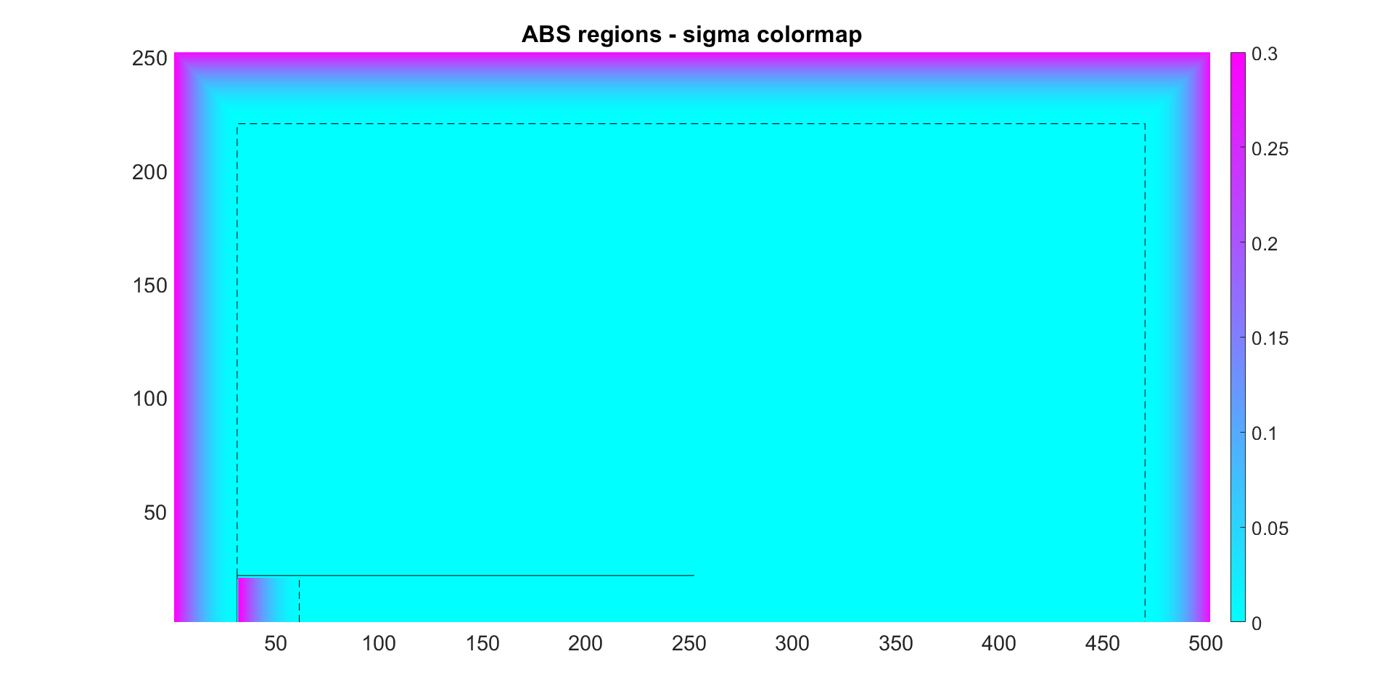

Figure - Absorbing regions. Colourmap show the value of .

# 2D Channel

Before we implement the axisymmetric models proposed, let’s get the results without the correction source term. Without it, the model represents a 2D slice of an infinite channel, which should present results different then the cylindrical duct model.

## Without Flow

In this simulation case, there is no mean flow inside the duct. The excitation is a sine sweep shown below. To avoid discontinuities in the excitation signal, the chirp starts with a -90 degrees phase and an exponential decay is added to the last 200 timesteps, so the amplitudes do not rise or fall abruptly.



Figure - Chirp excitation. Density fluctuation for the 2D case without mean flow.

The results are shown below.



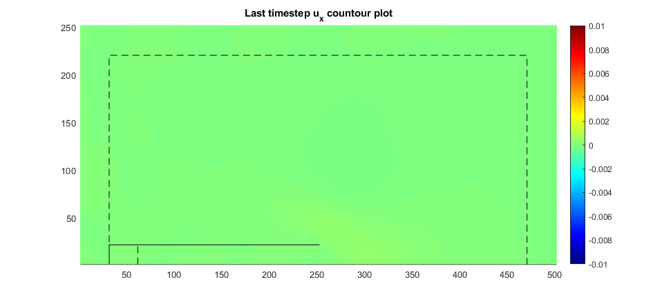



Now we may compare the Reflection Coefficient results obtained for this 2D channel to the one expected for a Cylindrical duct. The Reference we have for the cases without flow is the analytical results obtained by Levine and Schwinger and both are show below. As expected, they do not agree very well.



## With Flow

For this simulation case we have a mean flow with that must stablish before we add the chirp excitation. In order to do this, we add a transient time before the sine sweep, long enough for the flow do develop and stabilize. This is shown in the figure below, note that the sweep only begins after 1733 timesteps.



Figure - Chirp excitation. Density fluctuation for the 2D case with mean flow of .



Before we analyze our results, we must verify our simulation. For this case, the most important parameter is the flow properties. The following figures show how the flow was at the last timestep, after the sound waves left the duct and dissipate in the acoustic sponges.

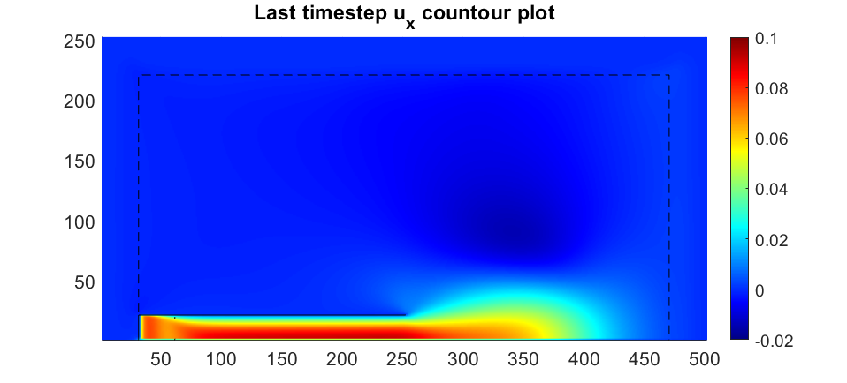

A more detailed analysis of the velocity field is show in the figure below. We can see that the flow profile is parabolic and is zero at the duct wall and maximum at the central axis, with and . This provides a fear confidence to the acoustic results we calculated.



For the following results, we use only the acoustic pressure and velocity after the initial transient (after timestep 1733). The same procedures described here were adopted for the following cases (2.1, 2.2, 3.1 and 3.2) and will not be mentioned again.





# Reis and Phillips’s Model

## Without Flow

In this simulation case, we implemented the axisymmetric model of Reis et al. without flow. The excitation used is shown below.



Figure - Chirp excitation. Density fluctuation for the Reis model case without mean flow.



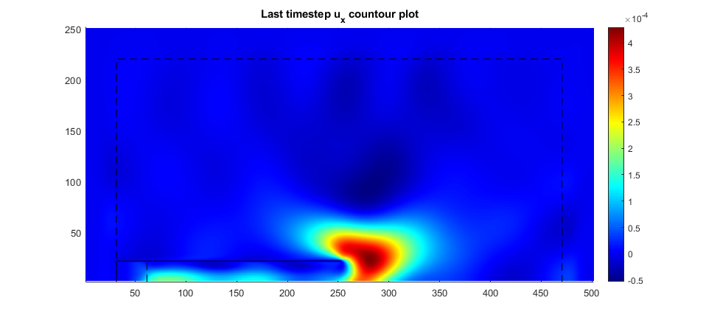





## With Flow

In this simulation case, we implemented the axisymmetric model of Reis et al. with mean flow of . For model efficiency comparison, the time it took to run the simulation is show below.

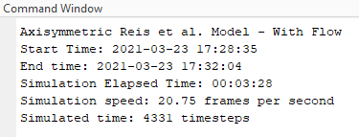



Figure - Chirp excitation. Density fluctuation for the Reis Model case with mean flow of M=0.1.



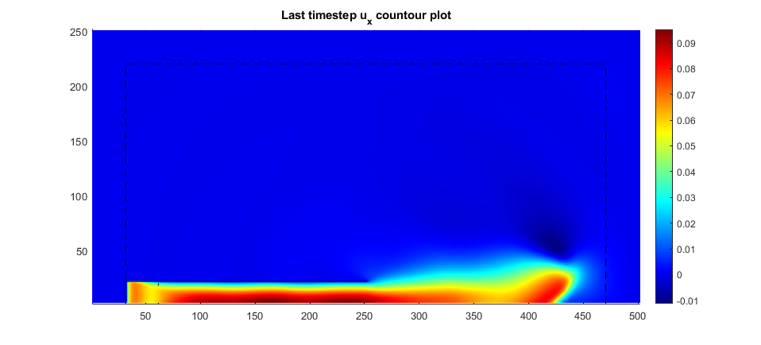

With this setup we got and .







# Zhou’s Model

## Without Flow

In this simulation case, we implemented the axisymmetric model of Zhou without flow. The excitation used is shown below.



Figure - Chirp excitation. Density fluctuation for the Zhou model case without mean flow.



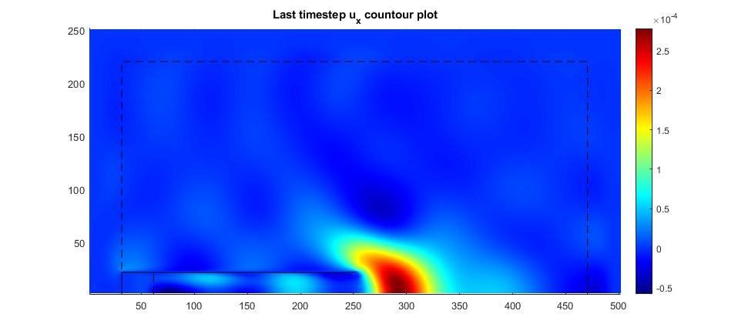





## With Flow

In this simulation case, we implemented the axisymmetric model of Zhou with mean flow of . For model efficiency comparison, the time it took to run the simulation is show below.

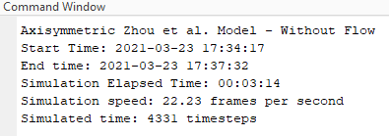

Comparing this with the simulation speed achieved with Reis’s et al. model (20.75 frames per second), we can attest that this code was roughly more efficient in this simulation conditions.

The excitation used is shown below.



Figure - Chirp excitation. Density fluctuation for the Zhou Model case with mean flow of .



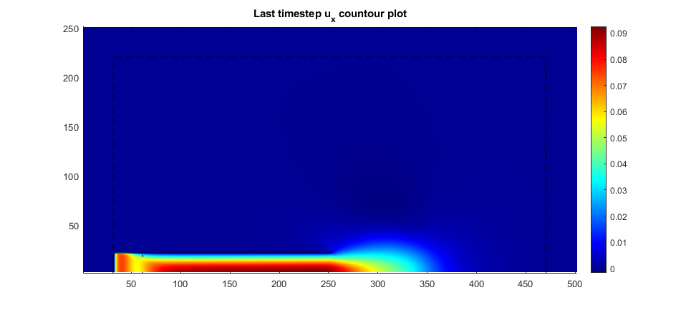

With this setup we got and .







# Results

The results for reflection coefficient for all simulated cases are shown below.

