Modal Analysis – Prof. Arcanjo Lenzi
Lucas Schroeder – Feb 25th, 2021

Exercise List II

SDOF – Hysteretic Damping
The objective of this work is to investigate a MDOF systems with proportional structural damping and closely spaced complex natural frequencies. The system is illustrated in Figure 1.
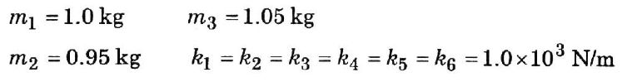
Figure 1 - System sketch and its parameters.
Using Newton’s second law we can derive $[M]$ and $[K]$, the mass and stiffness matrices, respectively:
 | $$\left[M\right]=\left[\begin{matrix}m_{1} & 0 & 0 \\ 0 & m_{2} & 0 \\ 0 & 0 & m_3\end{matrix}\right],$$ | Eq. 1

 | $$\left[K\right]=\left[\begin{matrix}k_{1}+k_{4}+k_{6} & -k_{4} & -k_{6} \\ -k_{4} & k_{2}+k_{4}+k_{5} & -k_{5} \\ -k_{6} & -k_{5} & k_{3}+k_{5}+k_{6}\end{matrix}\right].$$ | Eq. 2

Objective: Analyze natural frequencies and mode shapes for proportional structural damping with $d_{j}=0.05k_{j}$, or $\left[D\right]=β[K]$, with $β=0.05$. Compare with Ewing’s results.
Solving the eigenvalue problem $\det\left(\left[K\right]-iβ\left[K\right]-λ^{2}\left[M\right]\right)=0$, provide de following results:
Ewing’s results | Calculated
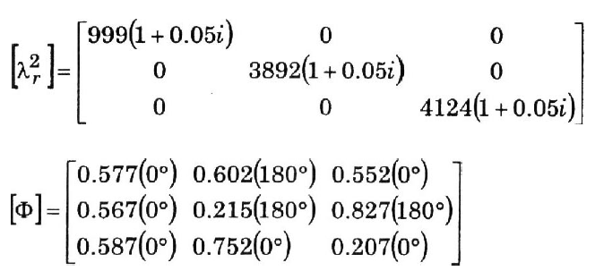 | $$\left[λ_{r}^{2}\right]=\left[\begin{matrix}999.4+500i & 0 & 0 \\ 0 & 3892+194i & 0 \\ 0 & 0 & 4124+206i\end{matrix}\right]$$
 | $$\left[Φ\right]=\left[\begin{matrix}0.5769 & -0.6020 & 0.5521 \\ 0.5674 & -0.2150 & -0.8273 \\ 0.5866 & 0.7519 & 0.2070\end{matrix}\right]$$
Which are essentially the same presented in Ewing’s book.
Matlab’s eig() function provided an eigenvector matrix $\left[Ψ\right]$ that needed to be mass-normalized to be compared, which was accomplished using the following relation:
 | $${\left\{Φ\right\}}_{r}=\frac{1}{\sqrt{m_{r}}}\{{Ψ\}}_{r},$$ | Eq. 3
where
 | $$m_{r}={\left\{Ψ\right\}}^{T}\left[M\right]\left\{Ψ\right\}.$$ | Eq. 4

Objective: Plot receptance curves $α_{j1}(ω)$, for $j=1,2,3$
The system’s receptance was calculated using
 | $$H_{jk}=α_{jk}\left(ω\right)=\sum_{r=1}^{N}{\frac{{{}_{r}^{}Φ}_{j}{}_{r}^{}{Φ_{k}}}{ω_{r}^{2}-ω^{2}+iη_{r}ωω_{r}}}.$$ | Eq. 5

Objective: Plot the Nyquist circles including the three resonant frequencies. From this, find the modal damping $c_{r}$and amplitudes ${{}_{r}^{}A}_{1k}$ for $r=1,2,3$
The Nyquist plot consists of plotting the imaginary part of the FRF against the real part. To find the modal damping and modal amplitudes we can take a look on the real part of the FRF around each resonant frequency, identified by the peaks in the FRF. As an extension of the SDOF vibration systems theory, we know that the receptance magnitude in the $r^{th}$resonant frequency is $\left|a_{jk}\left(ω_{r}\right)\right|=1/(η_{r}k_{r})$, which is the diameter of the Nyquist circle for that mode. The circle’s diameter can be measured by taking the maximum ($MX$) and minimum ($MN$) peaks of the real part of receptance around the $r^{th}$resonant frequency. From Eq. 5, we know that $\left|a_{jk}\left(ω_{r}\right)\right|={{}_{r}^{}A}_{jk}/(η_{r}ω_{r}^{2})$, so we can combine them to find the modal constant
 | $${{}_{r}^{}A}_{jk}=\left(\left|MX\right|+\left|MN\right|\right)ω_{r}^{2}η_{r}.$$ | Eq. 6

Each mode damping parameter $η_{r}$ can also be found using the real part of Nyquist’s circle, taking the frequency at which the maximum ($MX$) and minimum ($MN$) peaks of the real part occurs. Then, using the definition of half-pawer bandwidth we can plug in the frequencies found and obtain the $r^{th}$ damping parameter $η_{r}$.
The problem with this procedure is that when resonant frequencies are too close and the damping is sufficiently high, it become really hard to distinguish them in the FRF data. In fact, depending on the frequency resolution of the measurement equipment, it becomes impossible to do so. In the case being analyzed, we know there must be three natural frequencies, $f_{1}=5.03 Hz$, $f_{2}=9.93 Hz$ and $f_{3}=10.22 Hz$. The distance between $f_{2}$ and $f_{3}$ is less than $0.3 Hz$, so the frequency resolution must be at least $0.15 Hz$ for us to have a chance of distinguish them, which usually requires expensive equipment. However, in this numerical analysis we can easily plot the FRF with a resolution of $Δf=0.01 Hz$, and the peaks can be visualized in the amplified Figure 4.
Figure 2 - Nyquist plots of the receptance.
Figure 3 - Real and imaginary parts of the receptance vs. frequency.

Figure 4 - Zoom in the second and third natural frequencies in receptance between DoF 1 and DoF 1.
Even with this extremely high frequency resolution, it’s hard to write a code to identify the two different peaks of $f_{2}$ and $f_{3}$. In the end, the code implemented could only find two peaks: $f_{1}=5.02 Hz$, $f_{2}=9.95 Hz$, which limits our capacity to reconstruct the FRF from the modal constants measured.

Objective: From $ω_{r}$, $c_{r}$and ${{}_{r}^{}A}_{1k}$ recompose the receptance plots.
Using Eq. 5 with the modal constants measured with Eq. 6 we were able to reconstruct the three measured receptance FRF. Even with only two modes (resonant frequencies) detected by the code, the FRFs are fairly good below the maximum $ω_{r}$.
Figure 5 - Reconstructed FRF's

Objective: Plot mode shapes in the complex plane.
As expected, the mode shapes are all real numbers, and the plot in Figure 5 shows them. Although it can be read as real and imaginary part, this type of plot makes it easier to read as magnitude and phase.

Figure 6 - Mode shapes in complex plane, in polar coordinates.

Objective: Plot the imaginary part of $α_{j1}^{-1}(ω)$.

