MercadoNavarro

Software Architecture Document

Version <1.0>

Revision History

|  |  |  |  |
| --- | --- | --- | --- |
| **Date** | **Version** | **Description** | **Author** |
| <5/Oct/17> | <1.0> | Scope inicial | Grupo 7 |
|  |  |  |  |
|  |  |  |  |
|  |  |  |  |

Table of Contents

1. Introduction 3

1.1 Purpose 3

1.2 Scope 3

1.3 Definitions, Acronyms, and Abbreviations 3

1.4 References 3

1.5 Overview 3

2. Architectural Representation 3

3. Architectural Goals and Constraints 3

4. Use-Case View 3

5. Logical View 3

5.1 Overview 3

5.2 Architecturally Significant Design Packages 3

5.3 Use-Case Realizations 3

6. Process View 3

7. Deployment View 3

8. Implementation View 3

8.1 Overview 3

8.2 Layers 3

9. Data View (optional) 3

10. Size and Performance 3

11. Quality 3

Software Architecture Document

# Introduction

## Purpose

This document provides a comprehensive architectural overview of the system, using a number of different architectural views to depict different aspects of the system. It is intended to capture and convey the significant architectural decisions which have been made on the system.

## Scope

This Software Architecture Document provides an architectural overview of the MercadoNavarro System.

## Definitions, Acronyms, and Abbreviations

ABM: altas, bajas y modificaciones.

## References

-Vision Document.

## Overview

See table of contents.

# Architectural Representation

This document presents the architecture as a series of views.

# Architectural Goals and Constraints

All performance and loading requirements, as stipulated in the Vision Document, must be taken into consideration as the architecture is being developed.

# Use-Case View

MercadoNavarro use cases are:

- Login.

- Registro.

- Modificación de datos.

- Baja de usuario.

- ABM de artículos.

- Búsqueda de artículos.

- Comprar artículo.

# Logical View

## Overview

This subsection describes the overall decomposition of the design model.

## Architecturally Significant Design Packages

The design packages are divided in Model, View and Data and their link is in the next image.

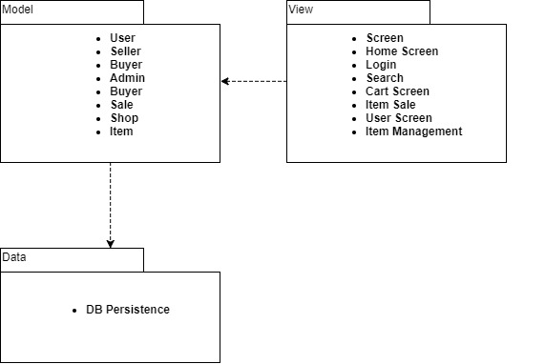

**•** **searchDisplay**

**•** **itemIterator**

## Use-Case Realizations

See Use-Case view.

# Process View

No process views.

# Deployment View

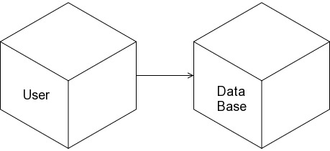

# Implementation View

No implementation views.

## Overview

## Layers

# Data View (optional)

Not needed.

# Size and Performance

The chosen software architecture supports the key sizing and timing requirements.

# Quality

The software architecture supports the quality requirements.