Zebra Vision

Aiding the Visually Impared to Navigate Zebra Crossings

Lucas Geurtjens

Griffith University

2812ICT

[lucas.geurtjens@griffithuni.edu.au](mailto:lucas.geurtjens@griffithuni.edu.au)

**Abstract – The safety of the blind and visually impaired pedestrian is at a greater risk while crossing Zebra crossings. Thus, a computer vision tool was created to predict whether a pedestrian is within or outside the boundaries of the Zebra crossing. This has been achieved using Hough Line Transformation. The software was able to correctly predict if the pedestrian was in a safe or dangerous position, however, struggled with detecting lines for older and well-worn crossings. Overall, the software performed well and made accurate predictions.**

**Keywords – Zebra crossing aid; Visually impaired; Hough Lines Transform.**

# Introduction

The project goal is to create a computer vision tool that aids the visually impaired navigate Zebra crossings. The blind and visually impaired comprise 2.2 billion of the population [1]. In contrast, 270,000 pedestrians lose their lives to traffic accidents each year (totaling to 22% of traffic fatalities) [2]. In light of these statistics, it is crucial that the visually impaired, who make up a significant amount of the population and are highly disadvantaged when it comes to crossing roads, are given tools that make this process safe and easy. Thus, an algorithm will be developed for such purposes.

The aim of the algorithm will be to alert the pedestrian when they are too close to the vertical boundaries of the Zebra crossing (e.g. heading horizontally toward the road). This will be done by giving them a “safe” or “danger!” message depending on their position on the crossing. It is the hope that this software is able to improve the safety and quality of life for the blind and visually impaired while crossing Zebra crossings.

# Previous Work

Previous works using line detection has been found in the area of lane detection with self-driving cars. Related articles include the topics of real-time lane detection for driving [3], and lane detection for self-driving cars [4].

# Technical approach

In order to solve the Zebra crossing boundary detection problem, Hough Line Transform will be utilized. Hough Line Transform is able to find straight lines in an image. The algorithm will attempt to find all vertical straight lines in the image (lines with a theta less than approximately 30 degrees and greater than 150 degrees).

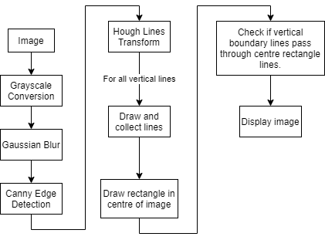

Figure 1: Algorithm flow

As seen in Figure 1, the flow of the algorithm will be to pass in an image, convert it to grayscale, blur the image to soften its edges, perform canny edge detection, and then develop its Hough Lines. Here, the vertical lines will be collected and will be compared against the lines of a center point hitbox rectangle (the boundary of the pedestrian). If the lines of the hitbox are colliding with the boundary, a *danger* message will be given, otherwise a *safe* message will be given.

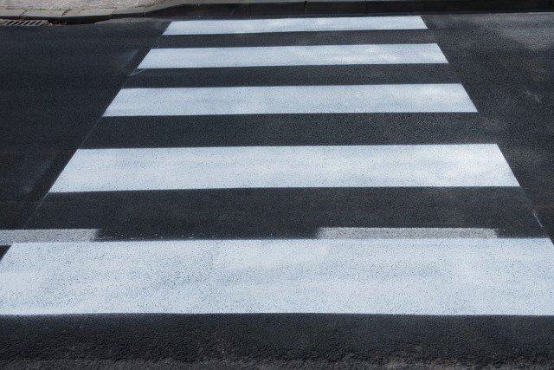

Figure 2: Generic Zebra Crossing Example

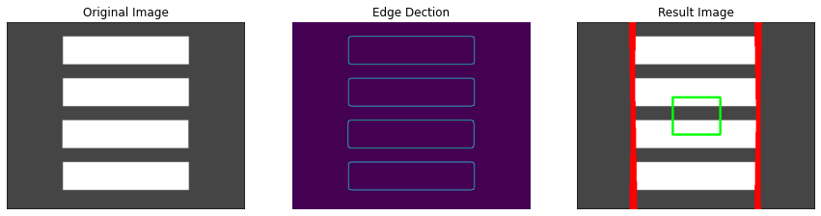

Figure 3.1: Perfectly ideal, computer-drawn crossing (safe)

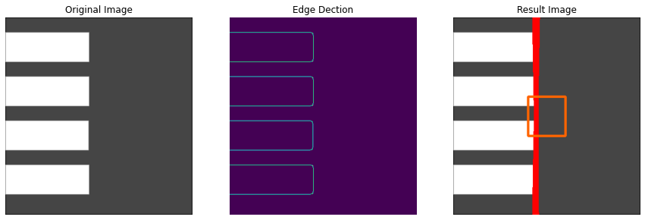

Figure 3.2: Perfectly ideal, computer-drawn crossing (danger)

The algorithm will handle generic Zebra crossing images (as seen in Figure 2). A computer-drawn perfect control image will be used, in addition to new, well-conditioned Zebra crossings sampled from Google Images, and finally old and well-worn Zebra crossings sampled by myself. The implementation will be for static images only and not include video.

Figure 3.4: Ideal crossing 1 (danger)

Figure 3.5: Ideal crossing 2 (safe)

Figure 3.6: Ideal crossing 2 (danger)

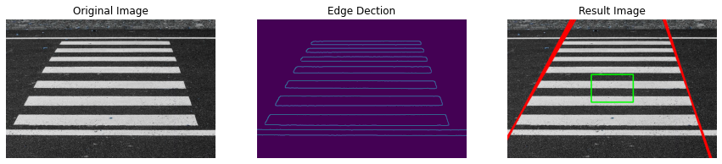

Figure 3.3: Ideal crossing 1 (safe)

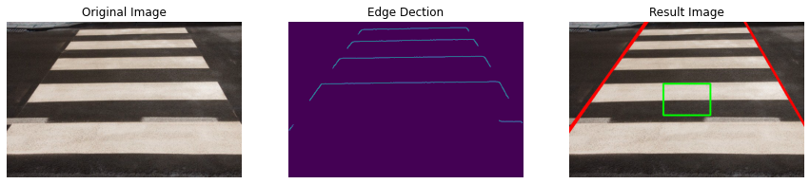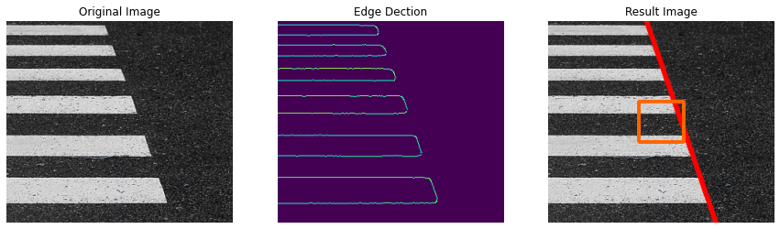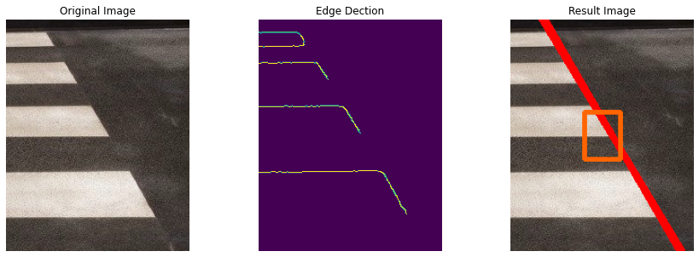

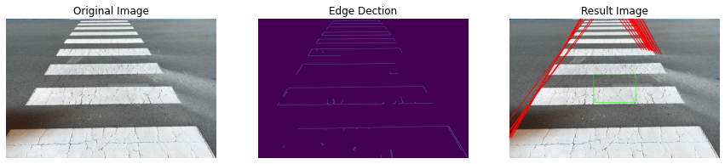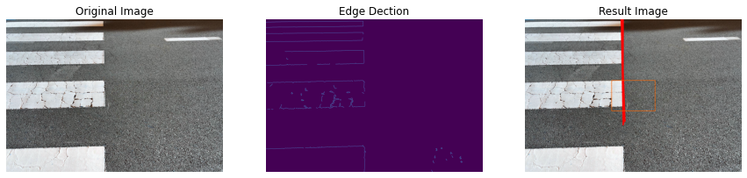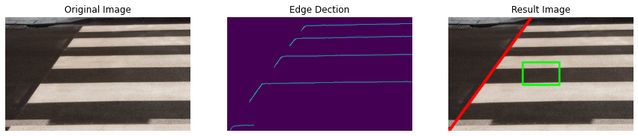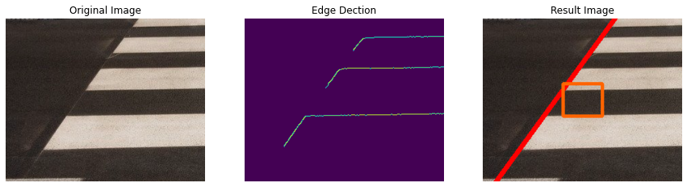

Figure 3.10: Old, well-worn crossing (safe)

Figure 3.9: Old, well-worn crossing (danger)

Figure 3.8: Ideal crossing 2 (safe)

Figure 3.7: Ideal crossing 2 (danger)

# Experiments

Experiments were made upon 10 sample images of Zebra crossings (see Figures 3.1 – 3.10). *NOTE: The red lines indicate the boundaries, the green rectangle indicates a safe hitbox and an orange hitbox indicates a colliding danger hitbox.* The images outline various safe and dangerous positions on the crossing and vary in the quality (ranging from a drawn, perfect control crossing in Figures 2.1 – 2.2, to a new and easily visible crossing in Figures 2.3 – 3.8, to old, well-worn crossing in Figures 3.9 – 3.10). As seen in all images, the algorithm was able to identify the vertical Hough Lines and made the correct predictions whether the hitbox was crossing the boundary. The only problems seem to occur from the well-worn crossings in Figures 3.9 – 3.10. Here, the algorithm failed to identify the complete boundary lines of the crossing. This was likely due to its higher resolution and unoptimized parameters of the Canny Edge Detection (these images were sampled by myself on a smart phone camera).

Furthermore, issues of over-detecting lines in the non-computer-drawn crossing images were incurred during development. This was fixed by tweaking the parameters of the canny edge detection whereby a more optimal lower and upper threshold were selected. Similarly, the addition of a gaussian blur greatly improved the performance of the algorithm.

# Conclusions

In summary, it appeared that the developed algorithm could successfully predict collision with the boundaries of the Zebra crossing and identify if the pedestrian was in a *safe* or *dangerous* position. Seeing as the algorithm struggled with the older, well-worn Zebra crossings, more experiments with these types of crossings would be helpful for future investigation, in addition to exploring crossings with occlusions (pedestrians or vehicles on the road) and other unique styles of Zebra crossings.

##### References

1. World Health Organization (2018). *Blindness and vision impairment*. [online] Who.int. Available at: https://www.who.int/news-room/fact-sheets/detail/blindness-and-visual-impairment.
2. World Health Organization, Fia Foundation For The Automobile And Society and World Bank (2013). *Pedestrian safety : a road safety manual for decision-makers and practitioners*. Geneva: World Health Organization.
3. Ganokratanaa, T. (2013). *REAL-TIME LANE DETECTION FOR DRIVING SYSTEM USING IMAGE PROCESSING BASED ON EDGE DETECTION AND HOUGH TRANSFORM*.
4. Chen, Z. and Huang, X. (2017). End-to-end learning for lane keping of self-driving cars. *2017 IEEE Intelligent Vehicles Symposium (IV)*.