Proposed Actions to Improve Sales

- Focus on Offers for the "Consumer" Segment: This segment generates the most sales, totaling about 1.15 million. Reinforcing marketing actions, such as promotions or discounts specific to consumers, could further increase sales volume. This action aims to consolidate this group's preference and encourage higher purchase frequency.
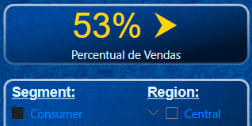

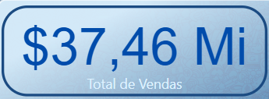
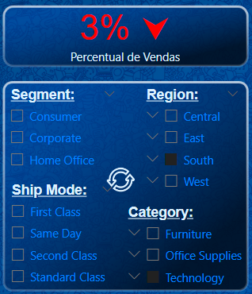
- Expand Reach in the South Region and in Technology Products: The South region has the lowest sales value compared to the other regions. Initiatives such as regional campaigns, adapting the portfolio to local preferences, or even investing in targeted advertising could boost sales in this area. In addition, the Technology category, which already has a high sales value, could also be reinforced with new launches or partnerships, capitalizing on consumer interest in this type of product. ​

