Report Project

P2P network

Lucas Fernandez

5DV205

1. Presentation

For the project I choose to build a peer-to-peer file sharing system using the BitTorrent protocol.
The working is simple, the client download a torrent file on a website, the client connect to a tracker
or server thanks to information contains in the torrent then the tracker send to the client a list of
peers who got pieces of the file and then the client connect with peers and start downloading the file
but with the BitTorrent protocol the peer or client who download pieces of a file is also uploading to
other peers pieces that he already got.

2. Goal

My purpose was to create a simple version of a BitTorrent client (like BitLord or μTorrent) using
the BitTorrent protocol were a client could either create a new torrent from a existing file and send
it to the tracker or just download a file. The project is coded in java for the graphics par I would
have used the library JavaFx but due to a lack of time I could not do that last part.

3. Motivation

Why do I choose to build a peer-to-peer network ? Cause peer-to-peer represents approximately
43% to 70% of all internet traffic and is something that I use almost every to download some files
and I found the technology behind this very interesting so it was a good way for me to learn more
about that cause it something that we have seen a lot in classes so it was a way to develop a
technology that we have overview in classes.
Why using BitTorrent protocol for creating this application and not an other one instead ? Well
BitTorrent is a protocol specialize and also the most common to distributing large files and data, it
also represents 3.35% of all bandwidth and it used in most of the application in file sharing.

4. Architecture

quick resume of the architecture of the project :
First a client create a Torrent file from an exiting file. Once the torrent file is created it need to be send to the tracker so others people can have access to that (I skip that part I directly put the torrent in the tracker class) then if other people have the torrent they can connect with the address containing in the torrent to the tracker, ask for the file they want then the tracker send back a list of peers then this client can connect to others peers or seeders and start downloading once he finished to download all the file he become a seeder.

The project is divided in four main part :
- First part : The Torrent, the program create a torrent from an existing file. A Torrent is a file that
contains all information about the file. Here is a picture of what can contains a torrent file.
Attributes in red are those contain in the project.
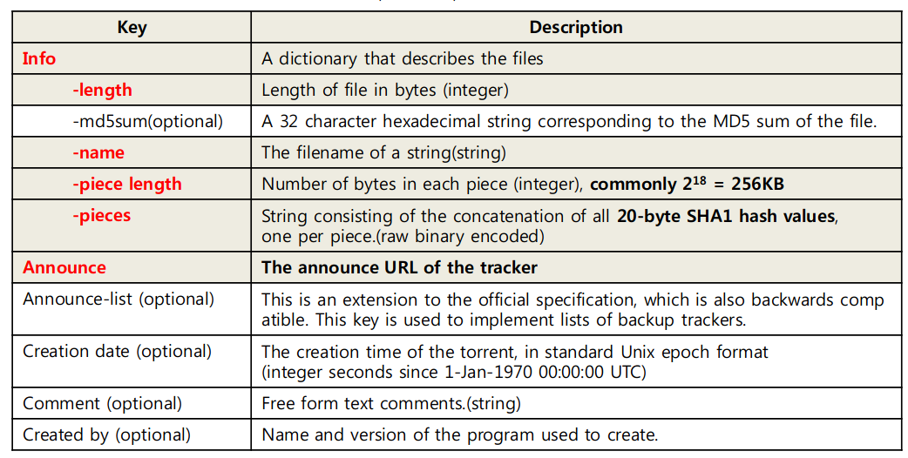
- Second part : The tracker, is the server responsible of keeping track of each torrent and who have
that pieces, for doing that I implement a class call ‘Torrent_track’ which take a torrent and a map of
an array of byte representing the piece and a list of peers. Hence the tracker have a map of an array
byte representing the SHA-1 hash of the filename and a torrent_track. It also have a port where or a
port, since we are in local else it would take a URL, for listening and responding to the client
request. We use the TCP protocol and Socket in java to connect the tracker and a client.

- Third part : The client class is use to connect the client to the tracker and collecting peers. The tracker chose randomly 5 pieces and send to the client the concatenated list of all peers.

- Fourth part : Peers, are the people who are uploading and downloading the file. When the client
got the list of peers from the tracker, a new peer is created with the same id and port that the client
and connect with peers contains in the list. I used Socket to do that, each peer have a client and
server side to receive and sent the data. A peer become a seeder when he has downloaded all the
pieces of the file. To handle the multiple request from uploading and downloading the data, each peers created a new thread for each others peers he is connected with then when it’s finish the thread is close.

5. Conclusion

For this project I have been able to implement the creation of a torrent from a file, the connection between the client and the tracker from the torrent and the send back of the list of the peers and the connection between the client to the others peers from this list of peers. For that used the Socket in java, that something that I never used before. The project still a couple of thing to be a real BitTorrent client like the Mainline DHT which is used to find peers in a purpose to have decentralized BitTorrent protocol and a graphical part so it can be more readable for a normal person but also some minor improvements like instead of using HTTP for connect the client and the tracker like it says in the documentation of BitTorrent or instead of choosing pieces randomly most of the client in the market choose pieces with the ‘rarest first’ technique.

6. Resources

Github project : https://github.com/lucas101199/P2Pa
Documentation of BitTorrent protocol : https://www.bittorrent.org/beps/bep_0000.html
Source of the image and helpful documentation : https://dandylife.net/docs/BitTorrent-Protocol.pdf
Wikipedia page of BitTorrent protocol : https://en.wikipedia.org/wiki/BitTorrent

