**Creating a new Committee Group:**

1. Go to the C&S Connect Overlay page
2. Click the “Committee Groups” button
3. Click the “ + New Group” button that appears
4. Add the group title
5. Add Committees
   1. Blank inputs will be ignored. If you create too many inputs, leave them blank.
6. Save

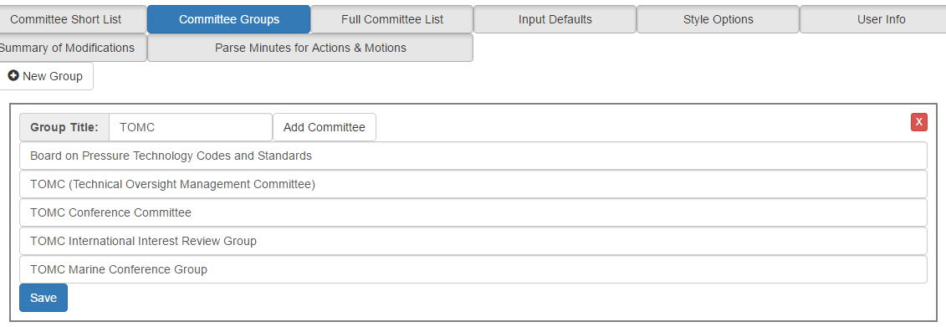

**Committee Groups appear on new Component or Entire Document Ballots**

**There are two buttons for each group:**

1. In Section C, directly beneath “Committees to be Balloted”

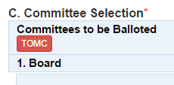

* 1. This adds committees to their appropriate level, not for review and comment

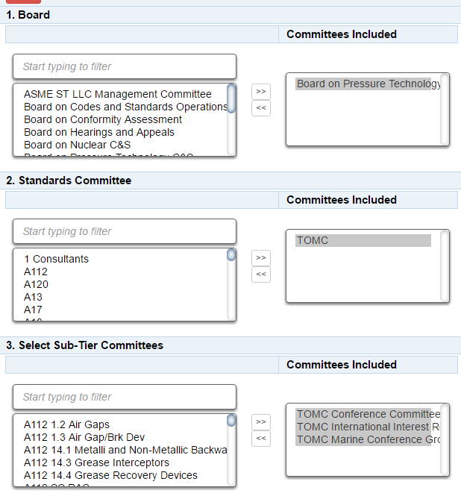

1. Next to section C.4. “Committees for Review and Comment”

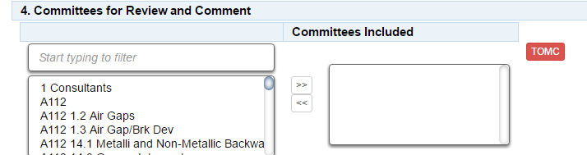

* 1. This adds the committees for review and comment, not at their level

