Rough Draft

# Introduction

Invasive carp have proven problematic among ecosystems and are known for their ability to cause drastic, lasting damage to the environment and local species. Therefore, determining the optimal level of treatment to target these invasive carp, while leaving native species unharmed, is of high importance. Three seperate trials were conducted involving bluegill, yellowhead perch, fathead minnow, common carp, and other carp. Invasive carp were initially administered different levels of dosage to determine the lethal threshold in gavage trials. Leaching trials were performed to observe how much of the given treatment would pass from the fish into the water. Indoor and outdoor trials focused on comparing the mortality of the invasive carp compared to other species among the same tanks, after the lethal dose was applied.

# Preparing and Cleaning the Data

The researches provided two data sets to be analyzed. The morphometrics data set contained information on the height, weight, and species of each fish, along with the trial and dosage level. This data set initially contained 631 observations, with 1 missing. Since this observation was only 0.15% of the data set, and missing both height and weight we elected to removed it from the data set. An important note in this data set is that each observation is an individual fish, whereas each observation in the other provided data set related to groups of fish.

The height and the weight of the raw data were labeled in grams, milligrams, and mg/kg/d. In order to standardized the units, grams were computed to milligrams. Also, mg/kg/d were assumed to be equivalent to milligrams. These were then compiled in a new column labeled Dose.

The survival data set did not include height and weight for each individual fish, but rather information on mortality and dosage leak rate for each trial and tank pair. This data set consisted of the three different trials: Gavage, Leaching, and Indoor/Outdoor. Not all variables were necessary for every one of the trials since each trial had a unique purpose. Therefore, we built three seperate data sets containing information necessary for each trial.

The Gavage trial data set consisted of the trial and tank, the dosage level administered, the mortality rate, and a variable keeping track of the deaths occuring over a time range of one hour to three days. The Leaching trial set also contained the trial, tank, dosage level administered, mortality rate, but instead of the deaths over time, it contained the concentation of treatment in the water from one hour to three days after the fish were treated. The Indoor/Outdoor trials did not contain the mortality and treatment water level over time, but contained everything else.

Although this data set included information on mortality rates, the raw data came as a fraction of string type which needed to be cleaned before further use. The first number in the fraction represented the number of deaths in the tank and was extracted from each row and saved in a seperate column. Furthermore, the denominator represented the total number of fish in the that tank and was also extracted. This was then stored in a seperate column while the original mortality rate was then discarded.

# Exploring the Data

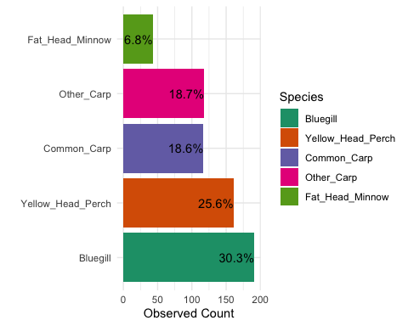

Figure 4

As shown in figure one, carp make up the majority of fish in the morphology data set. They account for 235 of the 630 fish present (37.3%). Bluegill and yellowhead perch are the next most prominent species, followed by fathead minnows.

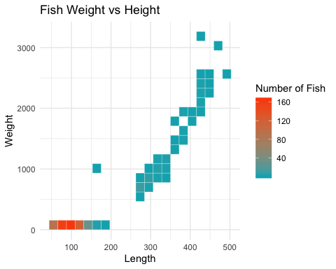

Figure 3

Researchers were interested in understanding length and weight of the fish in order to analyze the relationship between size of the fish and mortality rate. In figure 2, it appears that the majority of the fish are smaller in size with some fish reaching to be much longer and heavier.

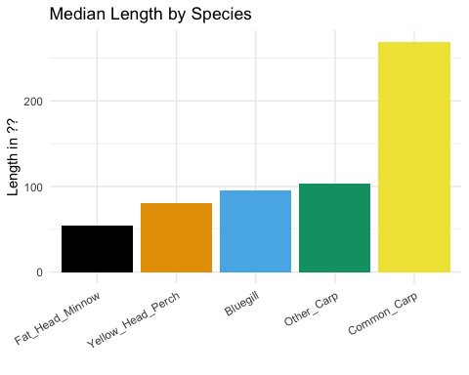

Figure1

|  |  |
| --- | --- |
| Species | median_weight |
| Bluegill | 25.63 |
| Yellow_Head_Perch | 9.46 |
| Common_Carp | 698.20 |
| Other_Carp | 21.83 |
| Fat_Head_Minnow | 3.06 |
|  |  |

As seen in Figure 3, both forms of carp seem to be bigger than other species of interest in this study. Specifically, Common Carp are the biggest by a large margin in this study, followed by Other Carp which are comparable to Bluegill in size.

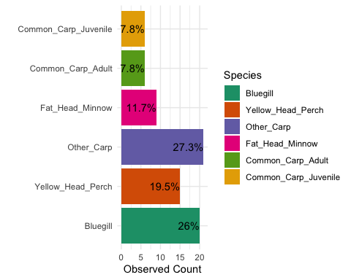

Figure represents the counts of trials each species fish took place in.

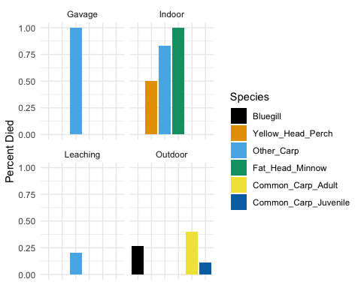

# Statistical Methods

### Gavage Trials

The Gavage trials consist of 2 observation of 3 different administered doses. This means that there were two tanks for the 26, 52, and 106 mg levels. It was determined to split the 3 doses (26, 52, and 106 mg) into low, medium, and high respectively. From there, a t-test was implemented, due to it’s robustness and statistical power. The results showed that there is no significant difference between 106 and 52 mg (pval = 0.5). There does seem to be some kind of difference between 52 and 26 mg (pval = 0.063). Therefore, it was determined that the lethal does was 52mg. However, the definition of lethal dose can be subjective. We elected to define a lethal dose as killing a high percentage of fish (above 80%).

# Results

When addressing the mortality of carp, the indoor trials provided a higher rate of mortality than the outdoor trials. Furthermore, it appears that 20mg appears to be the optimal dosage. Due to limited trials and data, more exploration is needed to be conclusive.

At the 20 mg level, Fathead Minnows were severe effected by the dosage level. This drastic effect may be due to the size of the minnows. As discovered earlier, these were the smallest of the species involved in the study based off of weight and height. Although this species seems to be sensitive to the treatment at this level, this must be taken into account when determining how to target invasive carp. Some of the other species such as Yellowhead Perch seem to be relatively unnaffected by dosage levels. Again, more data is required to verify this.

One interesting observation is that at the control level (0 mg), there are fish that died. More specifically, the bluegill and yellowhead perch saw higher death rates than other fish. This should be investigated further, as it could provide an insight into fatality explained by confounding factors.

