INFO601 Physics 1, instructor: Michael Feeney
Project #2 Fall 2023: Broad phase: Accelerated collision detection in a 3D scene
Weight: Project weight evenly distributed across the “project” portion of marks
Due Date: Friday, December 15th at 11:59 PM
Note: This project can be done alone or in pairs.
(you must indicate if you are working within the group or alone before submitting)
Description and Purpose

You are to create a 3D simulation with large, complex models accelerated using hierarchical bounding boxes. The suggestion is using hierarchical Axis Aligned Bounding Boxes (AABBs).

Your application will only demonstrate Newtonian motion and collision detection, not collision response; if your player or ship (or whatever, see below) hits a wall, it will take damage and stop and/or explode, not bounce off. Of course, space ships don’t usually “bounce off” things in real life, but I’m no expert here.

Any demonstration where a small user controlled something is moving around and/or in a “large” scene. You could:
- Recreate the “Descent” game from the 90s!
- Make Half Life 1 ½ where you move your player through a secret base.
- You could be a wizard at some wizard school.
- You could drive a taxi around a cit.
- You could be a bird flying among the trees in a large forest...
- ...or a fish swimming around a coral reef.

You demo should implement the following:

- A 3D environment
- A complex model being moved through a complex world
- The model being controlled by external forces (for movement)
- The model exhibiting detailed collisions with the environment
  - hierarchical bounding areas & narrow phase detection
- “decent” frame-rate
  - Broad phase detection

Requirements
On completing this project you should be able to:
- Renders a large, complex 3D environment
- Must contain a user controllable ship (or equivalent, like a plane, tank, bunny, etc.) that can be manipulated through multiple degrees of translational (and optionally, rotational) freedom

- Must have a complex (we’re talking hundreds of thousands of polygons here) static environment that the entity navigates through. If you are using a terrain (flight simulator), then it must be some sort of mountainous terrain with objects (trees, building, etc.) that the airplane (or whatever) can smash into.
- Must detect a reasonably small, exact collision point or volume (something like 10% the size of the ship would be sufficient – see pictures below). In other words, we should see that we banged the right, front engine, not just that the entire thing smashed into the wall.
- If the object collides, it should simply stop, avoiding penetration and collision response. In other words, simply clamp the velocity to zero when it touches a wall.
- Rotational response is a bonus. If you implement it, you can treat the response like the translational response and clamp it to zero. In other words, if your entity hits a wall while rotating, you only need to reduce the rotational velocity to zero (like the translational velocity). This is realistic: think of the nose of a 747 rotating and hitting a wall; the nose will be damaged and the rotation will stop, but the plane won’t “bounce off” the wall, rotating the other way.
- The location of the collision should be shown somehow, ideally on screen (perhaps with a bounding volume or that part of the model turning a different colour, but can be displayed as text also).
- Suggestion (bonus): To assist in locating the ship, and since we haven’t use shadows yet, you might implement a point light at the location of your model. And perhaps spot lights for headlights! That would also be SO COOL!!

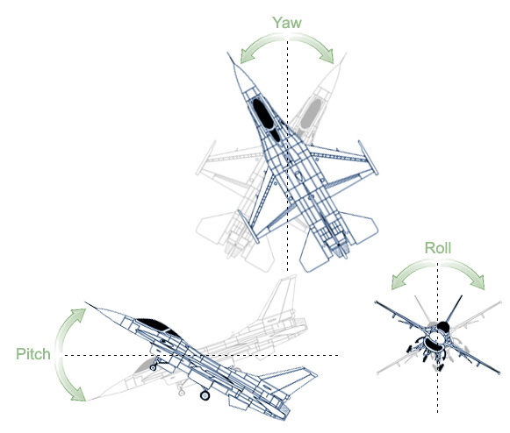
These are ‘reasonable sized’ collision volumes
(taken from: http://www.acme-worldwide.com/dynamic_motion_seat_Fixed.htm)

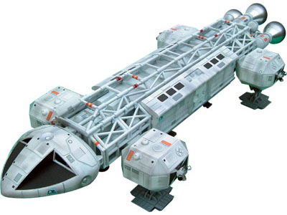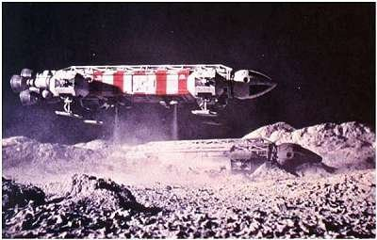

Note the “thrusters” on this sexy “Space 1999” Eagle space ship! Groovy, baby!
(from: http://www.sixteen12.com/s1999_eagle.html)

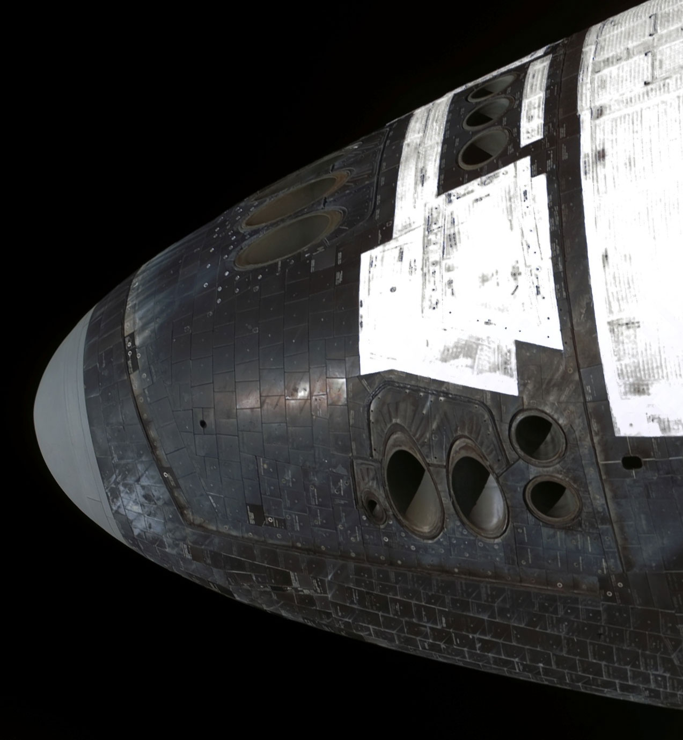

And the thrusters on a real space ship, the Space Shuttle
(taken from: http://upload.wikimedia.org/wikipedia/commons/f/f7/Shuttle_front_RCS.jpg)

And let’s not forget the sweet Viper from Battlestar Galactica:

(I couldn’t find still of the thrusters in action, but if you watch the show – the new one, not the crappy 1970’s one – you can see Starbuck flinging her Viper around with the thrusters. Oh yeah.)

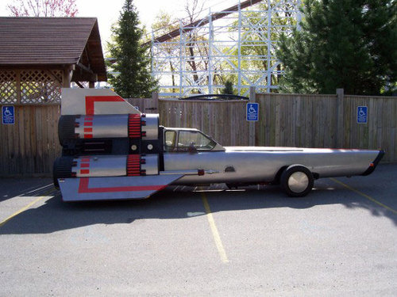
(from: http://forbiddenplanet.co.uk/blog/2010/street-legal-bsg-viper-car/)

Grading Scheme

- You may use any code that has been provided to you in class or you have written yourself.
See the "plagiarism" test, later in this document, for more details.
- You cannot simply use an existing game engine (or part of a game engine), even if it's a "from source" engine (i.e. you have the entire source) to complete this assignment; it should be either completely new of significantly modified. This includes, but is not limited to: Unity, Unreal, Cry, Anarchy, XNA, Cocos, Ogre, the framework from the OpenGL text, LearnOpenGL, etc. In other words, you are expected to have made the vast majority (essentially all) of the engine in this term by yourselves, from "scratch" - i.e. starting from something a rudimentary as the "OpenGL Book" code or the GLFW starter code (we started with that in class).
- This also extends to generative AI (chatGPT, etc.). It’s a great learning tool, but beware of just dropping code in unchanged.

Note: A simple test for all of this is asking you questions about your code. This isn’t a new idea: if you’ve written it – and so understand it – then you can discuss it. If you have no idea what’s going on/how to change it/why things are done a certain way, etc., then I’m going to assume you didn’t write it.

Also note that if I suspect you of plagiarism, you have to convince me that you didn’t, not the other way around. I’m exceptionally forgiving about this, giving students the “benefit of the doubt”... up to a point.

- If you code does not even compile, I will not mark it. Actually, I will: it’ll be a mark of zero.
- If you code does not build (i.e. linker error) and run (i.e. no crazy run-time crash that is unexpected), I may investigate this further, but only if there is some simple problem and/or slight configuration error.
- You may use certain libraries like AssImp, glm, XML or JSON loaders/handlers, LoadPNG, so long as these are separate (i.e. you can’t say “I’m using Ogre because it has a texture loader...” – you have to be just using that part as a separate item).
- You may not use boost. If you have boost, you’ll get a mark of zero.
- Your submission must build in Visual Studio 2022 with the 64-bit debug AND release library settings with the default build settings (ISO C++ 14 is the default, not 17 or higher).
  - If you feel you “need” something beyond version 14, clarify this with me in advance.
  - The reason I’m doing this is most C/C++ development does not use the later “modern” aspects of C++. If anything, it’s more “C” than “C++”. i.e. it’s not uncommon in industry to use C++ 98/2003 and turn off exceptions.
  - TLDR: I’ll be leaving my compiler setting at “C++ 14”, so if you’re using something beyond this it won’t build. And if it won’t build, then you get zero, right?

Please include a video recording showing off your project.

NOTE: No video submitted = mark of zero (0).

Environment is a “complex” 3D model of at least 100K triangles  or several million vertices (you get 0% if you have “tiny” models). | 10
Entity (i.e. spaceship, plane, etc.) is composed of at least 3K triangles or 30K vertices. | 10
Collision detection is implemented showing collision between environment and entity | 20
Collisions cause entity to stop (i.e. velocity is clamped) in the direction of the collision. In other words, if the ship is flying down (y-axis) and forward (z-axis) while hitting the “ground” (i.e. y-axis), the ship will continue to move forward (along z-axis). | 30
A hierarchical AABB (or equivalent) is implemented in at least one of the models (you can do this for both, or you can use another technique for your “moving”/player object – see point below about the “10% of your model”). This can be done at run-time (i.e. when the models are loaded) or as a “pre-process” (i.e. done off-line with the additional data saved). Note: If this is done as a pre-process, you must submit the code that does the generation. | 50
Collision details are shown on screen at an appropriate detail (i.e. if your spaceship hits a wall, only the part hitting the wall is highlighted (at most, this is 10% of your model). | 20
Entity is controllable by the user in three translational degrees of freedom (x,y,z) | 25
BONUS: Entity has three rotational degrees of freedom (controllable by the user) | 10%
Motion is controlled by “forces” rather than direct updates. Think “thrusters” in a space ship or the engines of a plane that “pushes” the object forward (Note: We will be looking into this in more detail soon, but the effect of “force” can be mimicked by controlling the acceleration of the entity; i.e. if you go “forward” ). | 20
Movement is simulated in discrete, real-time step (i.e. independent of frame rate). | 10
Detects a reasonably small (approx 10% size of ship or smaller) collision detection point – it is clear that a portion of the character has collided with world | 40
Collision point identified on screen somehow (colour change, explosion, etc.) | 10
Bonus: Some additional item to assist in locating the characters location in the world (lighting, shadows, point in the environment, etc.) | 5%

Project Corrections
If any corrections or changes are necessary they will be posted to the course web site and you will be notified of any changes in class. It is your responsibility to check the site periodically for changes to the project. Additional resources relating to the project may also be posted.
80/10-year old “squinty eye” plagiarism test:
I have very little tolerance for plagiarism, but many students are unclear about what it is.

Basically, it’s submitting somebody else’s work as your own.

There is sometimes some confusion over this because you could argue nothing is actually “unique” (see: http://everythingisaremix.info/ for a fascinating overview of this).

The whole point of assignments/tests/projects in this course (or any course, really) is to try to see if you are actually able to do the coding that’s asked of you. In other words: How competent are you? Handing me someone else’s code and/or making a trivial change isn’t good enough.

Also, it’s illegal (in Canada, the US, and Europe):
- http://www.plagiarism.org/ask-the-experts/faq/
- http://definitions.uslegal.com/p/plagiarism/
- http://en.wikipedia.org/wiki/Plagiarism
- https://www.legalzoom.com/articles/plagiarism-what-is-it-exactly

In other words, I’m not going to be drawn into a giant debate over how “different” your code is from mine or anyone else’s, if any sensible person (including me) would conclude that the code/application is pretty much the same thing, then it is. It is up to my discretion to decide this.

- While you may freely “borrow” mine (or anyone other) code but your code should be “sufficiently” different from mine (you might want to replace the word “sufficiently” with “significantly”).
- In other words, you cannot simply use an existing game engine (or part of a game engine) to complete this assignment; it should be either completely new of significantly modified.
- How will I determine this?

  - If I showed your application and/or your source code to either a pragmatic 75-year-old mother, or a typical 10-year-old, or even some random person walking down the hallway (i.e. a non-expert), and they looked at it, tilted their heads, squinted their eyes, and said “you know, they look the same,” then they are the same.
  - Another test would: How much time it would take for a "competent programmer" (for example, me) to make the changes you are submitting? The point here is that I don’t “care” if you tell me “But it took me weeks to make the changes!” Fine, but if I can make those same changes in 10 minutes, then not a lot of work has been done (certainly not sufficient work – these projects should show take days of work having been done).

Possible Groups

You have a choice of being in the group (of 2, so really, “pairs”) or not.

If you choose to be in a group, all group members receive the same mark.

Keep in mind that you will be doing the exams (and interviews, and a lot of your job...) alone…

I am not going to get involved with issues like “I did all the work, and he/she is a lazy bum”, or “we didn’t know/verify what so-and-so was doing, and when I checked, that had done nothing/everything/changed everything/moved to Florida/ate the flash drive with our only copy”, and so on; if you choose to work in a group, you also choose to manage the dynamics of the group entirely yourselves. This also includes group dynamics taking place in other courses that you feel are impacting this course and/or the policies/practices of other instructors regarding groups.

The only exception to this is something that would be considered an “exceptional circumstance” (as defined by the Fanshawe Evaluations policy), which practically means: accident, illness, death, etc.

Note that even under the policy, this is a “grey area” when it comes to projects, as, unlike a test/exam, you’ve had a relatively long time to work on it – if someone gets sick on the due date, and you have absolutely nothing to submit, that’s not quite in the spirit of an “exceptional circumstance”; it’s more like you did nothing until the last minute and fate/bad luck intervened.

You must indicate your grouping before submission. This can be in the comments portion on the submission page of Fanshawe Online (I would prefer that, actually, rather than a separate e-mail). What I will not accept is situations where after the assignment is submitted and marked, you try and tell me, with a shifty looking expression: “Yeah, I was in Bob’s group. Yeah, that’s it.”, or give me ETOTIs (“Epic Tales of Tragedy an Intrigue”, see earlier paragraph).

If there is any debate/confusion/disagreement about people being or not being in a group - i.e. one person claims to be in a group, yet the other person claims they are not in a group – then you are not in a group, and your submission (or lack of submission) will be treated accordingly (also, if you both submit the same thing, that’s cheating/plagiarism).

Only one student needs to submit, but if you are a realist (like me), then you may also have every member of group submit the same project to FOL. However, you need to make sure you are all submitting the same (i.e. “current” or “latest”) version of the code: if everyone in the group is submitting slightly different code, I won’t look too kindly on having to spend a ton of time determining what parts are “different” and/or “correct” and/or “the latest”

Either place this grouping information (or any other note you expect me to read) in the FOL comments, in an e-mail, or in some obvious place, like a “readme” file on the root of your project folder. Please don’t place them deep inside the comments of one of the files, buried within the code somewhere, in some alternate dimension, carved under a tree in some forest somewhere, etc.

