Intelligent Database Report

1. Introduction
The Intelligent Database Assistant is a software application designed to provide users with insights into data stored in a database using natural language queries. It leverages SQL for structured data retrieval and Prolog for reasoning-based queries, combining the strengths of both technologies. The project also includes a graphical user interface (GUI) for user interaction and a visualization tool for comparing query execution times.

2. Project Architecture

The project is divided into several components:
1. Graphical User Interface (GUI): Built using `Tkinter` and `CustomTkinter`, the GUI allows users to interact with the system, submit queries, and view results.
2.Backend Server: The backend server acts as a communication bridge between the Python-based GUI and the Prolog reasoning engine. It is responsible for receiving user queries, invoking the appropriate logic in Prolog, and returning the result to the GUI.
3. Reasoning Engine: Prolog scripts provide logic-based query capabilities, such as comparative and superlative queries(using SQL for better performance, explained later).
4. Visualization Tool (graph.py): Matplotlib is used to generate graphs comparing SQL and Prolog query execution times.
5. Docker Container: The project is containerized using Docker for portability and ease of deployment.

3. Tools and Technologies Used
3.1 Tkinter and CustomTkinter
Tkinter and CustomTkinter are used to build the graphical user interface. They provide a simple yet powerful framework for creating interactive applications, allowing users to submit queries and view results in a visually appealing format.

3.2 Matplotlib
Matplotlib is used for visualizing query execution times. It provides a clear comparison between SQL and Prolog performance, aiding in understanding the strengths and weaknesses of each technology.

3.3 SQL
SQL is employed for structured data retrieval from relational databases. It is efficient for handling large datasets and provides precise results for queries involving population, area, length, and accommodations.

3.4 Prolog
Prolog is a logic programming language used for reasoning-based queries. It excels in handling complex relationships and rules, making it ideal for comparative and superlative queries.

3.5 Docker
Docker ensures the project is portable and easy to deploy across different environments. It encapsulates all dependencies and configurations within a container.

4. Implementation Details
4.1 GUI
The GUI is implemented in `app.py`. It features:
- Buttons for predefined random queries.
- A read-only textbox for displaying system responses.
- An input box for user queries.
- A submit button to process queries.
- A clear button to clear the read-only box.

4.2 Reasoning Engine
Prolog scripts (`comparative_queries.pl`) handle logic-based queries. These scripts connect to a SQLite database to retrieve data and perform reasoning.

4.3 Visualization Tool
The visualization tool (`graph.py`) generates a graph comparing SQL and Prolog query execution times. This helps analyze the performance of both technologies.

4.4 Docker Container
The Dockerfile defines the environment setup, including installation of Python, Prolog, and required libraries. The `run.sh` script builds and runs the container.

4.5 Janus: Bridging Python and Prolog
Janus plays a crucial role in this project by acting as a bidirectional bridge between Python and Prolog, enabling seamless integration between the GUI/backend written in Python and the reasoning engine written in Prolog.

Importance of Janus:
Language Interoperability: Janus enables Python to directly call Prolog predicates and exchange data between the two languages. This is essential for executing logic-based queries from the Python GUI and retrieving results in real-time.
Efficient Communication: Without Janus, communication between Python and Prolog would require indirect approaches such as file I/O or subprocess calls, which are less efficient and harder to maintain. Janus enables function-level integration with much lower latency.
Dynamic Reasoning: Using Janus, Python can pass dynamic user inputs to Prolog, which then processes the logic rules and returns answers. This supports features like comparative queries and real-time reasoning.
Simplified Architecture: Janus allows the system to maintain a clean, modular architecture by letting each language handle what it does best: SQL/Python for data access and GUI, and Prolog for reasoning.

5. Usage Examples
5.1 SQL Query Example
Query:"How many people live in Lisboa?"
- SQL retrieves structured data from the database using a query like:
```sql
SELECT SUM(N_INDIVIDUOS)
FROM LUGARES21_CONT
WHERE LUG21DESIG = 'Lisboa';
```
- Result: "545142 people live in Lisboa."

5.2 Prolog Query Example
Query: "What is the biggest city in Portugal?"
- Prolog uses logic rules to determine the answer:
```prolog
query_biggest_area(1, Result).
```
- Result: "Lisbon is the biggest city in Portugal."

5.3 Comparative Query Example
Query: "Between Porto and Lisboa what city is the biggest in population?"
- SQL retrieves data for both cities and compares them:
```sql
SELECT LUG21DESIG, SUM(N_INDIVIDUOS)
FROM LUGARES21_CONT
WHERE LUG21DESIG IN ('Porto', 'Lisbon')
GROUP BY LUG21DESIG
ORDER BY SUM(N_INDIVIDUOS) DESC
LIMIT 1;
```
- Prolog applies logic rules to determine the answer:
```prolog
query_biggest_population('Porto', 'Lisbon', Result).
```
- Result: "Lisbon is bigger in population."

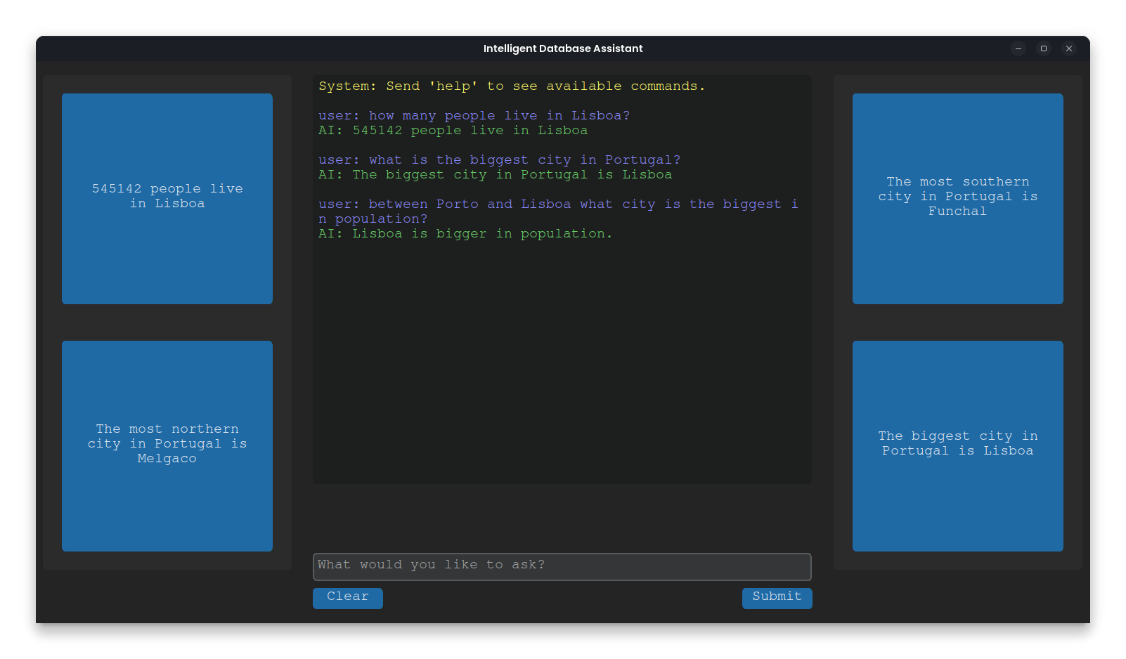

6. Differences Between SQL and Prolog
SQL
- SQL is designed for structured data retrieval from relational databases.
- It excels in handling large datasets and performing operations like filtering, grouping, and sorting.
- SQL queries are deterministic and rely on predefined schema and relationships.

Prolog
- Prolog is a logic programming language that uses rules and facts to infer answers.
- It is ideal for reasoning-based queries, such as determining relationships or solving complex problems.
- Prolog queries are declarative and focus on "what" rather than "how."

Key Difference
SQL is data-centric and operates directly on the database, while Prolog is logic-centric and uses rules to derive answers. SQL is faster for structured queries, whereas Prolog is better suited for reasoning and complex relationships.

7. Superlative Queries
Superlative queries are designed to identify extremes in data, such as the largest, smallest, or highest values across a dataset. Examples include:
- "What are the 5 biggest cities in population?"
- "What is the smallest city in area?"
- "What are the top 10 cities with the most accommodations?"

Why SQL is Used for Superlative Queries

1. Efficient Data Retrieval:
SQL is optimized for handling large datasets stored in relational databases. It can quickly filter, sort, and aggregate data using built-in operations like `ORDER BY`, `LIMIT`, and `GROUP BY`. For example:
```sql
SELECT LUG21DESIG, SUM(N_INDIVIDUOS) AS population
FROM LUGARES21_CONT
GROUP BY LUG21DESIG
ORDER BY population DESC
LIMIT 5;
```
This query efficiently retrieves the top 5 cities with the largest populations.

2. Scalability:
SQL is designed to scale with large datasets. Superlative queries often involve scanning and sorting thousands or millions of rows, which SQL handles efficiently using indexing and query optimization techniques.

3. Complex Aggregations:
Superlative queries often require aggregations, such as summing populations or calculating averages. SQL's aggregation functions (`SUM`, `AVG`, `MAX`, `MIN`) are highly optimized for such operations.

Why Not Prolog Logic?
1. Declarative Nature:
Prolog is a logic programming language that excels in reasoning and inference. It is better suited for queries involving relationships, rules, and reasoning, such as "Which city is the most northern?" or "Which city has the highest altitude?"

2. Performance Limitations:
Prolog is not optimized for handling large datasets or performing operations like sorting and filtering across thousands of rows. Implementing superlative queries in Prolog would require manually defining sorting algorithms and aggregations, which are less efficient than SQL's built-in capabilities.

3. Database Integration:
SQL operates directly on relational databases, making it ideal for queries that require extensive data manipulation. Prolog, on the other hand, relies on external libraries (e.g., `prosqlite`) to interact with databases, which adds overhead and complexity.

Conclusion
Superlative queries are implemented in SQL because of its efficiency, scalability, and ability to handle complex aggregations on large datasets. Prolog is reserved for reasoning-based queries where relationships and rules are the primary focus. By leveraging the strengths of both SQL and Prolog, the Intelligent Database Assistant achieves a balance between performance and flexibility.

8. Results
8.1 Query Execution Times
The project includes a graph comparing SQL and Prolog query execution times. SQL queries are generally faster for structured data retrieval, while Prolog queries are better suited for reasoning-based tasks.

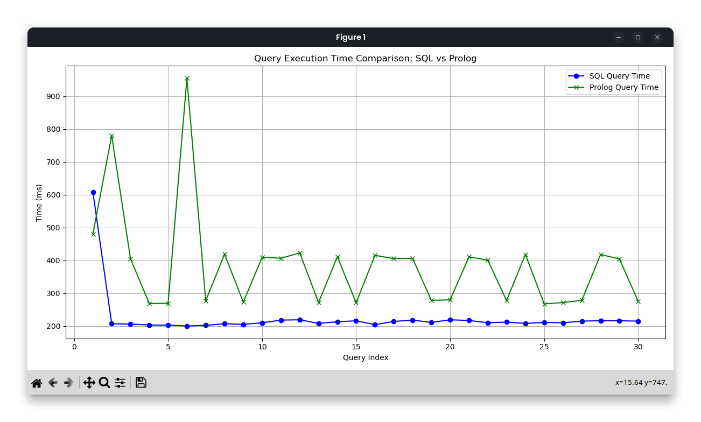

8.2 Comparative Queries
Prolog scripts demonstrate the ability to answer complex comparative queries, such as determining the city with the largest population or area.

9. Conclusion
The Intelligent Database Assistant successfully combines SQL and Prolog to provide a versatile querying system. The GUI enhances user experience, while the reasoning engine ensures robust query processing. The visualization tool and Docker container further improve usability and portability.

10. References
1. Tkinter Documentation: https://docs.python.org/3/library/tkinter.html
2. CustomTkinter Documentation: https://github.com/TomSchimansky/CustomTkinter
3. Matplotlib Documentation: https://matplotlib.org/
4. SQL Tutorial: https://www.w3schools.com/sql/
5. Prolog Documentation: https://www.swi-prolog.org/
6. Docker Documentation: https://docs.docker.com/

