CS5239 Assignment 1
Edison Tsui Ka Wing
Alan Ng Beng Hong
Divya Kannan

1 Performance Metrics & Measurement
Simple Matrix Multiplication program is developed (see attachment) to measure “wall time” and “CPU time”.
Wall time is measured by time() which shows how much real time is elapsed from start to end
CPU time is measured by clock() which shows how many CPU cycle is used. Time is calculated by total_clock_cycle_used/ CLOCKS_PER_SEC.
For accuracy, we only measure the “Wall time” and “CPU time” for multiplication part only, excluding initialization and deinitialization.

Part A
i) From experiment, we see that the different between the two time does not exceed 1 sec if we are running 1 instance. This may due to 1) the precision of time() and 2) matrix multiplication is CPU intensive function and do not involve other part like I/O so the two time converge. Below shown the experiment data:

N | 100 | 300 | 500 | 800 | 1000
CPU Time | 0.015 | 0.171 | 0.998 | 5.195 | 11.684
Wall Time | 0 | 0 | 1 | 5 | 12

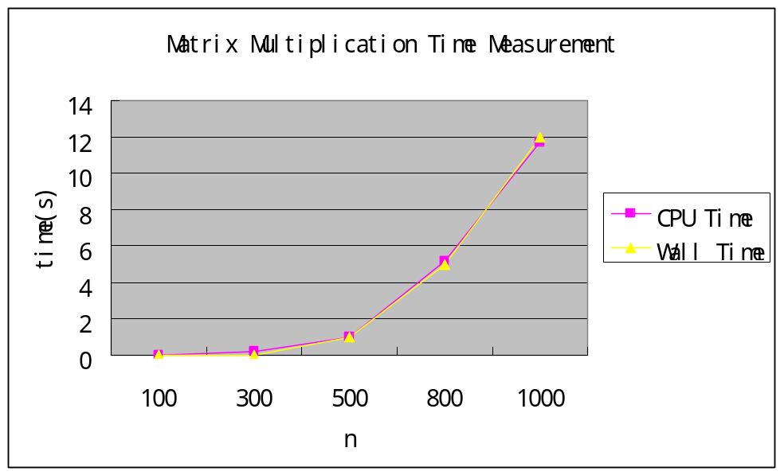

In order to show our assumption that CPU time and Wall time can be different and the converging data just reflect matrix multiplication is CPU intensive, we have run four instances of program with n = 1000. We can see that their CPU time is roughly the same and in line with single instance case, but wall time varies from 13 sec to 26 sec which may due to scheduling. Below shown the experiment
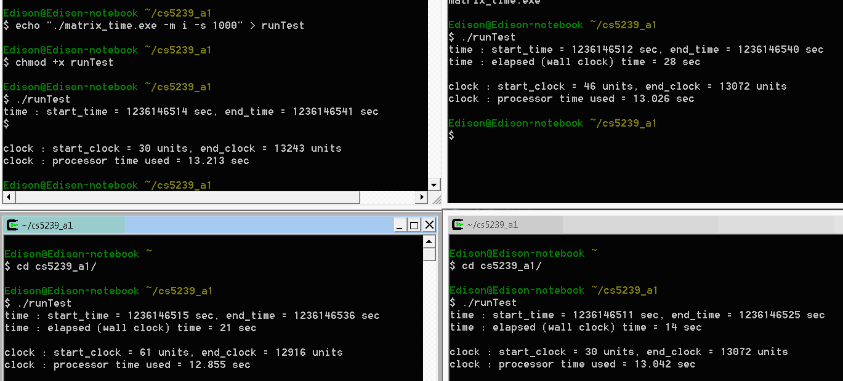

ii) Wall time should be used when measuring overall performance of a program as it gives more reliable time which account to CPU, I/O and communication channel delay, etc.
CPU time should be used when measuring/comparing performance of processor as it only take CPU cycle and clock speed into account.
However, both times metric is not linear which mean smaller “time” is performing better.

iii) Yes, for pure CPU load program, like matrix multiplication, the two times has a high chance to be the same given there is no other process eating up CPU.

Part B
For a N*N matrix, calculating matrix multiplication will have N summation and N multiplication for each element. Overall, it will have 2 *(N^3) instruction. For million instruction (10^6), setting n to 10^2 will give 2 million instructions.
MIPS = (2 * n^3) / ( CPU Time by integer Matrix Multiplication * 10^6 )
MFLOPS = (2 * n^3) / ( CPU Time by floating point Matrix Multiplication * 10^6 )

Also, we have developed the program to take floating point matrix to find out the performance of floating point instruction, e.g. –m (mode) f

In this experiment, we will only use CPU time as both MIPS and MFLOPS focus on processor performance only.

i)
From experiment, we get
n | 100 | 300 | 500 | 800 | 1000
MIPS | 133.3333 | 315.7895 | 250.501 | 197.1126 | 171.1743
MFLOPS | 133.3333 | 288.7701 | 246.5483 | 193.0618 | 167.5884
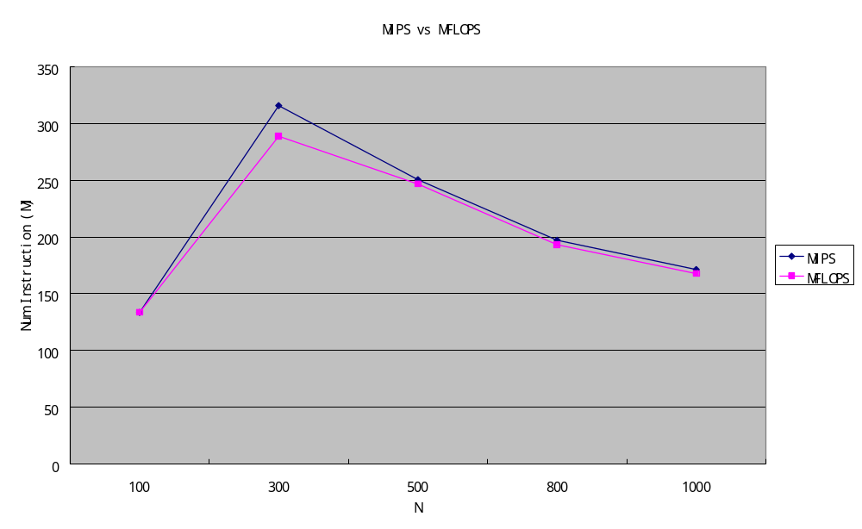
- The test processor is Intel Core 2 2.2GHz. As we do not add parallel programming in our test,
Please check here, I remember each cycle Intel CPU can take up to 4 instructions so it will be 8.8 G instruction per sec. But I forget where it is from.

